**DAMG 6210 DATA MANAGEMNET AND DATABASE DESIGN**

**Group Assignment 3: Project Report**

|  |  |
| --- | --- |
| **STUDENT** | **NUID** |
| Mohammed Omer Qasim Shaik | 002707760 |
| Rekha Samrajyutha Sajja | 002655060 |
| Sai Sindhu Thondapu | 002785016 |
| Shaiz Akhtar Mohammad | 002796856 |
| Srinivasa Reddy Akumalla | 002798166 |

**CONTENTS**

1. About the project…….……………………………………………………………………………………………. 3
2. Database Design & Implementation………………………………………………………………………. 3
   1. Business Rules………………………………………………………………………………………………….. 3
   2. Entities……………………………………………………………………………………………………………… 5
   3. Entity Relationship Diagram……………………………………………………………………………… 7
   4. Project Tracking………………………………………………………………………………………………… 8
   5. Reasons for successful completion……………………………………………………………………. 10
   6. Concepts and code……………………………………………………………………………………………. 10
   7. DDL Statements………………………………………………………………………………………………… 10
   8. Index…………………………………………………………………………………………………………………. 11
   9. Sequence…………………………………………………………………………………………………………… 11
   10. Scenario 1………………………………………………………………………………………………………….. 12
   11. Scenario 2………………………………………………………………………………………………………….. 12
   12. Scenario 3………………………………………………………………………………………………………….. 12
   13. Scenario 4………………………………………………………………………………………………………….. 13

**PROJECT REPORT**

**About the Project:**

**Matrix** is a reliable, efficient, and integrated bus, streetcar and subway network that draws its high standards of customer care from rich traditions of safety, service, and courtesy.

The main goal of the project is to construct a database for Matrix company that comprises of tables that they can use to manage their work on a regular basis. The project tables are classified based on the client's specifications, which are as follows:

* Records of staff employees should be kept, which essentially hold personal information, working hours, and their off schedule.
* A list of vehicles utilized for public transportation should be kept.
* The company should keep records on the types of services offered based on age and the routes in order to notify passengers about these things.
* Information regarding every passenger using the company's services should be kept up to date.

Our team is able to give the whole picture of how the Matrix maintains its employees, passengers, transit vehicles, and service routes. This project will assist the customer in getting a complete understanding of their needs, enabling them to function without interruption on a daily basis.

**Database Design & Implementation:**

**Business Rules:**

|  |  |  |  |  |  |
| --- | --- | --- | --- | --- | --- |
| **ID** | **Rule** | **Condition** | **Ownership** | **Date Added** | **Status** |
| EBR01 | Every department should have exactly one manager. | N/A | Department | 26/11/2022 | Active |
| EBR02 | Every employee should have exactly one sin number. | N/A | Employee | 26/11/2022 | Active |
| EBR03 | Each employee should have only one schedule. | Employee should not be on leave | Employee | 26/11/2022 | Active |
| IBR01 | One of the following abbreviated notations  [H, HL, HE, HLE]should be selected as the insurance  type. For complete forms, see the page of abbreviations. | N/A | Insurance | 26/11/2022 | Active |
| IBR02 | The insurance type should be H, meaning health insurance and it is mandatory for every employee. | N/A | Insurance | 26/11/2022 | Active |
| IBR03 | Employees may opt for additional insurance in future. | Must follow IBR01 | Insurance | 26/11/2022 | Not Active |
| VBR01 | The vehicle type should be chosen from the list below [B,BE,BG,T,TG].  For complete forms, see the page of abbreviations. | N/A | Vehicle | 28/11/2022 | Active |
| VBR02 | Each vehicle must undergo maintenance inspections  every three months or after traveling 10,000 miles,  whichever comes first. | N/A | Vehicle | 28/11/2022 | Active |
| RBR01 | There should only be one fare for each trip. | N/A | Ride | 28/11/2022 | Active |
| CUBR01 | Each customer should only have one login. | N/A | Customer | 28/11/2022 | Active |
| CUBR02 | As the customer boards the bus, they have the option of paying the fare with cash, a debit card, or by tapping their travel card.To pay with debit card or cash customer must approach the driver. | N/A | Customer | 28/11/2022 | Active |
| CUBR03 | For each boarding, the customer should tap the travel card. Each tap is only valid for three hours. | N/A | Customer | 28/11/2022 | Active |
| CUBR04 | The customer should pay the fare using cash or a  debit card if the transaction failed while the card was being tapped owing to an unforeseen problem.Refer CUBR02. | N/A | Customer | 28/11/2022 | Active |

**Entities:**

The entities in our system are

* Customer
* Department
* CustAccount
* Card
* Employee
* EmpSchedule
* FareEnum
* HelpDesk
* Insurance
* Maintainance
* Payroll
* Ridehistory
* Route
* TransactionHistory
* Vehicle
* VehicleSchedule
* Vendor

**Entity Relationship Diagram:**

An entity relationship model, also known as an entity-relationship (ER) diagram, is a graphical representation of entities and their relationships to one another that is commonly used in computing to organize data in databases or information systems.

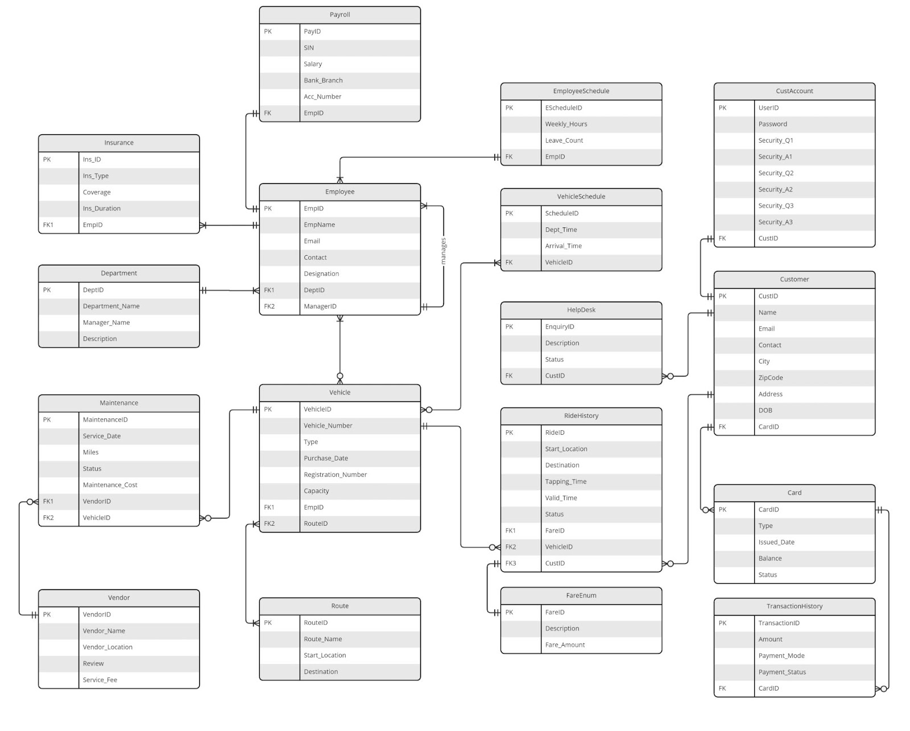

**Project Tracking:**

In order to successfully complete the project, our team has kept a project tracker. We used this tracker to track the progress of the tasks while they were being executed.

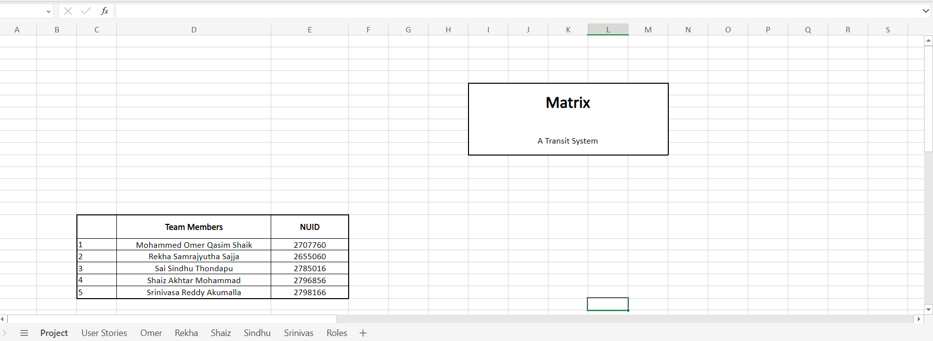

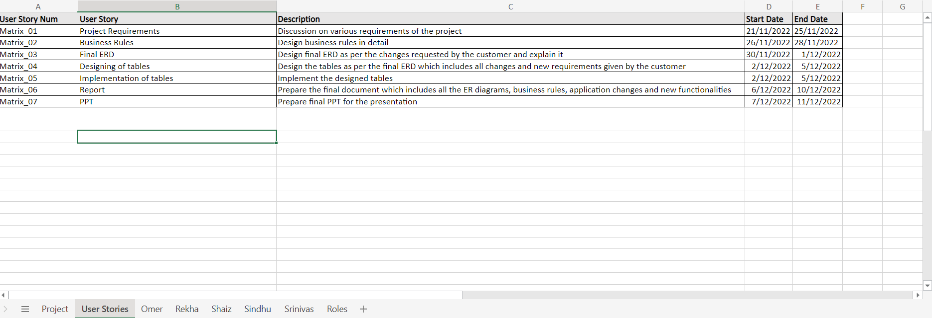

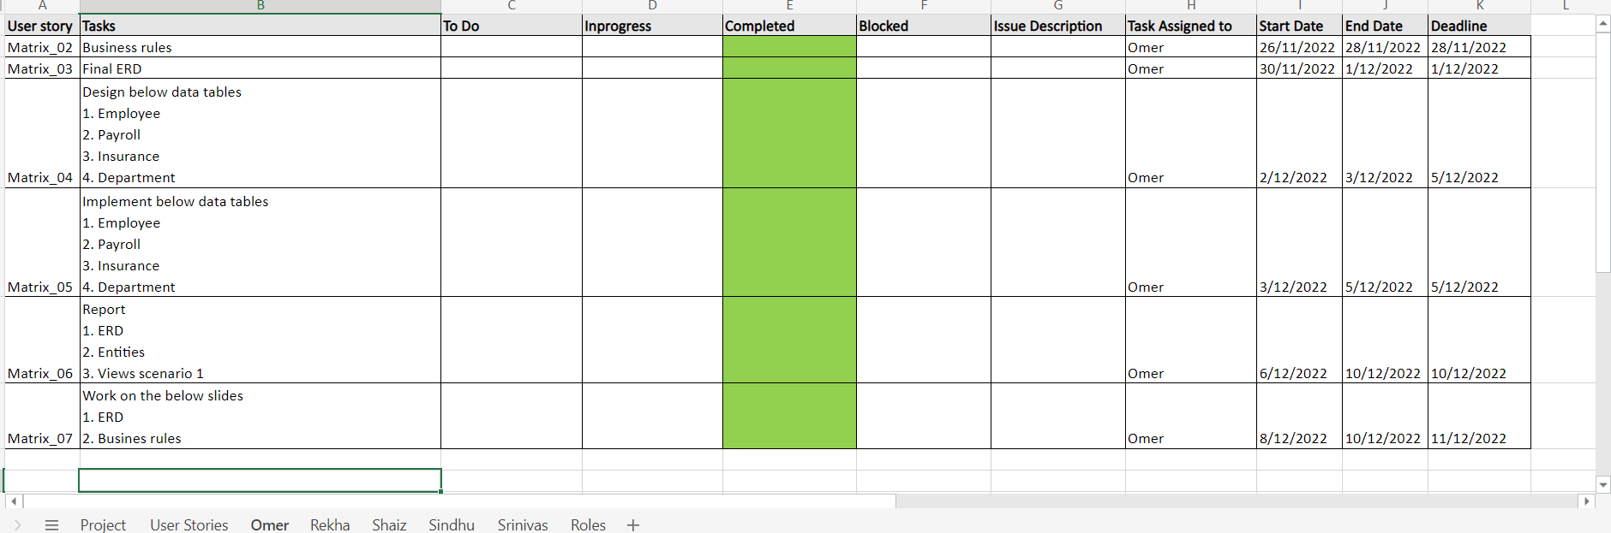

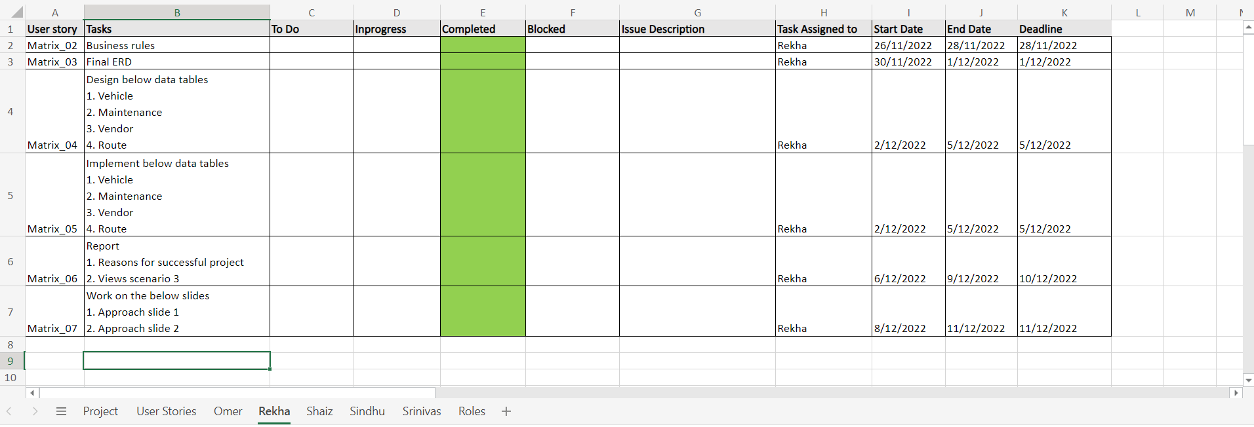

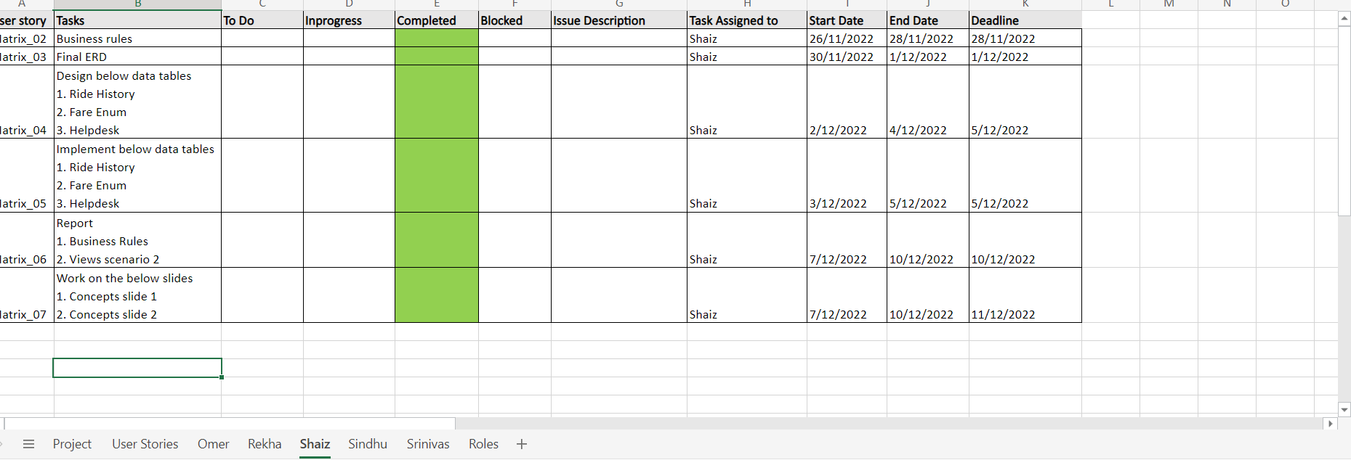

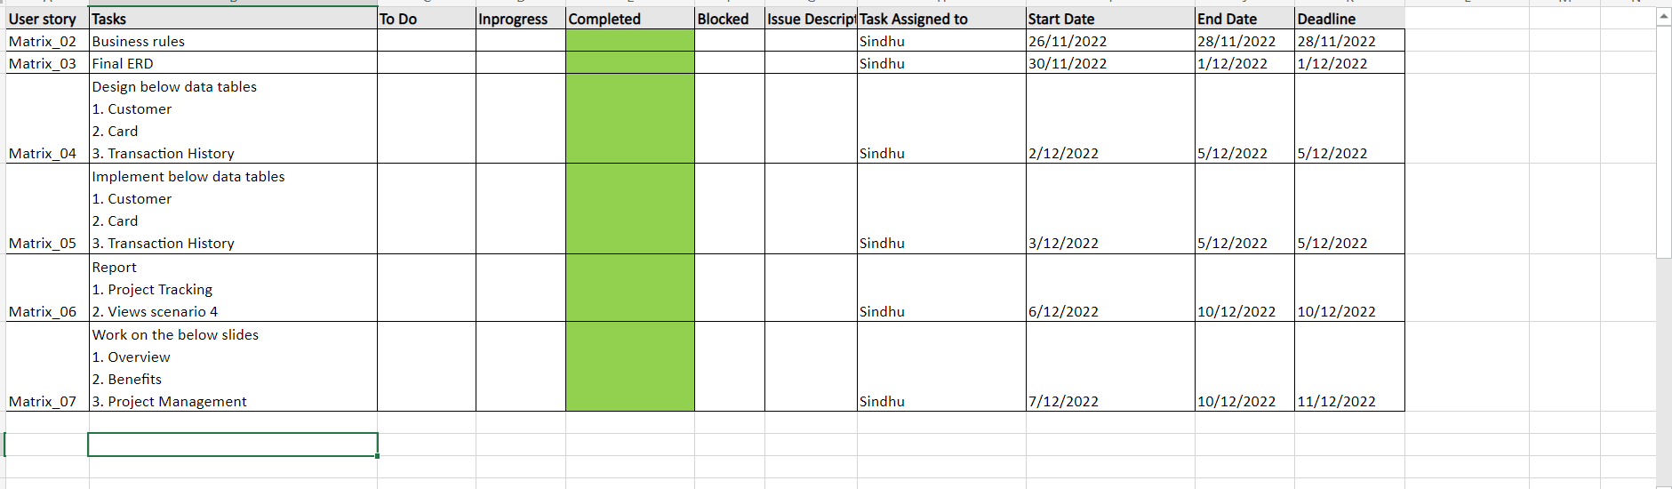

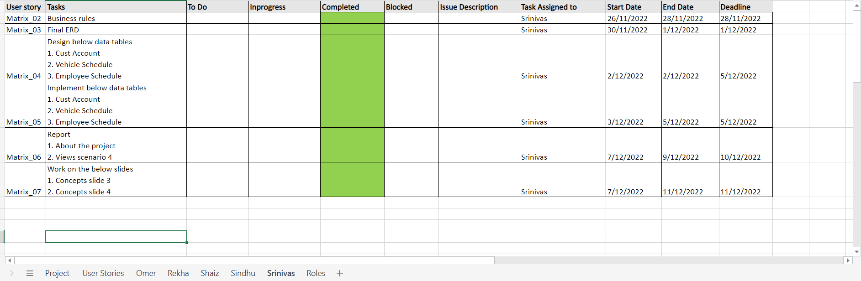

**Reasons for successful completion:**

* Proper communication between team members which avoided conflicts in the team​
* Everyone participated and took the ownership of the team project​
* Everyone showed-up during team meetings which were held regularly in order to maintain team transparency.​
* All the participants in the team ensured to meet the deadlines without compromising the quality of the project.

**Concepts and code:**

|  |  |
| --- | --- |
| **Object Type** | **Quantity/Implemanted(Yes or No)** |
| Data Tables | 17 |
| Data Values | 10 |
| Table Level Check Constraint | Yes |
| Views | Yes |
| Index | Yes |
| Sequences | Yes |
| Sub Queries | Yes |
| Joins | Yes |

**DDL Statements:**

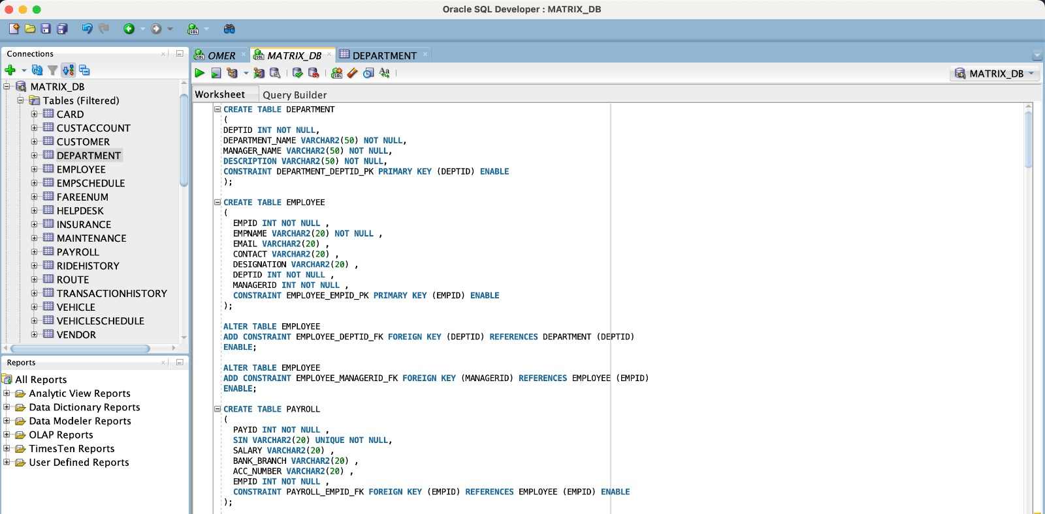

**Index:**

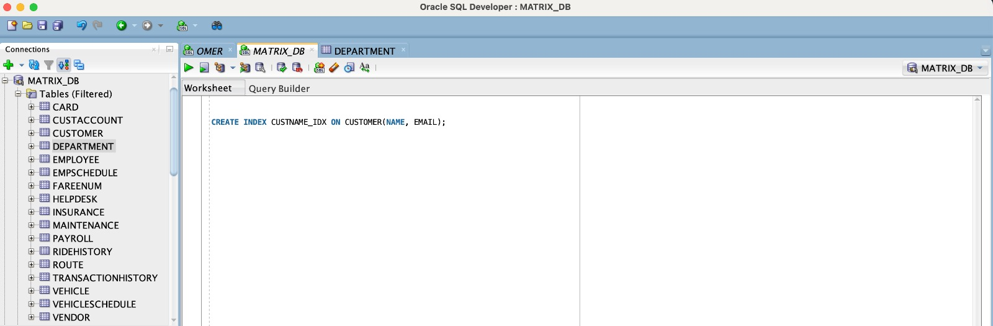

**Sequence:**

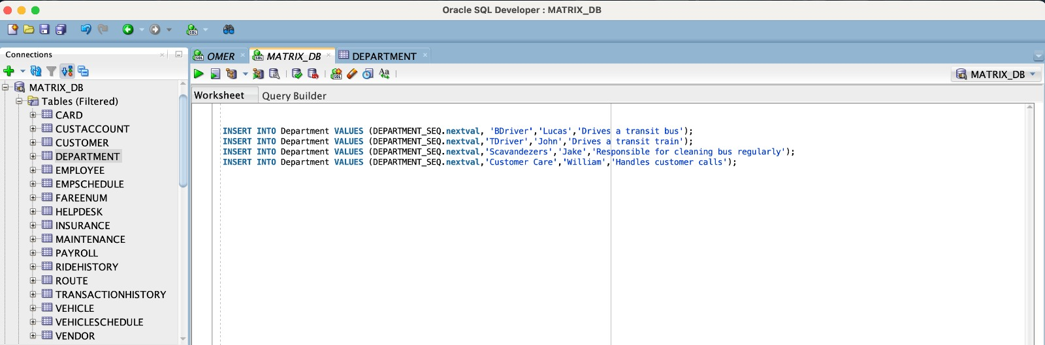

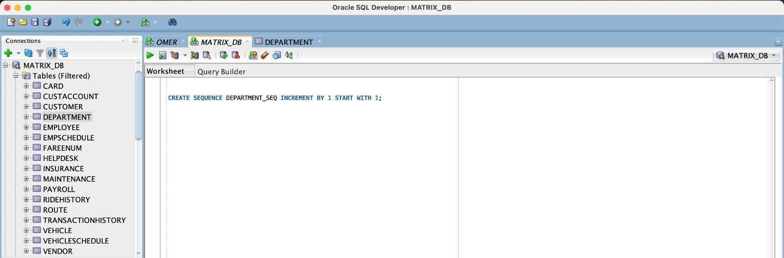

**Scenario 1: Create a view for a bus engineer to check vehicle maintenance record**

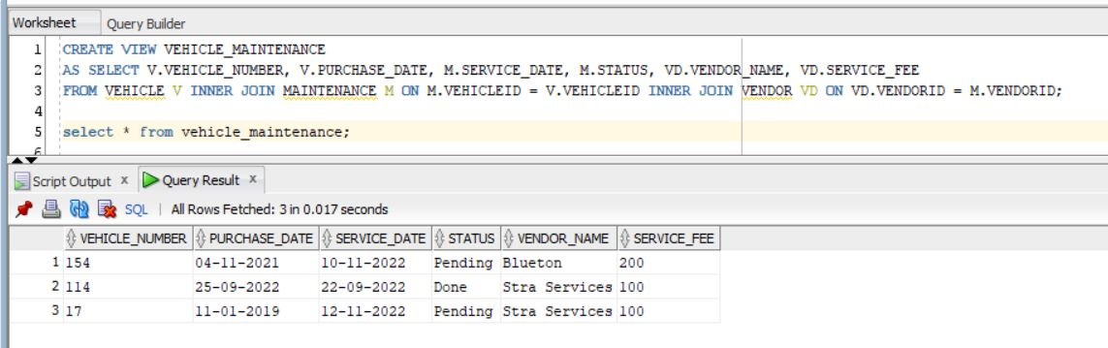

**Scenario 2: Create a View for HR to check employee salary and insurance details**

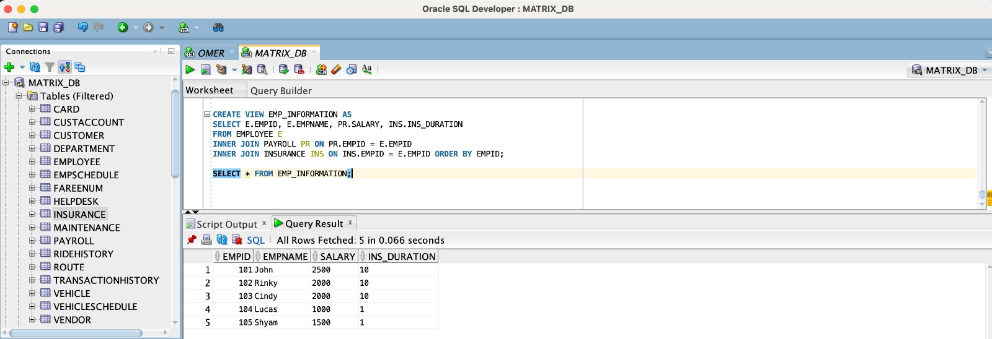

**Scenario 3: Create a view for customer when he logs in the ‘My Card’ section of the application**

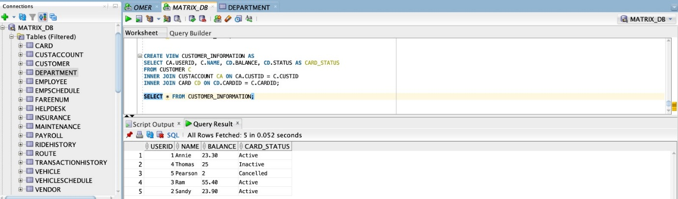

**Scenario 4: Create a view for customer when he logs in ‘Card Tap History’ section of the application**

