Technical Specification
Interface INT_XXXXI<xxx>_ErrorHandlingUsingAI

Document Identification
Field | Value
Interface ID | I<xxx>
Title | ErrorHandlingUsingAI
Version | 1.0.0
Level3 ID | —
Author | —
SAP Version | —
Interface Pattern | —

Revision History
Version | Author Of Revision | Creation Date | Comments | Incident/CR Number
1.0 | CI Pipeline | 2026-07-15 | Auto-generated from iFlow artifact via GitHub Actions | —

1. Detailed Functional Design
This section captures the functional requirements of the interface. It is not derivable from the iFlow export and must be completed manually (link the FSD / mapping sheet).

2. Detailed Technical Design Specifications
This section covers ABAP-side development (custom objects, enhancements, function modules). It is out of scope for automated generation from an iFlow export — complete manually if this interface includes ABAP-side components.

3. BTP-IS Technical Information
Covers SAP BTP Integration Suite components, configurations, and security details.

3.1 Package Details
Field | Value
Package / Bundle Name | ErrorHandlingUsingAI
Bundle Version | 1.0.0
Bundle SymbolicName | ErrorHandlingUsingAI; singleton:=true

3.1.1 Integration Flow Details
Field | Value
Name | ErrorHandlingUsingAI
ID | Process_1
Description | —
Namespace Mapping | —
Allowed Header(s) | —
Return Exception to Sender | —

Resources
Name | Type | Action
script1.groovy | Script | Included in iFlow
script2.groovy | Script | Included in iFlow
script3.groovy | Script | Included in iFlow

Externalized Parameters
No externalized parameters are defined in this iFlow.

3.2 Cloud Connector Configuration
Details connectivity between on-premise and cloud systems. Not derivable from the iFlow export — complete manually if this interface uses the Cloud Connector (e.g. an On-Premise proxy type appears in Section 3.7).

3.3 Pallet Functions
Participants
Name | Type
Receiver | EndpointRecevier
Gemini_3 | EndpointRecevier
Integration Process | IntegrationProcess

3.3.1 Start Event
Name: Start Timer 1
Marks the start of the process.

Name: Error Start 1
Marks the start of the process.

3.3.2 End Event
Name: End
Marks the end of the process.

Name: End 1
Marks the end of the process.

3.3.3 Content Modifier
Name: cm_setAPIKey_GenAIPrompt
Content Modifier step that sets 2 headers and 6 exchange properties.
Message Header — Headers
Action | Name | Type | Datatype | Value | Default
Create | Content-Type | constant |  | application/json
Create | X-goog-api-key | constant |  | [REDACTED]

Exchange Property — Properties
Action | Name | Type | Datatype | Value | Default
Create | GenAIPrompt | constant |  | { "contents": [ { "parts": [ { "text": " You are an SAP Integration consultant skilled in troubleshooting in SAP Cloud Integration (CPI). Above error is persisting while sending the message from sender to receiver system. For this error, Please respond using the following format, with each section clearly separated by a single line break in a direct and professional tone: 1. User-Friendly Error Message: A one sentence error that can be easily understood by non-technical stakeholders 2. Possible Reasons for the Error: List common causes for encountering this error in SAP CPI integration scenarios. 3. Possible Steps to Resolve the Error: Provide possible troubleshooting steps to address the issue and potentially resolve it. 4. HTTP Response: Provide appropriate HTTP error code (numerical value only) to be sent to sender system. " } ] } ] }
Create | StartPrompt | constant |  | "text": "
Create | CaptureCustomError | constant |  | User-Friendly Error Message:
Create | CapturePossibleSolution | constant |  | Possible Steps to Resolve the Error:
Create | CapturePossibleReason | constant |  | Possible Reasons for the Error:
Create | CaptureHTTPCode | constant |  | HTTP Response:

Message Body
Type: constant
Body: —

Name: cm_setContentTypeErrorResponse
Content Modifier step that sets 1 header.
Message Header — Headers
Action | Name | Type | Datatype | Value | Default
Create | Content-Type | constant |  | application/xml

Message Body
Type: constant
Body: —

3.3.4 Groovy Script
Name: cm_setAIPrompt
Custom transformation logic implemented in script1.groovy.
Attachment: attachments/script1.groovy

Name: script_CaptureGenAIResponse
Custom transformation logic implemented in script2.groovy.
Attachment: attachments/script2.groovy

Name: script_GenerateErrorResponse
Custom transformation logic implemented in script3.groovy.
Attachment: attachments/script3.groovy

3.3.5 Request-Reply / External Call
Name: RR_GenAI
Calls an external system via the adapter configured in Section 3.7 Connectivity.
See Section 3.7 Connectivity for the adapter/endpoint configuration this call uses.

High-Level Design
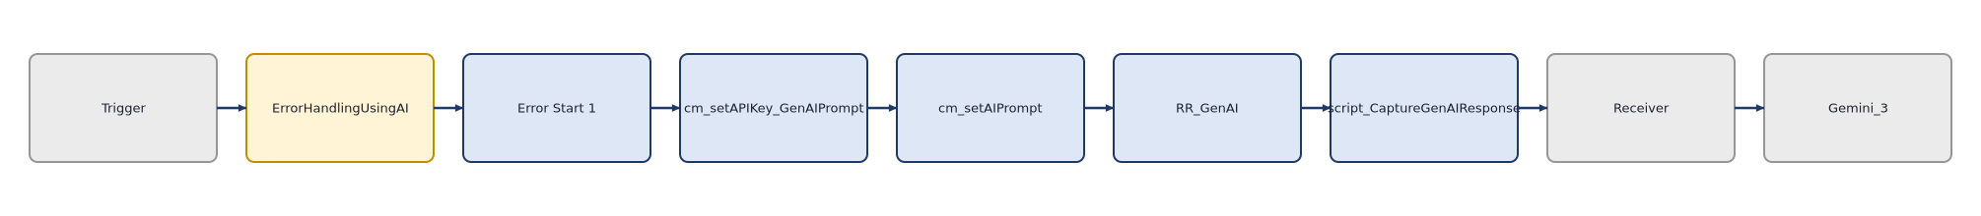

Message Flow Diagram
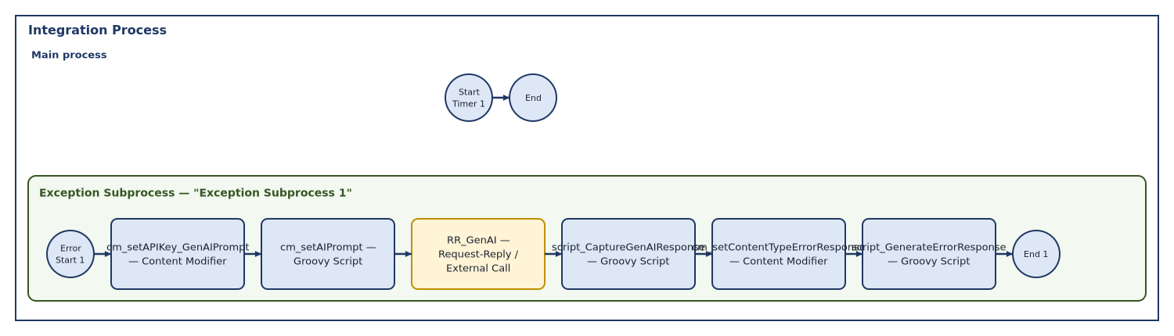

This iFlow contains 10 step(s) across 1 subprocess(es). Configured channels: HTTP (HTTP, Receiver), SFTP (SFTP, Receiver).

3.4 Security
Details authentication, encryption, and access controls.
Authentication method(s) detected across configured channels: Client Certificate, public_key.

Security Material
Name | Type | Status | Deployed By | Deployed On
sftp_key | public_key | — verify at deployment | — | —

Security Observations
Area | Configuration | Observation
HTTP | Client Certificate | Automatically detected from iFlow configuration — verify at deployment.
SFTP | public_key | Automatically detected from iFlow configuration — verify at deployment.

3.5 Manage Stores
Describes message persistence mechanisms (Data Store, Variables, Number Ranges).
No Data Store, Variable, or Number Range operations were found in this iFlow.

3.6 Monitoring and Error Handling
Captures error logging and alert mechanisms.
Log Configuration
Log level is not explicitly configured in the iFlow XML — uses the tenant default; verify in the Monitor before go-live.
No exception subprocess was found in this iFlow — verify error handling is configured as expected.
• No explicit exception subprocess was found in this iFlow.

3.7 Connectivity
Defines network, proxy, and API configurations.
This iFlow has 2 configured channel(s): HTTP (HTTP, Receiver), SFTP (SFTP, Receiver).

3.7.1 HTTP (HTTP — Receiver)
Property | Value
Adapter / Component Type | HTTP
Transport Protocol | HTTP
Message Protocol | None
Address / Endpoint URL | https://generativelanguage.googleapis.com/v1beta/models/gemini-3.1-flash-lite:generateContent
Direction | Receiver
apiName
Description
methodSourceExpression
apiArtifactType
providerAuth
privateKeyAlias | [REDACTED]
httpMethod | POST
apiprovider_location_id
allowedResponseHeaders | *
internetProxyType
TransportProtocolVersion | 1.19.2
proxyPort
streaming | false
enableMPLAttachments | true
httpAddressQuery
httpRequestTimeout | 60000
providerName
allowedRequestHeaders | Content-Type|X-goog-api-key
httpShouldSendBody | false
throwExceptionOnFailure | true
proxyType | default
retryIteration | 1
proxyHost
providerUrl
retryOnConnectionFailure | false
system | Receiver1
authenticationMethod | Client Certificate
locationID
retryInterval | 5
credentialName
httpErrorResponseCodes
MessageProtocolVersion | 1.19.2
httpAddressWithoutQuery | https://generativelanguage.googleapis.com/v1beta/models/gemini-3.1-flash-lite:generateContent
providerRelativeUrl

3.7.2 SFTP (SFTP — Receiver)
Property | Value
Adapter / Component Type | SFTP
Transport Protocol | SFTP
Message Protocol | File
Address / Endpoint URL | eu-central-1.sftpcloud.io/Test
Direction | Receiver
disconnect | 0
fileName | test.xml
Description
maximumReconnectAttempts | 3
stepwise | 1
fileExist | Override
autoCreate | 1
privateKeyAlias | [REDACTED]
location_id
TransportProtocolVersion | 1.20.1
flatten
sftpSecEnabled | 1
useTempFile | 0
path | /Test
proxyPort | 8080
host | eu-central-1.sftpcloud.io
connectTimeout | 10000
fastExistsCheck | 1
authentication | public_key
fileAppendTimeStamp | 0
credential_name
proxyProtocol | socks5
proxyType | none
proxyAlias
reconnectDelay | 1000
proxyHost
system | Receiver
tempFileName | ${file:name}.tmp
allowDeprecatedAlgorithms | 0
MessageProtocolVersion | 1.20.1
username | sftp_key

4. Event Mesh Technical Information
No Event Mesh components were detected in this iFlow. Section left for manual completion if applicable.

5. APIM Technical Information
No API Management components were detected in this iFlow. Section left for manual completion if applicable.

6. Test Cases
Identify the test scenarios to be used to test the development with. (Mandatory)

Test Considerations | Scope of Testing (IS / OS / BO) | Target Test Date
Verify successful processing of a valid message end-to-end | Inside SAP (IS) | TBD
Verify connectivity/authentication for channel "HTTP" | Both (BO) | TBD
Verify connectivity/authentication for channel "SFTP" | Both (BO) | TBD

Appendix A: Automated Review Findings
Supplementary AI-generated review — not part of the standard TSD template, kept for convenience.

Severity | Area | Finding | Recommendation
🔴 High | Security | Hardcoded credential-like value found in step "cm_setAPIKey_GenAIPrompt" (property "X-goog-api-key"). | Externalize as a Secure Parameter / User Credential and reference it via a property placeholder.

• This document was generated automatically from the iFlow export — no external services were called and no data left this pipeline. Narrative fields are templated from the parsed configuration only; review and expand manually where deeper business context is needed.

