Technical Specification
Interface INT_XXXXI<xxx>_ErrorHandlingUsingAI

Document Identification
Field | Value
Interface ID | I<xxx>
Title | ErrorHandlingUsingAI
Version | 1.0.0
Level3 ID | —
Author | —
SAP Version | —
Interface Pattern | —

Revision History
Version | Author Of Revision | Creation Date | Comments | Incident/CR Number
1.0 | CI Pipeline | 2026-07-14 | Auto-generated from iFlow artifact via GitHub Actions | —

1. Detailed Functional Design
This section captures the functional requirements of the interface. It is not derivable from the iFlow export and must be completed manually (link the FSD / mapping sheet).

2. Detailed Technical Design Specifications
This section covers ABAP-side development (custom objects, enhancements, function modules). It is out of scope for automated generation from an iFlow export — complete manually if this interface includes ABAP-side components.

3. BTP-IS Technical Information
Covers SAP BTP Integration Suite components, configurations, and security details.

3.1 Package Details
Field | Value
Package / Bundle Name | ErrorHandlingUsingAI
Bundle Version | 1.0.0
Bundle SymbolicName | ErrorHandlingUsingAI; singleton:=true

3.1.1 Integration Flow Details
Field | Value
Name | ErrorHandlingUsingAI
ID | Process_1
Description | —
Namespace Mapping | —
Allowed Header(s) | —
Return Exception to Sender | —

Resources
Name | Type | Action
script1.groovy | Script | Included in iFlow
script2.groovy | Script | Included in iFlow
script3.groovy | Script | Included in iFlow

Externalized Parameters
No externalized parameters are defined in this iFlow.

3.2 Cloud Connector Configuration
Details connectivity between on-premise and cloud systems. Not derivable from the iFlow export — complete manually if this interface uses the Cloud Connector (e.g. an On-Premise proxy type appears in Section 3.7).

3.3 Pallet Functions
Participants
Name | Type
Receiver | EndpointRecevier
Gemini_3 | EndpointRecevier
Integration Process | IntegrationProcess

3.3.1 Start Event
Name: Start Timer 1
The process is initiated by a timer, though the logic is primarily driven by the Exception Subprocess.

Name: Error Start 1
The entry point for the Exception Subprocess triggered by any error in the main flow.

3.3.2 End Event
Name: End
The standard end event for the main integration process.

Name: End 1
The termination point of the Exception Subprocess.

3.3.3 Content Modifier
Name: cm_setAPIKey_GenAIPrompt
Sets the initial prompt structure and headers, including the sensitive Google API key.
Message Header — Headers
Action | Name | Type | Datatype | Value | Default
Create | Content-Type | constant |  | application/json
Create | X-goog-api-key | constant |  | [REDACTED]

Exchange Property — Properties
Action | Name | Type | Datatype | Value | Default
Create | GenAIPrompt | constant |  | { "contents": [ { "parts": [ { "text": " You are an SAP Integration consultant skilled in troubleshooting in SAP Cloud Integration (CPI). Above error is persisting while sending the message from sender to receiver system. For this error, Please respond using the following format, with each section clearly separated by a single line break in a direct and professional tone: 1. User-Friendly Error Message: A one sentence error that can be easily understood by non-technical stakeholders 2. Possible Reasons for the Error: List common causes for encountering this error in SAP CPI integration scenarios. 3. Possible Steps to Resolve the Error: Provide possible troubleshooting steps to address the issue and potentially resolve it. 4. HTTP Response: Provide appropriate HTTP error code (numerical value only) to be sent to sender system. " } ] } ] }
Create | StartPrompt | constant |  | "text": "
Create | CaptureCustomError | constant |  | User-Friendly Error Message:
Create | CapturePossibleSolution | constant |  | Possible Steps to Resolve the Error:
Create | CapturePossibleReason | constant |  | Possible Reasons for the Error:
Create | CaptureHTTPCode | constant |  | HTTP Response:

Message Body
Type: constant
Body: —

Name: cm_setContentTypeErrorResponse
Sets the Content-Type header to application/xml for the final response.
Message Header — Headers
Action | Name | Type | Datatype | Value | Default
Create | Content-Type | constant |  | application/xml

Message Body
Type: constant
Body: —

3.3.4 Groovy Script
Name: cm_setAIPrompt
Executes script1.groovy to inject the caught exception into the AI prompt.
Attachment: attachments/script1.groovy

Name: script_CaptureGenAIResponse
Executes script2.groovy to parse the AI response and extract troubleshooting data.
Attachment: attachments/script2.groovy

Name: script_GenerateErrorResponse
Executes script3.groovy to build the XML body and log the final error details.
Attachment: attachments/script3.groovy

3.3.5 Request-Reply / External Call
Name: RR_GenAI
Performs the external HTTP call to the Gemini API.
See Section 3.7 Connectivity for the adapter/endpoint configuration this call uses.

High-Level Design
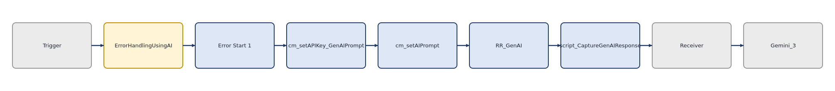

Message Flow Diagram
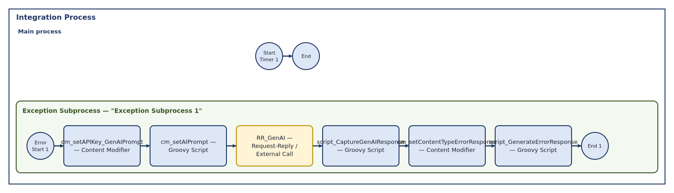

The iFlow utilizes an Exception Subprocess to catch runtime errors. Upon failure, it constructs a prompt containing the exception details, sends a request to the Gemini API via an HTTP adapter, parses the AI-generated response, and maps the findings into a custom XML error structure. The process concludes by throwing an exception to propagate the error back to the sender while logging the AI analysis to the MPL.

3.4 Security
Details authentication, encryption, and access controls.
The iFlow uses Client Certificate authentication for the HTTP receiver and public key authentication for SFTP. However, the Google API key is currently hardcoded in the Content Modifier, which is a significant security risk.

Security Material
Name | Type | Status | Deployed By | Deployed On
sftp_key | public_key | — verify at deployment | — | —

Security Observations
Area | Configuration | Observation
Authentication | Client Certificate (HTTP) | Standard secure practice for receiver connectivity.
Authentication | Public Key (SFTP) | Standard secure practice for file transfer.
Secrets Management | Hardcoded API Key | The Google API key is exposed in the Content Modifier header table.

3.5 Manage Stores
Describes message persistence mechanisms (Data Store, Variables, Number Ranges).
No Data Store, Variable, or Number Range operations were found in this iFlow.

3.6 Monitoring and Error Handling
Captures error logging and alert mechanisms.
Log Configuration
Log level is not explicitly configured in the iFlow XML — uses the tenant default; verify in the Monitor before go-live.
The iFlow makes extensive use of the MessageLogFactory to attach AI-generated analysis and exceptions to the MPL, providing good visibility into the AI troubleshooting process.
• The entire logic is encapsulated within an Exception Subprocess, ensuring it only triggers on failure.
• script3.groovy explicitly throws a new Exception at the end of the process to ensure the calling system receives a failure signal.
• The HTTP adapter is configured with 'throwExceptionOnFailure' set to true, ensuring connectivity issues with the AI provider are caught.

3.7 Connectivity
Defines network, proxy, and API configurations.
The iFlow connects to an external cloud-based AI service via HTTPS and an external SFTP server, with a 60-second timeout configured for the HTTP call.

3.7.1 HTTP (HTTP — Receiver)
Property | Value
Adapter / Component Type | HTTP
Transport Protocol | HTTP
Message Protocol | None
Address / Endpoint URL | https://generativelanguage.googleapis.com/v1beta/models/gemini-3.1-flash-lite:generateContent
Direction | Receiver
apiName
Description
methodSourceExpression
apiArtifactType
providerAuth
privateKeyAlias | [REDACTED]
httpMethod | POST
apiprovider_location_id
allowedResponseHeaders | *
internetProxyType
TransportProtocolVersion | 1.19.2
proxyPort
streaming | false
enableMPLAttachments | true
httpAddressQuery
httpRequestTimeout | 60000
providerName
allowedRequestHeaders | Content-Type|X-goog-api-key
httpShouldSendBody | false
throwExceptionOnFailure | true
proxyType | default
retryIteration | 1
proxyHost
providerUrl
retryOnConnectionFailure | false
system | Receiver1
authenticationMethod | Client Certificate
locationID
retryInterval | 5
credentialName
httpErrorResponseCodes
MessageProtocolVersion | 1.19.2
httpAddressWithoutQuery | https://generativelanguage.googleapis.com/v1beta/models/gemini-3.1-flash-lite:generateContent
providerRelativeUrl

3.7.2 SFTP (SFTP — Receiver)
Property | Value
Adapter / Component Type | SFTP
Transport Protocol | SFTP
Message Protocol | File
Address / Endpoint URL | eu-central-1.sftpcloud.io/Test
Direction | Receiver
disconnect | 0
fileName | test.xml
Description
maximumReconnectAttempts | 3
stepwise | 1
fileExist | Override
autoCreate | 1
privateKeyAlias | [REDACTED]
location_id
TransportProtocolVersion | 1.20.1
flatten
sftpSecEnabled | 1
useTempFile | 0
path | /Test
proxyPort | 8080
host | eu-central-1.sftpcloud.io
connectTimeout | 10000
fastExistsCheck | 1
authentication | public_key
fileAppendTimeStamp | 0
credential_name
proxyProtocol | socks5
proxyType | none
proxyAlias
reconnectDelay | 1000
proxyHost
system | Receiver
tempFileName | ${file:name}.tmp
allowDeprecatedAlgorithms | 0
MessageProtocolVersion | 1.20.1
username | sftp_key

4. Event Mesh Technical Information
No Event Mesh components were detected in this iFlow. Section left for manual completion if applicable.

5. APIM Technical Information
No API Management components were detected in this iFlow. Section left for manual completion if applicable.

6. Test Cases
Identify the test scenarios to be used to test the development with. (Mandatory)

Test Considerations | Scope of Testing (IS / OS / BO) | Target Test Date
Simulate a connectivity error to trigger the Exception Subprocess | BO | TBD
Verify the AI correctly identifies a common CPI error (e.g., Mapping error) | OS | TBD
Test SFTP connectivity with the provided private key | BO | TBD
Validate the XML structure of the final error response | IS | TBD

Appendix A: Automated Review Findings
Supplementary AI-generated review — not part of the standard TSD template, kept for convenience.

Severity | Area | Finding | Recommendation
🔴 High | Security | Hardcoded API Key | Move the Google API key to a Secure Parameter or Credential artifact.
🟠 Medium | Error Handling | Forced Exception | The final throw in script3.groovy may cause the message to be marked as 'Failed' in monitoring, which is intended, but ensure it doesn't cause infinite retry loops.
🟡 Low | Design | String Manipulation | Using string index/substring for JSON parsing in script2.groovy is fragile; consider using a proper JSON library if the AI response format changes.

• Verify if the Gemini API model 'gemini-3.1-flash-lite' is the correct and supported version for the environment.
• Confirm the SFTP path '/Test' exists on the target server.
• Ensure the sender system is configured to parse the custom XML error response.

