ErrorHandlingUsingAI — Technical Specification
Change History
Version | Date | Author | Change Description
1.0 | 2026-07-05 | CI Pipeline | Auto-generated from iFlow artifact via GitHub Actions

Table of Contents
1. Overview
2. Interface Overview
3. High-Level iFlow Design
4. Message Flow Diagram
5. Externalized Parameters
6. Dependencies & Referenced Artifacts
7. Deployment Configuration Checklist
8. Sender & Receiver Channels
9. Mappings & Transformations
10. Security Configuration
11. Error Handling & Logging
12. Test Plan
13. Version & Metadata
14. Review & Recommendations

1. Overview
The 'ErrorHandlingUsingAI' iFlow is designed to intercept integration errors and leverage a Generative AI model (Gemini) to provide human-readable troubleshooting insights, including potential causes and resolution steps. It captures the exception, constructs a prompt for the AI, parses the response, and generates an XML-based error report for downstream consumption.

2. Interface Overview
Direction | System / Partner | Adapter Type | Authentication | Endpoint / Address
Receiver | HTTP | HTTP | Client Certificate | https://generativelanguage.googleapis.com/v1beta/models/gemini-3.1-flash-lite:generateContent
Receiver | SFTP | SFTP | public_key | eu-central-1.sftpcloud.io/Test

3. High-Level iFlow Design
High-Level Design
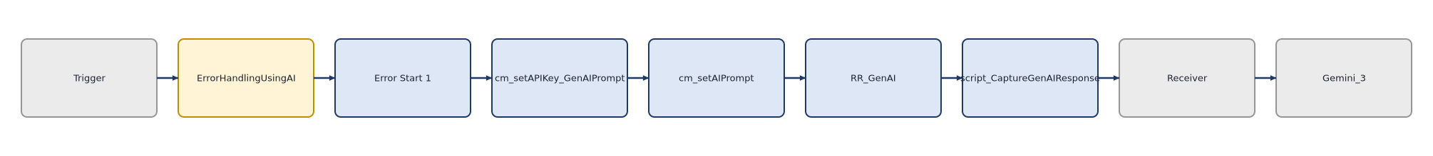
Message Flow Diagram
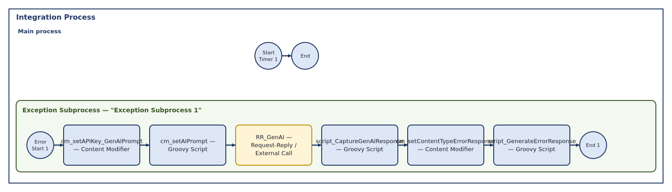
The iFlow utilizes an Exception Subprocess to catch errors occurring in the main integration flow. Upon triggering, it enriches the message with a prompt, invokes the Gemini API via a Request-Reply step, parses the AI's response using Groovy scripts, and finally constructs a structured XML error message before terminating with an exception to signal the failure.

4. Message Flow Diagram

4.1 Integration Process
Step # | Step Name | Type | Description
1 | Start Timer 1 | Unknown | Initializes the integration process via a timer trigger.
2 | End | Unknown | Marks the completion of the main integration process.

4.1.1 Exception Subprocess 1
Step # | Step Name | Type | Description
1 | Error Start 1 | Unknown | Acts as the entry point for the Exception Subprocess when an error occurs.
2 | cm_setAPIKey_GenAIPrompt | Content Modifier | Enriches the message with the AI prompt template and the Google API key header.
3 | cm_setAIPrompt | Groovy Script | Executes script1.groovy to inject the caught exception into the AI prompt.
4 | RR_GenAI | Request-Reply / External Call | Invokes the Gemini API to generate troubleshooting insights based on the provided prompt.
5 | script_CaptureGenAIResponse | Groovy Script | Executes script2.groovy to parse the JSON response from the Gemini API.
6 | cm_setContentTypeErrorResponse | Content Modifier | Sets the Content-Type header to application/xml for the final error response.
7 | script_GenerateErrorResponse | Groovy Script | Executes script3.groovy to build the XML error response and throw the final exception.
8 | End 1 | Unknown | Terminates the Exception Subprocess.

5. Externalized Parameters
No externalized parameters are defined in this iFlow.

6. Dependencies & Referenced Artifacts
The iFlow depends on an external Google Generative AI API (Gemini) and an SFTP server. It also requires a valid Google API key and a private key alias for SFTP authentication.

7. Deployment Configuration Checklist
• Ensure the Google API key is stored in a secure Credential artifact and referenced correctly.
• Verify the SFTP host and credentials are configured in the target environment.
• Confirm the Gemini API endpoint is reachable from the SAP Cloud Integration tenant.
• Validate that the required private key alias exists in the Keystore.

8. Sender & Receiver Channels
HTTP (HTTP — Receiver)
Property | Value
Adapter / Component Type | HTTP
Transport Protocol | HTTP
Message Protocol | None
Address / Endpoint URL | https://generativelanguage.googleapis.com/v1beta/models/gemini-3.1-flash-lite:generateContent
Direction | Receiver
apiName
Description
methodSourceExpression
apiArtifactType
providerAuth
ComponentNS | sap
privateKeyAlias | [REDACTED]
httpMethod | POST
apiprovider_location_id
allowedResponseHeaders | *
internetProxyType
TransportProtocolVersion | 1.19.2
ComponentSWCVName | external
proxyPort
streaming | false
enableMPLAttachments | true
httpAddressQuery
httpRequestTimeout | 60000
ComponentSWCVId | 1.19.2
providerName
allowedRequestHeaders | Content-Type|X-goog-api-key
httpShouldSendBody | false
throwExceptionOnFailure | true
proxyType | default
componentVersion | 1.19
retryIteration | 1
proxyHost
providerUrl
retryOnConnectionFailure | false
system | Receiver1
authenticationMethod | Client Certificate
locationID
retryInterval | 5
cmdVariantUri | ctype::AdapterVariant/cname::sap:HTTP/tp::HTTP/mp::None/direction::Receiver/version::1.19.2
credentialName
httpErrorResponseCodes
MessageProtocolVersion | 1.19.2
httpAddressWithoutQuery | https://generativelanguage.googleapis.com/v1beta/models/gemini-3.1-flash-lite:generateContent
providerRelativeUrl

SFTP (SFTP — Receiver)
Property | Value
Adapter / Component Type | SFTP
Transport Protocol | SFTP
Message Protocol | File
Address / Endpoint URL | eu-central-1.sftpcloud.io/Test
Direction | Receiver
disconnect | 0
fileName | test.xml
Description
maximumReconnectAttempts | 3
stepwise | 1
fileExist | Override
ComponentNS | sap
autoCreate | 1
privateKeyAlias | [REDACTED]
location_id
TransportProtocolVersion | 1.20.1
flatten
sftpSecEnabled | 1
useTempFile | 0
ComponentSWCVName | external
path | /Test
proxyPort | 8080
host | eu-central-1.sftpcloud.io
connectTimeout | 10000
fastExistsCheck | 1
ComponentSWCVId | 1.20.1
authentication | public_key
fileAppendTimeStamp | 0
credential_name
proxyProtocol | socks5
proxyType | none
proxyAlias
componentVersion | 1.13
reconnectDelay | 1000
proxyHost
system | Receiver
tempFileName | ${file:name}.tmp
allowDeprecatedAlgorithms | 0
cmdVariantUri | ctype::AdapterVariant/cname::sap:SFTP/tp::SFTP/mp::File/direction::Receiver/version::1.13.3
MessageProtocolVersion | 1.20.1
username | sftp_key

9. Mappings & Transformations
Transformation is implemented entirely through custom Groovy scripts and Content Modifier steps rather than standard Message Mapping artifacts.
• script1.groovy: Injects the caught Camel exception into the AI prompt template.
• script2.groovy: Parses the JSON response from Gemini and extracts specific troubleshooting sections.
• script3.groovy: Formats the extracted AI insights into an XML structure and manages custom log headers.

10. Security Configuration
Area | Configuration | Observation
Authentication | HTTP Adapter | Hardcoded Google API Key found in Content Modifier header table.
Authentication | SFTP Adapter | Private key alias is set to [REDACTED]; ensure this exists in the tenant keystore.
Credentials | HTTP Adapter | API Key is passed as a header; ensure this is not logged in plain text.

11. Error Handling & Logging
• The entire logic resides within an Exception Subprocess, triggered automatically upon failure.
• script3.groovy explicitly throws a new Exception at the end of the process, ensuring the overall integration status remains failed.
• The flow attempts to parse AI responses; however, it lacks robust handling for cases where the AI returns an error or unexpected format.

12. Test Plan
Suggested test scenarios derived from the iFlow structure (extend with business-specific cases):

# | Test Scenario | Type | Expected Result
1 | Simulate system error | Negative | Verify Exception Subprocess triggers and AI generates troubleshooting steps.
2 | Verify XML output | Happy Path | Confirm the generated XML structure matches the expected schema.
3 | Test API connectivity | Security | Ensure the Google API key is valid and the HTTP adapter successfully authenticates.

13. Version & Metadata
Field | Value
iFlow Name | ErrorHandlingUsingAI
Bundle Version | 1.0.0
Source | Auto-generated by CI pipeline (GitHub Actions)
Generated On | 2026-07-05
Status | Draft — review before publishing

14. Review & Recommendations
Automated best-practice review (verify against your project standards):

Severity | Area | Finding | Recommendation
🔴 High | Security | Hardcoded API Key | Remove the hardcoded API key from the Content Modifier and use a secure Externalized Parameter or Credential artifact.
🟠 Medium | Error Handling | Unconditional Exception | The script3.groovy throws an exception regardless of AI success; consider conditional logic if the AI response is optional.
🟡 Low | Design | Hardcoded Logic | The prompt template and key names are hardcoded in the Content Modifier; consider moving these to external parameters for easier maintenance.

Appendix

• Verify if the Gemini API endpoint requires specific proxy configurations in the tenant.
• Confirm the SFTP server path '/Test' is accessible and writable by the service user.
• Check if the 'CamelExceptionCaught' property contains sensitive data that should be sanitized before sending to the AI.

