Reproducible Research: Peer Assessment 1

## Loading and preprocessing the data

### 1. Load the data as data frame

stepsdata<-read.csv("C:/RLanguage/data/activity.csv")

### 2. Tidy the data

Convert the Date variable to a Date class and interval variable to Factor Class.

stepsdata$date <- as.Date(stepsdata$date, format = "%Y-%m-%d")  
stepsdata$interval <- as.factor(stepsdata$interval)

## What is mean total number of steps taken per day?

We create a new data frame (stepsbyday) which has aggregate steps for each day and date as 2 fields. We use this data frame to calculate Mean and Median. We plot the steps per day and sum of daily steps as a histogram using ggplot.

library(ggplot2)  
stepsbyday <- aggregate(steps ~ date, stepsdata, sum)  
stepsMean <- mean(stepsbyday$steps, na.rm=TRUE)  
stepsMedian <- median(stepsbyday$steps, na.rm=TRUE)  
cat("The mean is", stepsMean, "and median is", stepsMedian)

## The mean is 10766.19 and median is 10765

ggplot(stepsbyday, aes(x = steps)) +   
 geom_histogram(fill = "blue", binwidth = 1000) +   
 labs(title="Histogram of Steps Taken per Day",   
 x = "Number of Steps per Day", y = "Number of times in a day(Count)")

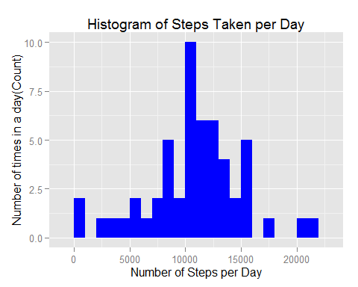

## What is the average daily activity pattern?

### 1. Time Series Plot

We create a new data frame (stepsByInterval) which has 5-minute interval and mean of steps as 2 fields. We plot this data frame as time series using ggplot.

stepsByInterval <- aggregate(stepsdata$steps, by=list(interval = stepsdata$interval), mean, na.rm=TRUE)  
stepsByInterval$interval<-as.integer(levels(stepsByInterval$interval)[stepsByInterval$interval])  
colnames(stepsByInterval) <- c("interval", "steps")  
ggplot(stepsByInterval, aes(x=interval, y=steps)) +   
 geom_line(color="blue", size=1) +   
 labs(title="Average Daily Activity Pattern", x="Interval", y="Number of steps") +   
 theme_bw()

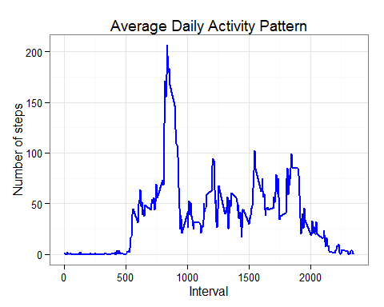 ### 2. Maximum Number of steps in any 5-minute interval We determine which 5-minute interval has maximum number of steps.

maxInterval <- stepsByInterval[which.max(stepsByInterval$steps),]  
cat("The ", maxInterval$interval, "interval has ", as.integer(maxInterval$steps), "steps")

## The 835 interval has 206 steps

## Imputing missing values

### 1. Total Number of missing values

Total number of missing values in steps field is calculated and stored in missingVals Variable

missingVals <- sum(is.na(stepsdata$steps))  
cat("Total Number of missing values are ", missingVals)

## Total Number of missing values are 2304

### 2. Strategy to fill missing values.

We choose to replace missing values with mean value at the same interval across days. We create a funtion (fillNA) with takes 2 data frames as input and populates missing values in the first data frame using the mean value stored in the 2nd data frame in the same 5-minute interval.

fillNA <- function(data, pervalue) {  
 na_index <- which(is.na(data$steps))  
 na_replace <- unlist(lapply(na_index, FUN=function(idx){  
 interval = data[idx,]$interval  
 pervalue[pervalue$interval == interval,]$steps  
 }))  
 fill_steps <- data$steps  
 fill_steps[na_index] <- na_replace  
 fill_steps  
}

### 3.Create a new data frame (filledData) with missing values filled using the mean of same 5-minute bin across days.

filledData <- data.frame(   
 steps = fillNA(stepsdata, stepsByInterval),   
 date = stepsdata$date,   
 interval = stepsdata$interval)  
  
str(filledData)

## 'data.frame': 17568 obs. of 3 variables:  
## $ steps : num 1.717 0.3396 0.1321 0.1509 0.0755 ...  
## $ date : Date, format: "2012-10-01" "2012-10-01" ...  
## $ interval: Factor w/ 288 levels "0","5","10","15",..: 1 2 3 4 5 6 7 8 9 10 ...

### 4. Analysis of new data frame and comparison of results with original data frame.

filledStepsByInterval <- aggregate(filledData$steps, by=list(interval = filledData$interval), mean, na.rm=TRUE)  
filledStepsByInterval$interval<-as.integer(levels(filledStepsByInterval$interval)[filledStepsByInterval$interval])  
colnames(filledStepsByInterval) <- c("interval", "steps")  
ggplot(filledStepsByInterval, aes(x=interval, y=steps)) +   
 geom_line(color="blue", size=1) +   
 labs(title="Average Daily Activity Pattern", x="Interval", y="Number of steps")

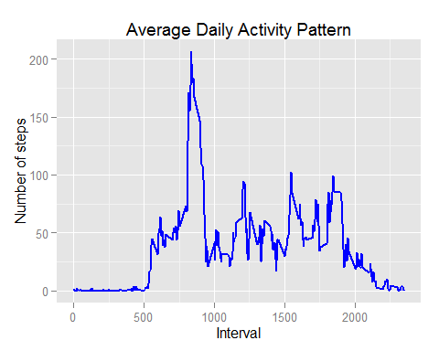

filledStepsbyday <- aggregate(steps ~ date, filledData, sum)  
filledMean <- mean(filledStepsbyday$steps, na.rm=TRUE)  
filledMedian <- median(filledStepsbyday$steps, na.rm=TRUE)  
  
cat("The mean is", stepsMean, "and median is", stepsMedian)

## The mean is 10766.19 and median is 10765

cat("The filled mean is", filledMean, "and filled median is", filledMedian)

## The filled mean is 10766.19 and filled median is 10766.19

The median differ slighly in the new data frame with filled data. The mean value is same as before. The new data frame mean and median value are same.

## Are there differences in activity patterns between weekdays and weekends?

1. We create a new factor variable in the new data set indication weekday/weekend. 2.We plot the same in in time series plots with 2 frame, one for weekday and another for weekend. We analyse the same to identify differences in activity patterns between weekdaya and weekend.

find_day <- function(date) (  
ifelse (format(date, "%A") %in% c("Saturday", "Sunday"), "Weekend", "Weekday")  
)  
filledData$dayofweek <- find_day(as.Date(filledData$date))  
filledData$dayofweek <- as.factor(filledData$dayofweek)  
ggplot(filledData, aes(x=interval, y=steps))+geom_line(color="blue")+facet_wrap(~ dayofweek, nrow=2, ncol=1)+labs(x="Interval", y="Number of steps")

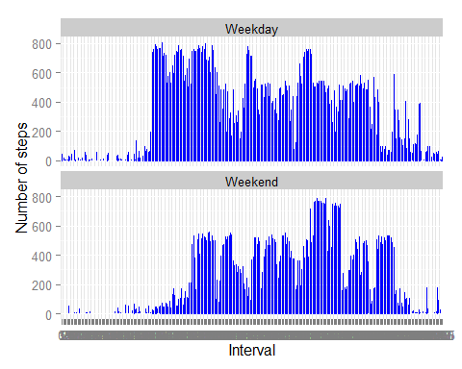

The weekdays seems to be more active than weekend. The weekend has more peaks indicaties some lean periods indicating some non work related activities.