The dataset contains healthcare cost information from an HMO (Health Management Organization). Each row in the dataset represents a person. Health Management Organizations (HMOs) are medical insurance groups that offer health care in exchange for a set annual charge. The dataset that we were given has 14 columns and contains data on 7,583 people. The columns broadly focus on several categories, including the individual’s unique identifier, age, geographic location, gender, education level, marital status, number of children, and healthcare expenditure. They also ask about the individual’s exercise, smoking, BMI, annual physical examination status, and hypertension status. Based on the facts at hand, we deliver actionable information through our research, and we also successfully anticipate which consumers will spend a lot of money on healthcare. — Project Goal • Predict people who will spend a lot of money on health care next year (i.e., which people will have high healthcare costs). • Provide actionable insight to the HMO, in terms of how to lower their total health care costs, by providing a specific recommendation on how to lower health care costs. — Part 1: Data Acquisition (Loading the data)

#loading the readr package to import the data file  
library(readr)  
library(tidyverse)

## ── Attaching core tidyverse packages ──────────────────────── tidyverse 2.0.0 ──  
## ✔ dplyr 1.1.1 ✔ purrr 1.0.1  
## ✔ forcats 1.0.0 ✔ stringr 1.5.0  
## ✔ ggplot2 3.4.2 ✔ tibble 3.2.1  
## ✔ lubridate 1.9.2 ✔ tidyr 1.3.0  
## ── Conflicts ────────────────────────────────────────── tidyverse_conflicts() ──  
## ✖ dplyr::filter() masks stats::filter()  
## ✖ dplyr::lag() masks stats::lag()  
## ℹ Use the ]8;;http://conflicted.r-lib.org/conflicted package]8;; to force all conflicts to become errors

datafile <- "https://intro-datascience.s3.us-east-2.amazonaws.com/HMO_data.csv"  
  
#using the read_csv function to read the CSV file into a data frame called hmo_data  
hmo_data <- read_csv(datafile)

## Rows: 7582 Columns: 14  
## ── Column specification ────────────────────────────────────────────────────────  
## Delimiter: ","  
## chr (8): smoker, location, location_type, education_level, yearly_physical, ...  
## dbl (6): X, age, bmi, children, hypertension, cost  
##   
## ℹ Use `spec()` to retrieve the full column specification for this data.  
## ℹ Specify the column types or set `show_col_types = FALSE` to quiet this message.

#checking the number of rows and columns in the dataset  
dim(hmo_data)

## [1] 7582 14

#the dataset has 7582 rows and 14 columns

Part 2: Data Exploration (Finding out the data attributes)

#structure of the data frame  
str(hmo_data)

## spc_tbl_ [7,582 × 14] (S3: spec_tbl_df/tbl_df/tbl/data.frame)  
## $ X : num [1:7582] 1 2 3 4 5 7 9 10 11 12 ...  
## $ age : num [1:7582] 18 19 27 34 32 47 36 59 24 61 ...  
## $ bmi : num [1:7582] 27.9 33.8 33 22.7 28.9 ...  
## $ children : num [1:7582] 0 1 3 0 0 1 2 0 0 0 ...  
## $ smoker : chr [1:7582] "yes" "no" "no" "no" ...  
## $ location : chr [1:7582] "CONNECTICUT" "RHODE ISLAND" "MASSACHUSETTS" "PENNSYLVANIA" ...  
## $ location_type : chr [1:7582] "Urban" "Urban" "Urban" "Country" ...  
## $ education_level: chr [1:7582] "Bachelor" "Bachelor" "Master" "Master" ...  
## $ yearly_physical: chr [1:7582] "No" "No" "No" "No" ...  
## $ exercise : chr [1:7582] "Active" "Not-Active" "Active" "Not-Active" ...  
## $ married : chr [1:7582] "Married" "Married" "Married" "Married" ...  
## $ hypertension : num [1:7582] 0 0 0 1 0 0 0 1 0 0 ...  
## $ gender : chr [1:7582] "female" "male" "male" "male" ...  
## $ cost : num [1:7582] 1746 602 576 5562 836 ...  
## - attr(*, "spec")=  
## .. cols(  
## .. X = col_double(),  
## .. age = col_double(),  
## .. bmi = col_double(),  
## .. children = col_double(),  
## .. smoker = col_character(),  
## .. location = col_character(),  
## .. location_type = col_character(),  
## .. education_level = col_character(),  
## .. yearly_physical = col_character(),  
## .. exercise = col_character(),  
## .. married = col_character(),  
## .. hypertension = col_double(),  
## .. gender = col_character(),  
## .. cost = col_double()  
## .. )  
## - attr(*, "problems")=<externalptr>

#first six rows of the dataframe  
head(hmo_data)

## # A tibble: 6 × 14  
## X age bmi children smoker location locat…¹ educa…² yearl…³ exerc…⁴  
## <dbl> <dbl> <dbl> <dbl> <chr> <chr> <chr> <chr> <chr> <chr>   
## 1 1 18 27.9 0 yes CONNECTICUT Urban Bachel… No Active   
## 2 2 19 33.8 1 no RHODE ISLAND Urban Bachel… No Not-Ac…  
## 3 3 27 33 3 no MASSACHUSET… Urban Master No Active   
## 4 4 34 22.7 0 no PENNSYLVANIA Country Master No Not-Ac…  
## 5 5 32 28.9 0 no PENNSYLVANIA Country PhD No Not-Ac…  
## 6 7 47 33.4 1 no PENNSYLVANIA Urban Bachel… No Not-Ac…  
## # … with 4 more variables: married <chr>, hypertension <dbl>, gender <chr>,  
## # cost <dbl>, and abbreviated variable names ¹​location_type,  
## # ²​education_level, ³​yearly_physical, ⁴​exercise

#last six rows of the dataframe  
tail(hmo_data)

## # A tibble: 6 × 14  
## X age bmi children smoker location locat…¹ educa…² yearl…³ exerc…⁴  
## <dbl> <dbl> <dbl> <dbl> <chr> <chr> <chr> <chr> <chr> <chr>   
## 1 21222 39 30.9 4 no PENNSYLVANIA Urban Bachel… Yes Not-Ac…  
## 2 13023 63 30.9 3 yes NEW JERSEY Urban No Col… No Not-Ac…  
## 3 54813 53 46.7 2 no PENNSYLVANIA Urban Bachel… Yes Not-Ac…  
## 4 64221 42 28.3 3 yes PENNSYLVANIA Urban Bachel… No Active   
## 5 74732 33 27 2 no PENNSYLVANIA Country Bachel… No Not-Ac…  
## 6 13531 20 28.8 0 no NEW YORK Urban Bachel… No Active   
## # … with 4 more variables: married <chr>, hypertension <dbl>, gender <chr>,  
## # cost <dbl>, and abbreviated variable names ¹​location_type,  
## # ²​education_level, ³​yearly_physical, ⁴​exercise

#summary statistics of the dataset and cost column  
summary(hmo_data)

## X age bmi children   
## Min. : 1 Min. :18.00 Min. :15.96 Min. :0.000   
## 1st Qu.: 5635 1st Qu.:26.00 1st Qu.:26.60 1st Qu.:0.000   
## Median : 24916 Median :39.00 Median :30.50 Median :1.000   
## Mean : 712602 Mean :38.89 Mean :30.80 Mean :1.109   
## 3rd Qu.: 118486 3rd Qu.:51.00 3rd Qu.:34.77 3rd Qu.:2.000   
## Max. :131101111 Max. :66.00 Max. :53.13 Max. :5.000   
## NA's :78   
## smoker location location_type education_level   
## Length:7582 Length:7582 Length:7582 Length:7582   
## Class :character Class :character Class :character Class :character   
## Mode :character Mode :character Mode :character Mode :character   
##   
##   
##   
##   
## yearly_physical exercise married hypertension   
## Length:7582 Length:7582 Length:7582 Min. :0.0000   
## Class :character Class :character Class :character 1st Qu.:0.0000   
## Mode :character Mode :character Mode :character Median :0.0000   
## Mean :0.2005   
## 3rd Qu.:0.0000   
## Max. :1.0000   
## NA's :80   
## gender cost   
## Length:7582 Min. : 2   
## Class :character 1st Qu.: 970   
## Mode :character Median : 2500   
## Mean : 4043   
## 3rd Qu.: 4775   
## Max. :55715   
##

summary(hmo_data$cost)

## Min. 1st Qu. Median Mean 3rd Qu. Max.   
## 2 970 2500 4043 4775 55715

#checking for NA's/missing values in the dataset  
any(is.na(hmo_data))

## [1] TRUE

#checking for duplicated rows  
hmo_data_d <- duplicated(hmo_data)   
#hmo_data[hmo_data_d,] #0  
  
#calculating the total cost of the dataset  
sum(hmo_data$cost)

## [1] 30653732

#checking the total number and percentage of missing values in each column  
total <- colSums(is.na(hmo_data))  
percent <- total / nrow(hmo_data) * 100  
result <- data.frame(Total = total, Percent = percent)  
result

## Total Percent  
## X 0 0.000000  
## age 0 0.000000  
## bmi 78 1.028752  
## children 0 0.000000  
## smoker 0 0.000000  
## location 0 0.000000  
## location_type 0 0.000000  
## education_level 0 0.000000  
## yearly_physical 0 0.000000  
## exercise 0 0.000000  
## married 0 0.000000  
## hypertension 80 1.055131  
## gender 0 0.000000  
## cost 0 0.000000

#The 'bmi' and 'hypertension' columns contain missing values.  
#bmi has 78 null values  
#hypertension has 80 null values

#Inital Analysis:  
  
#1. The dataset contains 7,582 rows and 14 columns, where the 'X' column represents  
 #the unique identifier.  
  
#2. The 'smoker', 'yearly_physical', 'exercise', 'married', and 'gender' columns   
 #have binary values.  
  
#3. The 'bmi' and 'hypertension' columns contain missing values.  
  
#4. The 'location' and 'location_type' columns indicate the location and type of  
 #location, respectively.  
  
#5. The 'education_level' column indicates the highest education level of the   
 #individual.  
  
#6. The 'cost' column represents the medical cost of the individual.

Part 3: Data Cleaning (Using na_interpolation)

#loading the imputeTS function to  
library(imputeTS)

## Registered S3 method overwritten by 'quantmod':  
## method from  
## as.zoo.data.frame zoo

#imputing missing values in 'bmi' column  
hmo_data$bmi <- na_interpolation(hmo_data$bmi)  
  
#removing rows with missing values in 'hypertension' column  
hmo_data <- hmo_data[!is.na(hmo_data$hypertension),]  
  
#Checking for null values after cleaning  
sum(is.na(hmo_data$bmi)) #0

## [1] 0

sum(is.na(hmo_data$hypertension)) #0

## [1] 0

sum(is.na(hmo_data)) #0

## [1] 0

#the cleaned dataset has 7502 rows and 14 columns

Part 4: Dividing Dataset Into Expensive and Not Expensive People

#Since the Mean of Cost Column is $4043, we define people who are paying more than $4200 as expensive  
hmo_data$expensive <- ""  
for (i in 1:7502){  
 if(hmo_data[i,"cost"] > 4200)  
 hmo_data[i,"expensive"] <- "yes"   
 else  
 hmo_data[i,"expensive"] <- "no"  
}  
hmo_data$expensive <- as.factor(hmo_data$expensive)  
  
#Expensive attribute yes means the customer is expensive and no means it's not expensive.

Part 5: Data Visualization

#Age vs Cost Bar Plot  
library(ggplot2)  
ggplot(hmo_data, aes(x=age, y=cost)) +  
 geom_bar(stat="identity")

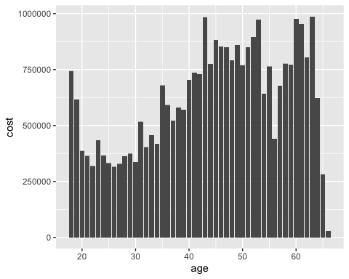

#BMI vs Cost Scatter Plot  
library(ggplot2)  
  
ggplot(data = hmo_data, aes(x = bmi, y = cost)) +  
 geom_point(alpha = 0.5, size = 3) +  
 labs(x = "BMI", y = "Cost", title = "BMI vs. Cost") +  
 theme_classic()

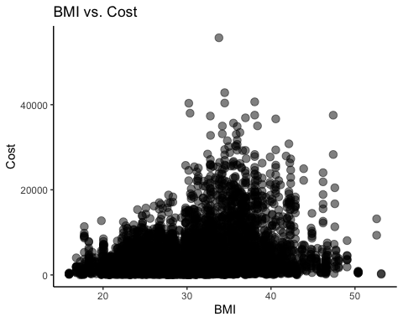

#Exercise Level vs Expensive Status  
library(ggplot2)  
ggplot(hmo_data, aes(x=exercise, fill=expensive)) +  
 geom_bar(position="dodge") +  
 xlab("Exercise Category") +  
 ylab("Count") +  
 ggtitle("# of Expensive and Not Expensive People According to Exercise Level")

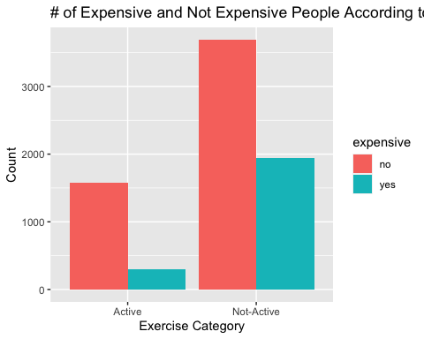

#Smoking Status vs Expensive Status  
library(ggplot2)  
ggplot(hmo_data, aes(x=smoker, fill=expensive)) +  
 geom_bar(position="dodge") +  
 xlab("Smoker Category") +  
 ylab("Count") +  
 ggtitle("# of Expensive and Not Expensive People According to Smoker Status")

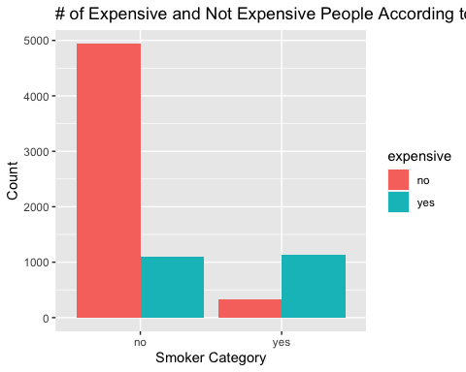

#Histogram of BMI  
library(ggplot2)  
ggplot(hmo_data, aes(x=bmi)) +   
 geom_histogram(binwidth=1, color="black", fill="blue") +   
 labs(title="BMI Distribution", x="BMI", y="Frequency")

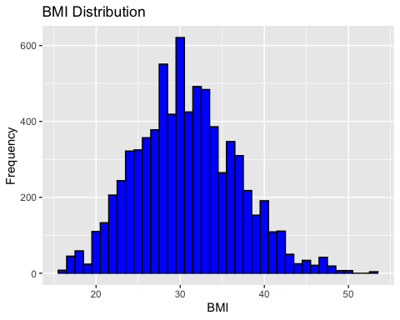

#Cost distribution  
hist(hmo_data$cost, breaks = 30, col = "green", main = "Cost Distribution", xlab = "Cost", ylab = "Frequency")

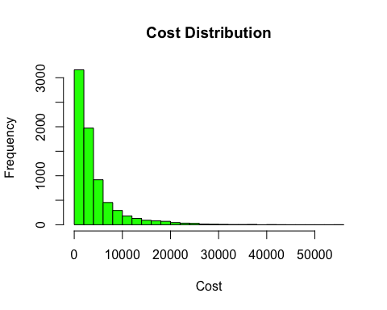

#Hypertension vs Expensive Status  
library(ggplot2)  
ggplot(hmo_data, aes(x=hypertension, fill=expensive)) +  
 geom_bar(position="dodge") +  
 xlab("Hypertension") +  
 ylab("Count") +  
 ggtitle("# of Expensive and Not Expensive People According to Hypertension")

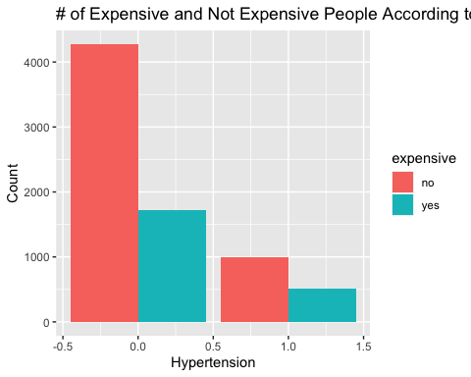

#Boxplot of Smoker  
ggplot(hmo_data, aes(x = smoker, y = cost)) + geom_boxplot()

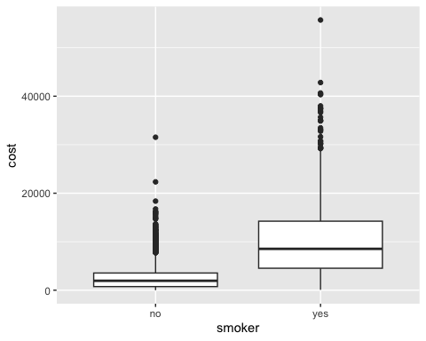

#Boxplot of BMI  
ggplot(hmo_data, aes(x = bmi)) + geom_boxplot()

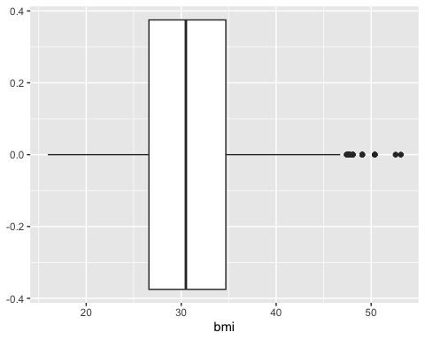

#Scatterplot of BMI and Cost with Smoker Status  
ggplot(hmo_data)+geom_point(aes(x=bmi ,y=cost, color = smoker))+  
ylab('cost')+xlab('bmi')+ggtitle("Cost vs BMI according to Smoker Status")

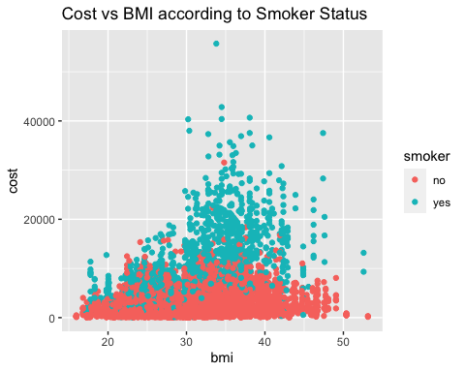

#Scatterplot of BMI and Cost with Yearly Physical Checkup  
ggplot(hmo_data)+geom_point(aes(x=bmi ,y=cost ,color=yearly_physical))+  
ylab('cost')+xlab('bmi')+ggtitle("Cost vs BMI according to Yearly Physical")

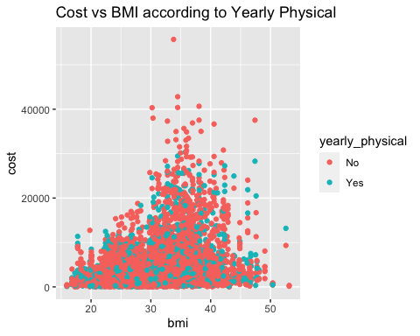

#Scatterplot of BMI and Cost with Exercise Status  
ggplot(hmo_data)+geom_point(aes(x=bmi ,y=cost ,color=exercise))+  
ylab('cost')+xlab('bmi')+ggtitle("Cost vs BMI according to Exercise Status")

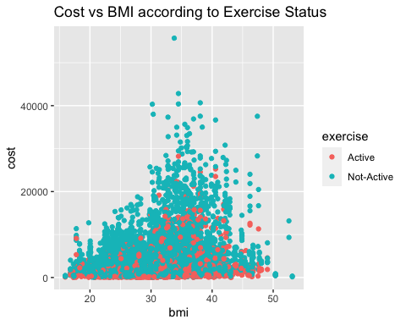

#Scatterplot of BMI and Cost with Hypertension Status  
ggplot(hmo_data)+geom_point(aes(x=bmi ,y=cost ,color=hypertension))+  
ylab('cost')+xlab('bmi')+ggtitle("Cost vs BMI according to Hypertension Status")

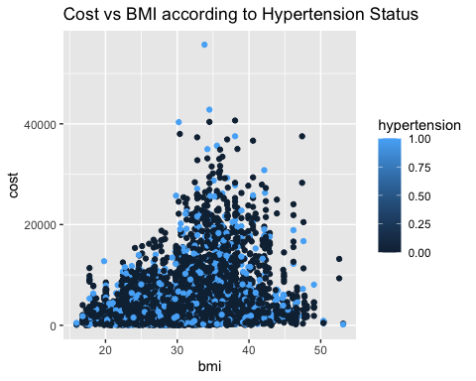

#Gender vs Expensive Status  
library(ggplot2)  
ggplot(hmo_data, aes(x=gender, fill=expensive)) +  
 geom_bar(position="dodge") +  
 xlab("Gender") +  
 ylab("Count") +  
 ggtitle("# of Expensive and Not Expensive People According to Gender")

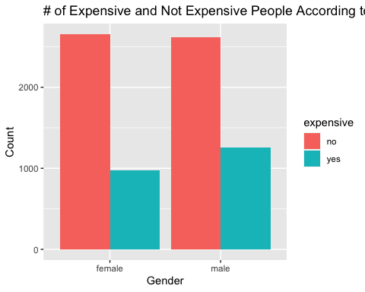

#Creating a duplicate dataset from the original dataset to use for model training  
hmodata1 <- data.frame(hmo_data)

#Predictive model svm  
  
hmodata1$cost_status<-with(hmodata1,ifelse(cost>4200,"TRUE","FALSE"))  
hmodata1$cost_status<-as.factor(hmodata1$cost_status)  
  
library(caret)

## Loading required package: lattice

##   
## Attaching package: 'caret'

## The following object is masked from 'package:purrr':  
##   
## lift

set.seed(123)  
hmodata_model <-data.frame(hmodata1)  
#Creating duplicate dataset to utilize for prediction models  
trainList <- createDataPartition(y=hmodata_model$cost_status,p=.60,list=FALSE) #Creating data partition of our data frame to create a trainset for model training and a testset for testing predictions  
trainSet <- hmodata_model[trainList,]   
testSet <- hmodata_model[-trainList,]  
hmodata_svm1 <- train(cost_status ~ X+age+bmi+children+smoker+location+location_type+education_level+yearly_physical +exercise+married+hypertension+gender, data = trainSet ,method = "svmRadial",trControl=trainControl(method ="none"), preProcess = c("center", "scale"))  
predict_svm <- predict(hmodata_svm1, newdata=testSet)  
  
confusionMatrix(predict_svm, testSet$cost_status)

## Confusion Matrix and Statistics  
##   
## Reference  
## Prediction FALSE TRUE  
## FALSE 1988 454  
## TRUE 120 438  
##   
## Accuracy : 0.8087   
## 95% CI : (0.7941, 0.8226)  
## No Information Rate : 0.7027   
## P-Value [Acc > NIR] : < 2.2e-16   
##   
## Kappa : 0.4867   
##   
## Mcnemar's Test P-Value : < 2.2e-16   
##   
## Sensitivity : 0.9431   
## Specificity : 0.4910   
## Pos Pred Value : 0.8141   
## Neg Pred Value : 0.7849   
## Prevalence : 0.7027   
## Detection Rate : 0.6627   
## Detection Prevalence : 0.8140   
## Balanced Accuracy : 0.7171   
##   
## 'Positive' Class : FALSE   
##

#SVM Model accuracy =80.87%   
#SVM Model sensitivity =94.31%

#install.packages("rio")   
library(rio)   
library(kernlab)

##   
## Attaching package: 'kernlab'

## The following object is masked from 'package:purrr':  
##   
## cross

## The following object is masked from 'package:ggplot2':  
##   
## alpha

library(rlang)

##   
## Attaching package: 'rlang'

## The following objects are masked from 'package:purrr':  
##   
## %@%, flatten, flatten_chr, flatten_dbl, flatten_int, flatten_lgl,  
## flatten_raw, invoke, splice

library(caret)   
set.seed(123)  
hmodata_ksvm1<-ksvm(data=trainSet,cost_status~X+age+bmi+children+smoker+location+location_type+education_level+yearly_physical+exercise+married+hypertension+gender,C=5, cross=3, prob.model=TRUE)  
predict_ksvm <- predict(hmodata_ksvm1, newdata=testSet)  
confusionMatrix(predict_ksvm, testSet$cost_status)

## Confusion Matrix and Statistics  
##   
## Reference  
## Prediction FALSE TRUE  
## FALSE 1986 342  
## TRUE 122 550  
##   
## Accuracy : 0.8453   
## 95% CI : (0.8319, 0.8581)  
## No Information Rate : 0.7027   
## P-Value [Acc > NIR] : < 2.2e-16   
##   
## Kappa : 0.6015   
##   
## Mcnemar's Test P-Value : < 2.2e-16   
##   
## Sensitivity : 0.9421   
## Specificity : 0.6166   
## Pos Pred Value : 0.8531   
## Neg Pred Value : 0.8185   
## Prevalence : 0.7027   
## Detection Rate : 0.6620   
## Detection Prevalence : 0.7760   
## Balanced Accuracy : 0.7794   
##   
## 'Positive' Class : FALSE   
##

#KSVM Model Sensitivity 94.21%   
#KSVM Model Accuracy 84.53%

#Prediction Model training rpart tree  
  
#install.packages('e1071', dependencies = TRUE)   
#install.packages("rpart.plot")  
library(rpart)   
library(rpart.plot)  
  
hmodata_tree<-data.frame(hmodata1)  
  
Treeplot<-rpart(cost_status ~ X+age+bmi+children+smoker+location+location_type+education_level+yearly_physical +exercise+married+hypertension+gender, data = trainSet, control = c(maxdepth = 5, cp=0.002))  
prp(Treeplot, faclen = 0, cex = 0.8, extra = 1)

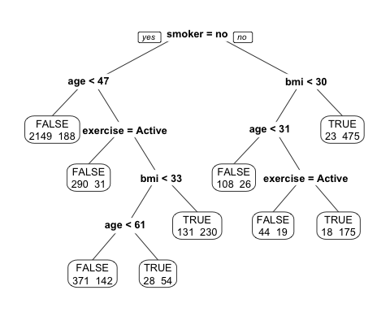

predict_tree <- predict(Treeplot, newdata=testSet, type = "class")  
  
confusionMatrix(predict_tree,testSet$cost_status)

## Confusion Matrix and Statistics  
##   
## Reference  
## Prediction FALSE TRUE  
## FALSE 1969 299  
## TRUE 139 593  
##   
## Accuracy : 0.854   
## 95% CI : (0.8409, 0.8665)  
## No Information Rate : 0.7027   
## P-Value [Acc > NIR] : < 2.2e-16   
##   
## Kappa : 0.6315   
##   
## Mcnemar's Test P-Value : 3.023e-14   
##   
## Sensitivity : 0.9341   
## Specificity : 0.6648   
## Pos Pred Value : 0.8682   
## Neg Pred Value : 0.8101   
## Prevalence : 0.7027   
## Detection Rate : 0.6563   
## Detection Prevalence : 0.7560   
## Balanced Accuracy : 0.7994   
##   
## 'Positive' Class : FALSE   
##

#Tree Model Sensitivity 93.41%   
#Tree Model Accuracy 85.4%

Map

library(ggplot2);   
library(maps);

##   
## Attaching package: 'maps'

## The following object is masked from 'package:purrr':  
##   
## map

library(ggmap);

## ℹ Google's Terms of Service: <]8;;https://mapsplatform.google.comhttps://mapsplatform.google.com]8;;>

## ℹ Please cite ggmap if you use it! Use `citation("ggmap")` for details.

library(mapproj);  
library(tidyverse)  
hmodatasortedDF <- hmo_data %>% group_by(location) %>% summarise(avgCost =   
mean(hmo_data$cost))  
us<- map_data("state")  
us$state_name <- tolower(us$region)  
hmodatasortedDF$location <- tolower(hmodatasortedDF$location)  
mergeddata <-   
merge(us,hmodatasortedDF,all.x=TRUE,by.y="location",by.x="state_name")  
ggplot(mergeddata, aes(map_id= state_name)) + aes(x=long, y=lat, group=group) +   
geom_polygon(aes(fill = avgCost), color = "black") +   
 scale_colour_gradient(low="blue", high="red")+  
expand_limits(x=mergeddata$long, y=mergeddata$lat)

