**ATOC5860 – Application Lab #6**

**Machine Learning with Weather Data**

**Spring 2022**

***Note: You will need to use the python environment provided (environment.yml), especially for notebook #2. These notebooks were written by Eleanor Middlemas in 2020 (***[***https://github.com/e-middlemas/ML_application_lab***](https://github.com/e-middlemas/ML_application_lab)***). They were last adapted/updated for use in ATOC5860 during Spring 2022.***

**Notebook #1**

**ATOC5860_applicationlab6_cluster_mesa_data.ipynb**

**LEARNING GOALS**

1) Use k-means clustering as an example of unsupervised (grouping events into different categories) machine learning

2) Become familiar with the limits and applicability of K-means clustering to detect seasons in Boulder, Colorado

3) Assess sensitivity of K-means to standardization, changing the variables used for the clustering (also called “features”), and number of clusters (4 vs. 3).

**DATA and UNDERLYING SCIENCE:**

You will be working with weather data from the NCAR Mesa Laboratory in Boulder, Colorado. We'll call this dataset the "Mesa dataset". The data go from 2016-2021. Information on the site and the instruments is here: <https://www.eol.ucar.edu/content/ncar-foothills-lab-weather-station-information>. Real-time data from the site is here: <https://archive.eol.ucar.edu/cgi-bin/weather.cgi?site=ml>. Note: Each year in this dataset has 365 days. Leap year data (i.e., Feb. 29 data for 2016 and 2020 have been excluded.)

In this notebook, you use K-means clustering to classify the mesa dataset weather data into different clusters. Why would we cluster weather observations? We already know which observations are in which season by looking at the date. But we all know that a day in February sometimes feels like summer and a day in September can feel like winter. We often have multiple seasons in a single week... So this could be quite fun to see how the algorithm decides how to cluster our data and assign each day to a "season". :) Will each cluster will look like a season – On Va Voir (We’ll See)!

**Questions to guide your analysis of Notebook #1:**

**1) Start with 4 clusters. Cluster the data at 17 UTC (mid-day in Colorado). What is the seasonal occurrence of the 4 clusters? Do the 4 clusters correspond to Fall, Winter, Spring, and Summer? Why or why not?**

*They mostly do not. Summer is very discernable, but the other seasons are very scattered. Cluster 2 shows no real opinion on anything. Cluster 1 and 4 show more preference for winter, spring, and fall, but it’s hard to infer much more than that.*

**2) Based on 2D and 3D scatter plots of the cluster centers and the data – Which weather variables help (or NOT help) define the clusters?**

*Temperature helps a lot in telling the seasons apart, in addition to wind speed. Wind direction though doesn’t seem too helpful, but it might be more telling to plot wind direction on a radial plot.*

**3) What do the clusters show during the time period from September 5-15, 2020 (Labor Day 2020)? Are the cluster assignments consistent with the weather experienced over that time period? Are there other date ranges that you would like to check out?**

*The clusters chosen during this week are all over the place, which is to be expected since this week had all seasons occur, but only one of those days was classified as “summer”. The rest are a combo of “fall” and “winter”. It’s hard to tell just looking at the raw data.*

**4) Re-run the analysis. But now use three clusters instead of four clusters. Compare your cluster analyses for 4 clusters and 3 clusters. Do the results for 4 clusters or 3 clusters make more sense to you based on your analysis and also your experience living in Boulder, Colorado? Which number of clusters provides a better fit to the data?**

*I think 3 seasons makes more sense, as the non-summer seasons fall into clearer clusters. Despite this, it’s still not concrete as to which cluster is spring, winter, and fall. Below are some examples. From what I have seen so far, I think the most influential variables would be: temperature, wind speed, and precipitation type.*

**Notebook #2**

**OPTION #1: ATOC5860_applicationlab6_supervised_ML.ipynb – Use environment.yml**

**or**

**OPTION #2: supervised.ipynb – Run in Google CoLabs**

***Note: You will need to change the google drive paths to match those on your computer.***

**LEARNING GOALS:**

1. See an example of the data processing pipeline (workflow) required to utilize supervised machine learning techniques.
2. Implement and compare four different supervised learning algorithms
3. Understanding two outcomes of supervised learning algorithms: prediction and feature importance.
4. Start building a foundation for future machine learning including the following terms: cross-validation, training vs. testing data, metrics (accuracy, recall, precision, f1 score, etc.), overfitting/underfitting, balancing datasets, hyperparameters, & feature importance. Some future learning resources are provided… but there’s a lot available! *Share resources you find valuable.*

**DATA and UNDERLYING SCIENCE:**

We will use the Christman dataset which contains weather observations from Fort Collins, Colorado for the year 2016. We will build and train four machine learning models to predict something we already know from the dataset: ***Is it raining?***. The point is not to conduct cutting-edge research or make novel predictions. Instead, the purpose here is to showcase supervised machine learning (ML) models and methods. By the end, we hope you can walk away with more confidence to learn and apply these tools to new problems.

Let's say you want to determine which features or atmospheric variables are the best predictors of rainfall. Often, one simply regresses some metric of precipitation onto various atmospheric variables. Then, you assume that whatever returns the highest regression coefficient is the best predictor. While this approach with linear regression presents a fine first guess, it poses a few problems. Linear regression assumes: 1) atmospheric variables are linearly related to precipitation, 2) atmospheric variables are uncorrelated. Yet, both are false assumptions. While a linear relationship between predictor & predictand is a good first guess, why limit yourself to linearity when you can just as easily relax that assumption using supervised Machine Learning...

This notebook will step through the following Machine Learning model pipeline:

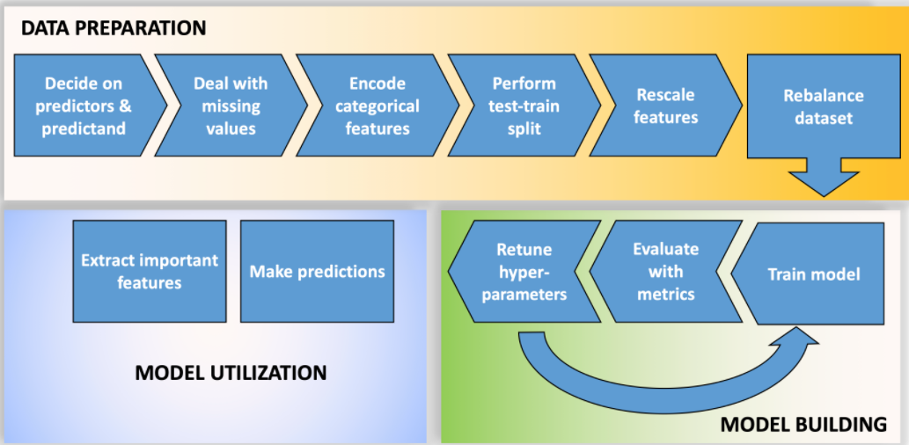

After prepping the data, we will build and train four machine learning models and make predictions with them. The four machine learning models we will implement are: Logistic regression, Random Forest, Singular vector machines/classifier, Neural Network. Finally, we will determine which variable ("feature") is the best predictor, i.e., we will assess "feature importance".

**Pros/Cons of these Methods (from Eleanor Middlemas)**

1. Logistic regression tends to overgeneralize or underfit data, but is easy to implement, to understand and easy to back out feature importance.
2. Singular Vector Machines are great at capturing complex relationships, but cannot back out feature importance. Plus, the use of the kernel makes them hard to interpret.
3. Random forests are easier to understand, generally do not overfit, and can capture complex relationships, and can provide feature importance, but they can be slow to train and there are a lot of hyperparameters to choose from.
4. Neural Networks are great at capturing complex relationships. But they are slow to train and are susceptible to overfitting.

**Questions to guide your analysis of Notebook #2 – See also questions at the end of supervised.ipynb:**

1) Which machine learning model performs the best to predict rainfall? What metrics did you use to make this assessment?

*It looks like overall the Singular Vector Machine performed the best. It had the second highest accuracy, second highest recall, and was the most certain in the prediction example (81% it was raining, which it was).*

*The main metrics used were accuracy, recall, and prediction example.*

2) Describe the difference between accuracy and recall. Why did we choose to use accuracy, recall, and predicted precipitation probability as a way to compare models? In forecasting: when is a false positive (you said it would rain, it didn’t rain) preferred over a false negative (you said it wouldn’t rain, it did rain)?

*Here, the difference between accuracy and recall is that accuracy looks at the number of correct predictions overall (true positives and negatives), while recall just looks at the amount of correct precipitating events (true positives). We chose these metrics because they give us insight into how the models behave in both training in testing. We want to have an idea of how the model does in each scenario, and try to maximize the score in both.*

*As for the preference for a false negative, this is when the human aspect comes in. If you are planning a big event outdoors (say, a wedding) and your app says it will rain, but doesn’t, not a lot of people will be upset. On the other hand, if your app says it won’t rain and the wedding is outside, and indeed does rain, a lot more people will be upset.*

3) One important "gotcha" in a machine learning workflow or pipeline is the order of data preparation. **Why should one should perform the train-test split before feature scaling and rebalancing?** *Hint: think about using a trained model for future predictions.* Do you want your scaling of the testing data to depend on the training data? Why perform a test-train split at all?

*This is to avoid adding unnecessary bias. If you were to feature scale and rebalance before the test-train split, the testing data would only see normalized data and not the actual data, which would be needed to make a sensible prediction. Ultimately, we want to train a model on some data, then give it new data the model hasn’t seen before, and perform well. That is what a test-train split helps accomplish.*

4) Collinearity, or non-zero correlation among features, results in a model that is overly complex, reduces the statistical significance of the fit of the model, and prevents one from correctly identifying the importance of features. ***Are there features included in our machine learning models to predict rain in the Christman dataset that are collinear?*** If so, how do you think we should address this collinearity? A couple of suggestions: If we don't have that many features, we could use our meteorological expertise to simply remove one of the features that shares collinearity with other features. Another way to address collinearity is to use feature regularization, or add weights that penalize features that add noise, ultimately reducing model complexity.

*Yes, I would say there are. For example, wind direction and wind gust direction are colinear, with wind speed and wind speed gusts probably being colinear as well. The other variables likely have some collinearity, as the atmosphere is a fluid and related, but those would be my first choices. We could simply get rid of one from the pair, or get rid of both altogether if after performing feature importance that variable doesn’t matter that much anyway.*