BCSE302L – Database Systems (Theory)

DA1: Problem Identification and Database Design
Name: Akshath Thoguparthy
Registration No.: 24BCE5150
Project Title:
Online Library Management System (OLMS)

--------------------------------------------------

1. Problem Statement

Most traditional libraries still depend on manual methods to maintain records related to books, members, borrowing history, fines, and staff details. These methods are slow, prone to human error, and become difficult to manage as the number of users and books increases.

The proposed Online Library Management System (OLMS) is designed to automate all major library operations such as managing books, registering users, tracking book issues and returns, calculating fines, handling reservations, and managing staff using a centralized database.

This system will:
• Minimize manual work
• Increase the accuracy and reliability of records
• Enable fast searching and retrieval of information
• Maintain complete transaction history
• Ensure data consistency and security

--------------------------------------------------

2. System Modules

2.1 User Management Module
- Register new members and manage existing users
- Store and update personal details and membership status

2.2 Book Management Module
- Add, modify, and remove book records
- Maintain book categories and availability status

2.3 Author Management Module
- Store author information
- Associate authors with their respective books

2.4 Publisher Management Module
- Maintain publisher details
- Link publishers to published books

2.5 Book Issue & Return Module
- Record book borrowing and returning activities
- Track issue dates, due dates, and return dates

2.6 Reservation Module
- Allow members to reserve books in advance
- Track the status of reservations

2.7 Fine Management Module
- Automatically calculate overdue fines
- Maintain fine payment records

2.8 Staff Management Module
- Store librarian and staff information
- Track staff roles and responsibilities

--------------------------------------------------

3. Entity Details and Attributes

Member(Member_ID, Name, Email, Phone, Address, Membership_Date, Status)

Book(Book_ID, Title, ISBN, Edition, Year, Category_ID, Publisher_ID)

Author(Author_ID, Name, Country)

Publisher(Publisher_ID, Name, Address, Contact)

Category(Category_ID, Category_Name)

Issue(Issue_ID, Issue_Date, Due_Date, Return_Date, Member_ID, Book_ID)

Reservation(Reservation_ID, Reservation_Date, Status, Member_ID, Book_ID)

Fine(Fine_ID, Amount, Payment_Status, Issue_ID)

Staff(Staff_ID, Name, Role, Phone, Email)

--------------------------------------------------

4. Relationships with Cardinality and Participation Constraints

Member borrows Issue: 1 : M (Total participation of Issue)

Book appears in Issue: 1 : M (Total participation of Issue)

Member reserves Book through Reservation: 1 : M

Publisher publishes Book: 1 : M (Total participation of Book)

Category categorizes Book: 1 : M (Total participation of Book)

Issue has Fine: 1 : 1 (Partial participation of Fine)

Author writes Book: M : N (Partial participation)

--------------------------------------------------

5. ER Diagram

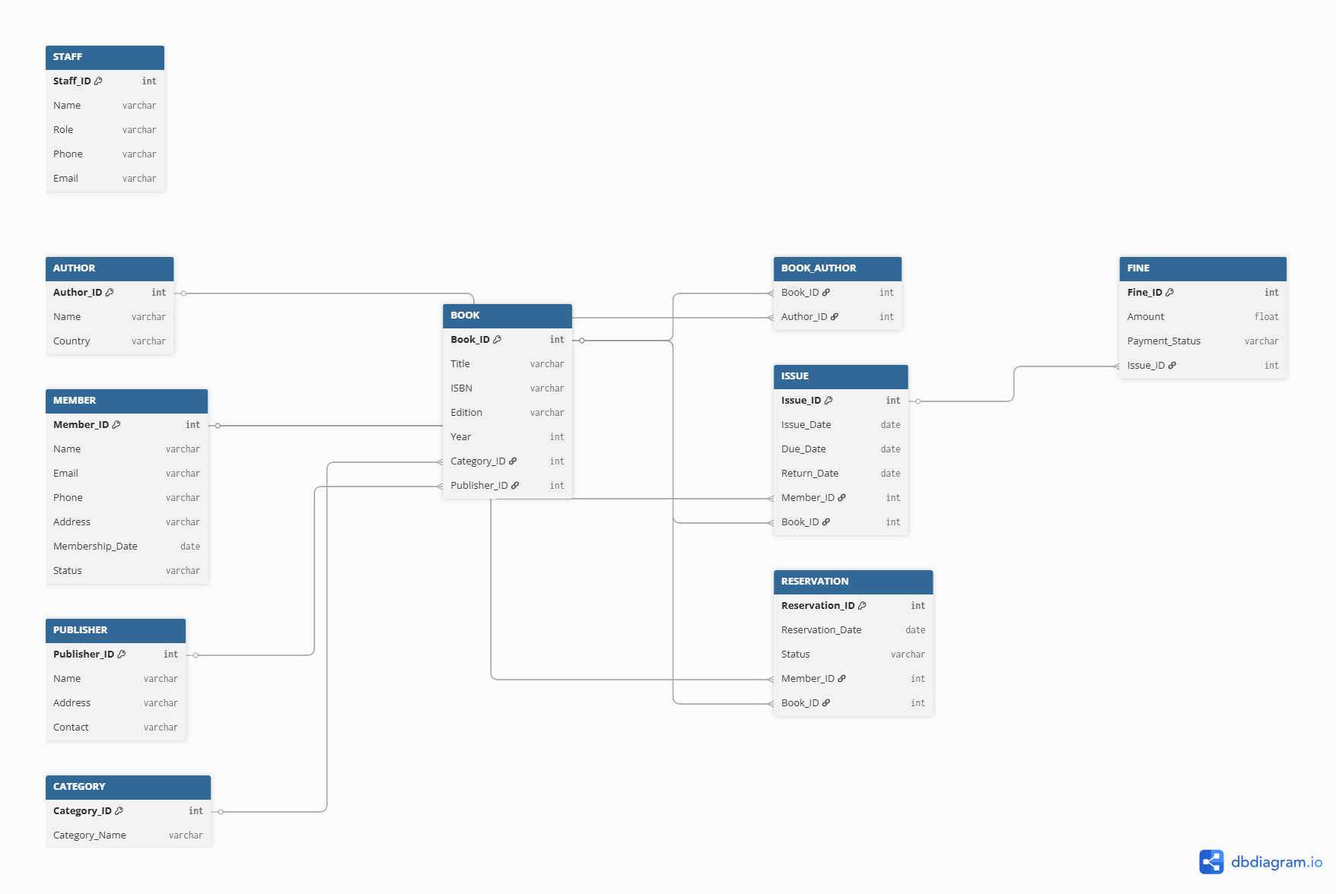

--------------------------------------------------

6. Relational Schema Mapping

MEMBER(Member_ID, Name, Email, Phone, Address, Membership_Date, Status)

BOOK(Book_ID, Title, ISBN, Edition, Year, Category_ID, Publisher_ID)

AUTHOR(Author_ID, Name, Country)

PUBLISHER(Publisher_ID, Name, Address, Contact)

CATEGORY(Category_ID, Category_Name)

ISSUE(Issue_ID, Issue_Date, Due_Date, Return_Date, Member_ID, Book_ID)

RESERVATION(Reservation_ID, Reservation_Date, Status, Member_ID, Book_ID)

FINE(Fine_ID, Amount, Payment_Status, Issue_ID)

STAFF(Staff_ID, Name, Role, Phone, Email)

BOOK_AUTHOR(Book_ID, Author_ID)

--------------------------------------------------

7. Schema Diagram

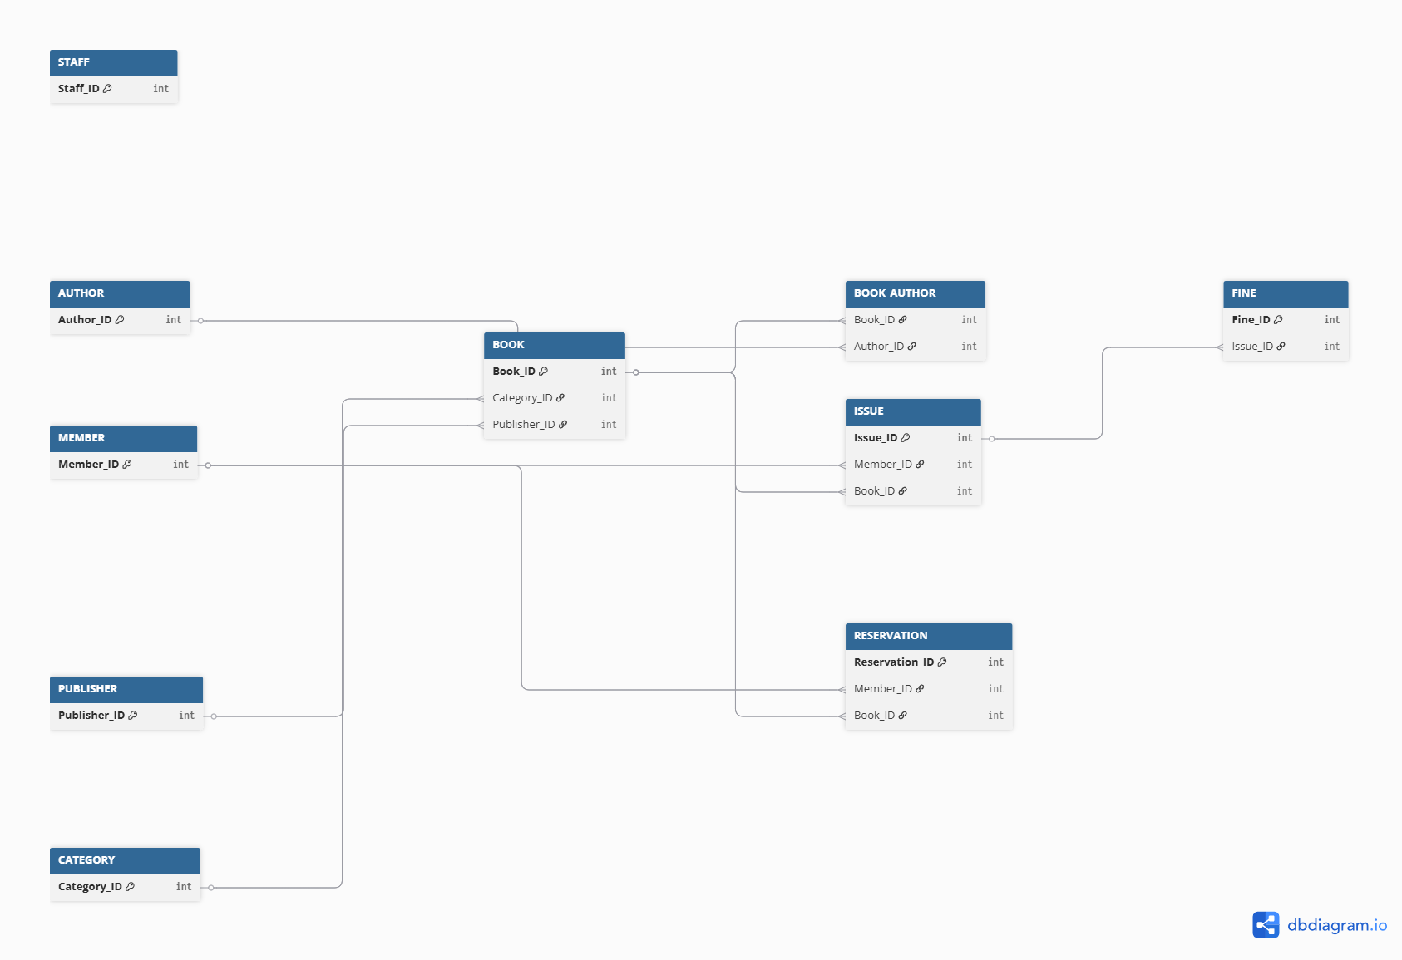

--------------------------------------------------

8. Conclusion

The Online Library Management System offers a well-structured and efficient database design for handling all major library operations. The proposed ER model ensures data integrity, minimizes redundancy, and supports future scalability. This design provides a solid foundation for normalization and SQL implementation in the next stages of the project.

--------------------------------------------------

