**Customer Profiling Dashboard & SQL Knowledge**

This exercise will be split into 2 parts

1. Customer Profiling Dashboard
2. SQL Test

**Topics tested in SQL test are**:

Select, from, where, group by, order by, having, with, case statements and window functions. All other basic manipulations on data types are also expected to be known.

The skills required in the 1-month exercise are R, Power Bi and SQL, in addition to a good understanding of ASI Business and ASI Data available.

The document below will be the only instruction/ hints that will be provided for building the **Customer Profiling Dashboard**

**Objective:**

You are required to build the following metrics using data from various Sources at both an account level and at a contact level as a part of the 1-month exercise. At the end 3 weeks the deliverables below are required:

Metrics/KPI involved in Dashboard:

|  |  |
| --- | --- |
| **No** | **Metric/KPI** |
| 1 | #No of Meetings |
| 2 | #No of Preference Center Signups (hint: comes from contact object) |
| 3 | #No Positive Event Feedback (to be defined by you) |
| 4 | #Bounced Emails |
| 5 | #Email Unsubscribes |
| 6 | #No Negative Event Feedback (to be defined by you) |
| 7 | #No of New Opps in last 12 months |
| 8 | #No of Later Stage Opportunities |
| 8 | Gross Sales in Last 12 Months |
| 9 | Gross Redemptions in Last 12 months |

**Main Output 1:** Customer Profiling Table:

Build the following for **Both Account and Contact Level**

|  |  |  |  |  |  |  |  |  |  |
| --- | --- | --- | --- | --- | --- | --- | --- | --- | --- |
| Account Name | Account ID | Asset Class | Region | Channel  (Institutional/ Wholesale) | Account Record Type | Account SubType | Snapshot Month | Aggregation Window | 9 Engagement Metrics **(One column for Each metric)** |
|  | Acc1 | FI |  |  |  |  | 01-01-2020 | Last 1 month |  |
|  | Acc1 | FI |  |  |  |  | 01-01-2020 | Last 3 months |  |
|  | Acc1 | FI |  |  |  |  | 01-01-2020 | Last 6 months |  |
|  | Acc1 | FI |  |  |  |  | 01-01-2020 | Last 9 months |  |
|  | Acc1 | FI |  |  |  |  | 01-01-2020 | Last 12 Months |  |
|  | Acc1 | FI |  |  |  |  | 01-01-2020 | 1st Quarter from date |  |
|  | Acc1 | FI |  |  |  |  | 01-01-2020 | 2nd Quarter from date |  |
|  | Acc1 | FI |  |  |  |  | 01-01-2020 | 3rd Quarter from date |  |
|  | Acc1 | FI |  |  |  |  | 01-01-2020 | 4th Quarter from date |  |
|  | Acc1 | FI |  |  |  |  | 01-01-2020 | 2020 Q1 |  |
|  | Acc1 | FI |  |  |  |  | 01-01-2020 | 2020 Q2 |  |
|  | Acc1 | FI |  |  |  |  | 01-01-2020 | 2020 Q3 |  |
|  | Acc1 | FI |  |  |  |  | 01-01-2020 | 2020 Q4 |  |

**Main Output 2:** **Customer Profiling Dashboard** (Sample Wireframe of Views to be built below):

Build a series of views in Power BI based on **above Engagement metrics** and **Tier Data**.

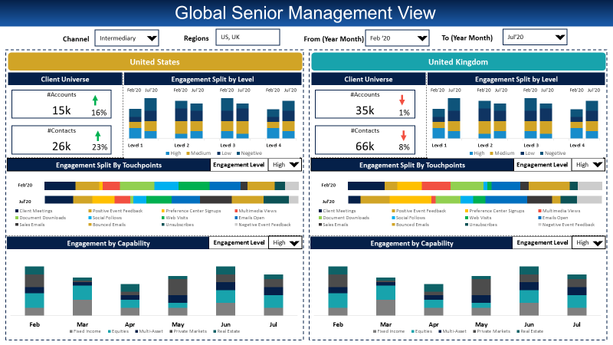

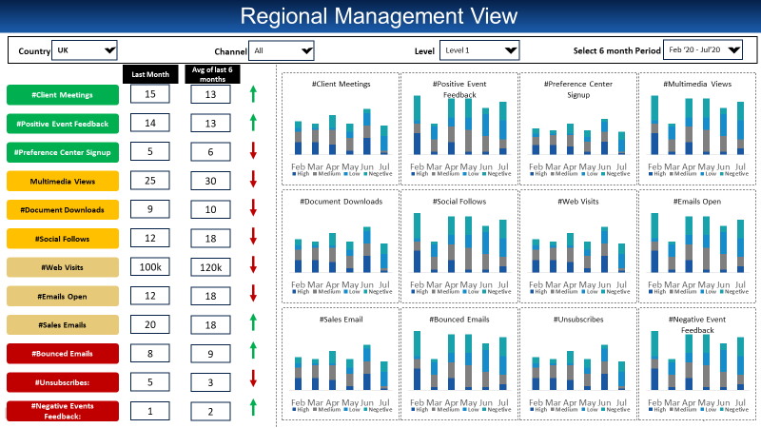

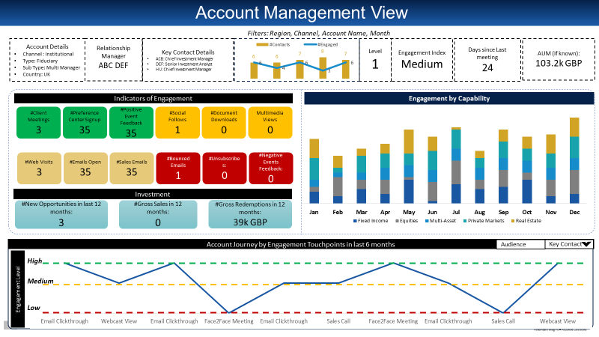

**Detailed Steps Involved & Expected Outputs:**

1. **Week1:** Data Identification & Exploration for KPI. Define metric calculation logic

**Expected Output from Week 1:**

* **Metric Sources Definition for all the above 9 metrics (Excel Output):**

*Sample Output structure:*

|  |  |  |  |
| --- | --- | --- | --- |
| **Metric** | **Source** | **Table/Object** | **Field** |
| Metric 1 | Salesforce | Table 1 | Field1 |
|  | Salesforce | Table 2 | Field2 |
| Metric 2 | Salesforce | Table 3 | Field1 |
|  | Salesforce | Table 3 | Field3 |

* **Logic for building the metrics for each of the above 9 metrics (Excel Output)**

A detailed flowchart that calls out how the required aggregation will be performed, mentioning the different tables involved and the joins involved.

*Sample Output structure:*

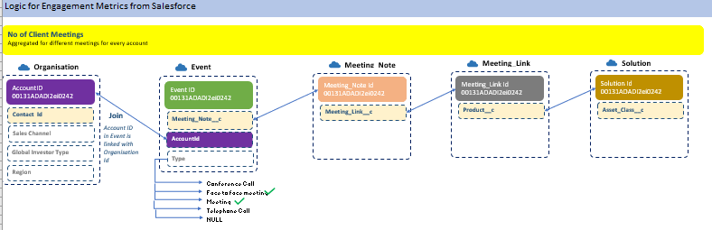

1. **Week 2:** Build required KPI in the structure required for the Dashboard

**Expected Output from Week 2:**

* **R Script** to calculate the Customer Profiling table in an automated manner (Use Loops to calculate all possibilities)

Variables/Inputs to be supplied to the R script are:

1. Input Tables required
2. Snapshot Month as a Vector
3. SQL Script read as a “.sql” file

**Process Outline:**

1. You are to create a SQL Script for each metric and run the SQL Script in R using *SQLDF. The SQL Script will create the above table for one value of* Snapshot Month *and one* Aggregation Window *(hardcoded)*
2. Read the Script into R console, you can read a sql script in R using *readlines.*
3. Code all data variables and any other variable required to aggregate the data in the query (ie, Snapshot Date and Aggregation Window) as variables in R passed on to the SQL Script using *sprintf command.* i.e. pass required hardcoded variables from step 1 as variables in R
4. You are to create a set of nested for loops in R wherein for each loop iteration, one snapshot date and one aggregation window will be passed and calculated in the SQL query. ie Pass all Snapshot Month and Aggregation Window as the two loop variables
5. Create a data frame that keeps getting updated with more rows as the loop runs. Once the final loop finishes running, the required table with metrics should be produced.

* Using the R Script mentioned above, build the following for Both **Account and Contact Level**

(One table to be given for account, One table to be given for contact)

|  |  |  |  |  |  |  |  |  |  |
| --- | --- | --- | --- | --- | --- | --- | --- | --- | --- |
| Account Name | Account ID | Asset Class | Region | Channel  (Institutional/ Wholesale) | Account Record Type | Account SubType | Snapshot Month | Aggregation Window | 9 Engagement Metrics **(One column for Each metric)** |
|  | Acc1 |  |  |  |  |  | 01-01-2020 | Last 1 month |  |
|  | Acc1 |  |  |  |  |  | 01-01-2020 | Last 3 months |  |
|  | Acc1 |  |  |  |  |  | 01-01-2020 | Last 6 months |  |
|  | Acc1 |  |  |  |  |  | 01-01-2020 | Last 9 months |  |
|  | Acc1 |  |  |  |  |  | 01-01-2020 | Last 12 Months |  |
|  | Acc1 |  |  |  |  |  | 01-01-2020 | 1st Quarter from date |  |
|  | Acc1 |  |  |  |  |  | 01-01-2020 | 2nd Quarter from date |  |
|  | Acc1 |  |  |  |  |  | 01-01-2020 | 3rd Quarter from date |  |
|  | Acc1 |  |  |  |  |  | 01-01-2020 | 4th Quarter from date |  |
|  | Acc1 |  |  |  |  |  | 01-01-2020 | 2020 Q1 |  |
|  | Acc1 |  |  |  |  |  | 01-01-2020 | 2020 Q2 |  |
|  | Acc1 |  |  |  |  |  | 01-01-2020 | 2020 Q3 |  |
|  | Acc1 |  |  |  |  |  | 01-01-2020 | 2020 Q4 |  |

1. **Week 3:** Build corresponding dashboard views

**Expected Output from Week 3:**

Customer Profiling Dashboard (Sample Wireframe of Views to be built below):

Build a series of views in Power BI based on **above Engagement metrics** and **Tier Data**.

**Note :**

Level is decided based on Tier (T1 is Level 1, T2 is Level 2 etc)

Touchpoints refer to the 9 engagement Metrics

Capability refers to Asset Class



**For each of the 9 metrics calculate the view below**





**Week 4: Feedback, Business Changes and Refreshing your SQL Knowledge.**

**Expected output:**

* Final Closure of all the main outputs
* Qualify in in the SQL Test Conducted **(**Score 25 of 50**)**