Модуль 1

public class Module1 {
public static void main (String[] args){
System.out.println("Задача 1: " + zadacha1(1,3));
System.out.println("Задача 2: " + zadacha2(7, 4));
System.out.println("Задача 3: " + zadacha3(5, 2, 8));
System.out.println("Задача 4: " + zadacha4(0.9, 3, 2));
System.out.println("Задача 5: " + zadacha5(12,3,36));
System.out.println("Задача 6: " + zadacha6('A'));
System.out.println("Задача 7: " + zadacha7(7));
System.out.println("Задача 8: " + zadacha8(8, 10));
int[] array = new int[]{1,5,9};
System.out.println("Задача 9: " + zadacha9(array));
System.out.println("Задача 10: " + zadacha10(42,5,10));
}
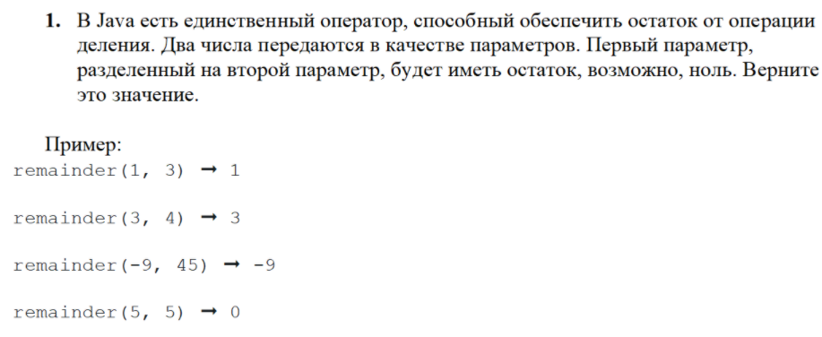
public static int zadacha1 (int a, int b) {
return a % b;
}
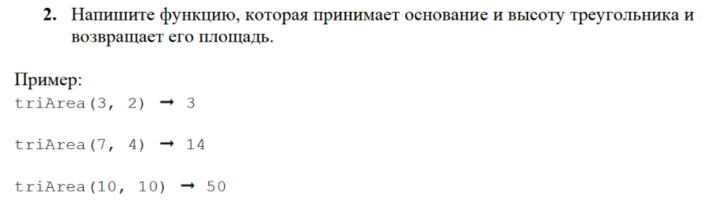
public static double zadacha2 (int a, int b){
return 0.5 * a * b;
}
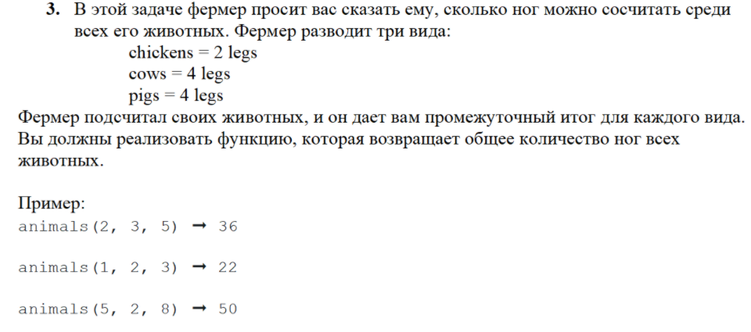
public static int zadacha3 (int a, int b, int c){
return 2 * a + 4 * b + 4 * c;
}
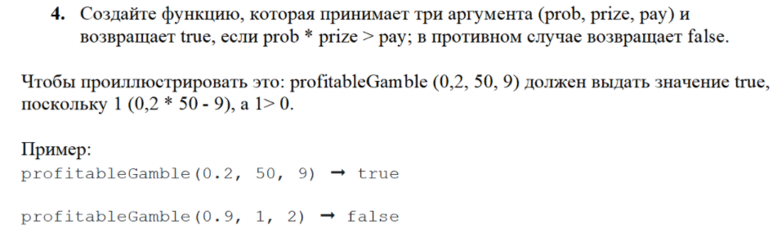
public static boolean zadacha4 (double prob, double prize, double pay){
return prob * prize > pay;
}
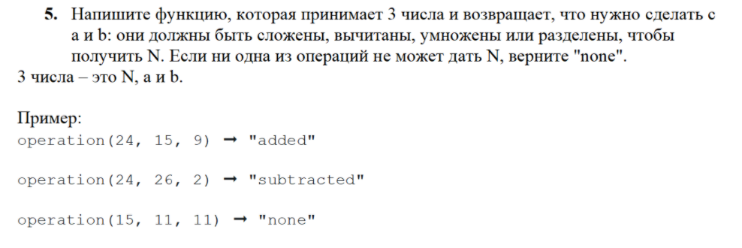

public static String zadacha5 (int a, int b, int n){
if (a + b == n){
return "Сложить";
}
else if (a - b == n){
return "Вычесть";
}
else if (a / b == n){
return "Разделить";
}
else if (a * b == n){
return "Умножить";
}
else return "None";
}

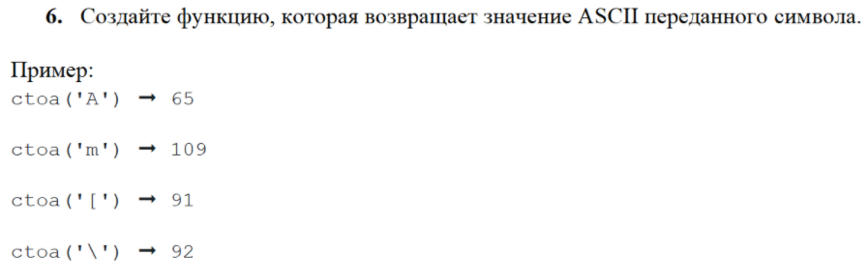
public static int zadacha6 (char number) {
return (int) number;
}
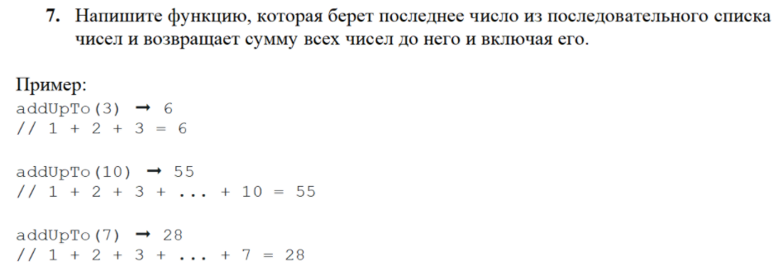
public static int zadacha7 (int a) {
int sum = 0;
for (int i = 1; i<=a;i++){
sum += i;
}
return sum;
}
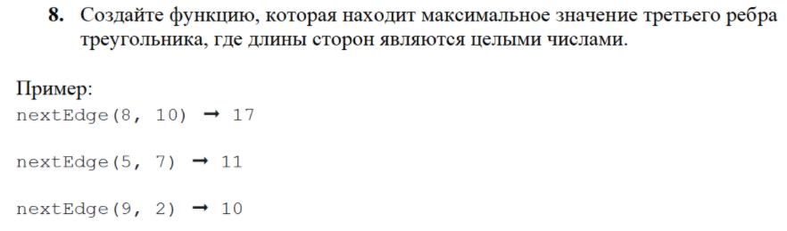
public static int zadacha8 (int a, int b) {
return (a + b - 1);
}
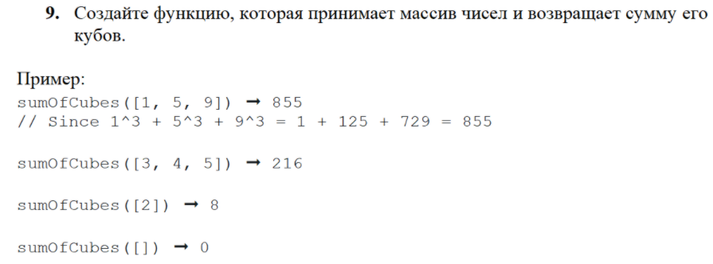
public static int zadacha9(int [] array){
int sum = 0;
for (int i=0; i< array.length; i++) {
sum += array[i]*array[i]*array[i];
}
return sum;
}
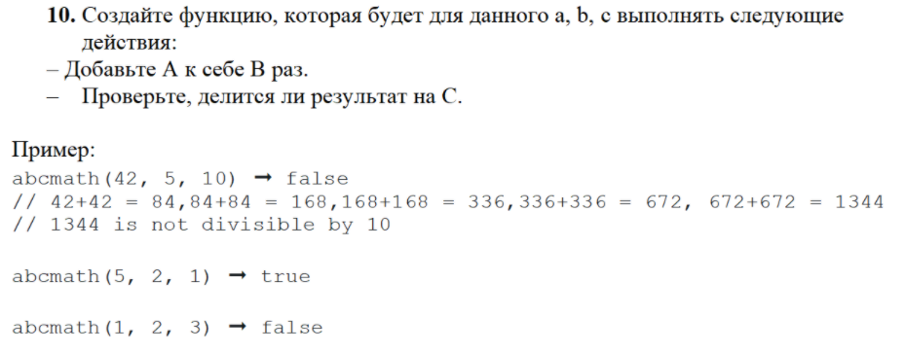
public static boolean zadacha10(int a, int b, int c){
a = a * b;
return a % c == 0;
}
}

Результат выполнения модуля:

