Модуль 2
import java.util.Arrays;
public class Module2 {
public static void main(String[] args) {
int[] array = new int[]{44, 32, 86, 19};
System.out.println("Задача 1: " + zadacha1("hello", 3));
System.out.println("Задача 2: " + zadacha2(array));
System.out.println("Задача 3: " + zadacha3(array));
System.out.println("Задача 4: " + zadacha4(array));
System.out.println("Задача 5: " + zadacha5("43.20"));
System.out.println("Задача 6: " + zadacha6(12));
System.out.println("Задача 7: " + zadacha7("12345"));
System.out.println("Задача 8: " + zadacha8("", ""));
System.out.println("Задача 9: " + isPrefix("automation", "auto-") + ", " + isSuffix("arachnophobia", "-phobia"));
System.out.println("Задача 10: " + zadacha10(1));
}
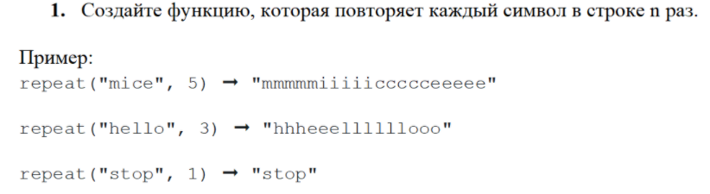
public static String zadacha1(String str, int n) {
String newstr = "";
for (int i = 0; i < str.length(); i++) {
for (int j = 0; j < n; j++) {
newstr += str.charAt(i);
}
}
return newstr;
}
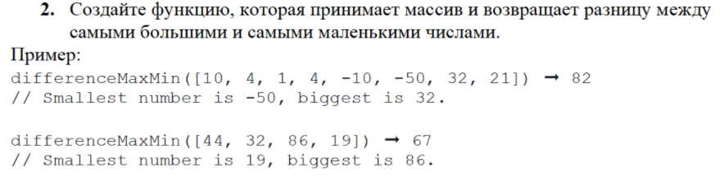

public static int zadacha2(int[] array) {
int k;
int max = -1000;
int min = 1000;
for (int i = 0; i < array.length; i++) {
if (array[i] > max) {
max = array[i];
}
if (array[i] < min) {
min = array[i];
}
}
k = max - min;
return k;
}

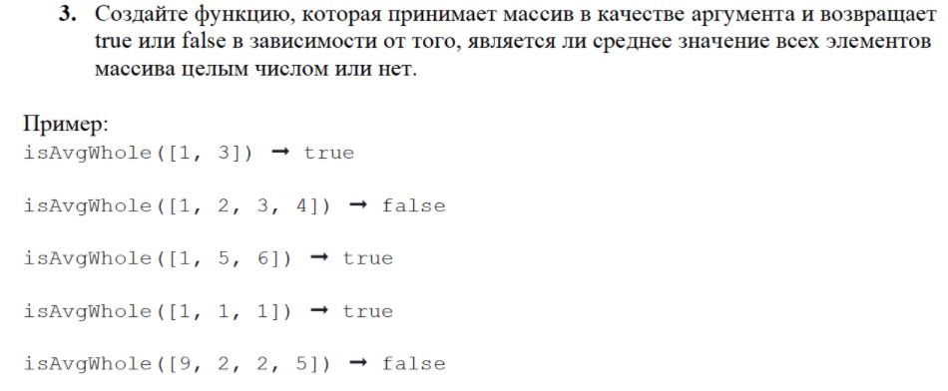
public static boolean zadacha3(int[] array) {
int sum = 0;
int k;
for (int i = 0; i < array.length; i++) {
sum += array[i];
}
k = sum % array.length;
return k == 0;
}
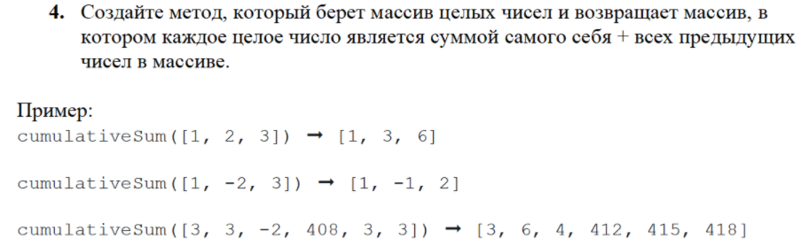
public static String zadacha4(int[] array) {
int[] arr = new int[array.length];
for (int i = 0; i < array.length; i++) {
for (int j = 0; j <= i; j++) {
arr[i] += array[j];
}
}
String ArrayString = Arrays.toString(arr);
return ArrayString;
}
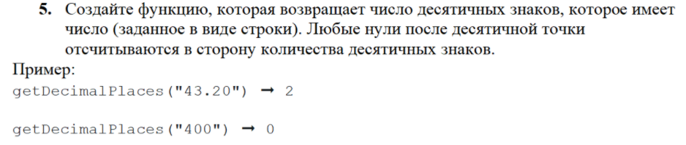
public static int zadacha5(String str) {
int index = str.indexOf('.');
if (index == -1) {
return 0;
}
String newstr = "";
int k = 0;
for (int i = index + 1; i < str.length(); i++) {
newstr += str.charAt(i);
}
for (int i = 0; i < newstr.length(); i++) {
k++;
}
return k;
}
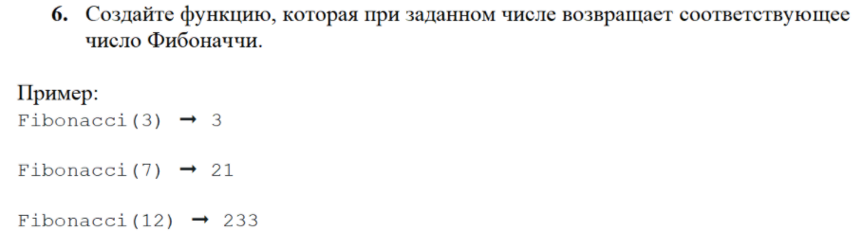
public static int zadacha6(int n) {
int[] arr = new int[n+1];
arr[0] = 1;
arr[1] = 1;
int k = 0;
for (int i = 2 ; i <= n; i++) {
arr[i] = arr[i-1] + arr[i-2];
}
return arr[n];
}
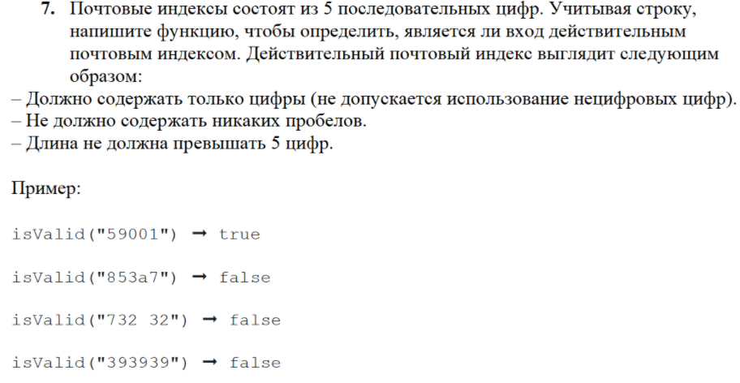
public static boolean zadacha7(String str) {
int index1 = str.indexOf(" ");
return ((str.matches("\\d+?")) && (index1 == -1) && (str.length() == 5));
}
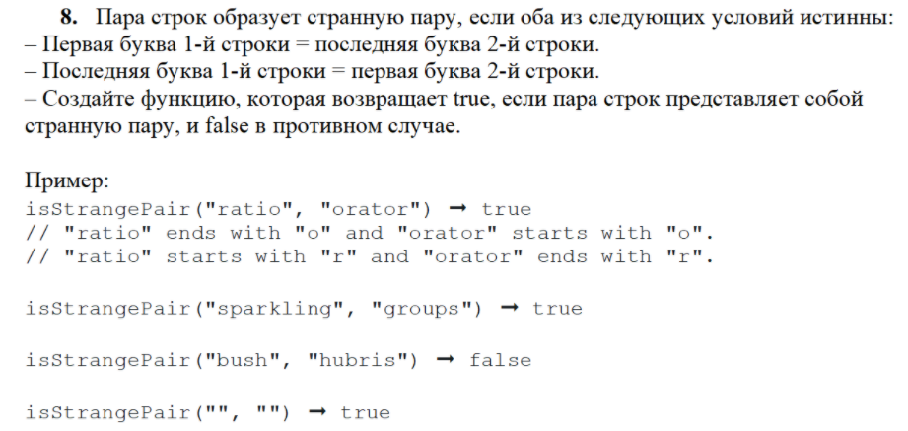
public static boolean zadacha8(String str1, String str2) {
if ((str1 == "") && (str2 == "")) {
return true;
}
String sub1_first = "" + str1.charAt(0);
String sub2_last = "" + str2.charAt(str2.length() - 1);
String sub1_last = "" + str1.charAt(str1.length() - 1);
String sub2_first = "" + str2.charAt(0);
return ((sub1_first.equals(sub2_last)) && (sub1_last.equals(sub2_first)));
}
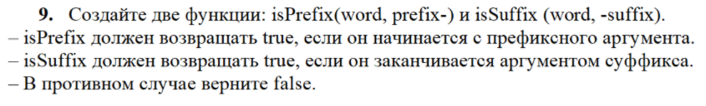
public static boolean isPrefix(String str1, String str2) {
int k = str2.length() - 1;
return str1.regionMatches(0, str2, 0, k);
}
public static boolean isSuffix(String str1, String str2) {
int k = str1.length() - str2.length() + 1;
int s = str2.length() - 1;
return str1.regionMatches(k, str2, 1, s);
}
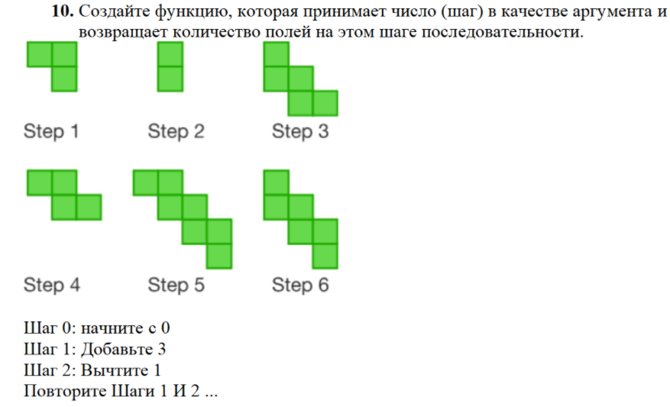
public static int zadacha10(int k) {
int sum = 0;
if (k % 2 == 0) {
sum = k;
}
else {
sum = k + 2;
}
return sum;
}
}

Результат выполнения модуля:

