Модуль 3

public class Module3 {
public static void main (String[] args){
System.out.println("Задача 1: " + zadacha1(1, 0 ,-1));
System.out.println("Задача 2: " + zadacha2("all zip files are zipped"));
System.out.println("Задача 3: " + zadacha3(496));
System.out.println("Задача 4: " + zadacha4("Cat, dog and mouse."));
System.out.println("Задача 5: " + zadacha5("#E38cF0"));
int[] arr1 = new int[]{1, 3, 4, 4, 4};
int[] arr2 = new int[]{2, 5, 7};
System.out.println("Задача 6: " + zadacha6(arr1,arr2));
System.out.println("Задача 7: " + zadacha7(297));
System.out.println("Задача 8: " + zadacha8("1110001101"));
System.out.println("Задача 9: " + zadacha9(24));
System.out.println("Задача 10: " + zadacha10(3, 4, 5));
}
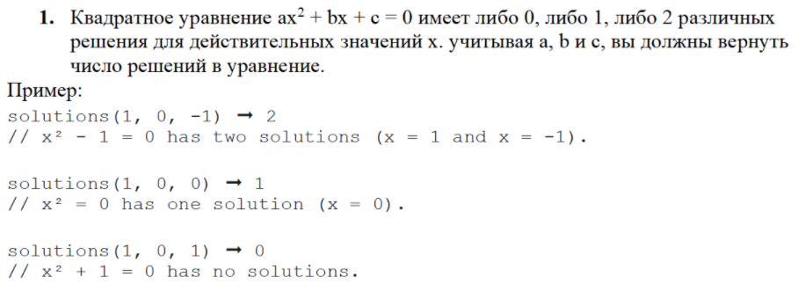
public static int zadacha1(int a, int b, int c){
int d;
int k = 0;
d = b * b - 4 * a * c;
if(d>0){
k = 2;
}
else if(d == 0){
k = 1;
}
return k;
}
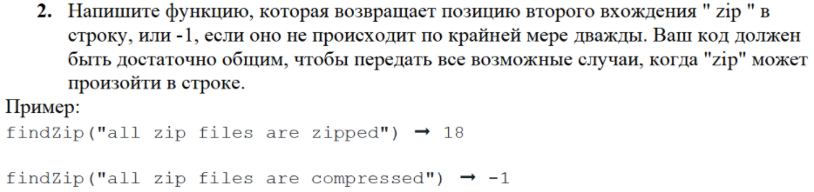
public static int zadacha2 (String str){
int index1 = str.indexOf("zip");
String substr = str.substring(0,index1) + str.substring(index1+3);
int index2 = substr.indexOf("zip");
if (index2 != -1){
index2 += 3;
}
return index2;
}
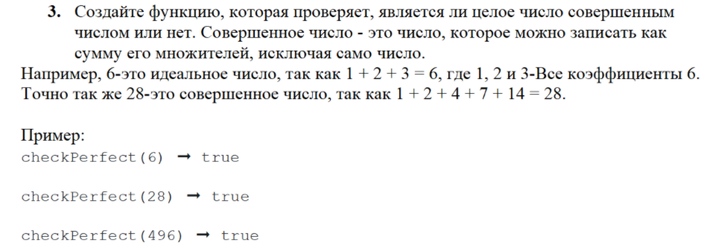
public static boolean zadacha3 (int number){
int sum = 0;
for(int i = 1; i < number; i++){
if(number % i == 0){
sum += i;
}
}
if (sum == 0) return false;
else return sum == number;
}
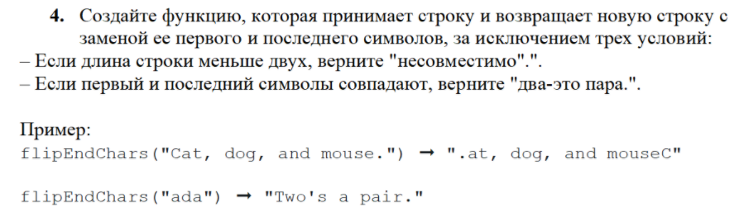
public static String zadacha4(String str) {
String substr = "";
if (str.length() < 2) {
return "несовместимо";
}
char char1 = str.charAt(0);
char char2 = str.charAt(str.length() - 1);
if (char1 == char2) {
return "два - это пара";
}
else {
substr = char2 + str.substring(1, str.length() - 1) + char1;
}
return substr;
}
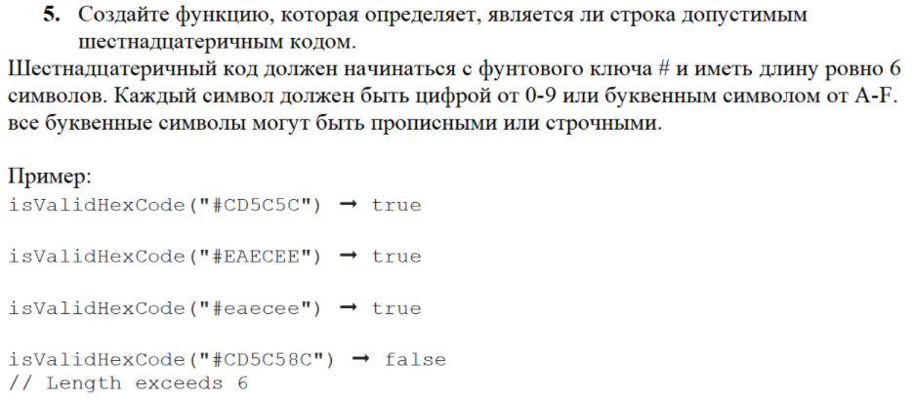
public static boolean zadacha5(String str){
return (str.matches("^#[A-Fa-f[0-9]]{6}"));
}
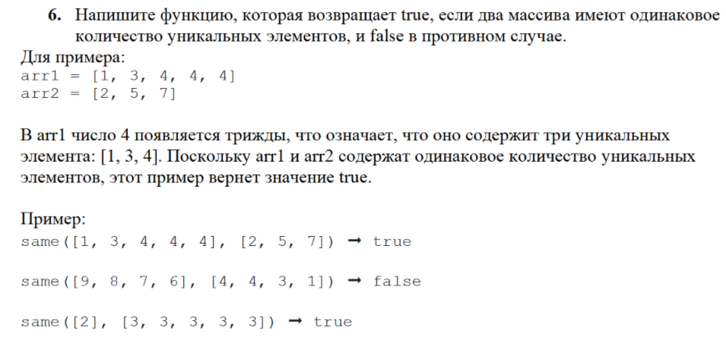
public static boolean zadacha6(int [] arr1, int [] arr2){
int n1 = arr1.length;
int n2 = arr2.length;
int k1 = 0;
int k2 = 0;
int l1 = 0;
int l2 = 0;
// первый массив
for (int i = 0; i < n1 - 1; i++){
for(int j = i+1; j < n1; j++){
if (arr1[i] == arr1[j]){
k1++;
break;
}
}
}
l1 = n1 - k1;
// второй массив
for (int i = 0; i < n2 - 1; i++){
for(int j = i+1; j < n2; j++){
if (arr2[i] == arr2[j]){
k2++;
break;
}
}
}
l2 = n2 - k2;
return (l2 == l1);
}
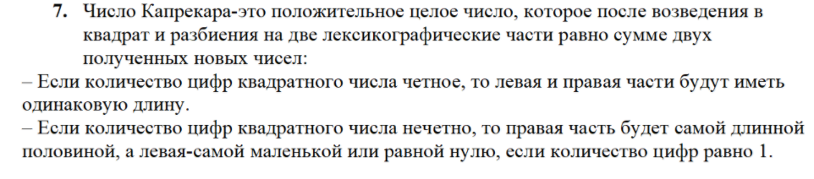
public static boolean zadacha7(int a){
int n = a * a;
int k=0;
int left = 0;
int right = 0;
while (n>0){
n = n / 10;
k++;
}
n = a * a;
if (k % 2 ==0){
left = (int) (n / (Math.pow(10,k/2)));
right = (int) (n % (Math.pow(10,k/2)));
}
else
{
left = (int) (n / (Math.pow(10,(k/2)+1)));
right = (int) (n % (Math.pow(10,(k/2)+1)));
}
int sum = left + right;
return sum == a;
}
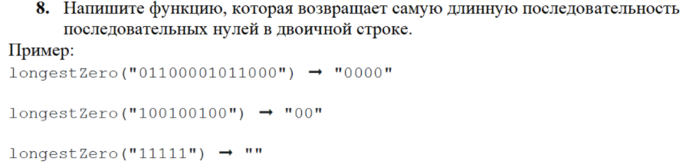
public static String zadacha8(String str){
String rez ="";
String substr = str;
int index1 = str.length() - 1;
int index2, index3;
int max = 0;
while (index1 > 0){
index2 = str.indexOf("0");
if (index2 == -1) break;
substr = substr.substring(index2,substr.length());
index3 = substr.indexOf("1");
if (index3 == -1) break;
substr = substr.substring(index3,substr.length());
if(index3>max)
{
max = index3;
}
index1 -= (index2 + index3);
}
for(int i = 0; i < max; i++){
rez +="0";
}
return rez;
}
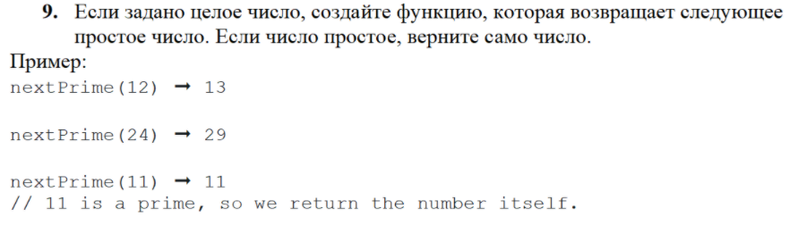
public static int zadacha9(int n){
int number = 0;
for (int i = n; i < 1000; i++){
if ((i == 2) || (i == 3) || (i == 5) || (i == 7)){
number = i;
break;
}
else if ((i % 2 != 0) && (i % 3 != 0) && (i % 5 != 0) && (i % 7 != 0) && (i != 1)){
number = i;
break;
}
}
return number;
}
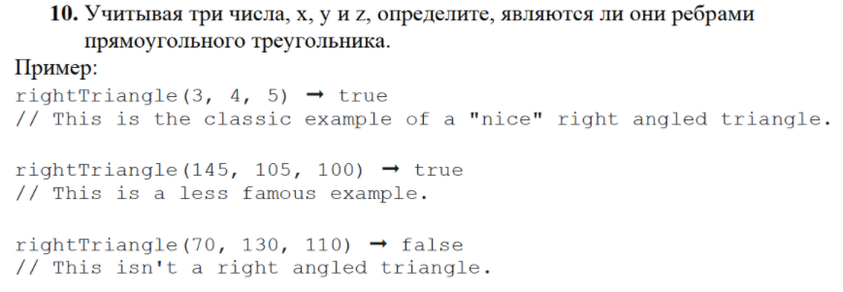
public static boolean zadacha10(int a, int b, int c){
return ((a * a == b * b + c * c) || (b * b == a * a + c * c) || (c * c == b * b + a * a));
}
}

Результат выполнения модуля:
