import javax.xml.bind.DatatypeConverter;
import java.math.BigInteger;
import java.nio.charset.StandardCharsets;
import java.security.MessageDigest;
import java.security.NoSuchAlgorithmException;
public class Module5 {
public static void main(String[] args) throws NoSuchAlgorithmException {
int [] array = new int[]{72, 33, -73, 84, -12, -3, 13, -13, -68};
int [] arr = new int[]{16, };
System.out.println("Задача 1: " + encrypt("Sunshine") +" " + decrypt(array));
System.out.println("Задача 2: " + zadacha2("ладья", "D3","D4"));
System.out.println("Задача 3: " + zadacha3("butl", "beautiful"));
System.out.println("Задача 4: " + zadacha4(arr));
System.out.println("Задача 5: " + zadacha5("toe, ocelot, maniac"));
System.out.println("Задача 6: " + zadacha6("1234567890123452"));
System.out.println("Задача 7: ");
System.out.println(numToEng(126));
System.out.println(numToRus(731));
System.out.println("Задача 8: " + zadacha8("password123"));
System.out.println("Задача 9: " + zadacha9("TYRION LANNISTER, HAND OF THE QUEEN"));
System.out.println("Задача 10: " + zadacha10(7));
}
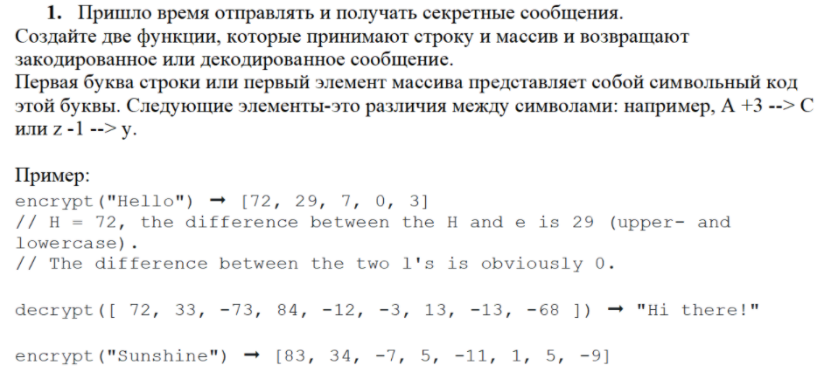
public static String encrypt(String str){
String result = "";
char letter1 = str.charAt(0);
char letter2;
result += (int)letter1 + ", ";
for (int i = 1; i < str.length(); i++){
letter2 = str.charAt(i);
result += letter2 - letter1 + ", ";
letter1 = letter2;
}
return result;
}
public static String decrypt(int [] array){
String result = "";
int letter = 0;
for(int i = 0; i < array.length; i++){
letter += array[i];
result += (char)letter;
}
return result;
}
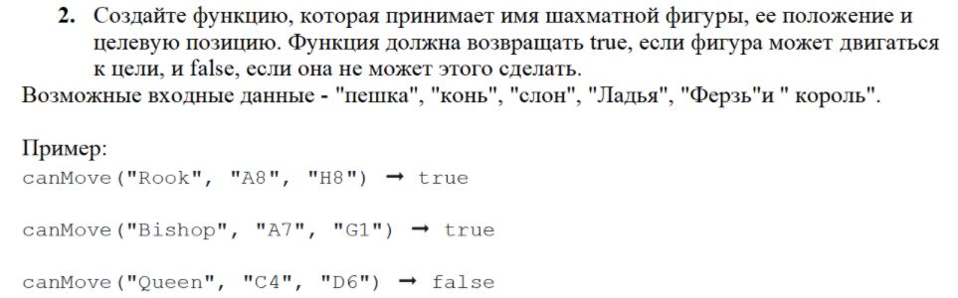
public static boolean zadacha2(String f, String p1, String p2) {
switch (f) {
case "пешка":
if ((p1.charAt(0) == p2.charAt(0)) && (p1.charAt(1) == p2.charAt(1) - 1 ||
p1.charAt(1) == p2.charAt(1) + 1) || (p1.charAt(0) == p2.charAt(0))){
return true;
} else {
return false;
}
case "конь":
if ((Math.abs(p1.charAt(0) - p2.charAt(0)) == 2 && Math.abs(p1.charAt(1) - p2.charAt(1)) == 1) ||
(Math.abs(p1.charAt(0) - p2.charAt(0)) == 1 && Math.abs(p1.charAt(1) - p2.charAt(1)) == 2)) {
return true;
}
else {
return false;
}
case "слон":
if ((p1.charAt(0) == p2.charAt(0)) || (p1.charAt(1) == p2.charAt(1))){
return true;
}
else {
return false;
}
case "ладья":
if((p1.charAt(0) == p2.charAt(0)) || (p1.charAt(1) == p2.charAt(1)) ||
(Math.abs(p1.charAt(0) - p2.charAt(0)) == Math.abs(p1.charAt(1) - p2.charAt(1)))){
return true;
}
else {
return false;
}
case "ферзь":
if(Math.abs(p1.charAt(0) - p2.charAt(0)) == Math.abs(p1.charAt(1) - p2.charAt(1))){
return true;
}
else {
return false;
}
case "король":
if (Math.abs(p1.charAt(0) - p2.charAt(0)) == Math.abs(p1.charAt(1) - p2.charAt(1)) &&
Math.abs(p1.charAt(0) - p2.charAt(0)) == 1 ){
return true;
}
return false;
}
return false;
}
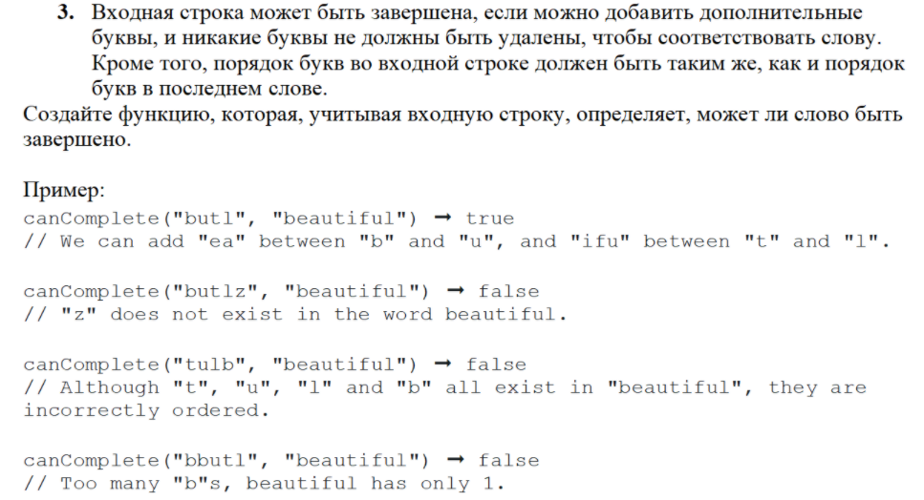
public static boolean zadacha3 (String substr, String str){
int j = 0;
if (substr.length() == 0){
return true;
}
for(int i = 0; i < str.length(); i++){
if(str.charAt(i) == substr.charAt(j)){
j++;
}
}
return (j==substr.length());
}
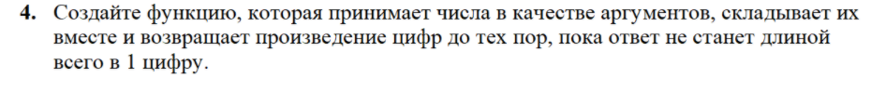
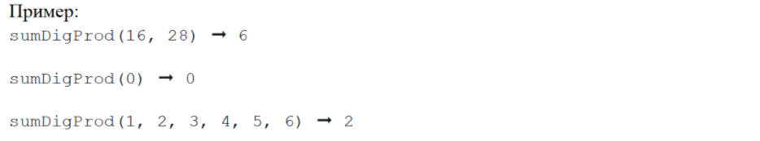

public static int zadacha4(int[] array) {
int sum =0;
for(int i = 0; i < array.length; i++){
sum += array[i];
}
int result = 10;
while (result > 9) {
result = 1;
if(sum < 10){
result = sum;
break;
}
while (sum > 0) {
result *= sum % 10;
sum = sum / 10;
}
sum = result;
}
return result;
}
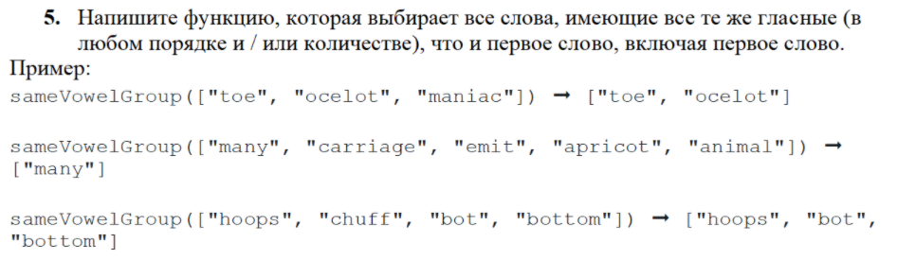
public static String zadacha5(String str){
String[] substr = str.split(", ");
String result = "";
result += substr[0];
String s1 = "";
String s2 ="";
char l1;
int check = 0;
for(int j = 0; j < substr[0].length(); j++){
l1 = substr[0].charAt(j);
if ((l1 == 'a') || (l1 == 'u') || (l1 == 'e') || (l1 == 'o') || (l1 == 'y') || (l1 == 'i')) {
s1 += l1;
}
}
for(int i = 1; i < substr.length; i++) {
for (int k = 0; k < s1.length(); k++) {
s2 += s1.charAt(k);
if(substr[i].contains(s2)){
check++;
}
s2 = "";
}
if (check == s1.length()){
result += " " + substr[i];
}
check = 0;
}
return result;
}
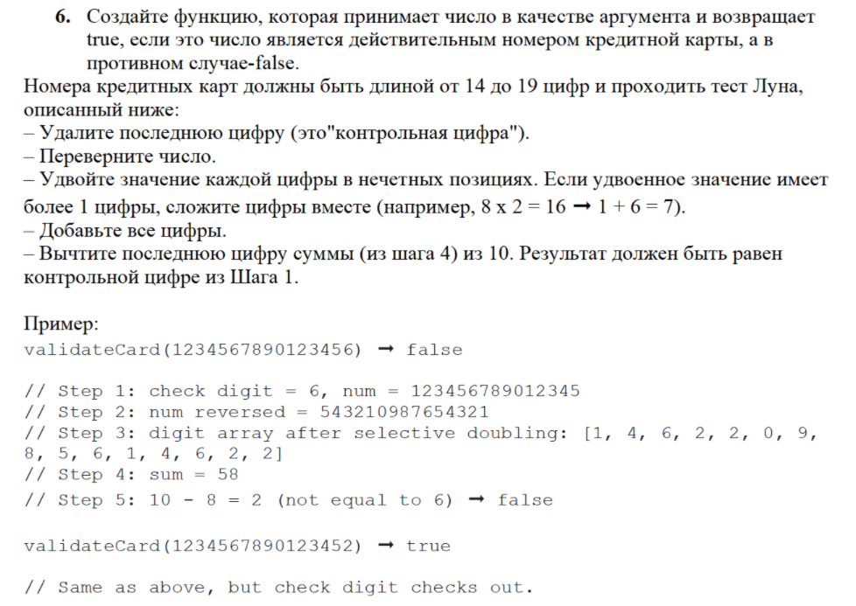
public static boolean zadacha6 (String str){
if(str.length() < 14 || str.length() > 19){
return false;
}
char last = str.charAt(str.length() - 1);
str = str.substring(0, str.length() - 1);
str = new StringBuilder(str).reverse().toString();
String substr ="";
int num;
int sum = 0;
for (int i = 0; i < str.length(); i++) {
if (i % 2 == 0) {
num = Integer.parseInt(String.valueOf(str.charAt(i))) * 2;
if (num > 9) {
num = num % 10 + num / 10;
}
substr += Integer.toString(num);
} else {
substr += str.charAt(i);
}
sum += Integer.parseInt(String.valueOf(substr.charAt(i)));
}
return 10 - sum % 10 == last;
}
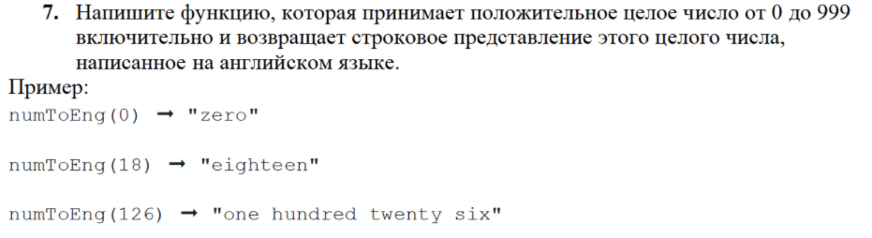
public static String numToEng(int n){
if(n == 0){
return "zero";
}
int d1 = n / 100;
int d2 = (n / 10) % 10;
int d3 = n % 10;
String[] single = {"zero", "one", "two", "three", "four", "five", "six", "seven", "eight", "nine"};
String[] dozen = {"zero", "ten", "twenty", "thirty", "forty", "fifry", "sixty", "seventy","eighty", "ninety"};
String[] exception = {"ten", "eleven", "twelve", "thirteen", "fourteen", "fifteen", "sixteen", "seventeen", "eighteen", "nineteen"};
String result = "";
if (d1 > 0) {
result += single[d1] + " hundred ";
}
else if(d2 == 0){
result += single[d3];
return result;
}
if (d2 != 1) {
result += dozen[d2] + " ";
if(d3 > 0){
result += single[d3];
}
}
else{
result += exception[d3];
}
return result;
}
public static String numToRus(int n){
if(n == 0){
return "ноль";
}
int d1 = n / 100;
int d2 = (n / 10) % 10;
int d3 = n % 10;
String[] hundred = {"", "сто", "двести", "триста", "четыреста", "пятьсот", "шестьсот", "семьсот", "восемьсот", "девятьсот"};
String[] single = {"ноль", "один", "два", "три", "четыре", "пять", "шесть", "семь", "восемь", "девять"};
String[] dozen = {"", "десять", "двадцать", "тридцать", "сорок", "пятьдесят",
"шестьдесят", "семьдесят", "восемьдесят", "девяносто" };
String[] exception = {"десять", "одиннадцать", "двенадцать", "тринадцать", "четырнадцать", "пятнадцать",
"шестнадцать", "семнадцать", "восемнадцать", "девятнадцать"};
String result = "";
if (d1 > 0) {
result += hundred[d1] + " ";
}
else if(d2 == 0){
result += single[d3];
return result;
}
if (d2 != 1) {
result += dozen[d2] + " ";
if(d3 > 0){
result += single[d3];
}
}
else{
result += exception[d3];
}
return result;
}
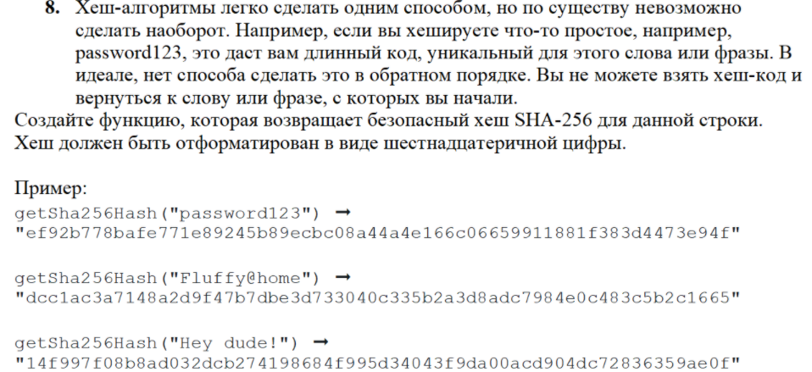

public static String zadacha8(String str) throws NoSuchAlgorithmException {
byte[] arr;
MessageDigest md = MessageDigest.getInstance("SHA-256"); //Используем дайджест сообщения MessageDigest с алгоритмом SHA-256
arr = md.digest(str.getBytes(StandardCharsets.UTF_8)); //Передаём данные и создаём дайджест
return DatatypeConverter.printHexBinary(arr).toLowerCase();
}
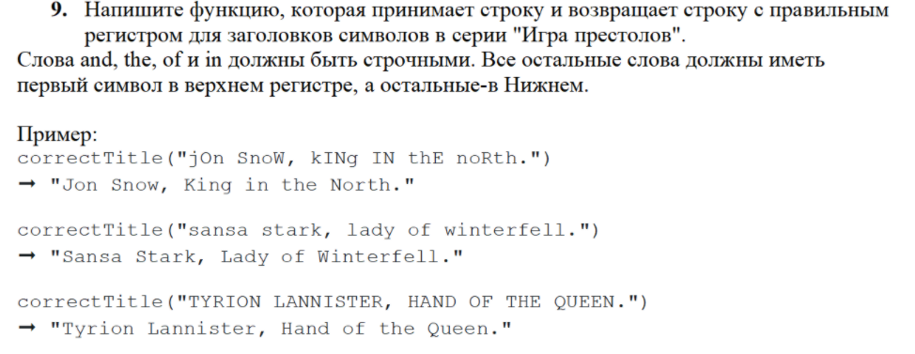
public static String zadacha9(String str){
str = str.toLowerCase();
String[] s = str.split(" ");
String substr = "";
for(int i = 0; i < s.length; i++){
if (!(s[i].contentEquals("and") ||s[i].contentEquals("of") || s[i].contentEquals("the")
|| s[i].contentEquals("in")))
{
substr += s[i].substring(0,1).toUpperCase() + s[i].substring(1,s[i].length()) + " ";
}
else{
substr += s[i] + " ";
}
}
return substr;
}
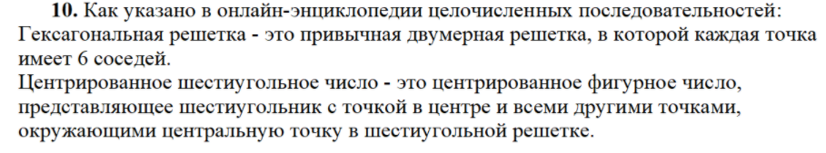
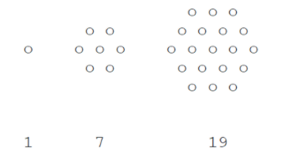
public static String zadacha10(int num){
// 3*n*n - 3*n + 1 - num = 0 формула числа
if((num - 1) % 6 != 0) {
return "недопустимое";
}
int d = (int) Math.sqrt((9 - 4 * 3 * (1 - num)));
int n = (3 + d) / 6;
int count = n * 2 - 1; // кол-во элементов в центральной строке
String result = "\n";
int space = count - n;
// верхняя часть и центр
for (int i = n; i <= count; i++){
for(int j = 1; j <= space; j++){
result += " ";
}
space--;
for (int k = 1; k <= i; k++){
result += "o ";
}
result += "\n";
}
// нижняя часть
space = 1;
for (int i = count - 1; i >= n; i--){
for (int j = 1; j <= space; j++){
result += " ";
}
space++;
for(int k = 1; k <= i; k++){
result += "o ";
}
result += "\n";
}
return result;
}
}

Результат выполнения модуля:
