import java.math.BigInteger;
import java.util.Arrays;
public class Module6 {
public static void main(String[] args) {
System.out.println("Задача 1: " + zadacha1(3));
System.out.println("Задача 2: ");
System.out.println(translateWord("have"));
System.out.println(translateSentence("I like to eat honey waffles"));
System.out.println("Задача 3: " + zadacha3("rgba(134,12,255,0.34)"));
System.out.println("Задача 5: " + zadacha5("Hey Parents, Surprise, Fruit Juice Is Not Fruit"));
System.out.println("Задача 6: " + zadacha6(206));
System.out.println("Задача 7: " + zadacha7("abcabcbb"));
System.out.println("Задача 8: " + zadacha8(3466));
System.out.println("Задача 9: " + zadacha9("6 * 4 = 24"));
System.out.println("Задача 10: " + zadacha10("11211230"));
}
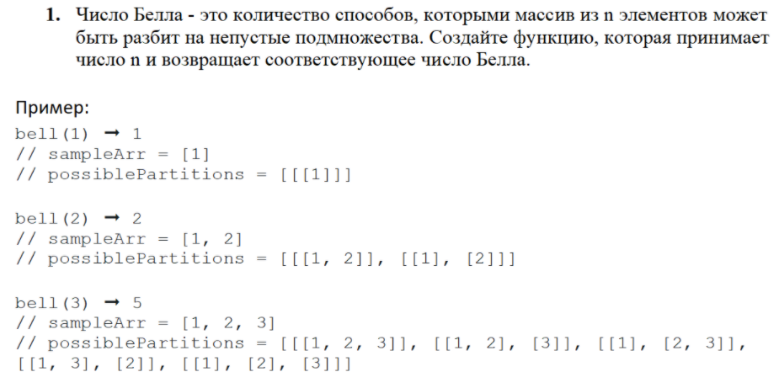
public static int zadacha1(int n) {
int[][] bellNum = new int[n + 1][n + 1];
bellNum[0][0] = 1;
for (int i = 1; i <= n; i++) {
bellNum[i][0] = bellNum[i - 1][i - 1];
for (int j = 1; j <= i; j++) {
bellNum[i][j] = bellNum[i - 1][j - 1] + bellNum[i][j - 1];
}
}
return bellNum[n][0];
}
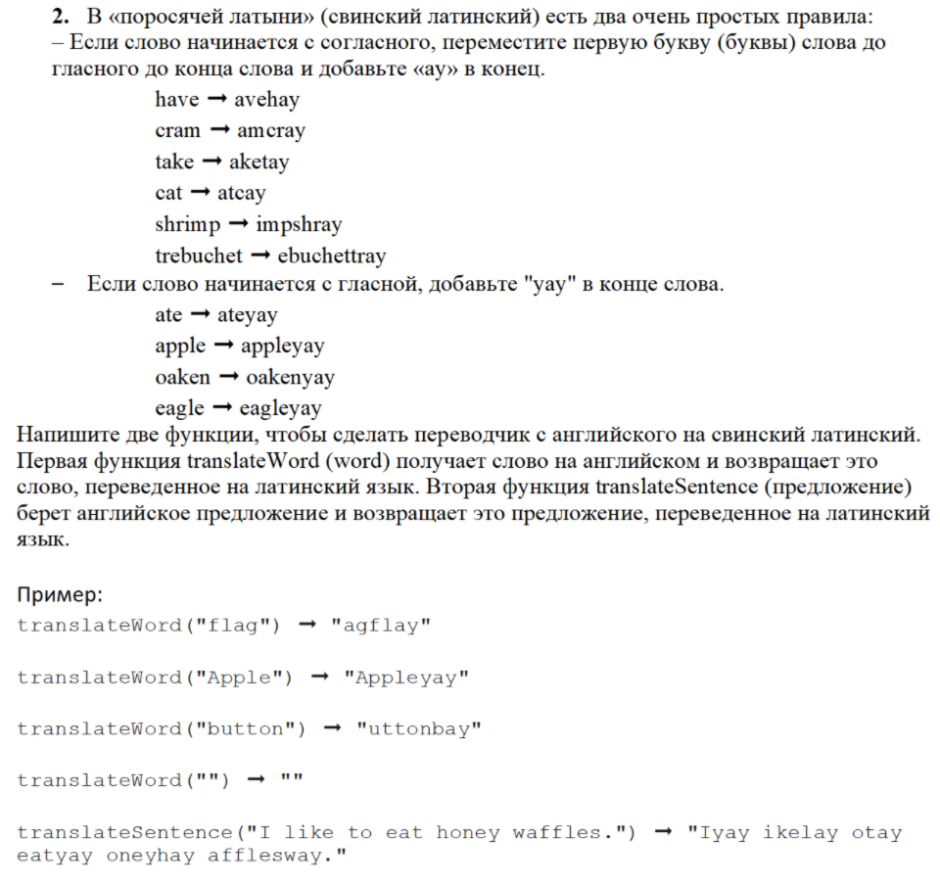
public static String translateWord(String word) {
String result = "";
String s1 = "";
char s2 = ' ';
if (word.length() == 0) {
return result;
}
char l1 = word.charAt(0);
if ((l1 == 'a') || (l1 == 'u') || (l1 == 'e') || (l1 == 'o') || (l1 == 'y') || (l1 == 'i') ||
(l1 == 'A') || (l1 == 'U') || (l1 == 'E') || (l1 == 'O') || (l1 == 'Y') || (l1 == 'I')){
result += word + "yay";
}
else {
s1 += word.charAt(0);
char l2;
int count = 1;
for (int i = 1; i < word.length(); i++) {
l2 = word.charAt(i);
if ((l2 == 'a') || (l2 == 'u') || (l2 == 'e') || (l2 == 'o') || (l2 == 'y') || (l2 == 'i') ||
(l2 == 'A') || (l2 == 'U') || (l2 == 'E') || (l2 == 'O') || (l2 == 'Y') || (l2 == 'I')) break;
else {
s1 += l2;
count++;
}
}
result += word.substring(count, word.length()) + s1 + "ay";
}
return result;
}
public static String translateSentence(String sent){
String[] str = sent.split(" ");
String result = "";
String s1 = "";
for(int i = 0; i < str.length; i++){
char l1 = str[i].charAt(0);
if ((l1 == 'a') || (l1 == 'u') || (l1 == 'e') || (l1 == 'o') || (l1 == 'y') || (l1 == 'i') ||
(l1 == 'A') || (l1 == 'U') || (l1 == 'E') || (l1 == 'O') || (l1 == 'Y') || (l1 == 'I')) {
result += str[i] + "yay ";
}
else {
s1 += str[i].charAt(0);
char l2;
int count = 1;
for (int j = 1; j < str[i].length(); j++) {
l2 = str[i].charAt(j);
if ((l2 == 'a') || (l2 == 'u') || (l2 == 'e') || (l2 == 'o') || (l2 == 'y') || (l2 == 'i') ||
(l2 == 'A') || (l2 == 'U') || (l2 == 'E') || (l2 == 'O') || (l2 == 'Y') || (l2 == 'I')) break;
else {
s1 += l2;
count++;
}
}
result += str[i].substring(count, str[i].length()) + s1 + "ay ";
}
s1 = "";
}
return result;
}
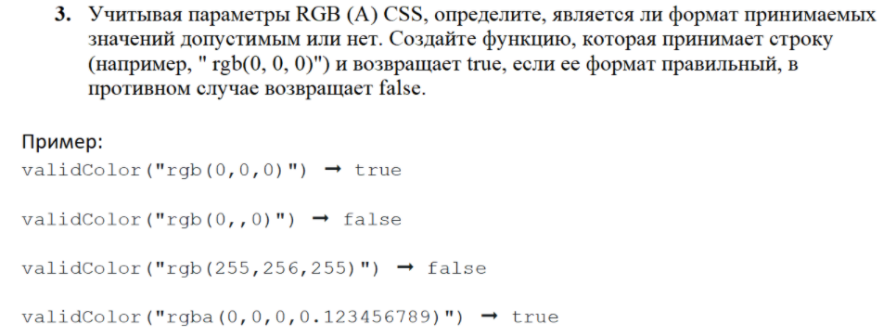
public static boolean zadacha3(String str) {
String s1 = "";
int num;
double n;
s1 = str.substring(0, str.indexOf("("));
str = str.substring(str.indexOf("(") + 1, str.indexOf(")"));
String[] s2 = str.split(",");
for (int i = 0; i < 3; i++) {
num = Integer.parseInt(String.valueOf(s2[i]));
if (num > 255 || num < 0) {
return false;
}
}
if (s1.equals("rgba")) {
if (s2.length != 4) return false;
else {
n = Double.parseDouble(String.valueOf(s2[3]));
if (n > 1 || n < 0) {
return false;
}
}
} else if (s2.length != 3) {
return false;
}
return true;
}
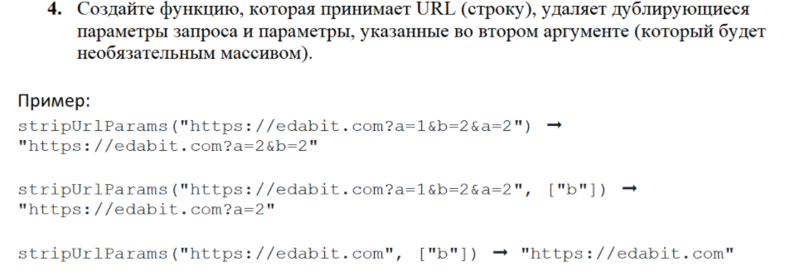
public static String zadacha4(String url, String ...paramsToStrip) {
String str = "";
if (!url.contains("?"))
return url;
else {
str = url.substring(url.indexOf("?") + 1);
url = url.substring(0, url.indexOf("?") + 1);
}
char[] params = str.toCharArray();
StringBuilder print = new StringBuilder();
for (char param : params) {
if (Character.isLetter(param))
if (!(print.toString().contains(String.valueOf(param)))) {
if (paramsToStrip.length > 0) {
for (String arg : paramsToStrip) {
if (!(arg.contains(String.valueOf(param))))
print.append(str, str.lastIndexOf(param), str.lastIndexOf(param) + 3).append("&");
}
}
else
print.append(str, str.lastIndexOf(param), str.lastIndexOf(param) + 3).append("&");
}
}
return url + print.substring(0, print.length()-1);
}
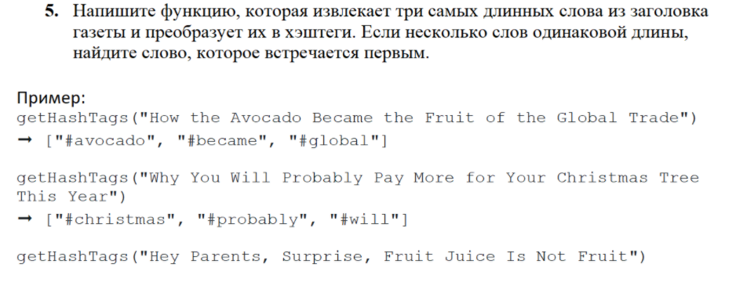
public static String zadacha5(String str) {
String[] sub = str.split(" ");
String result = "";
int num = 0;
int max = 0;
int count = 3;
while (count > 0) {
for (int i = 0; i < sub.length; i++) {
if (sub[i].contains(",")) {
sub[i] = sub[i].substring(0, sub[i].length() - 1);
}
if (sub[i].length() > max) {
max = sub[i].length();
num = i;
}
}
if (!sub[num].equals("")) {
result += "#" + sub[num].toLowerCase() + " ";
}
sub[num] = "";
max = 0;
count--;
}
return result;
}
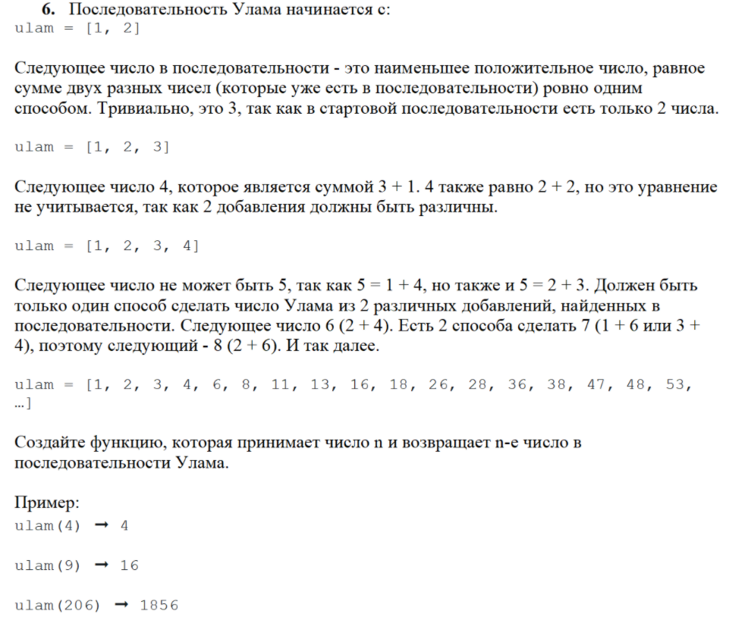
public static int zadacha6(int n) {
int[] ulam = new int[n + 1];
ulam[0] = 1;
ulam[1] = 2;
int check = 0;
int num = 3;
int index = 2;
while (index <= n) {
for (int i = 1; i < index; i++) {
for (int j = 0; j < i; j++) {
if (ulam[i] + ulam[j] == num) {
check++;
}
}
}
if (check == 1) {
ulam[index] = num;
index++;
}
num++;
check = 0;
}
return ulam[n];
}
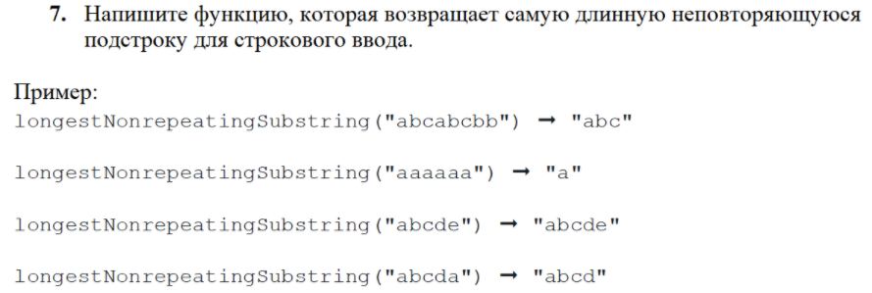
public static String zadacha7(String str) {
String substr = "", result = "";
for (int i = 0; i < str.length(); i++) {
if(!substr.contains(str.substring(i, i+1))){
substr += str.charAt(i);
}
else{
if(substr.length() > result.length()){
result = substr;
substr = "";
}
}
}
return result;
}
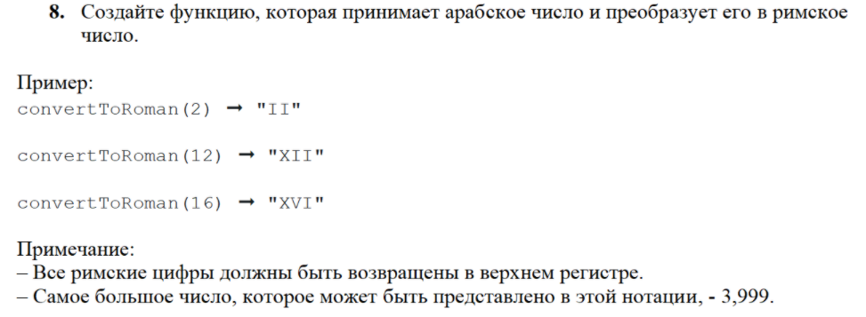
public static String zadacha8(int num) {
int d4 = num / 1000;
int d3 = num / 100 % 10;
int d2 = num % 100 / 10;
int d1 = num % 10;
String result = "";
if (d4 > 0) {
for (int i = 1; i <= d4; i++) {
result += "M";
}
}
if (d3 < 4) {
for (int i = 1; i <= d3; i++) {
result += "C";
}
}
if (d3 > 5 && d3 < 9) {
result += "D";
for (int i = 1; i <= d3 - 5; i++) {
result += "C";
}
}
if (d3 == 4) result += "CD";
if (d3 == 5) result += "D";
if (d3 == 9) result += "CM";
if (d2 < 4) {
for (int i = 1; i <= d2; i++) {
result += "X";
}
}
if (d2 > 5 && d2 < 9) {
result += "L";
for (int i = 1; i <= d2 - 5; i++) {
result += "X";
}
}
if(d2 == 4) result += "XL";
if (d2 == 5) result += "L";
if (d2 == 9) result += "XC";
if (d1 < 4) {
for (int i = 1; i <= d1; i++) {
result += "I";
}
}
if (d1 > 5 && d1 < 9) {
result += "V";
for (int i = 1; i <= d1 - 5; i++) {
result += "I";
}
}
if (d1 == 4) result += "IV";
if (d1 == 5) result += "V";
if (d1 == 9) result += "IX";
return result;
}
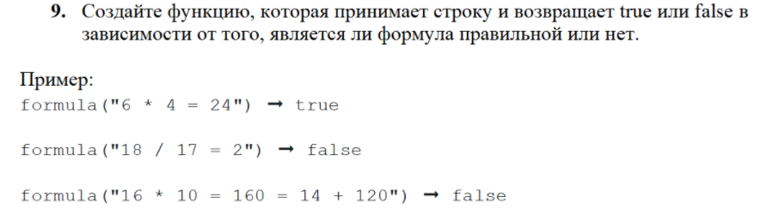
public static boolean zadacha9(String str){
String[] arr = str.split(" ");
int result1 = 0;
int result2 = 0;
if (!Character.isDigit(arr[0].charAt(0))) return false;
else result1 = Integer.parseInt(arr[0]);
int i = 1;
while (!arr[i].equals("=")) {
if (arr[i].equals("+")){
result1 += Integer.parseInt(arr[i + 1]);
}
if (arr[i].equals("-")){
result1 -= Integer.parseInt(arr[i + 1]);
}
if (arr[i].equals("*")){
result1 *= Integer.parseInt(arr[i + 1]);
}
if (arr[i].equals("/")){
result1 /= Integer.parseInt(arr[i + 1]);
}
i += 2;
}
String check = str.substring(str.indexOf("=") + 1);
if (check.contains("=")) return false;
else result2 = Integer.parseInt(arr[arr.length - 1]);
return result1 == result2;
}
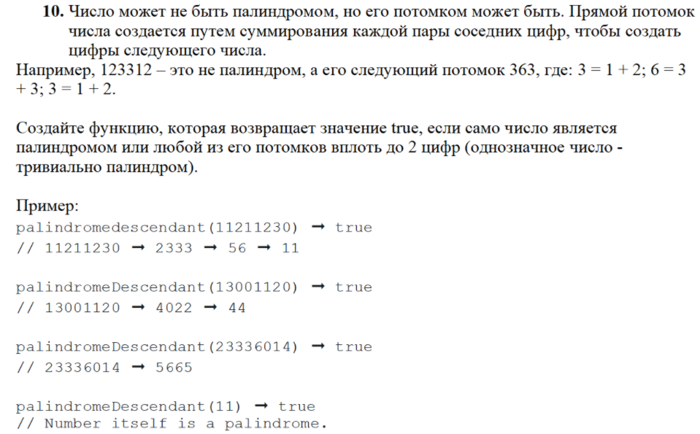
public static boolean zadacha10(String num){
int n;
String str = "";
String result = "";
while (num.length() > 1) {
for (int i = 1; i < num.length(); i += 2) {
n = Integer.parseInt(String.valueOf(num.charAt(i))) + Integer.parseInt(String.valueOf(num.charAt(i - 1)));
result += n;
}
num = result;
for (int k = result.length() - 1; k >= 0; k--) {
str += result.charAt(k);
}
if(result.equals(str)){
return true;
}
result = "";
str = "";
}
return false;
}
}

