Andrew Kutta

CS 490 – Wireless Networks

Assignment was to reproduce the results of the paper “Energy-Efficient Communication protocol for Wireless Microsensor Networks.” The initial setup is a 100x100 network array with 100 sensors randomly distributed across the area shown below.

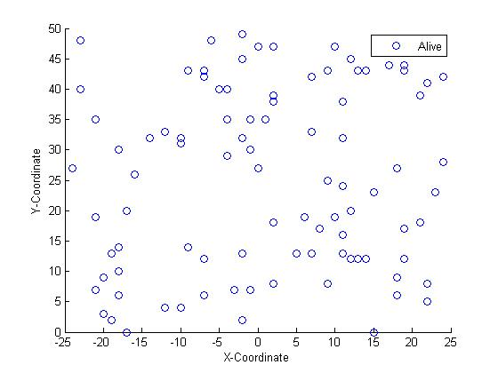

Figure 3. 100-node random network.

The initial two communication types are direct and MTE routing. The comparison of which is shown below.

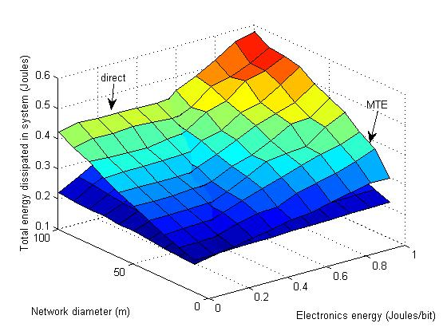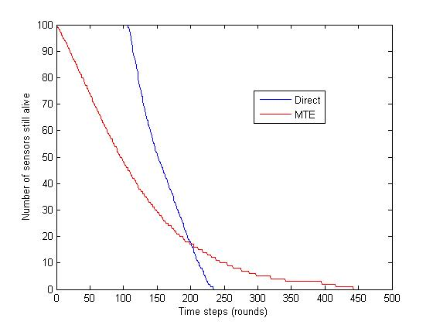

Figure 4. Total energy dissipated in 100-node random Figure 5. System lifetime using direct and MTE

network using Direct communication and MTE routing. transmission.

Upon further inspection it is obvious that there are limited benefits for both routing technics. Biggest problem is that both of the battery lives are rather low. By 450 iterations through every node in the system, there are no nodes that are alive anymore. However, the largest problem is that the nodes die in a very predictable manner as shown below.

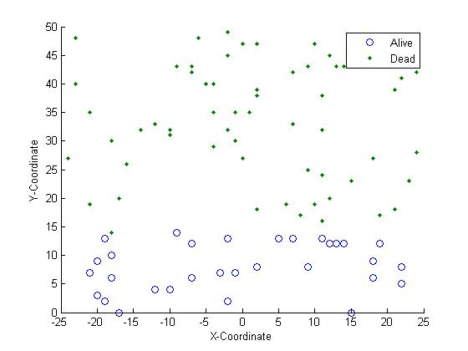 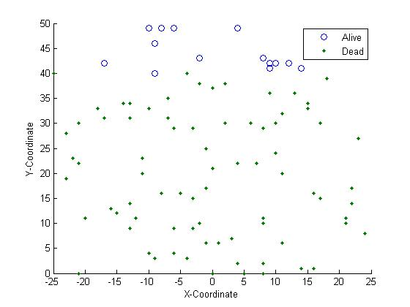

Figure 6a. Sensors remaining alive after 180 rounds. Figure 6b. Sensors remaining alive after 180 rounds

Direct transmission MTE Routing

LEACH is a new method of transmitting data in a more efficient and less predictable pattern. There are main cluster heads that every node within its cluster sends data to. The nodes always send the data to the closest cluster head as shown in two examples below.

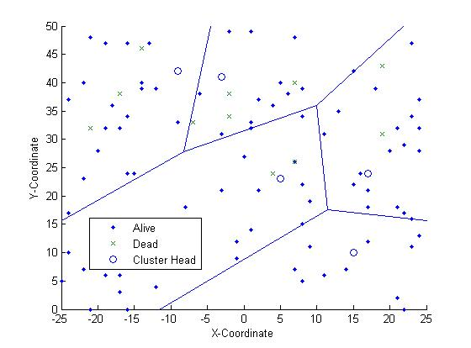 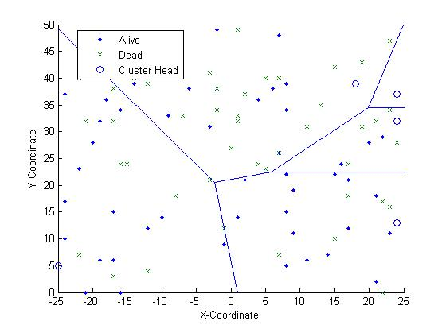

Figure 7a. Dynamic clusters at time 1 Figure 7b. Dynamic clusters at time 2

For the LEACH implementation, 5% of nodes were chosen to be the cluster head based on doing a quick study comparing the amount of energy dissipated by the system in comparison to percentage of the nodes that were cluster heads. Below is a graph comparing that data.

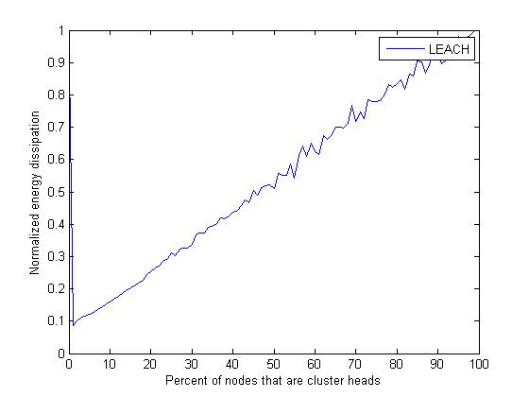

Figure 8. Normalized energy dissipation versus the

percentage of cluster heads. Normalized

around Direct Transmission energy.

The following are more direct comparisons of LEACH with both MTE and Direct.

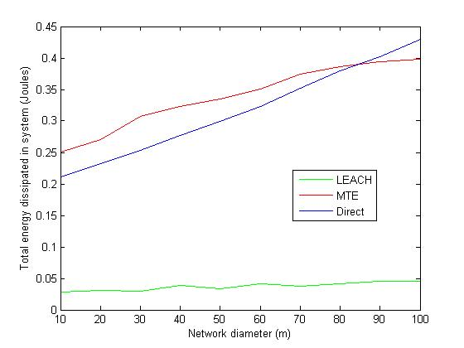

Figure 9. Total system energy dissipation using

Direct, MTE, and LEACH routing. Eelec = 50nJ/bit

E_amp = 100 pJ/bit/m^2, and messages are 2000 bits.

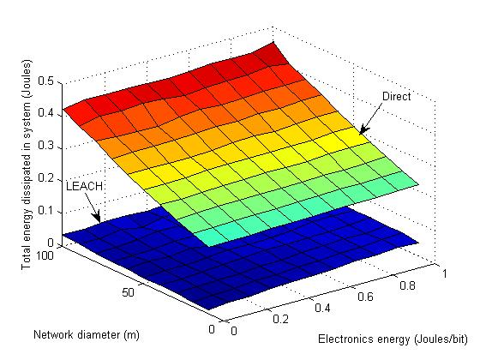 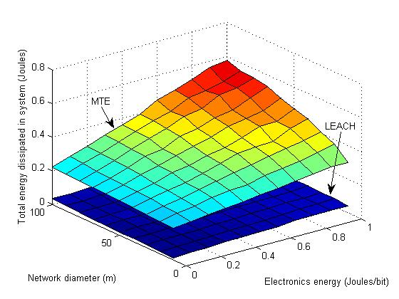

Figure 10a. Total system energy dissipated direct vs LEACH Figure 10b. Total system energy dissipated MTE vs LEACH

E_amp = 100 pJ/bit/m^2 and messages are 2000 bits E_amp = 100 pJ/bit/m^2 and messages are 2000 bits

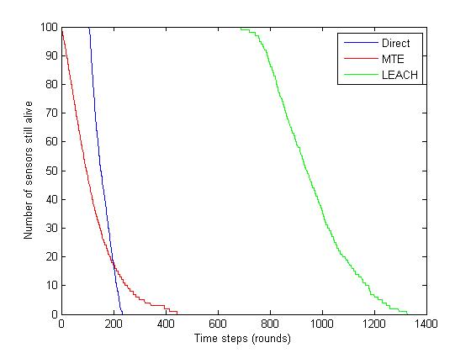

Figure 11. System lifetime using direct, MTE,

and LEACH Transmissions with 0.5 J/node

As seen in the above graphs, it is obvious how much longer LEACH lasts when compared to Direct and MTE transmission methods. In addition, LEACH solves the problem of predictable node life. Instead of the nodes dying in a specific pattern, they now run out of energy in a random pattern that is impossible to predict as shown below.

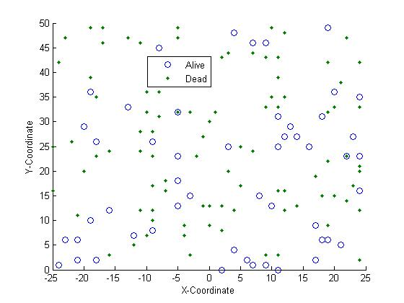

Figure 12. Sensors that remain alive (circles)

And those which are dead (dots) after 1200 iterations.