МИНИСТЕРСТВО ОБРАЗОВАНИЯ РЕСПУБЛИКИ БЕЛАРУСЬ
УЧРЕЖДЕНИЕ ОБРАЗОВАНИЯ
«БРЕСТСКИЙГОСУДАРСТВЕННЫЙТЕХНИЧЕСКИЙУНИВЕРСИТЕТ» ФАКУЛЬТЕТ ЭЛЕКТРОННО-ИНФОРМАЦИОННЫХ СИСТЕМ
Кафедра интеллектуальных информационных технологий
Отчет по лабораторной работе №4
Специальность ИИ-23
Выполнил А.А. Шурина, студент группы ИИ-23
Проверил К.В. Андренко,
ст. преп. кафедры ИИТ,
« » 2025 г.

Брест 2025

Цель работы: научиться осуществлять предобучение нейронных сетей с помощью
RBM
Вариант:13

Код программы :
import pandas as pd
import numpy as np
import torch
import torch.nn as nn
import torch.optim as optim
from sklearn.model_selection import train_test_split
from sklearn.preprocessing import StandardScaler
from sklearn.metrics import accuracy_score
def load_data(file_path):
data = pd.read_csv(file_path)
X = data.drop(columns=["RiskLevel"])
y = data["RiskLevel"]
mapping = {
"low risk": 0,
"mid risk": 1,
"high risk": 2
}
y = y.map(mapping).values
return X, y
class RBM(nn.Module):
def __init__(self, visible_units, hidden_units):
super(RBM, self).__init__()
self.W = nn.Parameter(torch.randn(hidden_units, visible_units) * 0.1)
self.h_bias = nn.Parameter(torch.zeros(hidden_units))
self.v_bias = nn.Parameter(torch.zeros(visible_units))
def sample_h(self, v):
prob = torch.sigmoid(torch.matmul(v, self.W.t()) + self.h_bias)
return torch.bernoulli(prob)
def sample_v(self, h):
prob = torch.sigmoid(torch.matmul(h, self.W) + self.v_bias)
return torch.bernoulli(prob)
def contrastive_divergence(self, v, k=1):
v0 = v
for _ in range(k):
h = self.sample_h(v)
v = self.sample_v(h)
return v0, v
def train_rbm(self, data, lr=0.01, batch_size=64, epochs=200):
optimizer = optim.SGD(self.parameters(), lr=lr)
for epoch in range(epochs):
epoch_loss = 0
for i in range(0, len(data), batch_size):
batch = data[i:i + batch_size]
v0, vk = self.contrastive_divergence(batch)
loss = torch.mean((v0 - vk) ** 2)
optimizer.zero_grad()
loss.backward()
optimizer.step()
epoch_loss += loss.item()
if epoch % 20 == 0:
print(f"RBM Epoch [{epoch}/{epochs}], Loss: {epoch_loss:.4f}")
print("RBM pretraining finished.\n")
class MLP(nn.Module):
def __init__(self, input_size, rbm_weights):
super(MLP, self).__init__()
self.fc1 = nn.Linear(input_size, 64)
self.fc1.weight.data = rbm_weights.clone()
self.fc2 = nn.Linear(64, 32)
self.fc3 = nn.Linear(32, 16)
self.fc4 = nn.Linear(16, 3) # 3 класса
def forward(self, x):
x = torch.relu(self.fc1(x))
x = torch.relu(self.fc2(x))
x = torch.relu(self.fc3(x))
x = self.fc4(x)
return x
def train_model(model, criterion, optimizer, X_train, y_train, epochs=300):
for epoch in range(epochs):
model.train()
optimizer.zero_grad()
outputs = model(X_train)
loss = criterion(outputs, y_train)
loss.backward()
optimizer.step()
if epoch % 20 == 0:
print(f"MLP Epoch [{epoch}/{epochs}], Loss: {loss.item():.4f}")
print("MLP training finished.\n")
def evaluate_model(model, X_test, y_test):
model.eval()
with torch.no_grad():
outputs = model(X_test)
_, preds = torch.max(outputs, 1)
acc = accuracy_score(y_test.numpy(), preds.numpy())
return acc
if __name__ == "__main__":
# !!! укажи путь к датасету !!!
X, y = load_data("Maternal Health Risk Data Set.csv")
X_train, X_test, y_train, y_test = train_test_split(
X, y, test_size=0.2, random_state=42, stratify=y
)
scaler = StandardScaler()
X_train = scaler.fit_transform(X_train)
X_test = scaler.transform(X_test)
X_train_tensor = torch.FloatTensor(X_train)
X_test_tensor = torch.FloatTensor(X_test)
y_train_tensor = torch.LongTensor(y_train)
y_test_tensor = torch.LongTensor(y_test)
rbm = RBM(
visible_units=X_train.shape[1],
hidden_units=64
)
rbm.train_rbm(X_train_tensor, lr=0.01, epochs=200)
# --- MLP ---
model = MLP(
input_size=X_train.shape[1],
rbm_weights=rbm.W
)
criterion = nn.CrossEntropyLoss()
optimizer = optim.Adam(model.parameters(), lr=0.001)
train_model(
model,
criterion,
optimizer,
X_train_tensor,
y_train_tensor,
epochs=300
)
accuracy = evaluate_model(
model,
X_test_tensor,
y_test_tensor
)
print(f"Accuracy with RBM pretraining: {accuracy:.4f}")
Результаты:
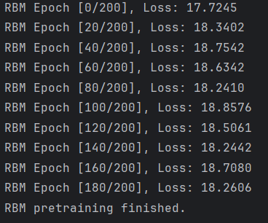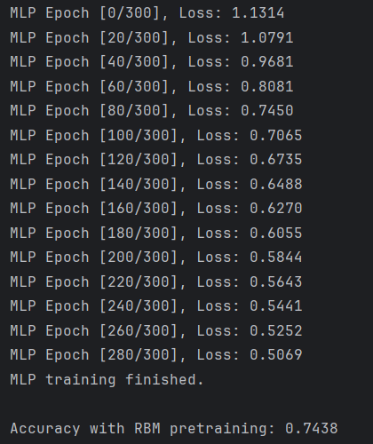
Вывод: научилась осуществлять предобучение нейронных сетей с помощью
RBM

