I. Data Preprocessing and Exploratory Data Analysis (EDA):

From my preliminary inspection of the given dataset, I found challenges concerning data quality and class distribution. Key findings include:

Missing Values:

The existence of missing values in the sub_category and crimeaditionalinfo columns required a deliberate imputation and removal process. My approach to missing subcategories was based on the self-relationship in category and sub_category, and chosen for the best data-oriented approach. Where a direct mapping was unavailable, I employed fuzzy matching techniques complemented by manual corrections guided by domain expertise. This combined strategy aimed to maximize data retention while ensuring logical consistency. For the crimeaditionalinfo column, given its centrality to the NLP analysis, rows with missing descriptions were removed to maintain the integrity of the textual analysis, acknowledging the trade-off between data quantity and analytical quality.

Feature Engineering:

Based on the potential importance of text variables, I created new derived variables named text_length and word_count from the column called crimeaditionalinfo. These features were to feed more quantity information to the model in terms of descriptions.

Class Imbalance:

One of the key observations that I got from the EDA was that "Online Financial Fraud" accounted for most of the dataset. This severely imbalanced distribution may be a threat to the model in terms of training, since it could lead to a bias towards the majority class. I presumed to face issues with class weighting or similar mitigation techniques during model training.

Textual Variability:

To my surprise, the EDA showed a significant variability in the length of the crime descriptions within different categories. This finding hinted that maybe the level of detail or complexity of crimes varies by type and therefore affects the model's ability to learn effective representations.

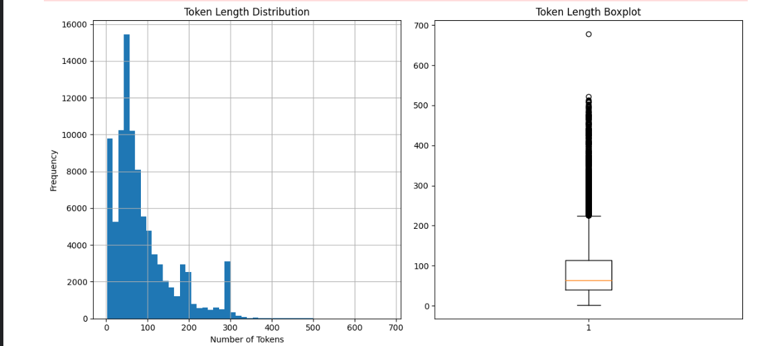
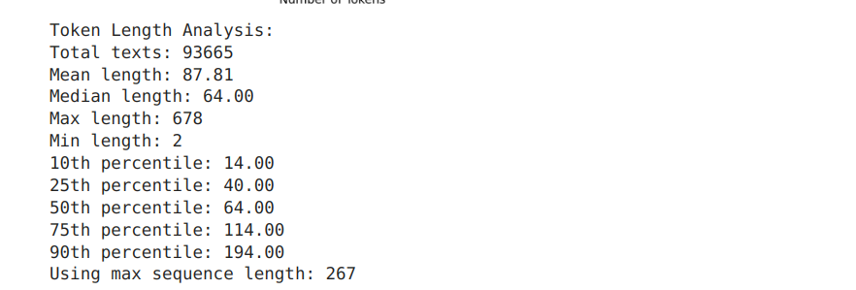

II. Natural Language Processing (NLP):

The heart of my analysis was to extract meaningful insights from the textual crime descriptions. My approach included the following steps :

Text Preprocessing To analyze text data, I applied a standard preprocessing pipeline: tokenization, lowercasing, and stop word removal. Tokenization This step separated the descriptions into individual words using NLTK's word_tokenize function. Lowercasing ensures that words from different cases are represented uniformly, such that semantic meaning is not lost with regard to capitalization issues. Removing stop words Using NLTK's stopwords corpus, it filters out common English words like "the," "a," and "an," most of which don't hold great semantic meaning in this context.

Word Frequency Analysis:

On this step, I proceeded to word frequency analysis to identify the most frequent terms in the cleaned crime descriptions. This was presented graphically via a bar chart showing the top 20 most frequent words. The results yielded recurring patterns such as financial crimes, where words like "account," "bank," "money," and "fraud" appeared prominently.

Word Cloud Visualization:

I created a word cloud to offer a more intuitive way to represent word frequencies. This visualization obviously brought the dominance of terms related to financial crime to light, thus providing a rapid and intuitive view of the main topics within the dataset.

III. Category and Subcategory Analysis:

In addition to the textual analysis, I investigated the distribution of and the relationships between crime categories and subcategories:

Category Distribution:

The bar chart visualization for the most prominent crime categories proved "Online Financial Fraud" to be the largest category, thus again making the training of the model with class imbalance a matter of serious consideration.

Train

Text Statistics:
--------------------------------------------------
text_length word_count
count 93665.000000 93665.000000
mean 398.365772 70.199231
std 329.303728 58.360233
min 1.000000 0.000000
25% 199.000000 33.000000
50% 284.000000 52.000000
75% 494.000000 90.000000
max 1517.000000 370.000000
Analyzing Text Length Distribution...

Key Insights:
1. Most common crime category: Online Financial Fraud (61.3% of all cases)
2. Average description length: 398.4 characters
3. Category with most detailed descriptions: RapeGang Rape RGRSexually Abusive Content

Total number of records: 93,665
Number of categories: 14
Number of sub-categories: 37

Test

Total number of records: 31,222
Number of categories: 14
Number of sub-categories: 37

Missing Values:
--------------------------------------------------
category 0
sub_category 0
crimeaditionalinfo 0
text_length 0
word_count 0
dtype: int64

Text Statistics:
--------------------------------------------------
text_length word_count
count 31222.000000 31222.000000
mean 399.151848 70.394465
std 326.924879 58.032038
min 1.000000 0.000000
25% 199.000000 33.000000
50% 288.000000 52.000000
75% 496.000000 91.000000
max 1521.000000 393.000000

Key Insights:
1. Most common crime category: Online Financial Fraud (60.5% of all cases)
2. Average description length: 399.2 characters
3. Category with most detailed descriptions: RapeGang Rape RGRSexually Abusive Content

Distribution among Subcategories:

To understand crime types at a more granular level, I visualized the top 15 most prominent subcategories. In doing so, I got an idea about the occurrence of some cybercrime types based on this dataset.

Category-Subcategory Inter-relationship:

I used a heatmap of the cross-tabulation between category and subcategory variables to investigate how categories and subcategories co-vary. This helped me to get a clearer understanding of a hierarchical structure created by the crime categories system, indicating which subcategories co-occur with each main category. Such insight into model predictions may be useful in making meaningful interpretations of the relationships between various types of crime.

Train

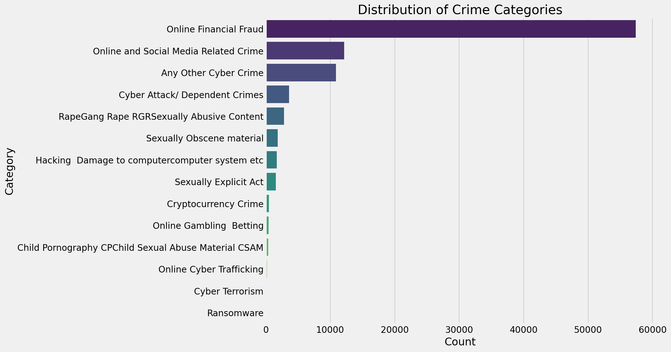

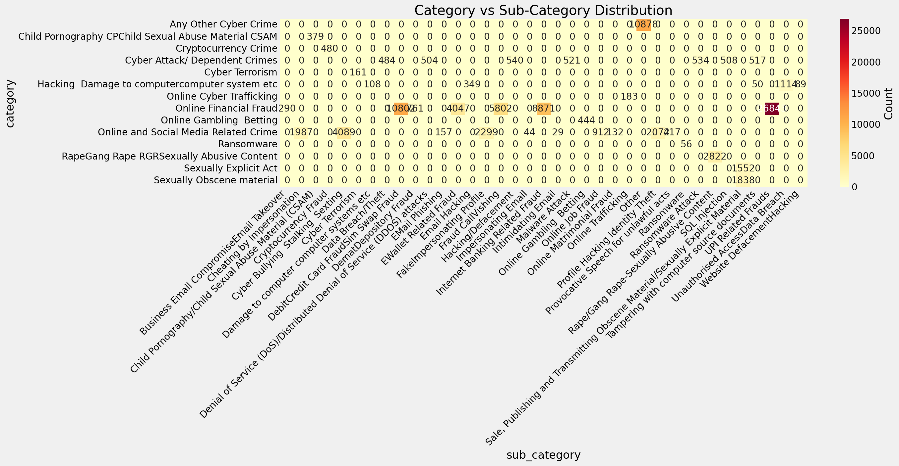

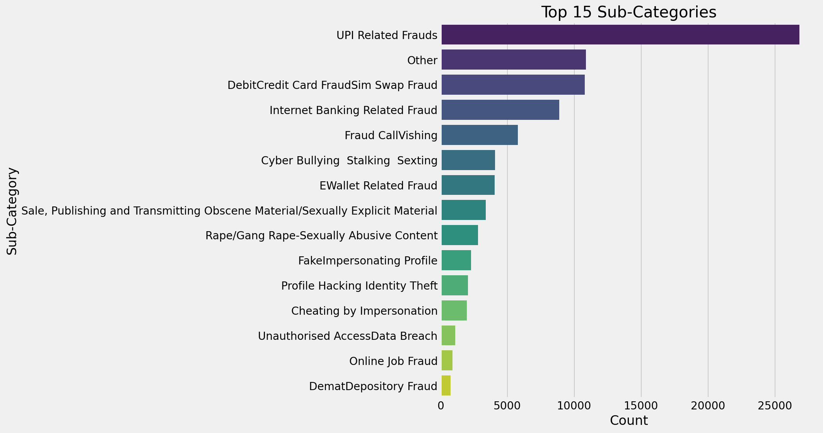
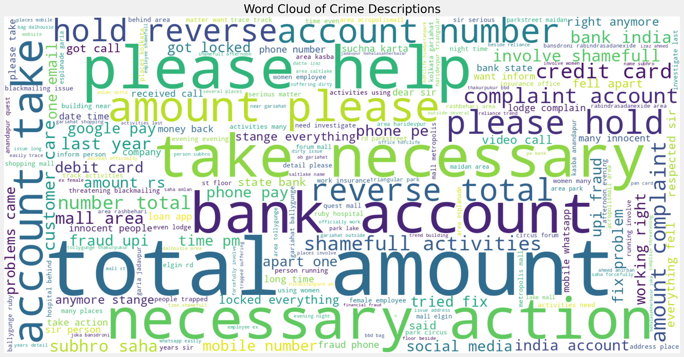

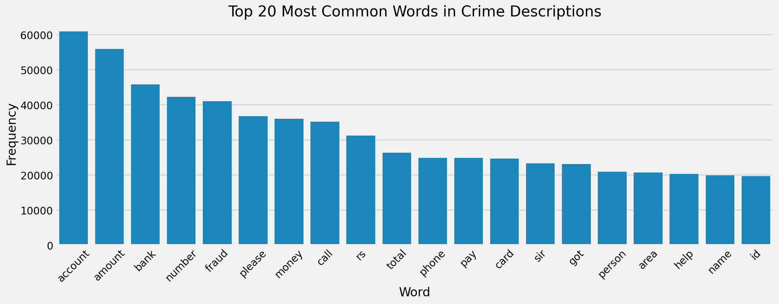
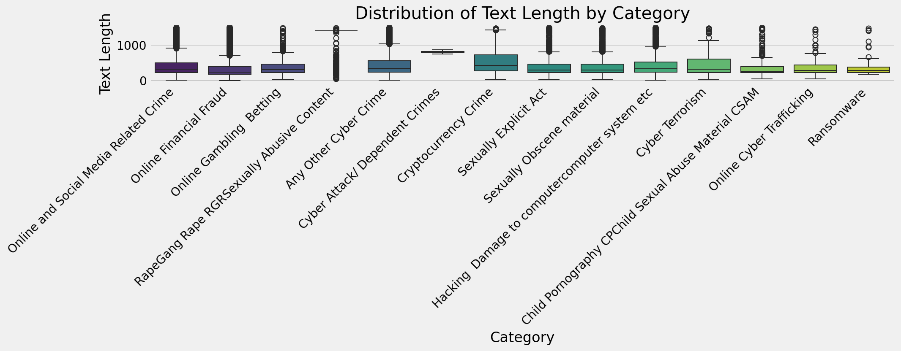

Test

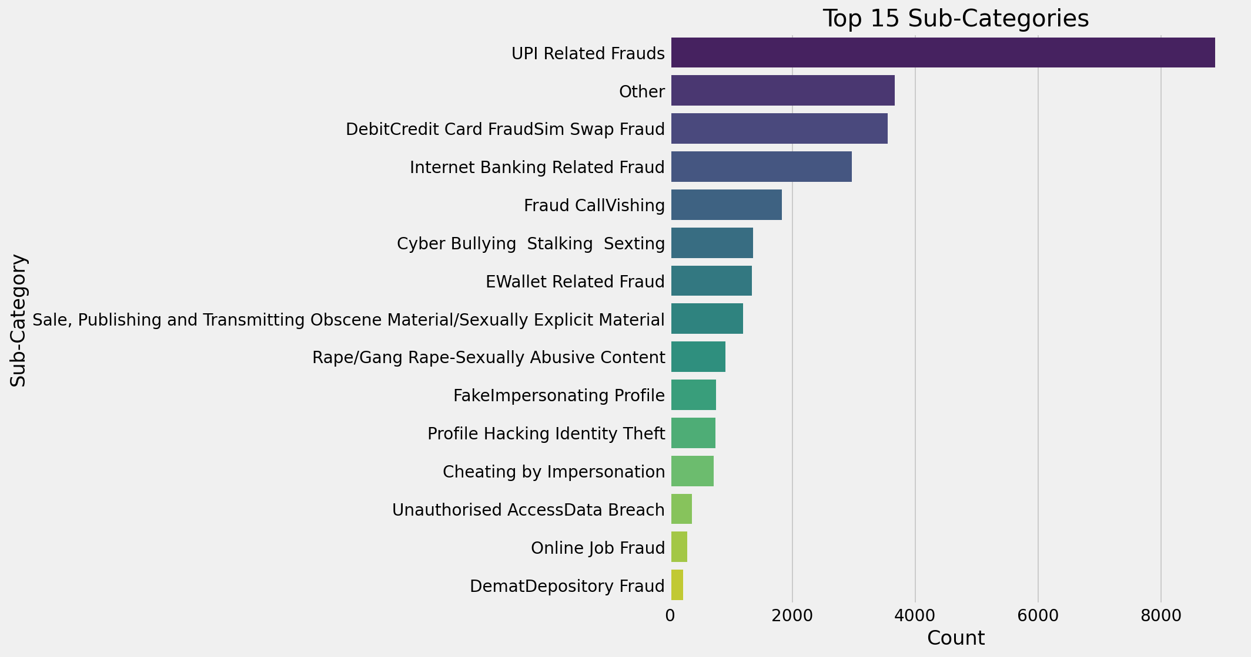
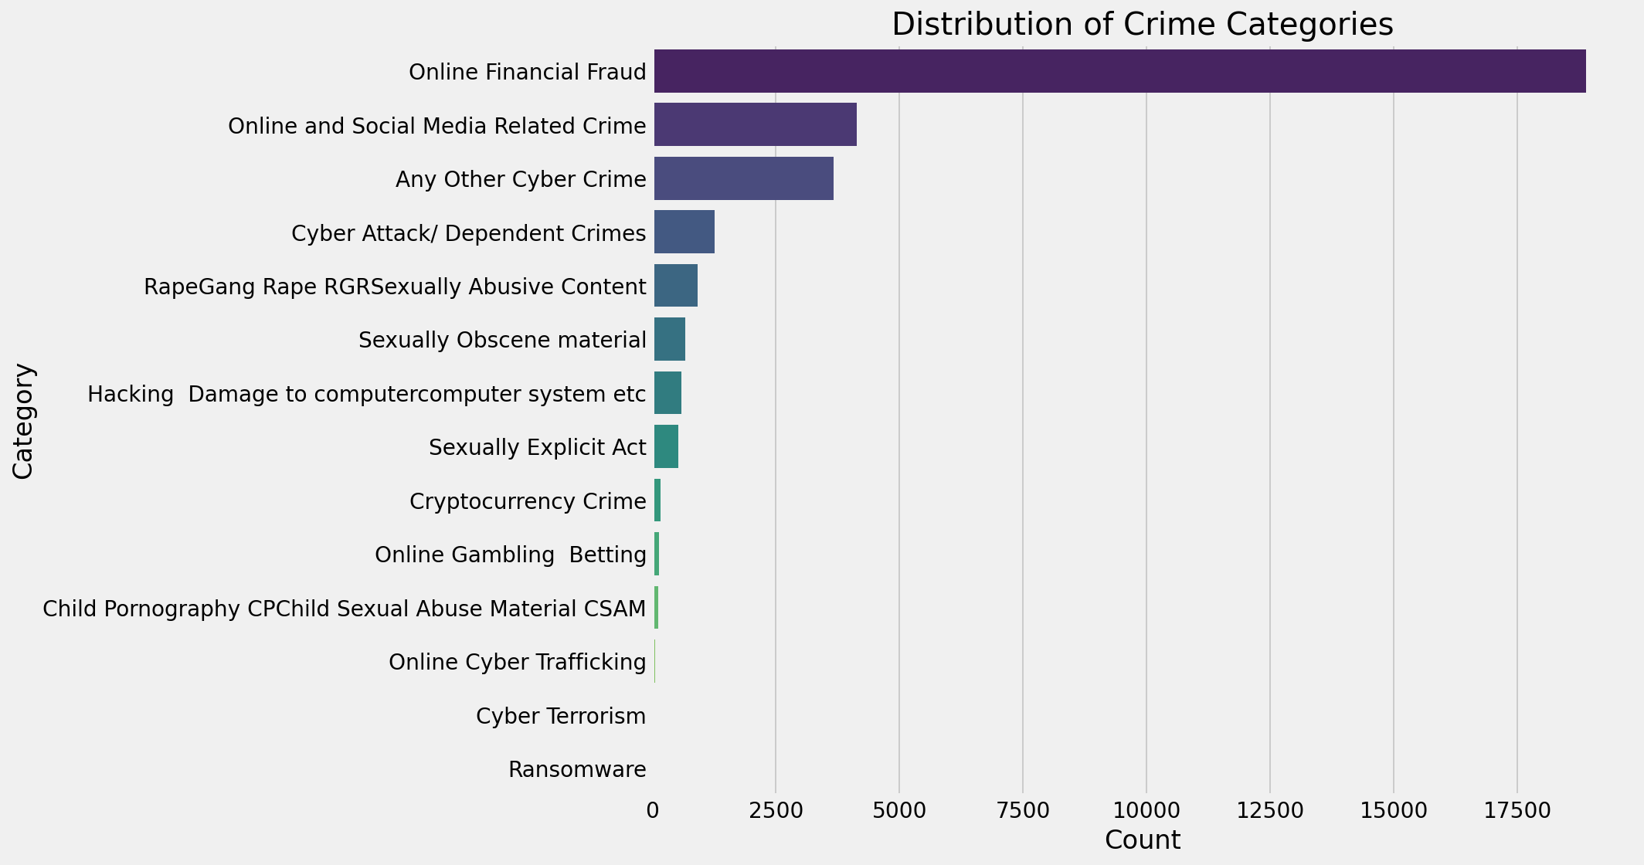

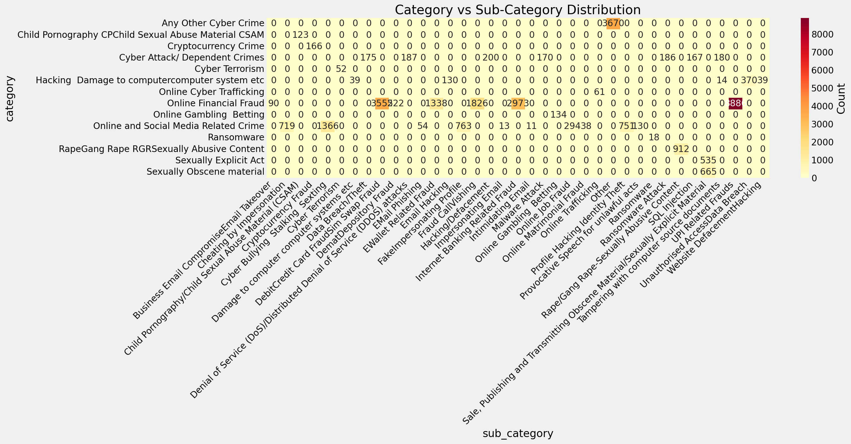

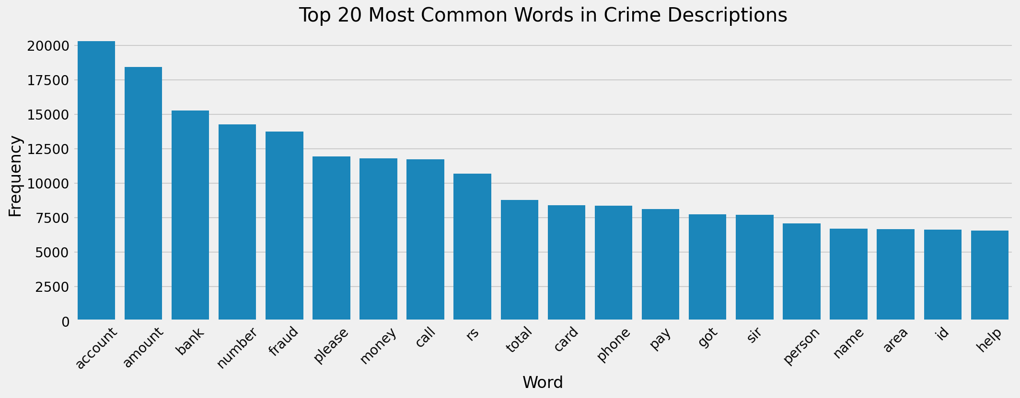

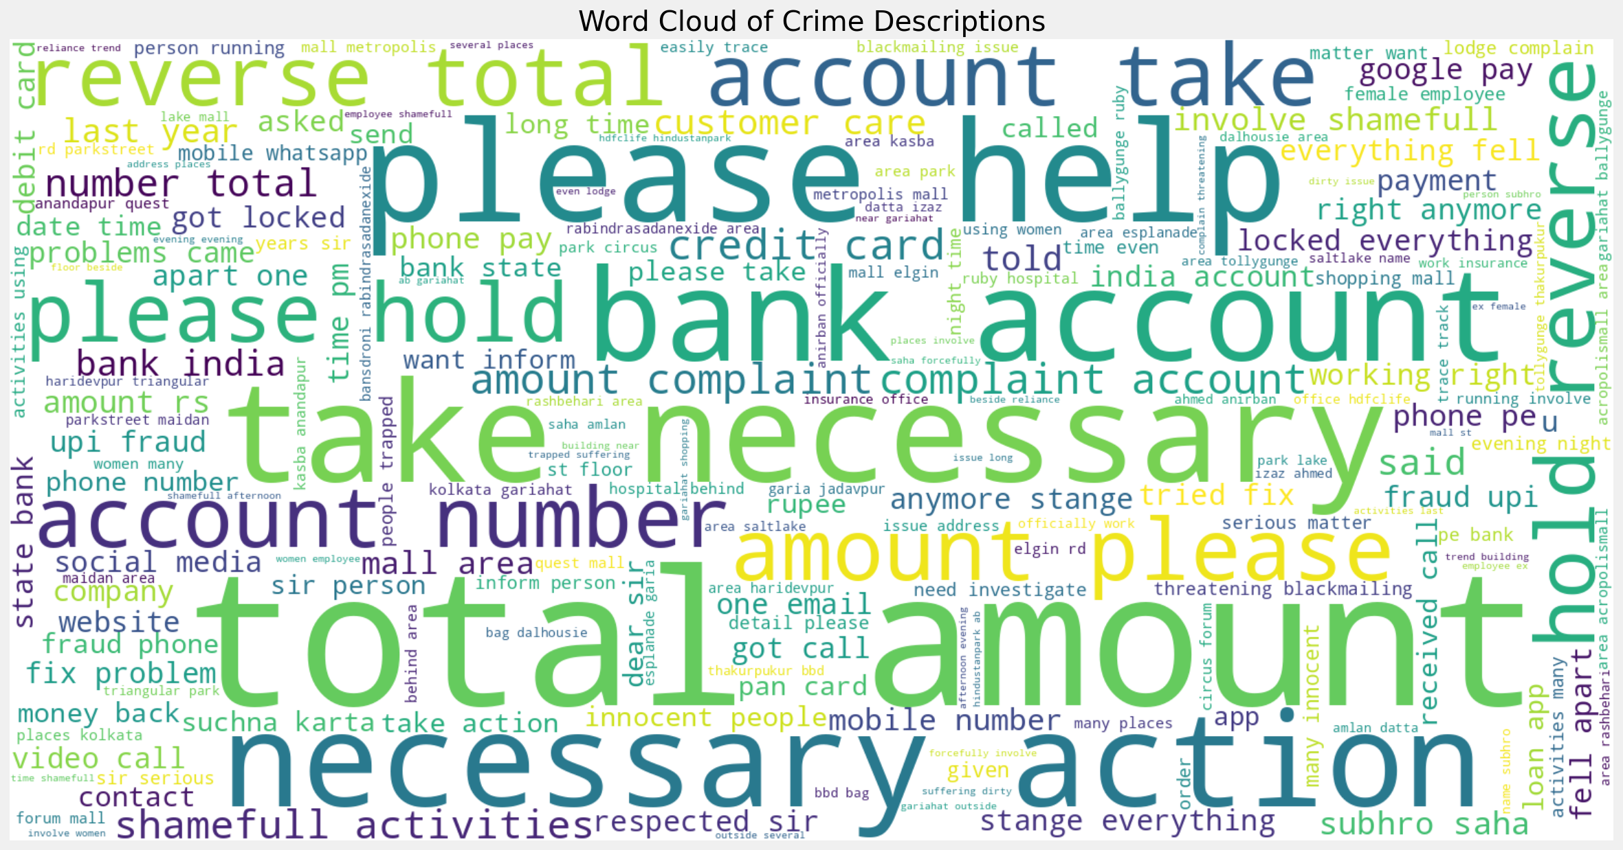

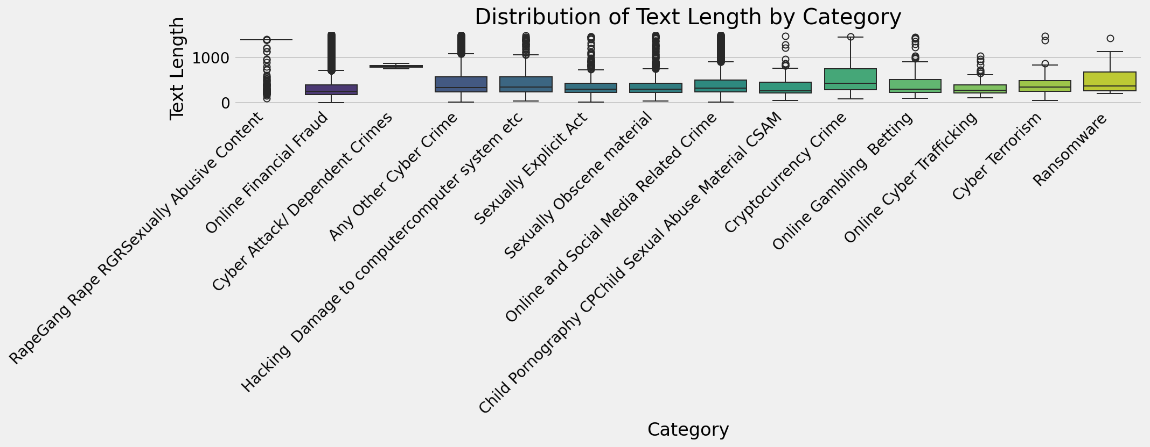

V. Analysis of Length of Text

There is a likelihood of text length affecting the model performance. Thus, I did an analysis of the distribution of text length across categories. Box plots are used to clearly visualize the variation in description lengths. This indicated that certain categories like "RapeGang Rape RGRSexually Abusive Content" tend to have longer and potentially more detailed descriptions as compared to others. It would inform feature engineering that makes features tailored to the characteristics of certain categories.

V. XGBoost Model and Evaluation:

In this experiment, I made use of the XGBoost model, which is a prominent gradient boosting algorithm suited ideally for classification operations. My implementation has taken into account the following important considerations:

TF-IDF Features :

Text descriptions were converted into numeric features through TF-IDF (Term Frequency-Inverse Document Frequency) vectorization. TF-IDF captures the importance of words in a document, relatively to a larger corpus and hence serves as robust representation of textual data for our model.

Class Weighting:

I utilized balanced class weighting during training of the model. That is, it gives higher weights to underrepresented classes. This allows one to penalize misclassifications over an underrepresented class much more severely than the rest and accordingly teach the model towards more well-balanced representations.

Model Parameters:

The XGBoost model was initialized with a set of hyperparameters aimed at balancing model complexity and performance. These parameters included objective, eval_metric, tree_method, learning_rate, max_depth, and others. These parameters govern various aspects of the model's training process, influencing its ability to learn from the data and generalize to unseen examples.

Evaluation Metrics:

The performance of the model was evaluated using a whole set of metrics, including precision, recall, F1-score, and support for each category and subcategory. Because of class imbalance, weighted F1-score was selected as the performance metric that gave a balanced measure for the overall effectiveness of the model. A classification report with detailed metrics across the individual classes was further generated to understand how the model was performing on each class separately.

Category prediction is fairly good, with the weighted F1-score equaling 0.6681, whereas subcategory prediction has a lower score with a weighted F1-score at 0.4926. This may be due to increased complexity and granularity of the subcategory classification task with additional inherent class imbalance.

==================================================
Total training completed at 2024-11-22 22:55:12
Total training time: 166.3 minutes
==================================================

==================================================
Evaluating model performance
==================================================

==================================================
Starting predictions at 2024-11-22 22:55:12
==================================================

Transforming texts to TF-IDF features...
Feature matrix shape: (31222, 5000)

Making category predictions...

Making subcategory predictions...

Predictions completed in 0.1 minutes

Category Classification Report:
precision recall f1-score support

0 0.32 0.45 0.37 3670
1 0.18 0.41 0.25 123
2 0.21 0.84 0.34 166
3 1.00 1.00 1.00 1265
4 0.00 0.00 0.00 52
5 0.20 0.66 0.30 592
6 0.00 0.02 0.00 61
7 0.94 0.69 0.80 18890
8 0.04 0.33 0.06 134
9 0.57 0.34 0.42 4139
10 0.06 0.17 0.09 18
11 1.00 0.91 0.95 912
12 0.13 0.24 0.17 535
13 0.21 0.37 0.27 665

accuracy 0.62 31222
macro avg 0.35 0.46 0.36 31222
weighted avg 0.76 0.62 0.67 31222

Category F1 Score (Weighted): 0.6681

Subcategory Classification Report:
precision recall f1-score support

0 0.05 0.21 0.08 90
1 0.14 0.21 0.17 719
2 0.23 0.40 0.30 123
3 0.29 0.77 0.43 166
4 0.47 0.50 0.48 1366
5 0.00 0.00 0.00 52
6 0.07 0.08 0.07 39
7 0.17 0.19 0.18 175
8 0.67 0.68 0.67 3555
9 0.06 0.21 0.09 222
10 0.15 0.17 0.16 187
11 0.10 0.20 0.13 54
12 0.43 0.49 0.46 1338
13 0.27 0.44 0.33 130
14 0.38 0.45 0.41 763
15 0.24 0.34 0.28 1826
16 0.15 0.12 0.14 200
17 0.00 0.00 0.00 13
18 0.59 0.59 0.59 2973
19 0.00 0.00 0.00 11
20 0.10 0.11 0.10 170
21 0.05 0.20 0.08 134
22 0.20 0.66 0.31 294
23 0.04 0.11 0.06 38
24 0.00 0.00 0.00 61
25 0.47 0.17 0.25 3670
26 0.45 0.42 0.43 751
27 0.05 0.42 0.09 130
28 0.15 0.22 0.18 18
29 0.12 0.11 0.12 186
30 0.99 0.91 0.95 912
31 0.12 0.13 0.12 167
32 0.41 0.28 0.33 1200
33 0.15 0.11 0.13 194
34 0.83 0.56 0.67 8886
35 0.17 0.51 0.26 370
36 0.04 0.05 0.04 39

accuracy 0.47 31222
macro avg 0.24 0.30 0.25 31222
weighted avg 0.56 0.47 0.49 31222

Subcategory F1 Score (Weighted): 0.4926

VI. Implementation Plan (Moving Forward):

Following the results and model evaluation, I propose the following steps for further development and improvement:

Add Augmentation:

To address the imbalance class, I would suggest exploring data augmentation techniques like SMOTE or back-translation. These methods synthetically generate samples for under-represented categories to enhance the model's ability to learn a better representation of the classes.

Advanced Feature Engineering:

Beyond TF-IDF, I would propose exploring more advanced text-embedding techniques, such as Word2Vec or BERT, to capture the semantic relationships among words. Another approach might be to seek data from diverse contexts to gain further contextual information.

Model tuning and exploration - Further hyperparameter fine-tuning of the XGBoost model, using for example, techniques in grid search or Bayesian optimization, is suggested. In addition, exploration of additional architectures of the model, deep learning models are known to perform well when having complex dependencies between data elements.

In-depth Error Analysis: A thorough error analysis is crucial for understanding the specific types of misclassifications the model makes. This analysis can reveal biases, feature limitations, or data quality issues that require attention. Manual inspection of misclassified examples can provide valuable insights.

Deployment and Monitoring:

Once the model reaches satisfactory performance, it is deployed to a production environment for real-time classification. The deployed model needs to be continuously monitored, and new data is fed into it at regular intervals for retraining it to maintain accuracy and update according to changing cybercrime trends.

Libraries Used:
- pandas
- numpy
- matplotlib
- seaborn
- wordcloud
- nltk
- sklearn
- xgboost
- difflib
- re

