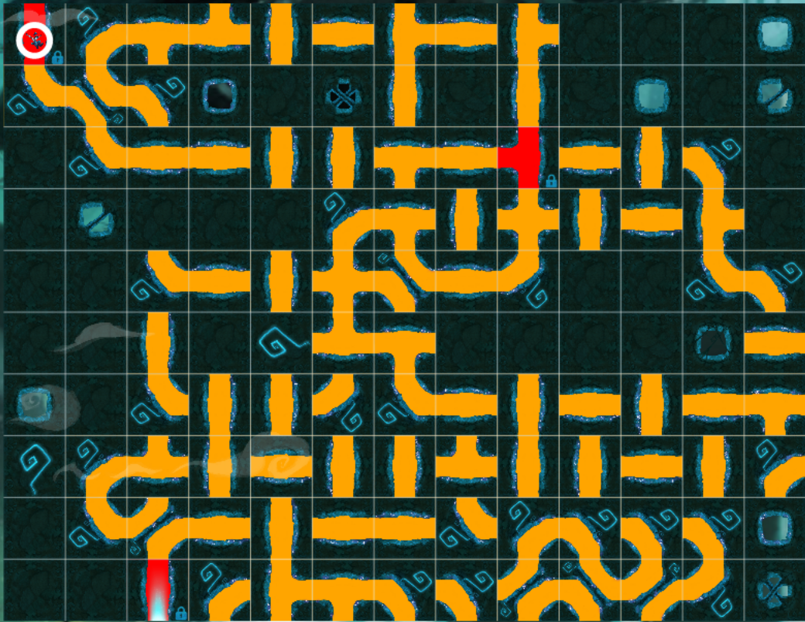
SIZE 13 x 10
-3 12 8 6 3 2 7 2 7 0 0 0 0
11 5 13 0 0 0 3 0 3 0 0 0 0
0 11 2 2 3 3 8 2 -9 2 3 13 0
0 0 0 0 0 12 8 3 1 3 2 7 0
0 0 11 2 3 1 5 2 10 0 0 11 13
0 0 3 0 0 6 8 0 0 0 0 0 2
0 0 11 3 3 10 11 2 3 2 3 2 8
0 12 6 3 2 3 3 6 3 3 2 3 12
0 11 4 2 3 2 2 11 12 13 13 13 0
0 0 -3 12 7 8 13 13 4 5 4 10 0
EXIT=2
Turn: 0,0 / T
1 | 2 | 3 | 4 | 5 | 6 | 7
 |  | 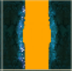 | 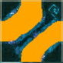 |  | 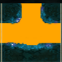 | 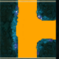
8 | 9 | 10 | 11 | 12 | 13
 | 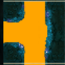 |  |  | 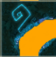 | 

