
Vanthrex for IBM i
Product documentation — every feature, what it does and why it helps

Modern IBM i (AS400, iSeries) development in Visual Studio Code: browse libraries, source members and the IFS; edit, check and compile RPG, CL, SQL and DDS with errors on the right line; query and edit Db2 for i data; understand programs with a call graph; operate the system — without a green screen.
Version 3.2.0
November 2026
Author: Gaurav Gupta
Install: VS Code Marketplace — gauravgupta0612.vanthrex-ibmi
Online documentation: gauravgupta0612.github.io/vanthrex-ibmi-docs
Source code: github.com/gauravgupta0612/silverlake-ibmi
Free and open source under the MIT License. Not affiliated with IBM. IBM i is a trademark of IBM Corp.
Contents

Right-click the table of contents and choose Update Field if the page numbers are not shown.

1. Introduction
Vanthrex puts everything you do on IBM i in one VS Code sidebar: connect, browse, edit, compile, query, monitor and fix — with checks while you type, an AI assistant, Git and a call graph built in.

Why teams use it
- Fewer errors reach production. More than 50 checks run while you type in RPG, CL and SQL — prototypes that no longer match, wrong argument counts, %SUBST or array index out of range, numeric overflow, UPDATE / DELETE without WHERE, undeclared CL variables — most with a one-click fix.
- Faster everyday work. Suggestions while you type (IF %FOUND after CHAIN, an SQLCODE test after embedded SQL, MONMSG after CHKOBJ…), code generated from data structures and tables, fix-all commands and one menu (Ctrl+Alt+A) for every tool.
- Understand any application. Call graph and impact analysis, where used, who calls each exported procedure, flowcharts of procedures, data structure layouts and database diagrams.
- Easier for new developers. A modern editor with outline, go to definition, hovers that explain codes and messages, F4 prompters and guided forms, next to familiar PDM options and SEU-style source dates.
- Safe with production and with AI. Connections marked Production ask before every change; the AI never sees passwords, keys, personal data or host names, production stays limited to metadata, and every AI request is logged.
- No licence cost, and the interface in English, French, Spanish, German, Italian, Portuguese (Brazil), Japanese and Simplified Chinese.

What it replaces
IBM i development usually means switching between several tools:
Task | Traditional way | With Vanthrex
Edit source | SEU / PDM in a 5250 session | VS Code editor with colours, outline, F12 / F2
Compile | WRKMBRPDM option 14, then read the spool file for errors | Ctrl+Alt+C → errors underlined on the right line
Run SQL | STRSQL or a separate SQL client | Ctrl+Enter → sortable grid, CSV export, autocomplete
Look at data | UPDDTA / DFU / a query | Edit Table Data grid
Check the system | WRKACTJOB, WRKSYSSTS, DSPMSG QSYSOPR | System Dashboard, Active Jobs and Messages views
Find code | FNDSTRPDM, DSPPGMREF printouts | Ctrl+Alt+F, Ctrl+Alt+O, Where Used
Undo a mistake | Hope someone kept a backup | Local History on every open and save
See what changed when | SEU date column | Source dates in front of every line, kept on save
Someone else has the member | "Member in use" error, then WRKOBJLCK | Lock banner with the person's name and Ask to release

Vanthrex puts all of this in one place. It is built for people who are new to IBM i (guided forms, templates, plain-language messages) as well as experienced developers who want speed and modern tooling.

Why it is powerful
- Nothing to install on the IBM i. It only needs SSH. Fast SQL ("Mapepire") is uploaded and started automatically, and needs only Java, which IBM i already has.
- Safe by default.
  - It asks before risky SQL (DROP, DELETE without WHERE).
  - It asks before deleting objects or ending jobs, and before writing table data.
  - Passwords go in the VS Code secret store, never in settings files.
- Never lose work. Every member you open or save is copied locally, so you can compare and restore any version.
- Understands RPG. It knows declarations, procedures, /COPY members and fixed-format columns, so navigation, rename and checks work on real code.
- Clear when something goes wrong. Errors appear inline or as clear messages, and every command sent to the IBM i is written to an output log you can read.
- Configurable. Compile commands, checks, page sizes and refresh times are all ordinary VS Code settings.

Who it is for
Developers and teams working with IBM i (AS400, iSeries): RPGLE and free-form RPG, ILE RPG, SQLRPGLE, CL / CLLE, DDS, Db2 for i SQL, the IFS and source physical files — RPG developers, technical leads, IBM i consultants and administrators who want a modern VS Code workflow instead of, or next to, PDM and SEU, and teams working on IBM i modernization.

2. Getting started

Install in one minute
- Install from the VS Code Marketplace, or in a terminal:
code --install-extension gauravgupta0612.vanthrex-ibmi
- Connect: click the Vanthrex icon in the activity bar → Add IBM i Connection… → host, user, password or SSH key → Test connection.
- Work: open a member from Libraries & Source, edit, save with Ctrl+S, compile with Ctrl+Alt+C. Press Ctrl+Alt+A at any time to see every tool that fits the file you are in.
Coming from Code for IBM i? Run Import My Code for IBM i Setup…: your connections, library lists and compile actions are ready in Vanthrex in one step. A team can share its whole setup with Export a Team Setup File….
Offline install: download the .vsix from Releases, then Extensions → … → Install from VSIX…. What the IBM i needs is in Requirements.

Requirements on the IBM i
- SSH server running: STRTCPSVR SERVER(*SSHD). The user profile needs a home directory (e.g. /home/MYUSER).
- SQL, one of these (the Automatic setting tries them in order):
- Mapepire over SSH, which needs nothing installed beyond Java (5770-JV1). Vanthrex uploads the Mapepire server JAR to ~/.mapepire on first use and runs it over your SSH session.
- Mapepire daemon, if you already run one (port 8076).
- db2util (yum install db2util).

Your first five minutes
- Install: Extensions view → … → Install from VSIX… → the .vsix from the GitHub Releases page.
- Click the Vanthrex icon in the activity bar, then Add IBM i Connection.
- Fill in the host, user and library list, click Test connection, then Save.
- Click the connection to connect. The status bar shows the system name. Click it, or press Ctrl+Alt+I, at any time for the quick menu.
On the IBM i, the SSH server must be running: STRTCPSVR SERVER(*SSHD).

3. What you can do
The features grouped by what you want to do. Chapter 5 describes every feature in detail.
You want to… | Vanthrex gives you
Explore the system | Libraries & source, IFS, spooled files, PDM in one screen, object and source search, Go to Anything (Ctrl+Alt+J), System Tracker and dashboard, jobs, messages and a 5250 session in one click.
Write RPG, CL and SQL | Free and fixed format, outline, go to definition into /COPY members, rename, F4 prompters, column hints, fixed → free conversion, snippets, suggestions while typing, Surround With, IF → SELECT, toggle value and the Developer Toolbox.
Compile and fix | Ctrl+Alt+C with the right command for the source type, errors inline and in Problems, compile history, objects out of date with their source, local Git folders deployed to the IFS.
Check quality | Code checks with quick fixes, team coding standards (or your rpglint.json), a code health report of a whole library, metrics with grades, unused code and copybooks, binder source and prototype copybooks from the exports.
Work with Db2 for i | SQL with autocomplete, results grid, Explain and index advisor, table data editor, generate DDL, compare data between systems, export to Excel / CSV / JSON.
Understand dependencies | Call graph (programs, service programs, files), where used, callers of each exported procedure, signature checks, CRUD matrix and database diagrams.
Run and debug | Run CL with your library list, call a program with its real parameter types, step-through debugging of RPG, COBOL and CL.
Operate the system | Work with subsystems, job queues, output queues, user profiles, system values, journals, authorities, storage and live alerts.
Use AI safely | @vanthrex in the chat: explain, document, review, modernize, write tests, fix compile errors, write SQL against your real tables — with your data protected.

New in 3.2: visual insights. Library and IFS Space Maps, an Active Jobs Map (the job waiting for a reply shows in red), a Batch Job Timeline, a Journal Activity Heat Map, an Index Advice Chart with the CREATE INDEX for each and a Source Change Calendar. In 3.1: DDS checks while you type, Format Document for CL, RPG semantic highlighting and links that open a member at a line. See what is new in 3.2, in 3.1 and the changelog.

Features by area and version
Every feature with why and how is in the Feature Guide and the documentation.
Area | What you get
AI assistant (new in 0.6) | @vanthrex in the VS Code chat: /explain, /document, /review, /modernize, /test (RPGUnit), /fix compile errors, /sql against your real tables, /object. It looks things up on the connected system (read-only, with confirmation) and its tools also work in Copilot agent mode.
Call graph & impact | Interactive diagram of callers and callees (programs, service programs, files with their usage), several levels deep, with Copy as Mermaid. New in 0.7: Find dynamic calls shows calls whose program name is in a variable.
Who calls each exported procedure? (new in 0.7) | For a service program: every program, source line and statement that calls each exported procedure — prototypes and /COPY members included — and the exports nobody calls.
Several systems at once (new in 0.6) | Stay connected to DEV, TEST and PROD and switch instantly; files always save to the system they came from.
SQL Explain (new in 0.6) | Table scans, indexes used, temporary indexes, sorts and advised indexes for a query, with CREATE INDEX suggestions.
Connect | Guided form with Test connection, SSH password or key, passwords in the VS Code secret store, status-bar quick menu (Ctrl+Alt+I), optional auto-reconnect.
Browse | Libraries & Source (source files, members, objects), IFS Browser, My Spooled Files. Find a member by pattern across your library list.
Edit | Members and IFS files open like local files; Ctrl+S saves to the IBM i. New RPG and CL members start from a template that compiles as-is.
Compile | Ctrl+Alt+C. The command is chosen from the source type, you pick once when several fit, and errors from EVFEVENT appear inline and in Problems.
SQL | Run SQL Query… (right-click a library, file, member or object, or in the call graph) opens an SQL editor with ready-made queries and the results underneath. Ctrl+Enter runs the statement under the cursor. Results grid with sort, filter, copy and CSV export. Confirmation before destructive statements. ibmi-… snippets for IBM i Services.
CL | Ctrl+Alt+L runs a CL command with your library list and keeps a history.
Spool | Open, save or delete your spooled files.
RPG | Highlighting for free and fixed format, outline and breadcrumbs, hovers for BIFs and opcodes, column hints on fixed-format specs, % completion, snippets, and fixed → free conversion of H, F, D, P and C specs.
CL / DDS | Syntax highlighting and snippets.
System dashboard (new) | CPU, system ASP, jobs, memory, top CPU jobs, latest QSYSOPR messages and PTF group levels, refreshing automatically.
Jobs & messages (new) | Active Jobs view (yours, a user, a subsystem or all): job log, hold, release, end. Messages view for QSYSOPR and your own queue: messages waiting for an answer come first and you reply in two clicks.
Table data editor (new) | Open any physical file or table in a grid: filter with a WHERE clause, page through rows, edit cells, add and delete rows. Values are checked against the column type before anything is written.
Object & source search (new) | Ctrl+Alt+O finds objects by name or text across your library list or all user libraries. Ctrl+Alt+F searches the source code of members. Where used lists the programs that reference a file or program. Open program source jumps from a *PGM to the member it was compiled from.
RPG navigation (new) | Go to definition (F12, also into /COPY members), find all references, rename (F2, scoped to the procedure), highlight occurrences, Ctrl+click on /COPY and /INCLUDE, and hover a name to see its declaration.
SQL autocomplete (new) | Table and view names after FROM/JOIN/INTO/UPDATE, columns after alias., columns of the tables in your statement, and hover for column types and descriptions.
Local history & compare (new) | Every member and IFS file you open or save is kept locally. Compare any version, restore it, compare your editor with the copy on the IBM i, or compare two members side by side.
SEU-style source dates (new in 0.3) | Each line shows its last-changed date (and sequence number), dates of untouched lines are kept on save, and you can highlight lines changed since any date.
F4 prompters (new in 0.3) | F4 on a fixed-format RPG or DDS line opens a labelled form for its columns. F4 on a CL command builds a form from the command's real definition.
Locks & conflicts (new in 0.3) | Shows who has a member open (name, job, lock) right in the editor, lets you ask them to release it or get notified when it's free, and warns before you overwrite changes made by someone else.
RPG code checks (new) | As you type: unused variables, GOTO, missing INLR/RETURN, empty ON-ERROR, SELECT , numbered indicators, overly long procedures and fixed/free mixing. Each check can be turned off, with quick fixes where possible.
Object tools (new in 0.4) | Object information page (owner, dates, last used, size, source, journaling), who has an object locked, compare two libraries (DEV vs PROD) with side-by-side member diffs, modules & exports of service programs.
SQL power tools (new in 0.4) | Generate SQL (DDL) for tables, views, indexes and routines; run a whole SQL script with per-statement results (Ctrl+Shift+Enter); SQL history and saved queries.
Procedure tools (new in 0.4) | Generate a prototype from a procedure, extract lines to a new procedure safely, and find unused /COPY members.
Debugger (new in 0.5) | Step-through debugging of RPG, COBOL and CL with breakpoints, variables and call stack (Ctrl+Alt+G), through IBM's IBM i Debug client and Debug Service, with a setup check that fixes the setup for you.
Insights (new in 0.8) | Index advisor with one-click index creation, table data compare between DEV and PROD by key, message help on hover for any CPF/MCH/RNQ/SQL ID, and a job log analyzer that points at the root cause.
System tools (new in 0.9) | Journal explorer (who changed which rows, from which program), authority checker that explains why a user can't use an object and offers the fix, data queue & data area viewer/editor, and a PTF & system health report compared with IBM's latest PTF levels.
Your language (new in 0.10) | The whole interface in English, French, Spanish, German, Italian, Portuguese (Brazil), Japanese and Simplified Chinese — it follows the VS Code display language.
Work with… (new in 0.11) | The 5250 WRK screens in VS Code: subsystems, job queues, output queues, job scheduler, user profiles, system values, security audit journal, save files (save / restore / download / upload), TCP/IP connections and servers.
Operations (new in 1.0) | Storage & cleanup advisor, live alerts (MSGW, QSYSOPR inquiries, abnormal job ends, disk), message file editor, field finder, and object promotion DEV → TEST → PROD with backup, compare, log and undo.
Data, performance & quality (new in 1.1) | Export to Excel / CSV / JSON and import CSV or Excel with a preview, a live performance monitor, code metrics with grades, Markdown documentation from source, and RPGUnit tests in VS Code's Testing view.
Safe on production (new in 1.2) | Mark a connection Production (every change asks first) or Read-only, a self-check of the system with fixes, and errors that explain what to do.
See and share (new in 1.3) | 5250 screen preview for display files, database diagrams with inferred relationships, compare two systems (member, objects, table rows, system values, PTFs), and spooled files to PDF / e-mail.
2.0: 20 new helpers | RPG code from a table, SQL formatter, find & replace across members, compile changed members, print preview, copy members / objects, test data, duplicates, table statistics, SQL INSERT export, submit & watch, recent jobs, spool compare, tail -f for IFS files, IFS search, library list sets and a CL command finder.
Security Admin (2.1, for SECADM users)* | Create, copy, change, reset, disable and delete user profiles, unused and powerful profiles, group profiles and authorization lists — shown only to users with *SECADM; passwords are always masked.
What did my source become? (2.2) | Objects built from a member (with out-of-date check), a status bar that warns when your program is older than the source or someone else has the member open, compile on save, and Find Member across all libraries.
Call, sign-on, notes (2.3) | Call a program with its real parameter types (no more packed(15,5) surprises), see who is signed on and message or end sessions, and keep notes on source lines — alone or shared with your team.
Layout, includes, signatures (2.3) | See every data structure subfield's positions and length, read a source with all /COPY members merged in, find programs that would fail with a signature violation and re-bind them, and list the jobs that ended abnormally.
AI-powered development (2.3) | @vanthrex explains compile errors with IBM's help, documents RPG with the program's real dependencies, suggests unit tests, explains program dependencies, and recommends fixes from the actual job log and the failing source statement.
Green screen (2.3) | Open a real 5250 session in one click, a 5250-style command line that shows every message and printed output and opens the right screen for WRKACTJOB, WRKOBJLCK, DSPMSG…, and Work with Active Jobs with the usual option numbers and function keys.
Local development, notebooks & editor (2.4) | Deploy a local Git folder to the IFS, compile local files with errors on the local lines, build with makei / gmake, a PASE terminal, IBM i notebooks with SQL / CL / shell cells and charts, the SQL error log, a schema browser, a stored procedure caller, folding / parameter hints / formatting for RPG, CL outline and navigation, folder upload / download (drag and drop) for the IFS, CL command help and keyword completion, quick fixes for compile errors, .cmd source checks with an F4 preview, RTVCLSRC, Run / Explain / RPG links in SQL files, RPG generated from a query or a JSON sample, find a value in table data, rows as INSERT scripts, compare a folder with the IFS, IFS archives, copy and move, and Work with Job Descriptions.
AI with your data protected (2.5) | Secrets, personal data and host names replaced by placeholders before anything reaches the AI (and put back only on your computer), sensitive columns masked, production limited to metadata, denied libraries, an audit trail; plus AI code edits shown as a diff, ✨ links above procedures, and /tune, /sqlio, /changes, /cl, /data, /health, /security, /spool.
Several systems, projects & reports (2.5) | Run SQL or CL on several systems at once, create an IBM i Project (Bob) for a local folder, document a library in Markdown, the CRUD matrix, an RPG program generated from a display file, problem characters fixed, TODO notes, reports to CSV, job run history and finding a message in job logs.
Database care & SQL generators (2.5) | Unused indexes (with the DROP), physical files not journaled (with STRJRNPF), programs that would get a level check, library snapshots compared before and after a release, CREATE TABLE from a CSV or Excel file, JSON_TABLE from a JSON sample, text search across spooled files, triggers enabled or disabled, and comment blocks that fold.
Modernize, data quality & audits (2.5) | A clickable flowchart of any procedure, matching IF / ELSE / END highlighted, SQL procedures over RPG and CL programs, DDS to SQL DDL, CRUD statements for a table, Expand SELECT *, Extract to constant, change-log entries, SQLCODE / SQLSTATE / RPG status explained on hover, packed / EBCDIC / date converters, data profiles, orphan rows, columns close to overflow, unused objects, SQL timing, adopted-authority audit, the job schedule by day, objects hidden in the library list and NetServer shares.
Speed (2.5) | Members that did not change open instantly from a local cache, sources indexed in a few round trips and searched as you type in milliseconds, Go to Anything (Ctrl+Alt+J) over members, objects and recent items, a warm-up right after connecting, batch compile and rebuilds in parallel, Go to Definition into other members and service programs, clickable IBM i references everywhere and a speed test with advice.
Flexible workflow (2.5) | Copy, CSV and Excel on every report table, file and field help in RPG from Db2 (hover, completion, Ctrl+click to the DDS), SQL watches in the status bar with alerts, CL macros with variables, bookmarks on member lines, saved sets of open sources, and Run Selection as CL or SQL (Ctrl+Alt+R).
Visual insights (3.2) | Library Space Map (every object as a tile sized by its disk space, coloured by kind or by last use), Active Jobs Map (every active job in its subsystem, red when it waits for a reply), Batch Job Timeline (a night of batch jobs on a time axis), Journal Activity Heat Map (which tables changed, hour by hour), Index Advice Chart (the indexes Db2 asked for, with the CREATE INDEX), IFS Space Map and Source Change Calendar (a year of member changes as a heat map).
More power in the editor (3.1) | DDS checks while you type (PF, LF, DSPF, PRTF), Format Document for CL, RPG semantic highlighting, DCL-PROC / END-PROC names edited together, END lines indented as you type, links that open a member at a line, and clickable members, message IDs and IFS paths in every terminal.
Everything in Vanthrex (3.0) | AS/400 GO menus (MAIN, PROGRAMMER, RPG…) and an AS/400 Menus view with favorites, about 30 more green-screen commands, import of your Code for IBM i connections, library lists and actions, team setup files, 17 team coding standards (or your rpglint.json) and a code health report of a whole library.
Developer Toolbox (2.6) | Ctrl+Alt+A opens the tools that fit the file and the selection: RPG rewrites, SQL from a data structure, COUNT before UPDATE / DELETE, fix-all commands, compile command, CL error handler, Markdown copy and more.
Daily RPG development (2.6) | Suggestions while you type (Tab accepts: IF %FOUND after CHAIN, SQLCODE tests, OPEN / FETCH, MONMSG after CL commands, variable types, call parameters; AI optional), 44 new code checks with quick fixes, in RPG, CL and SQL (UPDATE / DELETE without WHERE, undeclared CL variables, %SUBST or array index out of range, numeric overflow, undeclared SQL host variables, prototype not matching its interface, wrong argument count, CONST parameter changed, endless loops, CHAIN without %FOUND, unchecked SQL, cursors not closed, unreachable code…), close blocks and auto END, Surround With, IF→SELECT, comment toggle, keyword case, sorted and aligned declarations, wrap at column 80, embedded SQL formatting, parameter-name hints, call hierarchy, next / previous procedure, local completion, binder source and prototype copybook from the exports, headers for every procedure and 16 new snippets.
Stable connections (2.3) | Reconnects by itself when the network drops, shows when the system answers slowly, never loses a save made while offline, reopens your editors, and copies members or IFS files to another connected system.
Create & check (2.3) | Create a library (with source files and library list) or an IFS folder/file from anywhere; source quality report with grades; library list from a job description; *PUBLIC authority scan with fix; compare system values between two systems.
System Tracker (2.2) | One button for the whole system: what needs attention, every library with sizes, jobs, storage, QSYSOPR, users, PTFs and your own work — with actions on every row.
History, live job log, pins (2.2) | Compile history with one-click recompile of broken sources, your changes since the last compile, a live job log that alerts on escape messages, and a Pinned view for what you use every day.
PDM in one screen (2.2) | WRKLIBPDM, WRKOBJPDM and WRKMBRPDM in one view: PDM option numbers on many rows, F-keys (F5, F6, F12, F13 repeat, F16 user options, F17 subset), position to, sort, CSV export, and WRKMBRPDM typed in Run CL opens it.
More in 2.1 | Objects out of sync with their source, release notes of what changed, member templates, binder source and binding directories, row locks, running SQL with cancel, exit points, bulk owner / authority changes, installed software & license keys, PTF lookup, journals, IFS permissions, table structure compare, unused code, hard-coded library scan, any message queue, what a job is doing, QHST history log, file dependents, indicator usage, IFS CCSID, ping and web API calls from the IBM i.

4. Screenshots
Vanthrex in VS Code, with sample sources.
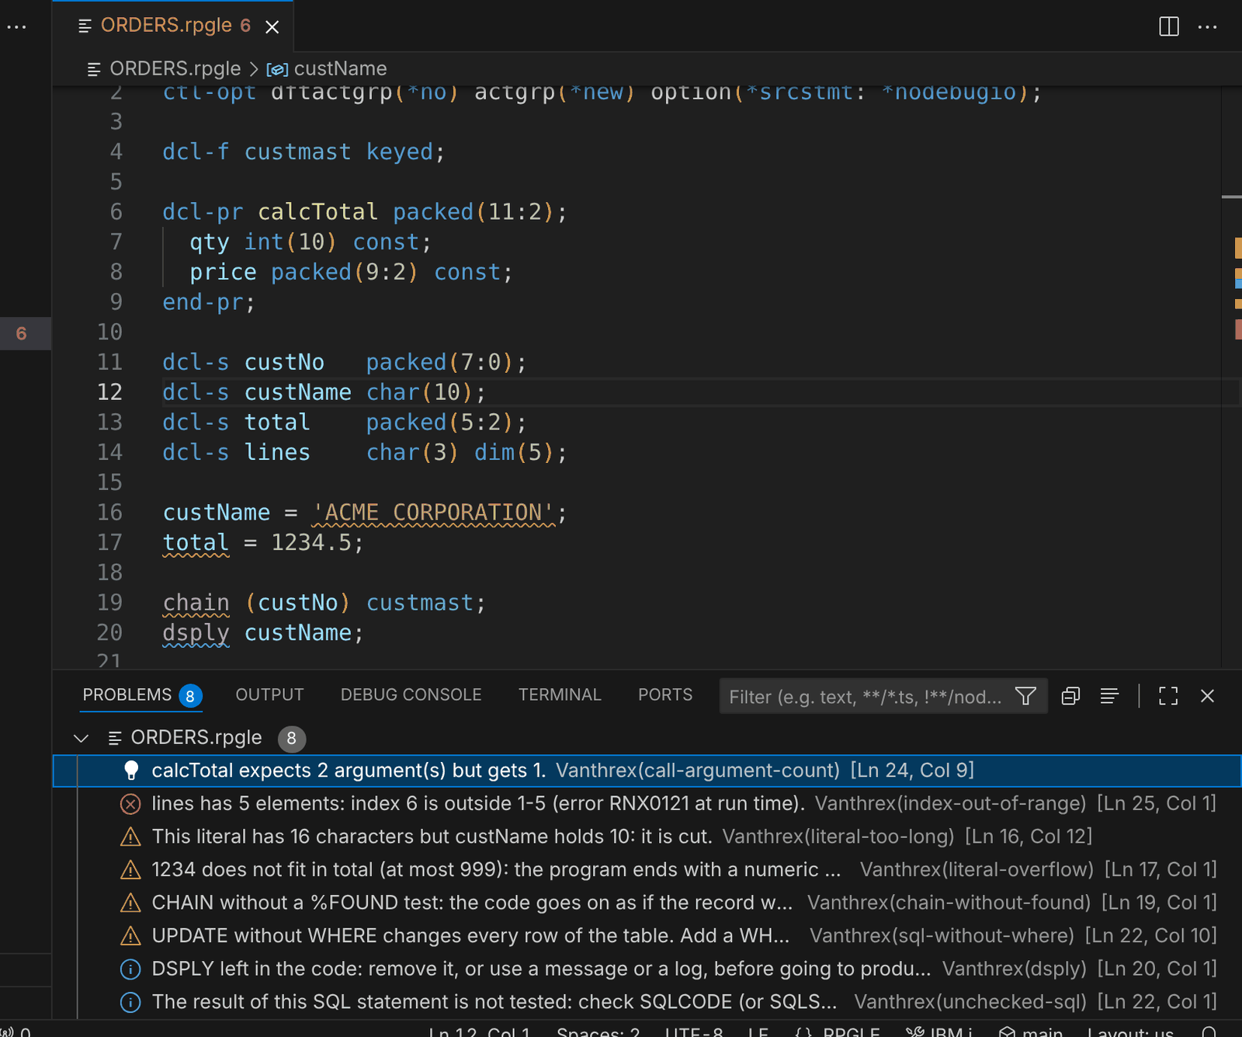
Checks while you type: RPG findings in the Problems view, each with its rule name.
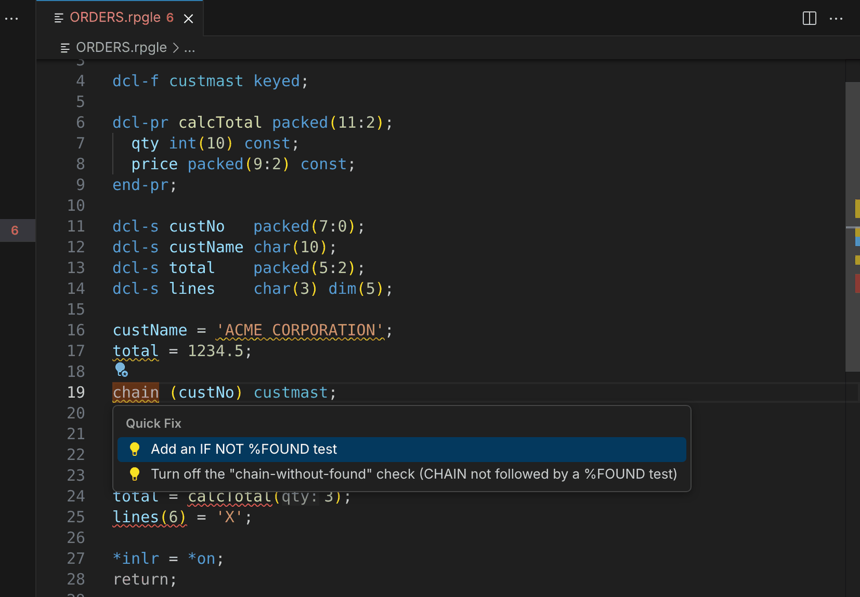
Quick fix (Ctrl+.): an IF NOT %FOUND test written after CHAIN.
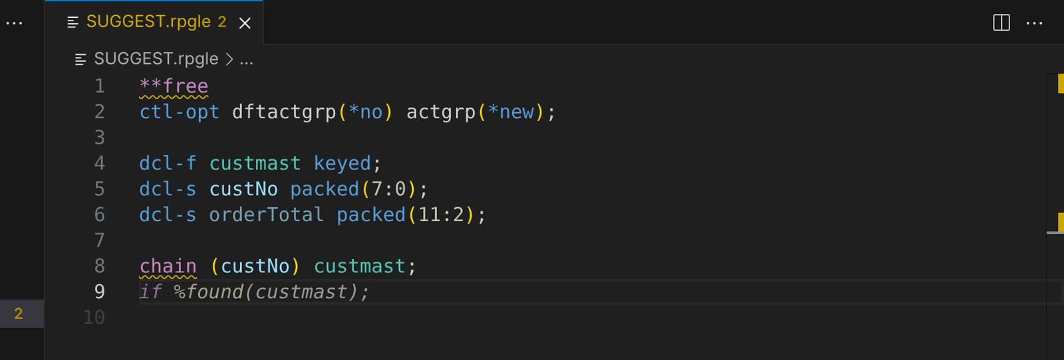
Suggestions while you type: the next line in grey, accepted with Tab.
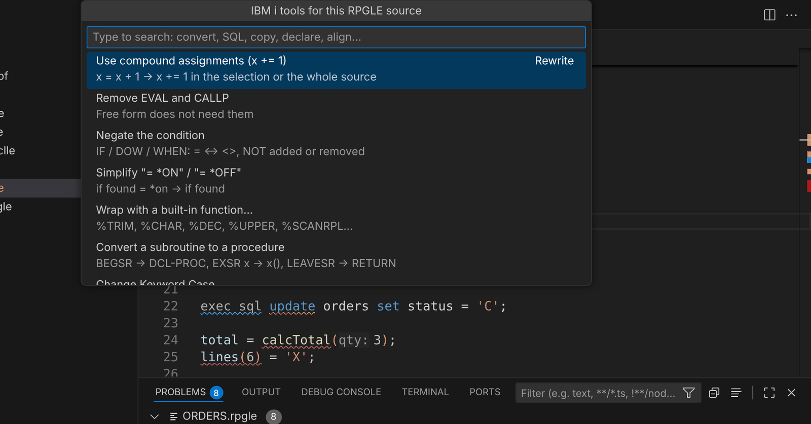
Developer Toolbox (Ctrl+Alt+A): every tool that fits the source you are in.
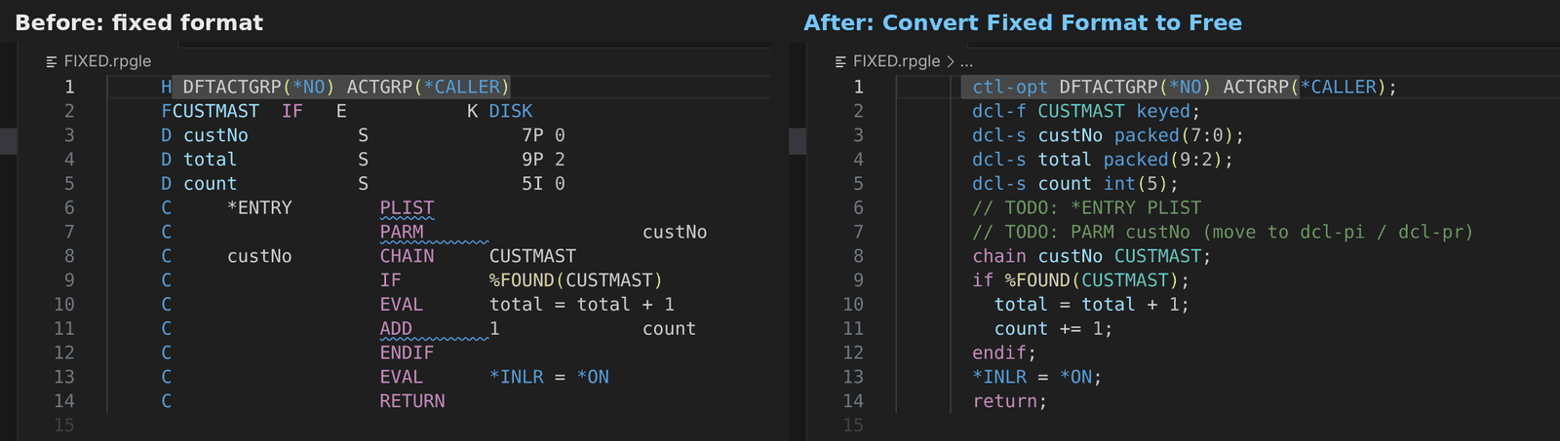
Fixed format converted to free in one command.
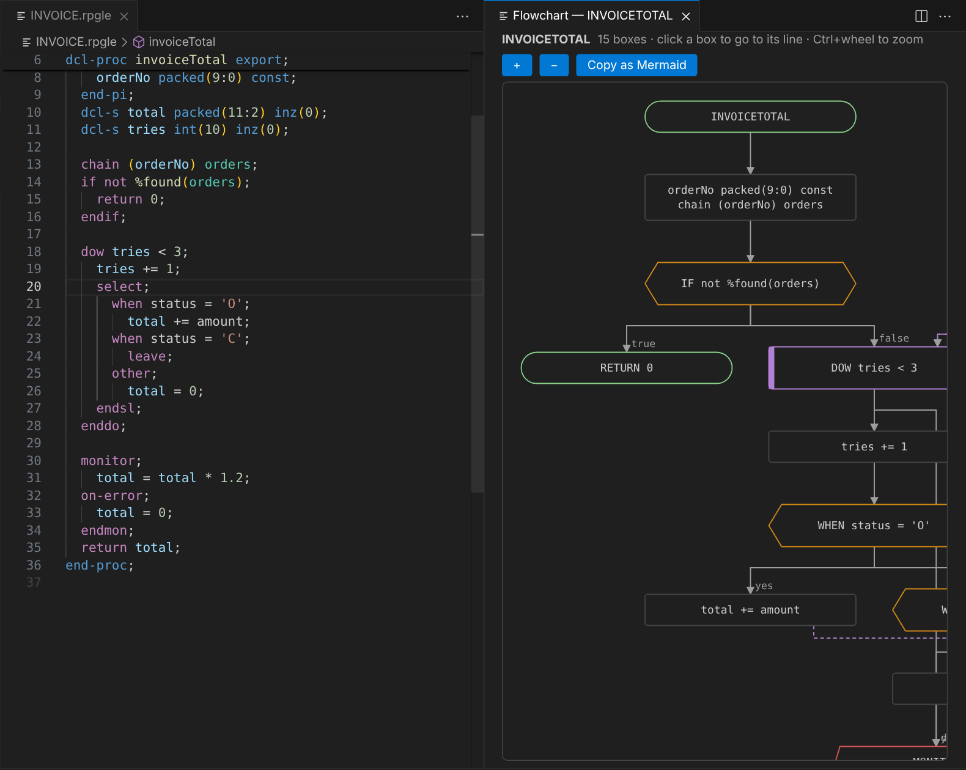
Flowchart of a procedure: click a box to go to its line, or copy it as Mermaid.
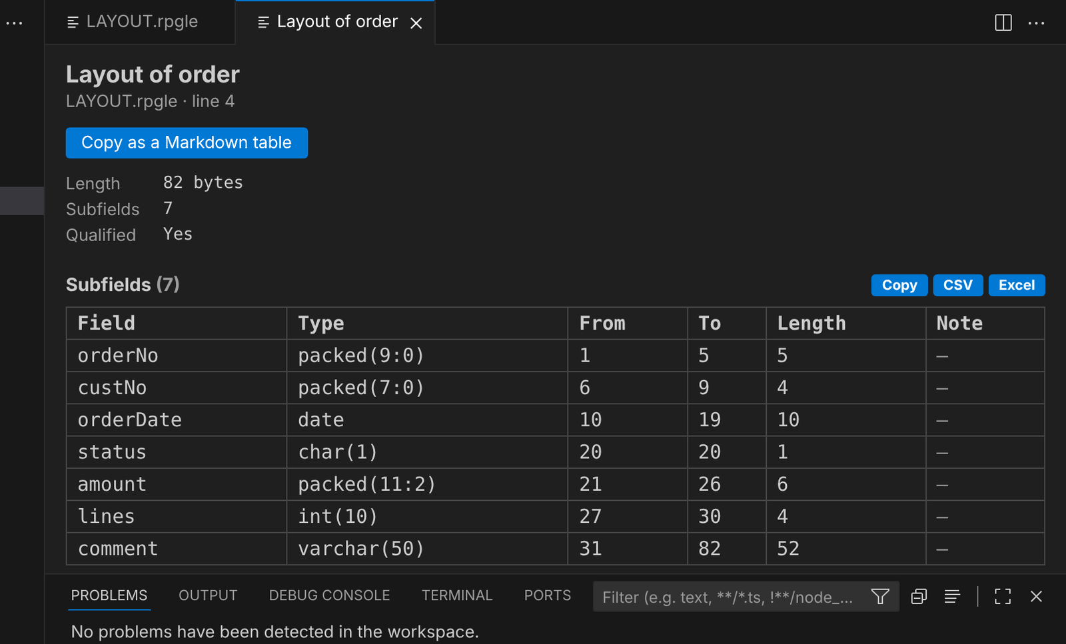
Data structure layout: positions and lengths, like the compile listing.
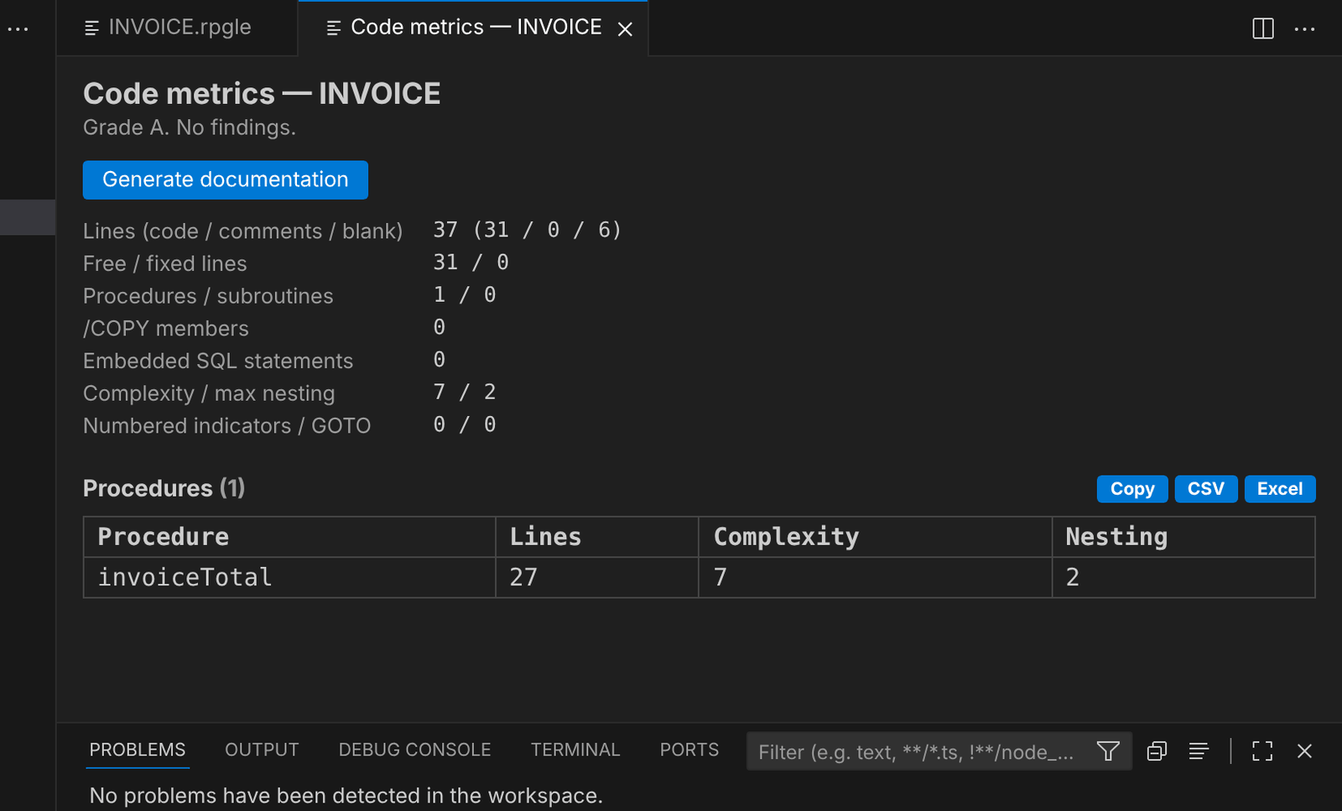
Code metrics of a source, with a grade.
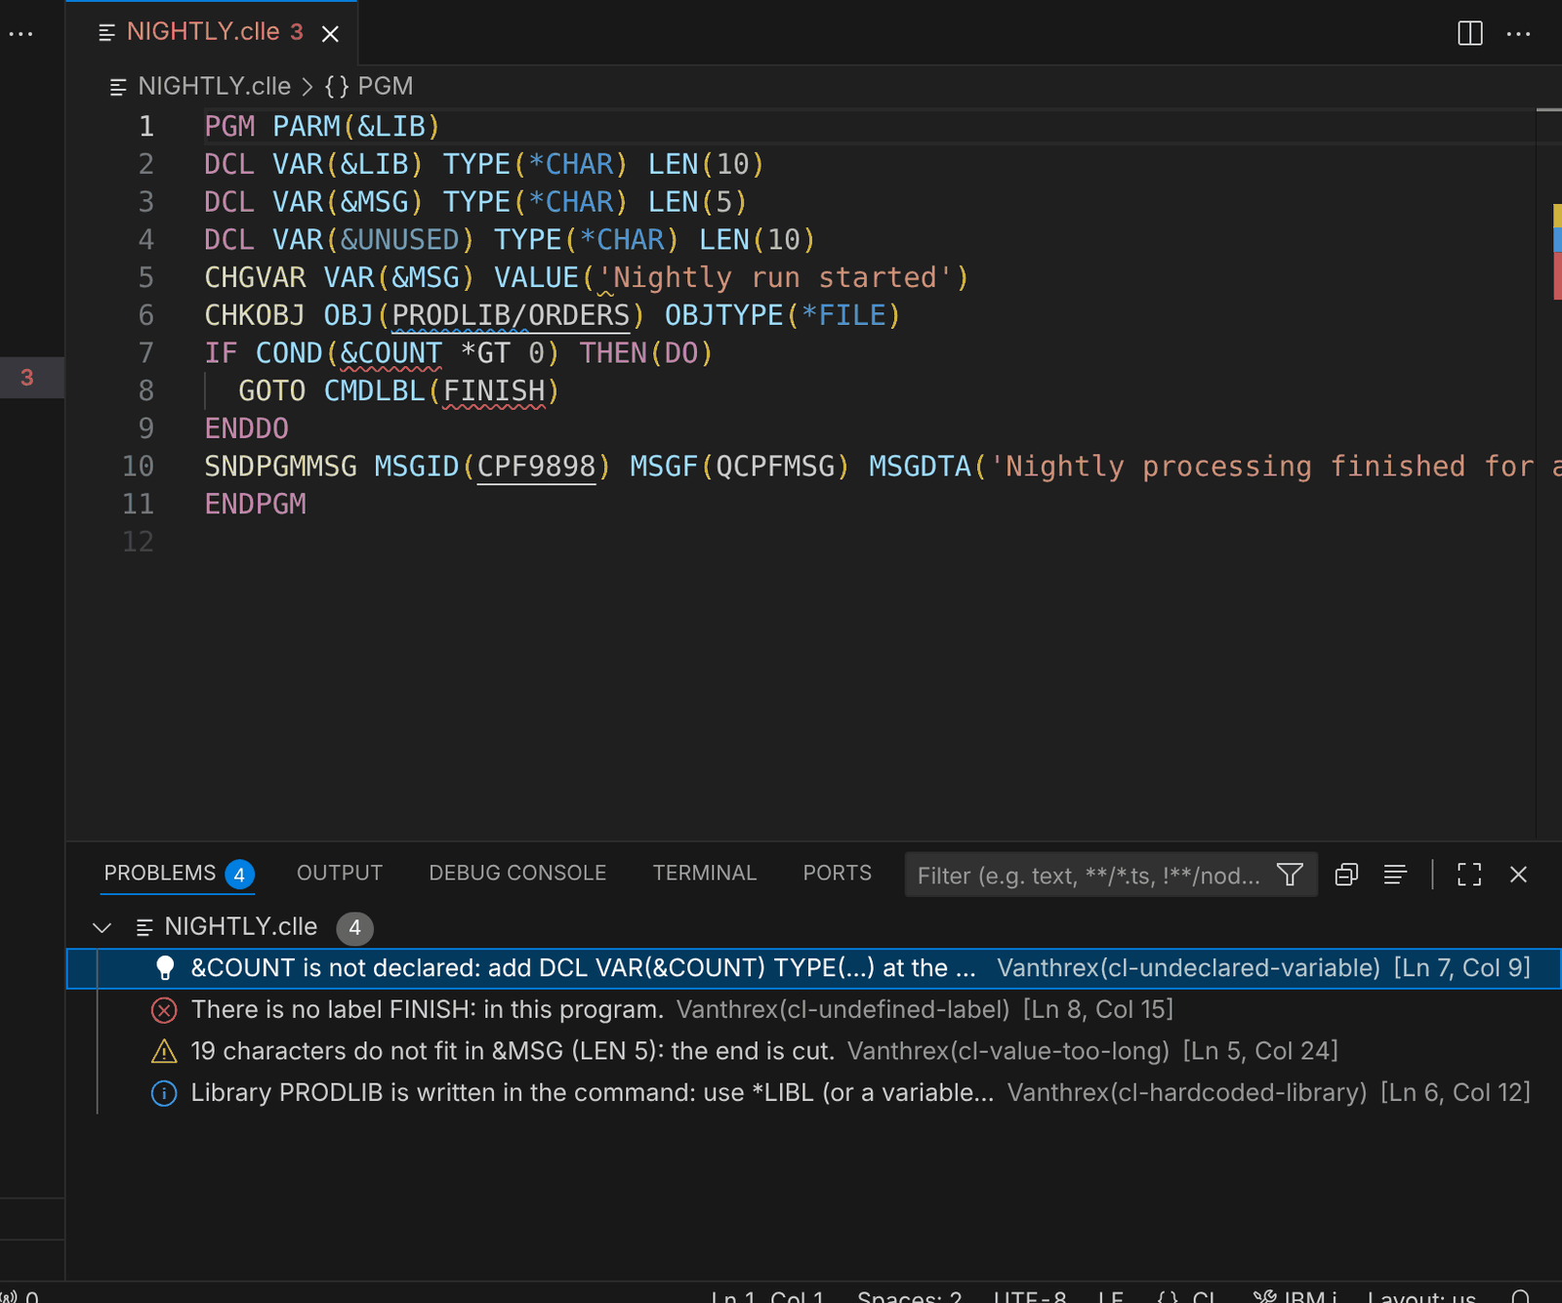
CL checks: undeclared variables, missing labels, values too long, hard-coded libraries.
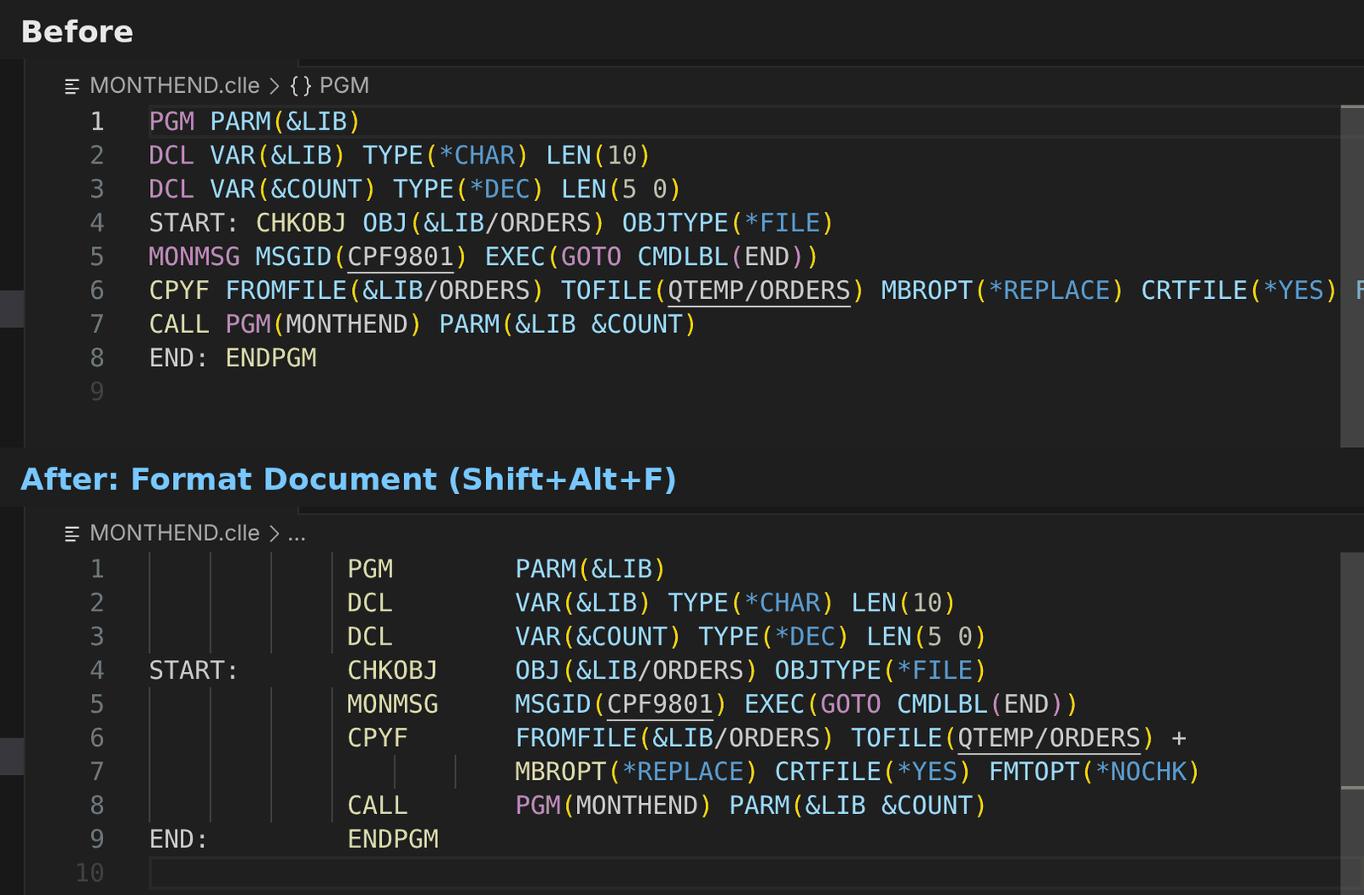
Format Document for CL: the prompter layout.
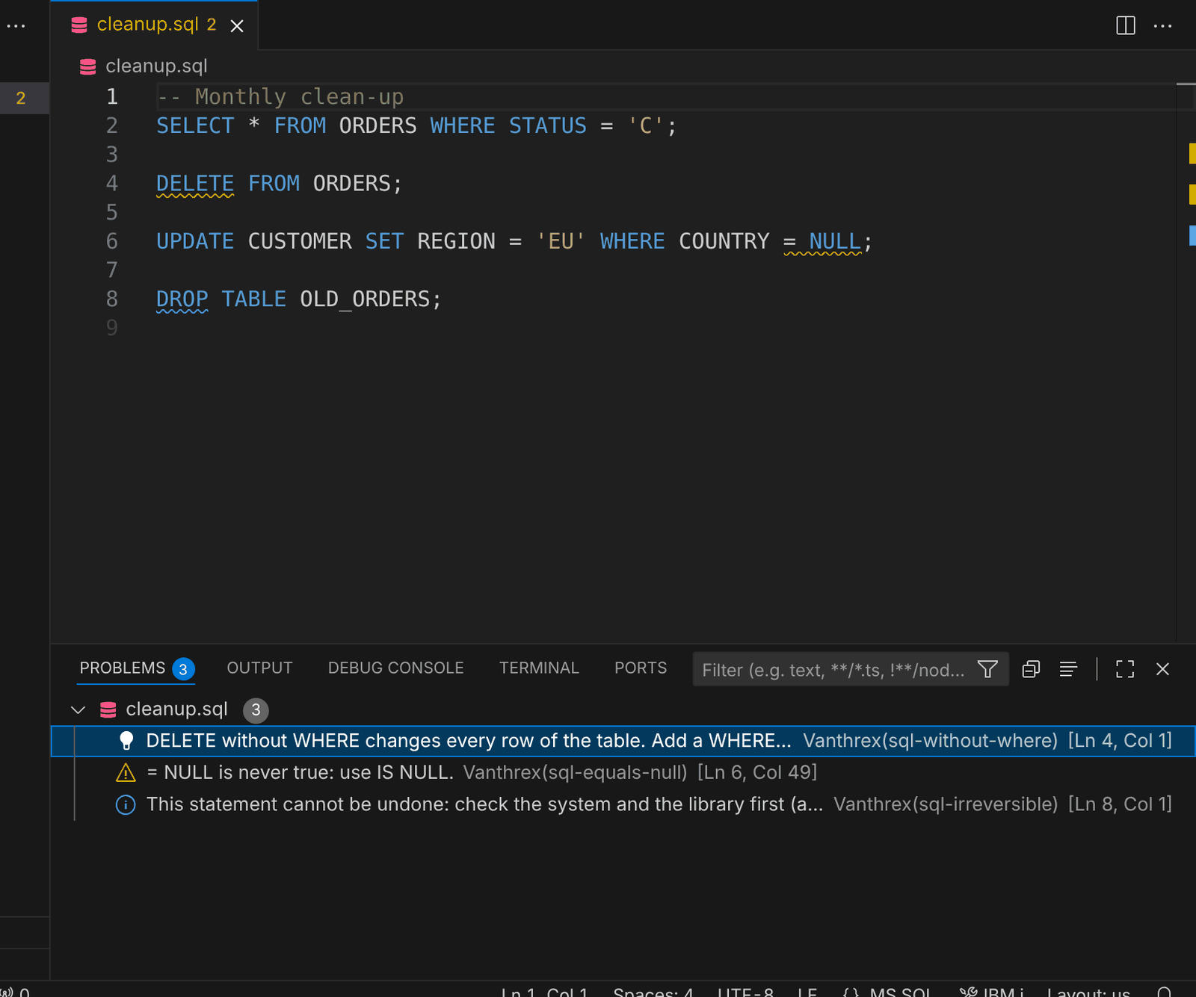
SQL checks before a script runs.
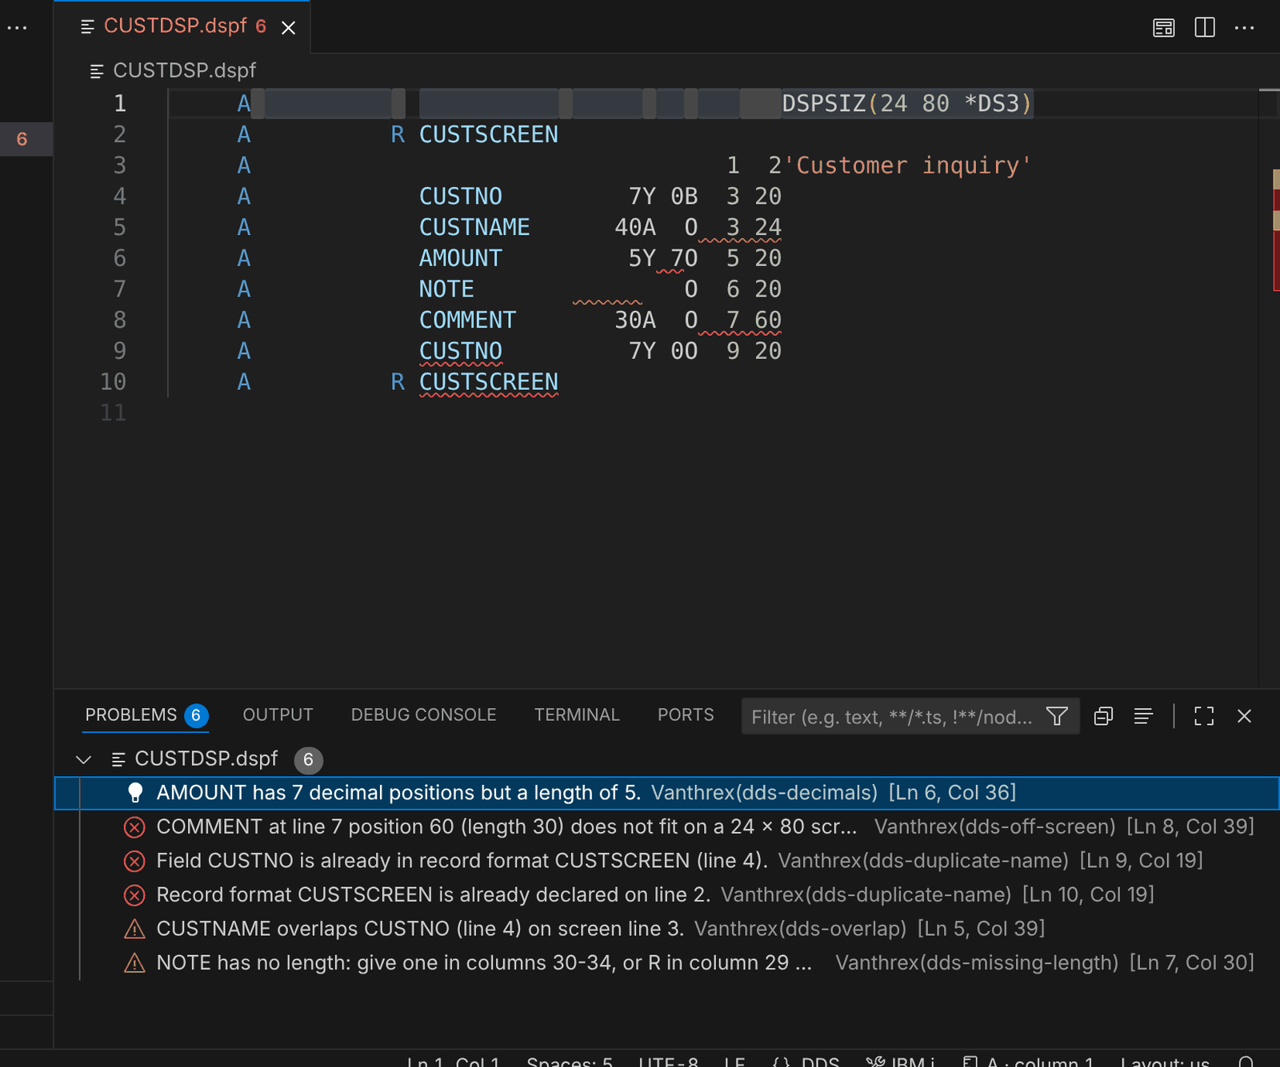
DDS checks while you type.
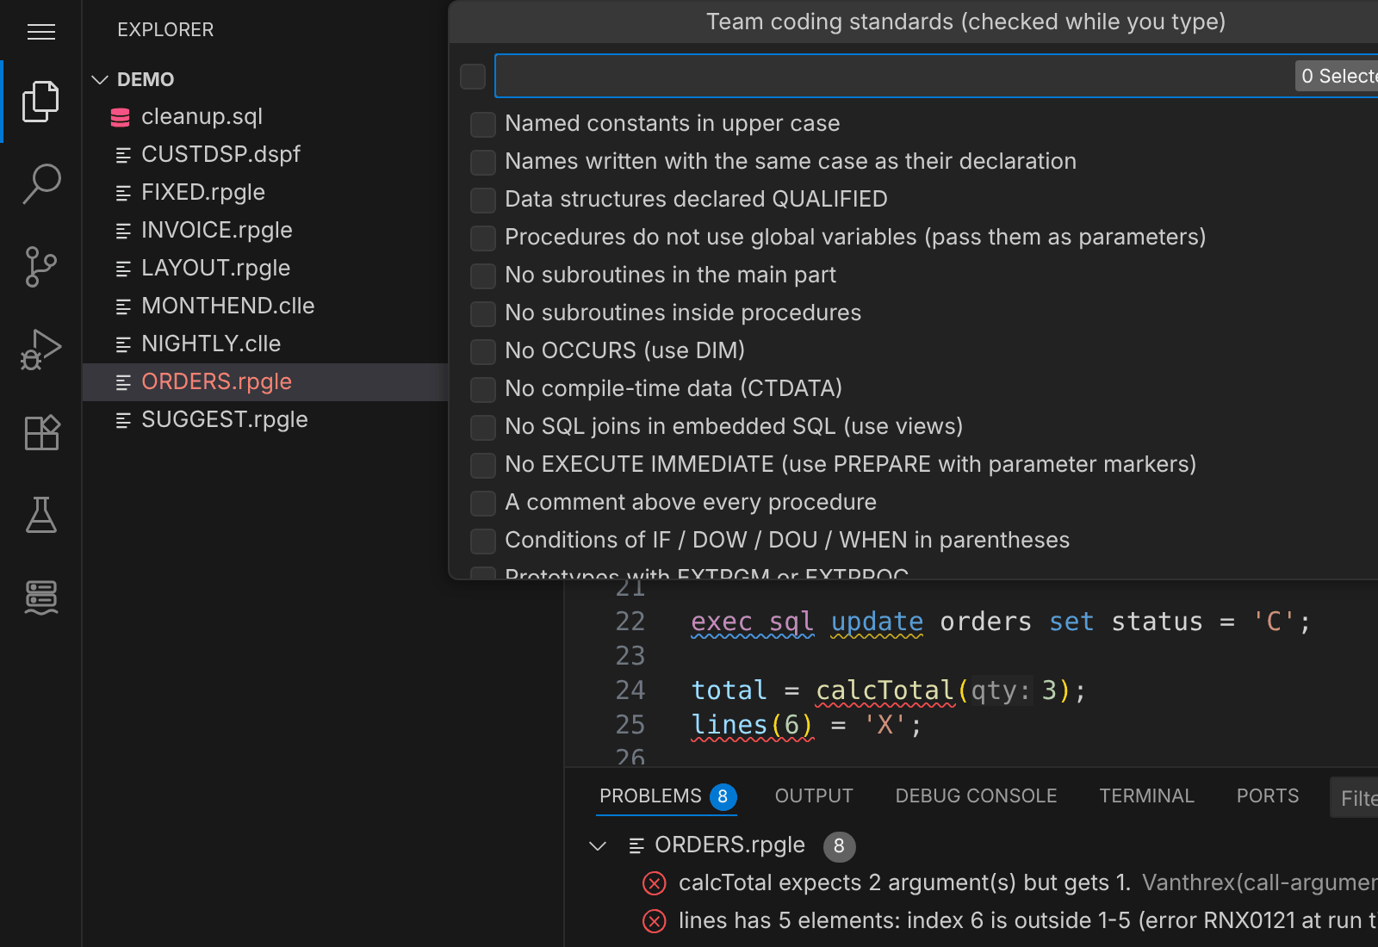
Team coding standards, checked while you type.
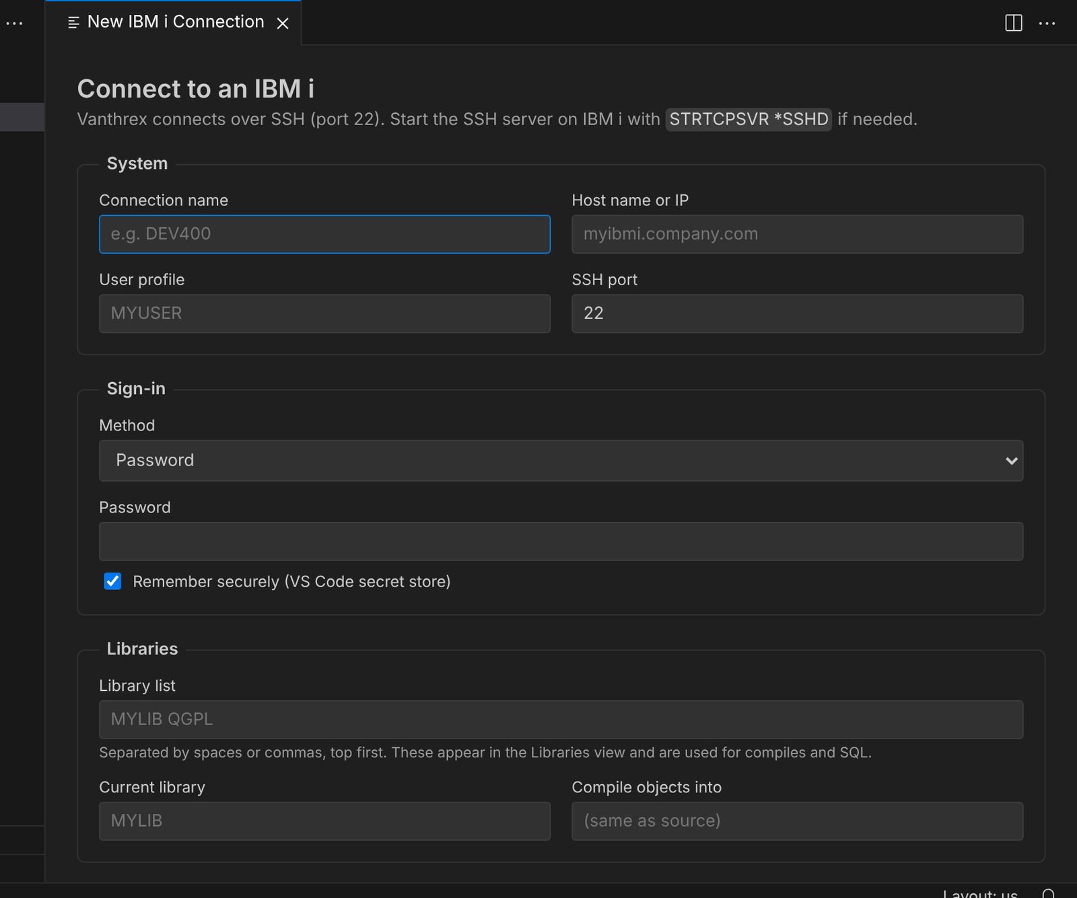
The connection form, with Test connection.

5. Feature reference
Every feature with what it does, why it helps and how to use it, in the order they were added. Features marked "new in" give the version that brought them.

1. Connection wizard and quick menu
What it does: A one-page form for host, user, sign-in method, library list, current library and SQL engine, with a Test connection button.
Why it helps: No hand-edited config files. The test tells you straight away whether SSH works and which SQL engine will be used.
How to use it:
- Add IBM i Connection (the + on the Connections view).
- Right-click a connection → Edit or Remove.
- Ctrl+Alt+I opens the quick menu: dashboard, run CL, SQL scratchpad, search, edit data, disconnect.

2. Libraries & Source browser
What it does: Your library list as a tree. Under each library are its Source files and members, and its Objects (programs, files, service programs…).
Why it helps: It is what PDM does, but with search, icons, descriptions and one-click open.
How to use it:
- Click a member to open it, and press Ctrl+S to save it back to the IBM i.
- Right-click a library → New Source File, Set as Current Library, Remove from List.
- Right-click a source file → New Member (RPG and CL members start from a template that compiles as-is).
- The search icon (Find & Open Member) finds a member by name across the library list, with wildcards such as ORD*.

3. IFS browser
What it does: Browse, open, create and delete stream files and folders.
How to use it: Click Go to IFS Directory to jump to any path. Right-click a folder → New File / New Folder.

4. One-key compile with inline errors
What it does: Ctrl+Alt+C compiles the open member or IFS file with the right command for its type (CRTBNDRPG, CRTSQLRPGI, CRTBNDCL, CRTPF, CRTDSPF…).
Why it helps: The compiler's errors land on the exact line and column, and in the Problems panel. You don't read a spool file.
How to use it:
- Ctrl+Alt+C (or the 🚀 icon in the editor title).
- When several commands fit, choose once and it is remembered. Compile With… lets you choose again.
- Add your own commands in Settings → Vanthrex: Compile Actions, using variables such as &LIB, &OBJLIB, &NAME and &SRCFILE.

5. SQL with results grid and autocomplete
What it does: Run Db2 for i SQL from any .sql file or the SQL scratchpad.
Why it helps:
- Results appear in a grid you can sort, filter, copy or export to CSV.
- Table and column names are suggested as you type, and hovering a column shows its type and description.
How to use it:
- New SQL Scratchpad, put the cursor in a statement, then press Ctrl+Enter.
- Type FROM to get table suggestions and alias. to get columns.
- Type ibmi- for ready-made IBM i Services queries (jobs, job log, locks, PTFs, message queues).

6. Table data editor
What it does: A spreadsheet-style editor for any physical file or table.
Why it helps:
- It is quicker and safer than DFU or UPDDTA.
- Every value is checked against the column's type and length before anything is written.
- You see a summary and confirm before the changes are saved.
How to use it:
- Right-click a file object → Edit Table Data, or run the command and type LIB/FILE.
- Type a WHERE condition to filter, and use ◀ ▶ to page.
- Click a cell to edit it. Use + Row, Delete row and Set NULL as needed, then Save.

7. System dashboard
What it does: A live page showing:
- CPU, system ASP, job counts and memory
- the top jobs by CPU
- the latest QSYSOPR messages
- installed PTF group levels
Why it helps: It answers "is the system OK?" in one glance instead of three green-screen commands.
How to use it: Click the dashboard icon on the Connections view, or use the quick menu. It refreshes every 30 s; change this with vanthrex.dashboard.refreshSeconds.

8. Active jobs
What it does: A list of your jobs, a user's jobs, a subsystem's jobs, or all active jobs. Jobs in MSGW (waiting for a reply) are listed first.
How to use it:
- The filter icon chooses which jobs to show.
- Click a job to see its job log.
- Right-click a job → Hold, Release or End Job (controlled or immediate, with confirmation).

9. Messages
What it does: The QSYSOPR queue and your own message queue. Messages that are waiting for an answer have a ? icon.
How to use it:
- Click the reply icon, then pick or type a reply (C, D, I, R, G…).
- Hover a message for its full help text.
- Use Send Message to message a user or the system operator.

10. Search objects, search source, where used
What and how:
- Ctrl+Alt+O: find objects by name or description, in your library list, one library or all user libraries. From a result you can open the source, see where it is used, edit data, call the program or copy its name.
- Ctrl+Alt+F: search the source code of a library or source file. Click a match to open the member at that line.
- Where Used (right-click any object): lists the programs that reference a file or program.
- Open Program Source: jumps from a program to the member it was compiled from.
Why it helps: Impact analysis before a change, with no printouts.

11. RPG navigation
What and how:
- F12 goes to the definition, including definitions inside /COPY members.
- Shift+F12 finds every use.
- F2 renames. A local variable is renamed only inside its procedure, and fixed-format columns are protected.
- Ctrl+click on a /COPY or /INCLUDE line opens that member.
- Hovering a name shows its declaration. Hovering a BIF or opcode shows its syntax.
- Hovering a fixed-format line shows which field that column belongs to (Factor 1, Result field…).
- The Outline view lists procedures, subroutines, data structures and prototypes.

12. RPG code checks
What it does: Warnings as you type:
- unused variables
- GOTO
- a program with no *INLR = *ON or RETURN
- empty ON-ERROR blocks
- SELECT *
- numbered indicators
- overly long procedures
- fixed-format code mixed into free format
Why it helps: Mistakes are caught before you compile, and team code stays consistent.
How to use it:
- Look at the underlined code and the Problems panel.
- The 💡 quick fix can remove an unused declaration, convert fixed-format code, or turn a check off.
- Each check can be switched on or off under Settings → Vanthrex: Lint Rules.

13. Fixed → free format conversion
What it does: Converts fixed-format RPG into free format — H, F, D and P specs (ctl-opt, dcl-f, dcl-s, dcl-c, dcl-ds, dcl-pr, dcl-pi, dcl-proc) as well as C-specs, with indentation, indicator handling and %FOUND / %EOF checks. Long names, continued keywords and literals, OVERLAY and program-described files are handled; compile-time data is left as it is.
How to use it: Select the lines → right-click → Convert Fixed Format to Free (H, F, D, P and C Specs), or run it with nothing selected to convert the whole source. Anything it can't convert safely is marked // TODO. Want it rewritten in modern style too? Ask @vanthrex /modernize.

14. Local history and compare
What it does: A local copy of every member and IFS file you open or save.
How to use it: Right-click inside a member and pick one of:
- Show Local History: choose a version → Compare or Restore.
- Compare with Copy on IBM i: see your unsaved changes, or someone else's changes on the server.
- Compare with Another Member: for example DEV against PROD (PRODLIB/QRPGLESRC(ORDENTRY)).
In the tree, right-click a member → Select for Compare, then right-click another → Compare with Selected.

15. SEU-style source dates
What it does: Every line of a member shows when it was last changed, like the date column in SEU. Lines you edit show today's date (highlighted) until you save.
Why it helps: You can see at a glance what changed recently, and saving keeps the dates of every line you didn't touch.
How to use it:
- Ctrl+Alt+D (or the 📅 icon in the editor title) cycles between date, sequence number + date and hidden.
- Hover the start of a line for its sequence number and full date.
- Right-click → Highlight Lines Changed Since… (7, 30 or 90 days, or any date) highlights the lines and lists them so you can jump between them.
- Settings: vanthrex.sourceDates.format chooses yymmdd (SEU) or iso.

16. F4 prompters
What and how:
- Fixed-format RPG and DDS: put the cursor on a C, D, F, H or P spec (or a DDS line) and press F4. A form shows each column area with its name (Factor 1, Opcode, Result field, Length…) and allowed values. Apply writes it back in the right columns. Apply & next line keeps going, like SEU. On a blank line, F4 asks which spec to create.
- CL commands: in a CL source, press F4 on a command. Vanthrex reads the command's real definition from the IBM i and shows every parameter with its prompt text, default and allowed values. The command is rewritten in proper CL source layout, with + continuations.
- Prompt and Run CL Command (quick menu): type a command name, fill in the form, and it runs.

17. Who has my member? (locks)
What it does: When a member is open somewhere else (for example in SEU), the editor shows a banner at the top: *🔒 Locked by name* (USER) · job … · SHRUPD*.
How to use it:
- ✉ Ask to release sends a message that pops up on their screen (break message), or goes to their message queue.
- 🔔 Notify me when free checks every 15 seconds and tells you when the lock is gone.
- More options: show their job log, or end their job (needs *JOBCTL authority, and they lose unsaved work, so you are asked to confirm).

18. Edit conflict protection
What it does: Before saving, Vanthrex checks whether the member changed on the IBM i after you opened it, or is locked by another job.
How to use it: You get Compare First (opens a side-by-side diff with the IBM i copy) or Overwrite. Turn it off with vanthrex.conflictCheck.

19. Member list with dates
- Each member shows its last change date in the tree. The tooltip adds the creation date and line count.
- Sort Members by Name / Date (Libraries view toolbar) puts the most recently changed members first.
- Right-click a source file → Filter Members by Last Change… shows only members changed today, or in the last 7, 30 or 90 days, or any number of days.

20. CL runner and spooled files
- Ctrl+Alt+L runs any CL command with your library list. Recent commands are remembered.
- My Spooled Files: open, save or delete your spooled output.

21. Object information
What it does: One page with everything about an object: owner, created, changed, last used and how many days it was used, size, the source member it was compiled from, journaling, last save, and every other attribute.
Why it helps: It replaces DSPOBJD, DSPPGM and a few queries, and the buttons take you straight to the next step.
How to use it:
- Click any object in Libraries & Source → Objects, or right-click it → Object Information.
- The buttons open the source, show who has the object locked, list where it is used, edit a file's data or generate its SQL.
- From the quick menu (Ctrl+Alt+I) → Object information… and type LIBRARY/OBJECT.

22. Who has this object locked?
What it does: The jobs holding a lock on any object (a file, data area, program…), with the person's name and the lock state — like WRKOBJLCK.
How to use it: Right-click an object → Who Has This Object Locked? Click a job to see its job log, send the user a message asking them to release it, or end the job (needs *JOBCTL).

23. Compare two libraries
What it does: Compares two libraries, for example DEV and PROD, and lists the source members and objects that are only in one of them or different. The newer side is shown.
Why it helps: Before a promotion you see exactly what will change, and you can open a side-by-side diff of any changed member with one click.
How to use it: Right-click a library → Compare Two Libraries… (or the quick menu), pick the two libraries. Click a different member to compare its text; click an object for its information.

24. Modules & exports
What it does: For a service program: its exported procedures and data in signature order. For a service program or ILE program: its bound modules with their source and dates. Modules whose source changed after they were compiled are highlighted.
How to use it: Right-click a SRVPGM or PGM → Show Modules & Exports. Click a module to open its source.

25. SQL power tools
- Generate SQL (DDL): right-click a file → Generate SQL (DDL), or run the command and type LIB/OBJECT. Works for tables, physical and logical files, views, indexes, procedures and functions. The CREATE statement opens in a new SQL editor. Needs a Mapepire SQL engine.
- Run SQL Script: Ctrl+Shift+Enter in a SQL editor runs every statement in the file (or the selection) one after another. Each statement shows ✔ or ✖, its time, its rows or row count, or its error. It stops at the first error unless you turn off vanthrex.sql.scriptStopOnError. It asks once before running destructive statements.
- SQL history: every statement you run is remembered (last 50). SQL History… lets you run it again, open it, insert it at the cursor or copy it. Click ☆ to save it.
- Saved queries: in a SQL editor, right-click → Save Query… and give it a name. Saved Queries… lists them for running or inserting; the 🗑 button deletes one.

26. Procedure & copybook tools (RPG)
- Generate prototype from procedure: put the cursor inside a free-form procedure → right-click → Generate Prototype from Procedure. The DCL-PR (return type and every parameter, with their keywords) is copied to the clipboard, ready to paste into your prototype copybook.
- Extract to procedure: select whole lines of free-form calculations → right-click → Extract to Procedure… and name it. The lines move into a new procedure at the end of the source and are replaced by a call. Vanthrex refuses when that would change what the code does: lines using local variables of the enclosing procedure, RETURN/LEAVE/ITER, declarations, or a block that is opened but not closed (and the other way round). Programs with procedures need CTL-OPT DFTACTGRP(*NO); you are reminded if it is missing.
- Check /COPY usage: right-click in an RPG source → Check /COPY Usage. Each copybook is listed with the declarations your source uses from it, so unused copybooks stand out. In fully free sources the ☐ button comments the unused ones out.

27. IBM i debugger
What it does: Step-through debugging of RPG, COBOL and CL programs: breakpoints, step over / into / out, variables, watch expressions and the call stack, in VS Code's normal debug view.
Why it helps: No more STRDBG in a 5250 session or DSPLY statements — set a breakpoint on the line in the editor and run.
How to use it:
- Once per PC: run Vanthrex: Debugger Setup Check (quick menu → Debugger setup check). Fix anything marked ✖ with the buttons on the page: install IBM's free IBM i Debug extension, start the Debug Service, download the certificate.
- Compile the program with DBGVIEW(*SOURCE) (all built-in compile actions do).
- Set breakpoints in the source, then Ctrl+Alt+G (or right-click the program → Debug Program, or the 🐞 button in the editor title).
- Confirm the command that starts the program, adding PARM(...) if it needs parameters. It runs in a batch job with your library list, and the debugger stops at your breakpoints.
The server side (the IBM i Debug Service, its PTFs and its certificate) is set up once by an administrator — see the Debugging page of the documentation.

28. AI assistant for IBM i (@vanthrex) — new in 0.6
What it does: An IBM i expert in the VS Code chat. Type @vanthrex and ask in plain language, or use a command:
Command | What it does
/explain | Explains the selected code or the open source: purpose, inputs, files and programs used, main flow
/document | Adds a program header and procedure comments without changing the logic
/review | Prioritised list of bugs, error-handling gaps, performance and security issues
/modernize | Rewrites fixed format / old-style code as modern **FREE RPG with the same behaviour
/test | Generates RPGUnit tests for a procedure
/fix | Explains each compile error and gives the corrected code
/sql | Writes Db2 for i SQL against your real tables and columns
/object LIB/NAME *TYPE | Explains an object: what it is, who uses it, what it touches

Why it helps: It knows your system — library list, IBM i release — and looks things up instead of guessing: object descriptions, table columns and indexes, source members, object search, system status and read-only queries.
Safe by design: it only reads. Queries must be a single SELECT / WITH / VALUES; data-change statements and functions with side effects (QCMDEXC, IFS_WRITE…) are refused, and Vanthrex asks before every query and before reading an IFS file. The code you ask about is sent to the language model you chose in VS Code chat.
How to use it:
- Needs a chat model in VS Code (for example GitHub Copilot Chat).
- Right-click in a source → Vanthrex AI → Explain / Document / Review / Modernize / Unit tests / Fix compile errors / Write SQL.
- On an IBM i compile error, the 💡 offers Ask AI to explain and fix this compile error.
- Right-click an object → AI: Explain This Object.
- In Copilot agent mode the same tools are available as #ibmiQuery, #ibmiSource, #ibmiObject, #ibmiSearch and #ibmiStatus.

29. Git for IBM i source — new in 0.6
What it does: Keep your IBM i source in Git (GitHub, GitLab, Azure DevOps, Bitbucket…) and move changes both ways.
Why it helps: Real version history, pull requests and code review for RPG and CL, without changing how the IBM i is organised.
How to use it:
- Right-click a library (or one source file) → Git: Export Source to a Git Repository…, choose a folder. Members are saved as library/sourcefile/member.type (for example mylib/qrpglesrc/ordentry.rpgle). Vanthrex offers to create the repository, make the first commit and publish it.
- Git: Get Changes from IBM i brings in only the members changed on the system since the last sync.
- Edit locally (or merge a pull request), then Git: Upload Changed Files to IBM i — to the libraries they came from or to another library such as your development library. New files become new members.
- Git: Commit & Push commits with your Git name, or with vanthrex.git.authorName / vanthrex.git.authorEmail, and pushes.
- In a member, Git: History of This Member (editor title … menu or right-click the member) lists every committed version: compare it with the IBM i copy or the previous version, open it, or restore it into the editor.
Files changed on both sides since the last sync are flagged and never overwritten silently. .vanthrex/sync.json remembers what was last exchanged — commit it with the source.

30. Call graph & impact analysis — new in 0.6
What it does: An interactive diagram of how objects connect: who calls a program or uses a file (callers — the impact of a change) and what it calls and uses (callees), several levels deep. Files show how they are used (input / output / update).
Why it helps: Before you change a file layout or a program's parameters, you see every program affected — across libraries — in seconds.
How to use it:
- Right-click a program, service program or file → Call Graph… or Impact Analysis (Who Uses This?)…, or use the quick menu.
- Choose the libraries to analyse (your library list, one library or a list).
- In the graph: Callers / Both / Callees, − / + for depth, Hide files, Fit, drag to pan and scroll to zoom. Click an object to centre the graph on it, open its source, see its information or ask the AI about it.
- Copy as Mermaid puts the diagram on the clipboard for a README, wiki or pull request.
- Find dynamic calls (new in 0.7) scans the source of the programs in the graph for calls whose target is a variable (CALL PGMVAR, EXTPGM(variable), CL CALL PGM(&PGM)) and shows them as dashed red nodes; click one to open the call.
Needs a Mapepire SQL engine (the cross-reference is built with DSPPGMREF in QTEMP).

30b. Who calls each exported procedure? — new in 0.7
What it does: For a service program, every program that calls each of its exported procedures — with the source member, line and statement.
Why it helps: "Program X is bound to service program Y" is not enough before you change a procedure's parameters. This tells you exactly which of the exports each program uses, and which exports nobody calls.
How to use it: Right-click a service program → Who Calls Each Exported Procedure?… (or use the button on Modules & Exports or in the call graph), then choose the libraries to analyse. Vanthrex finds the bound programs, reads their RPG and CL source with the prototypes of their /COPY members, and follows EXTPROC, *DCLCASE, fixed-form prototypes, CALLB, %PADDR and CALLPRC. Click a call to open the source at that line.

31. Several systems at once — new in 0.6
What it does: Stay connected to DEV, TEST and PROD together and switch in one click.
How to use it: Connect to a second system as usual — the first stays connected in the background. Switch with Switch IBM i System (quick menu, Connections view toolbar, or click a background connection). Views and commands follow the active system. A member or IFS file is always saved to the system it was opened from; Vanthrex refuses to save it to another one. Turn this off with vanthrex.connections.keepOthersOpen.

32. Explain SQL (performance) — new in 0.6
What it does: A Visual Explain-style summary of a query: table scans and why, indexes used, temporary indexes built, sorts, and the indexes the optimizer advises — with plain-language tips.
How to use it: Put the cursor in a SELECT in a SQL editor → Explain SQL (Performance) (editor title or right-click). Vanthrex runs the query (first 100 rows) under a database monitor in your SQL job and shows the report. Click an advised index to get a CREATE INDEX statement to review and run. Needs a Mapepire SQL engine.

33. Index advisor — new in 0.8
What it does: All the indexes Db2 for i recommended while your programs and queries ran (QSYS2.SYSIXADV), for your library list, one library or all user libraries: table, key columns, how often and when it was advised, and how expensive the slowest query was.
Why it helps: A missing index is the most common reason for a slow program. Explain SQL shows the advice for one statement; the advisor shows everything Db2 has learned, ranked, so you fix the biggest wins first.
How to use it: Right-click a library → Index Advisor (or the quick menu). Click a suggestion → confirm the proposed name → Create Index (or Copy SQL). Show Queries Running Now lists the active SQL statements.

34. Compare table data (DEV ↔ PROD) — new in 0.8
What it does: Compares the rows of the same table in two libraries, matched by key columns.
Why it helps: "It works in test but not in production" is often a data difference. You see exactly which rows are only on one side and which fields changed.
How to use it: Right-click a file → Compare Table Data, pick the other library and the key columns (the primary key is pre-selected). The page shows exact counts, the changed rows field by field, and the rows only in one copy. Export differences (CSV) saves them. Needs a Mapepire SQL engine.

35. Message help and job log analyzer — new in 0.8
- Hover any message ID — CPF, CPD, MCH, RNQ/RNX, SQL, CEE… — in any editor (job logs, compile listings, spooled files, comments) to see IBM's message text, severity, a plain-language what to do, and the full help text.
- Explain Message ID… (quick menu) shows the same for an ID you type.
- Analyze Job Log: right-click a job in Active Jobs (or run the command and type a job name). Errors are grouped, the most likely root cause is highlighted — the first real escape message, not the generic CPF9999 function check — with advice, and each message opens its full explanation.

36. Journal explorer — who changed this table? — new in 0.9
What it does: The row changes recorded in the journal for one table: which rows were added, updated or deleted, when, by which user, from which program and job — with the before and after record images of an update side by side, and a summary of who changed the table most.
Why it helps: "Who changed this customer's balance yesterday?" usually means DSPJRN to an outfile and a home-made query. Here it is one right-click.
How to use it: Right-click a file → Journal Explorer: Who Changed This Table?, pick a time range (last hour to last 30 days) and optionally a user. Click a change to see the full history of that row (by relative record number). If the file is not journaled, Vanthrex says so and offers the STRJRNPF command. Uses QSYS2.DISPLAY_JOURNAL; before images need IMAGES(*BOTH).

37. Authority checker — new in 0.9
What it does: Answers "can user X use this object, and if not, why not?" It resolves the user's authority the way IBM i does — ALLOBJ, the user's own authority, group profiles, authorization list, PUBLIC — checks *EXECUTE on the library too, and lists everyone with authority on the object.
Why it helps: "Not authorized" errors (CPF9802, CPF2189, SQL0551) are slow to untangle by hand with DSPOBJAUT, DSPUSRPRF and DSPAUTL. You get the exact source of the authority, what is missing, and the fix.
How to use it: Right-click any object → Check Authority…, enter the user and what they need to do (use, change data, manage). If something is missing, Grant… shows the GRTOBJAUT command to run or copy. Adopted authority is not taken into account.

38. Data queues and data areas — new in 0.9
- Data queues: right-click a *DTAQ → View Data Queue Entries to peek at the waiting entries (data, key, sender job and user, time) without removing them. Send a test entry… and Clear all entries… are on the page (both ask first).
- Data areas: right-click a *DTAARA → View Data Area (type, length, value by position) or Change Data Area Value… — the new value is checked against the type, length and decimals before CHGDTAARA runs.

39. PTF & system health — new in 0.9
What it does: One report with the release, system ASP use, PTF groups compared with the latest levels at IBM, PTFs waiting for an IPL or loaded but not applied, certificates expiring within 60 days, user profiles with default passwords or passwords about to expire — ranked worst first with what to do.
Why it helps: These are the things that cause outages and audit findings, and they live in five different places.
How to use it: Quick menu → PTF & system health, or right-click the active connection. Nothing is changed. The IBM comparison (SYSTOOLS.GROUP_PTF_CURRENCY) needs internet access from the IBM i; certificate and default-password checks need ALLOBJ and SECADM. Checks that can't run are listed as not checked.

40. Your language — new in 0.10
What it does: The interface — commands, menus, views, settings, walkthrough, messages, prompts and report titles — in English, French, Spanish, German, Italian, Portuguese (Brazil), Japanese and Simplified Chinese.
How to use it: Vanthrex follows the VS Code display language. Ctrl+Shift+P → Configure Display Language, choose the language (VS Code offers to install its language pack) and restart. IBM i commands, object types, message IDs and SQL are never translated; IBM's own help text (message help, job logs) comes from the IBM i in the language installed there. Want another language or found a better word? Open an issue — translations live in l10n/bundle.l10n.<lang>.json and package.nls.<lang>.json.

41. Work management — new in 0.11
What it does: Subsystems (WRKSBS), job queues and their waiting jobs (WRKJOBQ), output queues and their spooled files (WRKOUTQ), and job schedule entries (WRKJOBSCDE).
How to use it: IBM i: Work with… → pick a screen. Click a row for its options: start / end a subsystem, hold / release / clear a queue, release / hold / run next / end a waiting job, open / hold / release / move / delete a spooled file, add / hold / release / remove a schedule entry. Every command is shown before it runs, with Copy Command as an alternative.

42. Users & security — new in 0.11
- User profiles (WRKUSRPRF): filter non-IBM, disabled, with special authorities, or group profiles; enable, disable, expire the password (passwords are never shown or set); see the user's active jobs and owned objects.
- System values (WRKSYSVAL): all of them, read-only, with the important ones grouped and explained.
- Security audit journal (QAUDJRN): pick event types (authority failures, invalid passwords, profile and system value changes, deleted objects…), a time range and optionally a user. Needs AUDIT or ALLOBJ.

43. Save / restore — new in 0.11
What it does: Save files in a library (WRKSAVF) and their contents; save a library or objects to a save file (SAVLIB / SAVOBJ, target release, compression, run now or submit to batch); restore everything or some objects, also into another library (RSTLIB / RSTOBJ); download a save file to the PC or upload one.
How to use it: Right-click a library → Work with Save Files / Save Library or Objects…, or right-click a save file → Show Save File Contents. Listing contents needs IBM i 7.4 with recent Db2 PTF groups.

44. Network & services — new in 0.11
What it does: TCP/IP connections with the job and user behind each, and listening ports (NETSTAT); the common TCP/IP servers with their status and start / end (STRTCPSVR / ENDTCPSVR, STRHOSTSVR); IP interfaces and routes.
How to use it: IBM i: Work with… → TCP/IP connections, TCP/IP servers or IP interfaces. Ending SSHD or your own connection disconnects Vanthrex — you are warned first. Starting and ending servers needs *IOSYSCFG.

45. Storage & cleanup advisor — new in 1.0
What it does: For your library list, one library or all user libraries: libraries and objects by size, objects not used for a chosen number of days, files with many deleted rows, saved journal receivers older than 30 days, and old spooled files by user — with how much space each could free. IFS folders by size measures a folder tree in the IFS.
How to use it: Quick menu → Storage & cleanup advisor…, or right-click a library. Click a row for its options: reorganize a file (RGZPFM), delete a receiver or an unused object, delete a user's old spooled files. Nothing is deleted without asking.

46. Live alerts — new in 1.0
What it does: Notifications in VS Code when a job waits for a reply (MSGW), an inquiry message arrives on QSYSOPR, a batch job ends abnormally (end code 10 or more), or the system ASP passes the alert level.
How to use it: Jobs view toolbar → Live Alerts → Turn on (or set vanthrex.alerts.enabled). Reply to an inquiry or open the job log right from the notification. vanthrex.alerts.scope chooses your own jobs or all users, vanthrex.alerts.intervalSeconds how often to check, vanthrex.alerts.diskPercent the disk level.

47. Message files and field finder — new in 1.0
- Message files: right-click a *MSGF → Work with Message Descriptions: add (the next free ID is proposed), change, copy as ADDMSGD or remove messages.
- Field finder: quick menu → Field finder…, type a field name (wildcards * and % allowed) and pick the libraries; optionally search descriptions and headings too. Fields with the same name but different definitions are flagged. Click a result to see the programs using that file.

48. Object promotion (DEV → TEST → PROD) — new in 1.0
What it does: Copies objects from one library to another the safe way: compare first, back up what will be replaced, copy with SAVOBJ / RSTOBJ (attributes and authorities come along), and log it.
How to use it: Right-click an object or a library → Promote Objects…, pick the objects and the target library. The compare page warns about objects that are newer in the target and physical files that carry data; Promote shows every command before it runs. Promotion log lists every promotion with its backup save file and an Undo. The backup library is vanthrex.promotion.backupLibrary (QGPL by default).

49. Import and export table data — new in 1.1
Export: right-click a file → Export Table Data, pick Excel (.xlsx), CSV or JSON and optionally a WHERE condition. In a .sql editor, Export Query Result exports the result of the statement under the cursor. At most vanthrex.export.maxRows rows (100,000 by default).
Import: right-click a file → Import CSV or Excel into Table, pick the file, then add or replace. The preview shows how the file's columns map to the table's (by name, ignoring case and punctuation), the first 20 rows, and the rows that would be skipped and why. Import inserts the rows in batches of 100 (without commitment control) and can be cancelled.

50. Performance monitor — new in 1.1
What it does: Live charts of CPU used, system ASP used, active jobs and temporary storage (hover a chart for the value at each moment), the top jobs by CPU and by disk I/O between two samples, and the memory pools.
How to use it: Jobs view toolbar → Performance Monitor (or the quick menu). Click a job for its job log; Pause stops sampling. The interval is vanthrex.performance.intervalSeconds (5 s by default).

51. Code metrics and documentation — new in 1.1
- Code metrics: right-click a source file for every RPG/CL member (up to 300), or use Code Metrics in a member's editor menu for one source. Per member: code lines, % free form, procedures, subroutines, complexity, nesting, numbered indicators, GOTOs, SQL — and a grade A–D with advice.
- Generate documentation: in an RPG or CL member, Generate Documentation (Markdown) opens a Markdown document with the description (from the leading comments), parameters, files, called programs and procedures, copybooks, the procedures with their comments, and metrics — ready to complete and keep in Git or a wiki.

52. RPGUnit tests — new in 1.1
What it does: Unit tests for RPG with iRPGUnit, run from VS Code's Testing view.
How to use it: In a member with exported procedures, Generate RPGUnit Tests… creates a test member (T + member name) in the same source file with one test per procedure. Fill in the inputs and expected values, then click ▶ next to the member or a single test in the Testing view: Vanthrex compiles it with RUCRTRPG and runs it with RUCALLTST, and shows each test as passed or failed with the assertion message. Test members (with /include qinclude,TESTCASE) are found when opened, or with Find RPGUnit Tests… on a source file. Settings: vanthrex.rpgunit.library (where RPGUnit is installed, RPGUNIT by default) and vanthrex.rpgunit.testLibrary.

53. Production protection — new in 1.2
What it does: Per connection: No protection, Production: ask before every change, or Read-only: never change anything. Covers CL commands, SQL that changes data or objects, member saves and IFS writes; reading, querying, downloading and Vanthrex's own work in QTEMP are never blocked.
How to use it: In the connection form under Protection, or right-click a connection → Set Protection…. The status bar shows 🛡 (production, red) or 🔒 (read-only, amber).

54. Self-check and plain-language errors — new in 1.2
- Self-check: quick menu or right-click the active connection → Self-Check. Checks SSH and SQL latency, QSH/CL, the SQL engine and Java, CCSID, home directory, library list, release and Db2 PTF group, special authorities, RPGUnit and the debug service, and which IBM i services are missing (with the features they affect). Copy the report for a support issue. Runs automatically the first time you connect to a system in a session (vanthrex.selfCheck.onConnect).
- Errors explained: every error from IBM i, Db2 or SSH ends with what to do next (missing service → PTF group, not authorized → Check Authority, SQL7008 → WITH NC, locks → Who Has It Locked?, lost connection → reconnect…).

55. Screen preview for display files — new in 1.3
What it does: A 5250-style drawing of a DSPF record format: constants, input fields (underlined), output fields (X / 9), COLOR and DSPATR, 24×80 or 27×132, WINDOW records, and a subfile control drawn with SFLPAG rows of its subfile, plus a table of the record's fields.
How to use it: In a DSPF member, Preview Screen in the editor title (or right-click). It shows the record your cursor is in and updates as you type; pick another record from the list; click a field to go to its source line. Every conditioned field is shown, as if all indicators were on.

56. Database diagram — new in 1.3
What it does: An entity-relationship diagram of a library: tables and physical files with their columns and primary keys, declared foreign keys, and relationships inferred from column names that match another table's one-column primary key (dashed).
How to use it: Right-click a library → Database Diagram (pick the tables when there are more than 40). Click a table to highlight its links, Ctrl+wheel or +/− to zoom, Copy as Mermaid or Save as SVG.

57. Compare with another system — new in 1.3
What it does: Compare DEV and PROD (or any two connected systems): a source member side by side, the objects of a library (attribute and source date, newer side), the rows of a table by key, the system values, or the PTF group levels.
How to use it: Connect to both systems, then quick menu → Compare with another system…. Table compares read at most vanthrex.compare.maxRows rows per system.

58. Spooled files to PDF and e-mail — new in 1.3
- Save as PDF… on a spooled file: paged like the original; made locally from the text, or by the IBM i (vanthrex.spool.pdfMode: server, CPYSPLF WSCST(*PDF)) to keep fonts and graphics.
- Send by E-mail… on a spooled file attaches the PDF; E-mail Query Result in a .sql editor attaches the result as Excel. Mail is sent by the IBM i with SNDSMTPEMM, so SMTP must be set up there.

59. Development helpers — new in 2.0
- Generate RPG Code for This Table (right-click a file): a qualified template data structure and get / add / update / delete / list procedures in embedded SQL, opened as a new RPG document. When the table has no primary key, you pick the key columns.
- Format SQL: Shift+Alt+F (or right-click → Format SQL) in a .sql editor; also formats a selection.
- Find and Replace in Source File… (right-click a source file): text, whole word, match case or regular expression, previewed line by line; Apply keeps source dates (changed lines get today's date), skips members in use, and never makes a line longer than the source file allows.
- Compile Changed Members… (right-click a source file): members changed today / 7 / 30 days, or picked by hand, compiled with the matching compile action; the result page lists failures first.
- Print Preview (Printer File) in a PRTF member: the record formats printed once each on a page, with a ruler.
- Copy Members to Another Source File…, Copy Objects to Another Library…, Rename or Move… on the Libraries view.
- Find a CL Command…: search by keyword, then prompt the command with F4.

60. Data tools — new in 2.0
- Export Table Data now also writes SQL INSERT statements.
- Generate Test Data… (right-click a file): pick a row count, preview, then insert. Numeric keys continue after the highest existing value.
- Find Duplicate Rows… (right-click a file): pick the columns that should be unique.
- Table Statistics (right-click a library): rows, deleted rows, size, last change and use of every table.

61. Operations helpers — new in 2.0
- Submit to Batch and Watch… (quick menu) and Watch This Job (Jobs view): a spinner in the status bar while the job runs, a notification when it ends with its end code, and Job Log / Analyze buttons.
- My Recent Jobs (Jobs view toolbar): your recent jobs with completion status.
- Compare with Another Spooled File… (Spooled Files view): side-by-side diff of two spooled files.
- Follow File (tail -f) on an IFS file (vanthrex.ifs.followLines), and Search Text in Files… on an IFS folder.
- Library List Sets… (quick menu or right-click the active connection): save, switch and delete named library lists per system.

62. Security Admin center (*SECADM) — new in 2.1
What it does: User profile, group and authorization list administration in VS Code, for security administrators. It is visible only when your profile or one of its groups has *SECADM special authority.
How to use it: Connections view toolbar → Security Admin (or the quick menu). From the list of profiles: Create a user…, Copy a user…, and per profile Change attributes, Reset password, Enable / Disable, Expire password, Delete. Reports: Unused profiles (with Disable all), Powerful profiles, Group profiles, Authorization lists (create, add / change / remove entries, objects secured). Every command is shown before it runs; passwords are masked everywhere. Changing the special authorities of other administrators may also need *ALLOBJ, as IBM i requires.

63. Source and change tracking — new in 2.1
- Objects Out of Sync with Source (right-click a library): compares the source date stored in each program, service program, module, command and file at compile time with the member's current date. "Source newer" means the object was not recompiled after the last change; "source missing" means it cannot be rebuilt.
- What Changed (Release Notes)… (right-click a library): members and objects changed in the last 1–90 days; Copy as Markdown.
- New Member from Template… (right-click a source file): eight built-in templates plus yours in vanthrex.templates (&NAME, &TEXT, &DATE, &USER are filled in).
- Retrieve Binder Source (right-click a service program) and Work with Binding Directory (right-click a *BNDDIR).

64. Locks, SQL, exit points and bulk authority — new in 2.1
- Who Is Locking Rows? (right-click a file): QSYS2.RECORDLOCKINFO with the job holding or waiting for each row.
- Running SQL Statements (Jobs view toolbar): statements running now, longest first; Cancel a runaway query.
- Exit Points and Exit Programs (quick menu or Security Admin): registered exit programs and unprotected network exit points.
- Change Owner or Authority of Many Objects… (right-click a library): change the owner of every object matching a generic name, or grant / revoke authority in one command.

65. System, journals, IFS and message queues — new in 2.1
- Installed Software and License Keys, Is This PTF Installed?… (quick menu).
- Journals (quick menu or right-click a library): receivers, size, objects journaled; change receiver; STRJRNLIB.
- Permissions… on an IFS file or folder: data authorities and owner, with changes for one object or a whole folder tree.
- Work with Message Queue…: any message queue — reply, remove, explain, sender's job log, send.

66. Code and database quality — new in 2.1
- Compare Table Structure… (right-click a file): columns and indexes against another library or another connected system, with an ALTER script for the second copy.
- Find Unused Code (right-click in an RPG editor): definitions nothing in the source refers to.
- Find Hard-Coded Libraries (right-click in an editor, or on a source file): library-qualified names in source; allow your shared libraries with vanthrex.scan.allowedLibraries.

67. Jobs, history and dependencies — new in 2.1
- What Is This Job Doing? (right-click a job, or quick menu): status, wait reason, current SQL, call stack, locks and activation groups in one page.
- System History Log (QHST)…: recent system messages by severity, message ID or text.
- What Depends on This File? (right-click a file): logical files, indexes, views, constraints, triggers and foreign keys.

68. Source, IFS and network checks — new in 2.1
- Indicator Usage (right-click in an RPG or DDS editor): where each indicator is set and tested; suspicious ones flagged.
- Character Set (CCSID)… on an IFS file or folder: see, tag or convert the CCSID.
- Can the IBM i Reach This Host? (Ping)… and Call a Web API from the IBM i…: test connectivity and REST services from the system itself.

69. PDM in one screen — new in 2.2
- Work with Using PDM… (right-click a library, source file or file; Libraries view toolbar; quick menu; or WRKMBRPDM / WRKOBJPDM / WRKLIBPDM / STRPDM in Run CL Command): libraries, objects and members in one screen with the PDM option numbers, typed on many rows and run with Enter.
- F-keys: F3, F5, F6 create, F12 back, F13 repeat, F16 user-defined options, F17 subset, F21 CSV export, F23 more options (Shift+F1…F12 = F13…F24).
- User-defined options with &L &F &N &T &A &O &U &X (vanthrex.pdm.userOptions), plus extra options PDM never had: GH, UC, HL, WU, LK, DP, SF, LL, CL.

70. What did my source become? — new in 2.2
- Objects Built from This Source (right-click a member, editor menu, or PDM option OB): programs and service programs compiled from it, and whether each is out of date.
- Member status bar: up to date / out of date / never compiled, and who else has the member open.
- Compile on save (vanthrex.compileOnSave) and Find & Open Member… (Ctrl+Alt+M) across the library list or all user libraries.

71. History, live job log and pins — new in 2.2
- Compile History with Broken right now and Recompile the broken sources.
- Show My Changes Since the Last Compile (editor menu, PDM option SC).
- Live Job Log (right-click a job): messages as they arrive, alerts for escape messages, stops when the job ends.
- Pinned view for members, source files, libraries, objects and IFS files (right-click → Pin, PDM option PN).

72. System Tracker — new in 2.2
- Health score with reasons and trend; Queues (hold / release), Network (ports, services, encryption), security system values with advice; Copy summary.
- Scheduled jobs (hold / release), Journals (cleanup candidates), What changed (objects changed or largest), All systems side by side, subsystems, failed sign-ons, Save report (HTML).
- System Tracker (Connections toolbar, Ctrl+Alt+T): Overview with Needs attention, every library (with sizes on request), jobs, storage, QSYSOPR, users, PTFs and my work — with actions on every row.

73. Create from anywhere and new checks — new in 2.3
- Create Library… (with library list, current library and standard source files) and Create IFS Folder or File… (UTF-8, permissions) from the toolbars, quick menu and System Tracker.
- Source Quality Report (right-click a source file): scores and grades A–E per RPG member.
- Library list from a job description or user profile, *\PUBLIC Authority Scan with one-click fix, Compare System Values** between two systems.

74. Stable connections — new in 2.3
- Automatic reconnect with the saved sign-on, connection health in the status bar, no lost saves while offline, editors that reopen by themselves, and a warning before disconnecting with unsaved changes.
- Copy to Another System… for members and IFS files, with a preview of what changes.

75. Call, sign-on and notes — new in 2.3
- Call Program (Typed Parameters) from the program's own parameter list, with exact packed / zoned / integer literals; Who Is Signed On with break messages and ending sessions; member notes on lines, local or shared through an IFS file.

76. Layout, includes, signatures and failed jobs — new in 2.3
- Data Structure Layout with positions and lengths (also on hover), Show Source with /COPY Expanded, Check Service Program Signatures with one-click re-bind, and Failed Jobs from the history log with end codes and job logs.

77. AI-powered development — new in 2.3
- @vanthrex /errors explains compile errors with IBM's help text and the lines involved; /document and /test use the real dependencies, procedure signatures and data structure layouts; /depends LIB/PGM explains a program's dependencies and the impact of a change; /joblog number/user/name finds the failing statement from the job log and recommends a fix.

78. Green screen — new in 2.3
- Open 5250 Session (ACS, tn5250 or your own emulator), a 5250-style command line (F4 / F9 / F12, full messages, printed output shown, interactive commands open the matching screen) and Work with Active Jobs with the 3 / 4 / 5 / 6 / 7 / 8 / 10 / 11 options and F5 / F10 / F11.

79. Deploy a local folder to the IFS — new in 2.4
What it does: Deploy Changes to IBM i (IFS) uploads the new and changed files of your local (Git) folder to an IFS folder of its own; Deploy All Files sends everything again.
Why it helps: work the modern way — local Git, branches, pull requests — and still build on the IBM i, without copying files by hand.
How to use it: open the folder in VS Code, connect, right-click in the Explorer → Deploy Changes to IBM i (IFS). The folder is ${home}/builds/<folder name> unless you set vanthrex.deploy.directory (Set IFS Deploy Folder…). Files are tagged CCSID 1208; .git, node_modules, .vscode, *.key, *.pem, .env and logs are never sent (vanthrex.deploy.ignore). Turn on vanthrex.deploy.onSave to upload each file when you save it.

80. Compile a local file — new in 2.4
What it does: compile a .rpgle, .sqlrpgle, .clle, .sql… file that lives on your PC.
Why it helps: errors appear on the line of the local file you are editing (and on the local copybook when the error is in one), exactly like compiling a member.
How to use it: press the Compile key (Ctrl+Alt+C) or the ▶ button in the editor title. Vanthrex deploys the changed files, compiles the stream file with your compile actions (the IFS ones, &FULLPATH is the deployed path) and maps the errors back.

81. Build the project on IBM i — new in 2.4
What it does: Build Project on IBM i runs your build command in PASE in the deploy folder: makei build (Bob / IBM i Project Explorer), gmake, or your own script.
How to use it: the first time you choose or type the command (saved as vanthrex.deploy.buildCommand for that folder). /QOpenSys/pkgs/bin is on the PATH and CURLIB / LIBL come from the connection. The output goes to the Vanthrex Build panel; the summary shows the exit code and the message IDs found.

82. PASE terminal — new in 2.4
What it does: an interactive IBM i shell (bash, git, python, system…) in VS Code's terminal panel.
Why it helps: no separate SSH client and no second sign-on: it uses the connection you already have.
How to use it: Ctrl+Alt+P, right-click the connection → Open PASE Terminal, the terminal + menu → IBM i (PASE), or right-click an IFS folder → Open PASE Terminal Here. vanthrex.terminal.openSourcePath puts the open-source tools first on the PATH.

83. IBM i notebooks — new in 2.4
What it does: .vxnb files with SQL, CL and PASE shell cells and Markdown text — runbooks, health checks, investigations to keep or share.
How to use it: New IBM i Notebook opens a sample. Run a cell with Shift+Enter. SQL results are tables (not saved in the file, so no data ends up in Git); CL cells show every message and printed output (DSPLIBL, DSPJOB…); shell cells their output. Export Notebook to Markdown (notebook toolbar) writes the cells and their last results as Markdown.

84. Charts from SQL — new in 2.4
What it does: a bar, line or pie chart of a query result, right under the query.
How to use it: in a notebook, start the SQL cell with -- chart: bar Jobs per subsystem (or line, pie). The first column gives the labels, up to four number columns the series. -- rows: 5000 reads more rows than vanthrex.notebook.maxRows.

85. SQL Error Log — new in 2.4
What it does: which programs and jobs get which SQL errors, how often and with which statement, from the SQL Error Logging Facility (SELF, IBM i 7.4 TR7 / 7.5 TR1 and later).
Why it helps: find the program behind "something fails in production" without a debugger or a job log hunt.
How to use it: SQL Error Log (Who Gets Which SQL Error?) — most frequent first, click a row for the meaning of the SQLCODE. Turn SQL Error Logging On or Off… sets it for the whole system (*ERR, *ALL, chosen codes such as -204, -803, or *NONE; needs *SECADM) or only for your Vanthrex session.

86. Browse a schema — new in 2.4
What it does: every SQL object of a schema — tables, views, indexes, aliases, procedures, functions, triggers, sequences, global variables — with long and system names, counts by kind and a filter.
How to use it: right-click a library → Browse Schema (SQL Objects)…. Click an object: Show SQL source (QSYS2.GENERATE_SQL), Query the data, Edit the data, What depends on this table?, Call this procedure…, Copy name.

87. Call a stored procedure — new in 2.4
What it does: Call Stored Procedure… asks for each parameter with its SQL type and shows the OUT / INOUT values and the result set.
How to use it: type SCHEMA.PROC (or only the name to search). Values are checked as you type (numbers, lengths); type NULL for null, leave empty to use a parameter's default. OUT values come back through global variables in QTEMP (Mapepire SQL engine). Your last values are remembered per procedure.

88. Folding for RPG and CL — new in 2.4
What it does: fold procedures, data structures, prototypes, IF / DO / FOR / SELECT / MONITOR blocks and subroutines in RPG (free and fixed form, P-specs too), and DO / SELECT / SUBR blocks in CL — including IF … THEN(DO) and ELSE CMD(DO).

89. Parameter hints for RPG calls — new in 2.4
What it does: while you type myProc( the parameters of its prototype or procedure interface appear, the current one highlighted as you type :. Works for free-form and fixed D-spec prototypes in the source and for the common built-in functions (%SUBST, %SCAN, %SCANRPL, %DEC, %DATE, %DIFF, %SPLIT, %LOOKUP…).

90. Format fully free RPG — new in 2.4
What it does: Format Document (Shift+Alt+F) re-indents a **FREE source by block: nested IF / DOW / SELECT…, ELSE / WHEN / OTHER / ON-ERROR one level back, continuation lines keep their offset, directives and compile-time data stay as they are. vanthrex.editor.rpgIndent sets the spaces per level.

91. Fixed-format field help — new in 2.4
What it does: the status bar shows which field of an RPG or DDS fixed-format line the cursor is in (spec, name, columns). Ctrl+Alt+] / Ctrl+Alt+[ jump to the next / previous field (blanks are added when the line is shorter); click the status bar for Fields of This Line…. Turn off with vanthrex.editor.columnHints.

92. CL language support — new in 2.4
What it does: an outline of CL sources (PGM parameters, variables with type and length, declared files, labels, subroutines), Go to Definition for &variables, GOTO labels and CALLSUBR, Find All References, highlights of the same name, and a hover with the declaration.

93. Upload and download folders — new in 2.4
What it does: right-click an IFS folder → Upload Files or a Folder Here…, or drag files and folders from the Explorer or the desktop onto the IFS view; right-click an IFS file or folder → Download to This PC….
How to use it: whole folder trees go in one step with one progress bar; missing folders are created, .git is skipped, and you are asked once before files with the same names are replaced.

94. CL command help in the editor — new in 2.4
What it does: hover a command in a CL source to see what it does and its parameters (keyword, prompt, default, allowed values, required ones marked). While typing, the keywords not used yet are offered with their default, and inside KWD( the allowed values.
Why it helps: no need to press F4 or look up a command you use once a year; your own commands work too, because the definitions come from the connected system.
How to use it: connected, open a CL source and hover or type. Turn off with vanthrex.editor.clCommandHelp.

95. Quick fixes for compile errors — new in 2.4
What it does: after a compile, RNF7030 (name not defined) gets Declare it here (in the procedure, after its interface) and Declare it globally; unused declarations (RNF7031) are faded with Remove unused declaration.
How to use it: put the cursor on the underlined name and press Ctrl+. (the light bulb). Choose the type; fixed-format sources get a D-spec in the right columns.

96. Command definition sources — new in 2.4
What it does: in a .cmd source, what CRTCMD would reject is underlined as you type, and Preview Command Prompt (F4) from Source (editor title) shows the prompt screen with every parameter, its default and its values.
How to use it: type values in the preview and Show the command / Copy to see the command they build.

97. Retrieve CL Source — new in 2.4
What it does: right-click a CL program → Retrieve CL Source (RTVCLSRC): the source opens in an editor. Works for programs created with ALWRTVSRC(*YES) (the default).

98. Run / Explain / RPG links in SQL files — new in 2.4
What it does: above every statement of a .sql file: ▶ Run, and for queries Explain and RPG code. Turn off with vanthrex.editor.sqlCodeLens.

99. Generate RPG for a query — new in 2.4
What it does: Generate RPG for This Query (SQL editor right-click, or RPG code above a query): a data structure with the real column types, a cursor and a multi-row FETCH loop, null indicators when needed. vanthrex.codeGen.arraySize sets the rows per FETCH.

100. Generate RPG from a JSON sample — new in 2.4
What it does: select JSON in an editor, copy it, or right-click a .json file → Generate RPG from a JSON Sample…: templates for nested objects, dim() arrays with count fields (countprefix=num_), names made RPG-valid, and the DATA-INTO / DATA-GEN statements (YAJLINTO / YAJLDTAGEN).

101. Find a value in table data — new in 2.4
What it does: right-click a file → Find a Value in Table Data…: every row (up to 500) where any column holds the value, with the column it was found in and the RRN. Text is found anywhere in text columns, in any case; numbers in number columns; dates by their start (2026-10).

102. Rows as an SQL INSERT script — new in 2.4
What it does: right-click a file → Copy Rows as SQL INSERT Script…, give a WHERE condition (or none): the rows become INSERT … WITH NC statements in a new SQL editor, ready to run on another system. vanthrex.codeGen.insertRows limits the rows.

103. My SQL job — new in 2.4
What it does: right-click the connection → My SQL Job (Library List and Job Log): the job that runs Vanthrex's SQL, F4 prompts and command line, its library list and its job log (newest first) — the place to look when a statement behaves differently than in STRSQL.

104. Compare a folder with the IFS — new in 2.4
What it does: right-click a folder in the Explorer → Compare Folder with IFS…: every file newer on the PC, newer in the IFS, different or only on one side; click one to see the differences, upload it or download it.

105. Archives on the IFS — new in 2.4
What it does: right-click a .zip, .jar, .tar, .tar.gz or .gz → Extract Here…; right-click files or folders → Compress (zip / tar)…. Uses unzip / zip from the open-source packages when installed, otherwise jar.

106. Copy and move in the IFS — new in 2.4
What it does: right-click a file or folder → Copy To… or Move or Rename…. End the target with / to keep the name in another folder. Whole folders are copied with their CCSID tags and permissions; you are asked before anything is replaced.

107. Work with Job Descriptions — new in 2.4
What it does: right-click a library (or the quick menu) → Work with Job Descriptions: user, job queue, output queue, initial library list and logging of each job description. Click one to change its initial library list or job queue (CHGJOBD, after a confirmation) or to use its library list for your connection.

108. AI with your data protected — new in 2.5
What it does: everything Vanthrex sends to an AI model goes through one guard. Passwords, keys, tokens, private keys and credentials in URLs; e-mails, card numbers and IBANs; IP addresses and the host names of your connections; and your own list of words are replaced by placeholders (xxxx1, xxxx2…). The model only sees the placeholders; the real values are put back on your computer in the answer and in code you apply — only for what that request sent, and never inside a link or URL of an answer.
- Also: sensitive columns (PASSWORD, EMAIL, PHONE, IBAN, CARD, SALARY, BIRTH… — vanthrex.ai.sensitiveColumns) come back as xxxx; on protected (production) connections the AI reads source and catalog facts but cannot run queries of its own, nor read spooled files or non-source IFS files (vanthrex.ai.productionData); queries it writes elsewhere may not call HTTP, IFS-read, spooled-file, journal or QCMDEXC functions nor rename a sensitive column; only members of source files are read as source; libraries in vanthrex.ai.deniedLibraries (wildcards like PAY*) are refused; IFS files that look like keys or credentials are refused; system data is framed so instructions hidden in a comment or a row are not obeyed; the AI never changes anything on the IBM i.
- See it: after each answer, how many values were hidden. AI: Privacy and Security shows the settings, the counts and every request (time, system, feature, size — never the content); AI: Preview What the AI Sees puts the open file next to what would be sent. The audit trail is also in the Vanthrex AI Audit output and a file (vanthrex.ai.audit).

109. AI: change the selected code — new in 2.5
What it does: Ctrl+Alt+E (or right-click → AI): say what to change; the proposal opens as a diff and is applied only when you click Apply — one Ctrl+Z undoes it, and nothing is applied if the source changed meanwhile. vanthrex.ai.modelFamily chooses the model.

110. ✨ AI links above procedures — new in 2.5
What it does: ✨ Explain · Document · Tests above every RPG procedure and subroutine, for exactly that block (vanthrex.ai.codeLens).

111. More @vanthrex commands — new in 2.5
Command | What it does
/tune | Makes the SQL at the cursor faster: reads each table's size, indexes (and how often they were used) and the optimizer's index advice, then rewrites the statement and writes the CREATE INDEX worth creating.
/sqlio | Converts native file I/O (CHAIN, READ, SETLL, WRITE, UPDATE…) to embedded SQL, with SQLSTATE checks and locking notes.
/changes | Reviews only what you changed: against Git HEAD for local files, the copy on the IBM i for unsaved changes, or the latest change day (source dates) for members. Only the changed lines are sent.
/cl | Writes a CL program or command from a description, with the real command definitions of the system.
/data LIB/TABLE | Invented, realistic test data (INSERTs) that respects types, keys and foreign keys — only the table structure is read.
/health | Is the system healthy? CPU, storage, MSGW jobs, top CPU jobs, QSYSOPR, subsystems — what needs attention first.
/security LIB/OBJ or LIB | Reviews authorities: *PUBLIC exposure, owners, adopted authority — with the commands to fix each finding.
/spool | Explains a spooled file (right-click it → AI: Explain This Spooled File).

Also in the right-click menus: AI: Generate Test Data for This Table and AI: Review Authorities (Libraries view), AI: Is the System Healthy? (connection), AI: Explain This Spooled File (spooled files).

112. More tools for Copilot agent mode — new in 2.5
- #ibmiMessage (IBM message help), #ibmiMembers (members of a source file), #ibmiCommand (CL command definitions), #ibmiIndexes (table size, indexes and index advice) — read-only, through the same guard as the other Vanthrex tools.

113. Run on several systems — new in 2.5
What it does: Run SQL on Several Systems… and Run CL Command on Several Systems… — the same statement on every chosen connection; rows that are not on every system are listed first, with each system's time or error. Changes and CL commands ask first, naming the systems.

114. Create an IBM i Project — new in 2.5
What it does: right-click a local folder → Create IBM i Project (iproj.json, Rules.mk)…: iproj.json, .ibmi.json and a Rules.mk per folder with one target per source (Bob naming: name.pgm.rpgle → NAME.PGM) and its /COPY dependencies, ready for Build Project on IBM i (makei build).

115. Document a library — new in 2.5
What it does: right-click a library → Document This Library (Markdown): objects, programs with the files they use (C/R/UD) and what they call, files with their columns and users, the CRUD matrix and a Mermaid diagram.

116. CRUD matrix — new in 2.5
What it does: right-click a library → CRUD Matrix: programs × files with C (creates), R (reads), UD (updates / deletes), from DSPPGMREF; Save as CSV.

117. RPG program for a display file — new in 2.5
What it does: right-click a .dspf source → Generate RPG Program for This Display File: the WORKSTN file with SFILE and INDDS, the EXFMT loop with every function key, and for each subfile the clear / load / display / READC procedures with the indicators read from the DDS.

118. Problem characters — new in 2.5
What it does: tabs, control characters, no-break and zero-width spaces, curly quotes, characters lost in a CCSID conversion are underlined in sources; the light bulb fixes them all (vanthrex.editor.checkCharacters).

119. TODO notes — new in 2.5
What it does: TODO and FIXME Notes in Open Sources… lists TODO / FIXME / HACK / XXX / BUG comments of the open RPG, CL, DDS, SQL and COBOL sources.

120. Report to CSV — new in 2.5
What it does: right-click a spooled file → Report to CSV (Excel)…: the report's columns found automatically, page headers left out, IBM i number formats turned into plain numbers.

121. Job run history — new in 2.5
What it does: Job Run History…: each run of a job name from the history log — start, end, elapsed, CPU, end code — with the average, the longest, failures in red and unusually slow runs marked.

122. Find a message in job logs — new in 2.5
What it does: Find a Message in Job Logs…: a message ID or words of a message across the job logs of a user's recent jobs, with the sending program.

123. Unused indexes — new in 2.5
What it does: Unused Indexes of a Library…: indexes and keyed logical files not used by a query and not opened for 180 days (vanthrex.unusedIndexDays); unique and constraint indexes never proposed; Drop… asks first.

124. Journal coverage — new in 2.5
What it does: Journal Coverage of a Library…: physical files not journaled in red, with the STRJRNPF commands to journal them — reviewed first, run only on confirmation.

125. Level check finder — new in 2.5
What it does: Programs That Would Get a Level Check… (right-click a file): programs compiled against another record format level than the file has now, to recompile before they end with CPF4131.

126. Library snapshots — new in 2.5
What it does: Take a Library Snapshot and Compare Library With Snapshot…: objects added, changed or removed since the snapshot (kept on this computer, never data).

127. Create table from CSV — new in 2.5
What it does: Create Table From CSV or Excel File…: valid column names, types guessed from the data, LABEL ON with the headers; Create and Import loads the rows.

128. JSON_TABLE builder — new in 2.5
What it does: JSON_TABLE Query From a JSON Sample: one typed column per value, nested objects flattened, NESTED PATH for arrays — from the IFS, a column or a host variable.

129. Search spooled files — new in 2.5
What it does: Find a Text in Spooled Files…: a text across a user's recent spooled files, one click to open the one found.

130. Triggers on and off — new in 2.5
What it does: Trigger options in the schema browser: Enable this trigger / Disable this trigger (ALTER TRIGGER), after a confirmation.

131. Comment folding — new in 2.5
What it does: Blocks of three or more comment lines fold in RPG and CL.

132. Flowchart — new in 2.5
What it does: Flowchart of This Procedure: the main line, a procedure or a subroutine of RPG (free or fixed) or CL drawn as boxes, decisions and loops; click a box to go to its line; Copy as Mermaid.

133. Matching blocks — new in 2.5
What it does: The cursor on IF, ELSE, DOW, WHEN, MONITOR or END highlights the whole block in RPG and CL; Go to Matching IF / ELSE / END (Ctrl+Shift+\\).

134. SQL procedure over a program — new in 2.5
What it does: Create SQL Procedure for This Program…: CREATE PROCEDURE / FUNCTION … EXTERNAL NAME with the parameters of the program or exported procedure.

135. DDS to SQL — new in 2.5
What it does: Convert DDS to SQL: CREATE TABLE … RCDFMT with keys, nulls, defaults, aliases and labels; logical files to CREATE INDEX … RCDFMT … ADD or a view.

136. CRUD statements — new in 2.5
What it does: Generate SQL Statements…: SELECT INTO, INSERT, UPDATE, DELETE, MERGE and a cursor for a table, by its key.

137. Expand SELECT * — new in 2.5
What it does: Light bulb on SELECT *: replaced by the column list of the table.

138. Extract to constant — new in 2.5
What it does: Light bulb on a selected literal in RPG: a DCL-C with a proposed name, every occurrence replaced if wanted.

139. Change log entry — new in 2.5
What it does: Add Change Log Entry: date, user, ticket and text at the top of the source (vanthrex.editor.changeLogTemplate).

140. Codes explained — new in 2.5
What it does: SQLCODE, SQLSTATE and RPG status codes explained on hover and with Explain SQLCODE / SQLSTATE / RPG Status…, offline, with what to do.

141. Developer converters — new in 2.5
What it does: Packed / zoned / binary ↔ hex, a date in every IBM i format, timestamps and epoch, text ↔ EBCDIC hex for any CCSID.

142. Data profile — new in 2.5
What it does: Data Profile of a Table…: nulls, distinct values, smallest and largest of each column, with notes; the most frequent values of a column.

143. Orphan rows — new in 2.5
What it does: Find Orphan Rows…: child rows whose parent is missing, for a declared foreign key or any relation.

144. Capacity check — new in 2.5
What it does: Columns Close to Their Limit…: numbers near the largest value of their type, texts filled to their length.

145. Unused objects — new in 2.5
What it does: Unused Objects of a Library…: not used for a year or never, largest first, with save-and-delete commands to review.

146. SQL timing — new in 2.5
What it does: Time This SQL Statement: first run, average, median and 90th percentile over several runs.

147. Program attributes audit — new in 2.5
What it does: Program Attributes Audit…: adopted authority of QSECOFR or *ALLOBJ owners, dynamic SQL as the owner, old target releases.

148. Job schedule calendar — new in 2.5
What it does: Job Schedule for the Next Days: each scheduled entry by day and time.

149. Hidden objects — new in 2.5
What it does: Objects Hidden in the Library List: same name in two libraries — which one is used.

150. NetServer shares — new in 2.5
What it does: NetServer File Shares: paths, permissions and users; risky write shares marked.

151. Instant reopen — new in 2.5
What it does: Members that did not change on the IBM i open from a local cache: one small query instead of a copy (vanthrex.memberCache.enabled).

152. Source index — new in 2.5
What it does: Index Source Libraries for Instant Search…: sources copied with 150 members per round trip, then only changed members read again.

153. Instant search — new in 2.5
What it does: Instant Search in Indexed Sources… (Ctrl+Alt+Shift+F): results as you type, in milliseconds; re: and w:.

154. Go to Anything — new in 2.5
What it does: Ctrl+Alt+J: members, objects and recent items of the library list, filtered as you type; objects open with their main actions.

155. Warm-up — new in 2.5
What it does: After connecting: SQL job started, Go to Anything list loaded, index refreshed, recent members cached — in the background.

156. Parallel compile — new in 2.5
What it does: Batch compile runs several compiles at a time (vanthrex.compile.parallel).

157. Recompile what uses a file — new in 2.5
What it does: Recompile the Programs That Use This File…: every program using the file recompiled in parallel, with a report.

158. Definition across members — new in 2.5
What it does: F12 on a procedure defined in another member or service program opens its dcl-proc.

159. Clickable references — new in 2.5
What it does: LIB/FILE(MBR), PGM(LIB/OBJ), IFS paths, message IDs and job names are links in sources, spooled files and logs.

160. Speed test — new in 2.5
What it does: Speed Test of This Connection: SSH, QSH, SQL and transfer speed graded, with advice.

161. Export any report — new in 2.5
What it does: Copy, CSV and Excel buttons on every table of every report page.

162. File and field help — new in 2.5
What it does: Hover a declared file to see its fields, a field to see its type and text; completion of field names; Ctrl+click opens the DDS (vanthrex.editor.fileFieldHelp).

163. SQL watches — new in 2.5
What it does: Watch an SQL Value in the Status Bar…: refreshed every N seconds, alert on change or condition.

164. CL macros — new in 2.5
What it does: Run a CL Macro…: CL commands with ${VARIABLES} from vanthrex.macros, run in order, stop at the first error.

165. Run selection — new in 2.5
What it does: Ctrl+Alt+R: the selected text runs as SQL or CL.

166. Bookmarks — new in 2.5
What it does: Ctrl+Alt+B on a line of a member or IFS file; Ctrl+Alt+Shift+B lists them.

167. Sets of sources — new in 2.5
What it does: Save the Open Sources as a Set… and Open a Saved Set of Sources….

168. Daily code checks — new in 2.6
What it does: 19 new checks: old operation codes, CHAIN without %FOUND, unchecked SQL, cursors not closed, DSPLY, unreachable code, empty blocks, SELECT without OTHER, literals too long, duplicate names, deep nesting, CONST parameters, unused parameters and procedures, missing RETURN, long parameter lists, missing CTL-OPT, code past column 80, commented-out code.
Why it helps: Mistakes found while typing, before the compile.
How to use it: On by default; switch each one in vanthrex.lint.rules. Most have a quick fix (Ctrl+.).

169. Close blocks — new in 2.6
What it does: Ctrl+Alt+. writes the END of the open block; Enter after IF, DOW, FOR, SELECT, MONITOR, BEGSR or DCL-PROC adds it.
Why it helps: No more missing ENDIF.
How to use it: vanthrex.editor.autoCloseBlocks.

170. Surround With — new in 2.6
What it does: Ctrl+Alt+W puts IF, MONITOR, DOW, FOR, SELECT, BEGSR or a comment around the selection.
Why it helps: Add error handling in one key.
How to use it: Select lines, press Ctrl+Alt+W.

171. IF to SELECT — new in 2.6
What it does: IF / ELSEIF / ELSE becomes SELECT / WHEN / OTHER.
Why it helps: Cleaner long condition chains.
How to use it: Select the IF block, Ctrl+. → Convert IF / ELSEIF to SELECT.

172. Comments and keyword case — new in 2.6
What it does: Ctrl+/ toggles // (free) or * (fixed); Change Keyword Case… lower- or upper-cases operation codes.
Why it helps: Team style in one command.
How to use it: Command Palette → Vanthrex RPG.

173. Declarations — new in 2.6
What it does: Sort Declarations by Name and Align Declarations.
Why it helps: Readable D-specs in free form.
How to use it: Select DCL-S / DCL-C lines.

174. Long lines, ruler and markers — new in 2.6
What it does: Wrap Long Line, Insert Column Ruler, Clear Change Markers (columns 1-5).
Why it helps: Respect column 80 and tidy old sources.
How to use it: Command Palette, or the quick fix on code-past-column-80.

175. Embedded SQL — new in 2.6
What it does: Format Embedded SQL formats the EXEC SQL under the cursor.
Why it helps: Readable SQL inside RPG.
How to use it: Right-click → Format Embedded SQL.

176. Procedures — new in 2.6
What it does: Skeleton and header, next / previous procedure (Ctrl+Alt+PageDown / PageUp), current procedure in the status bar, DCL-PR from the source index.
Why it helps: Move and write procedures faster.
How to use it: Command Palette or Ctrl+. on a call.

177. Calls and references — new in 2.6
What it does: Parameter names before arguments, reference counts, call hierarchy (Shift+Alt+H), workspace symbols (Ctrl+T), local completion with call snippets.
Why it helps: See what a call passes and who calls what.
How to use it: vanthrex.editor.parameterNameHints, referenceCodeLens, localCompletion.

178. Fixed format and docs — new in 2.6
What it does: Column fields shaded with their names, /COPY peek on hover, IBM documentation for the word, 10 new snippets.
Why it helps: Less time looking up columns and syntax.
How to use it: vanthrex.editor.fixedColumnHighlight, docsRelease.

179. Checks for errors found late — new in 2.6
What it does: DCL-PR that does not match the DCL-PI, calls with the wrong number of arguments, CONST parameters changed, LEAVE / ITER outside a loop, loops that never end, hard-coded library names.
Why it helps: Errors the compiler finds only at the end, and traps it never reports, shown while you type.
How to use it: On by default in vanthrex.lint.rules; Ctrl+. on a prototype mismatch updates the DCL-PR.

180. Binder source and prototype copybook — new in 2.6
What it does: STRPGMEXP and a guarded copybook of DCL-PR built from the exported procedures; an open binder source keeps its order.
Why it helps: Service programs stay compatible and callers use the right prototypes.
How to use it: Right-click in a NOMAIN module → Generate Binder Source… or Generate a Prototype Copybook….

181. Headers, join lines and unused declarations — new in 2.6
What it does: A header for every undocumented procedure, joining a statement split over lines, removing unused one-line declarations.
Why it helps: Clean modules in seconds.
How to use it: Command Palette → Vanthrex RPG.

182. Suggestions while you type — new in 2.6
What it does: grey text with the next statement you usually write (IF %FOUND after CHAIN, SQLCODE test, OPEN / FETCH, MONMSG after CL commands), variable types from names, the file of %FOUND / %EOF and call parameters; AI suggestions when turned on.
Why it helps: less typing and fewer forgotten checks, offline and instant.
How to use it: type, then Tab to accept. vanthrex.editor.inlineSuggestions (on), vanthrex.ai.inlineSuggestions (off).

183. Checks on how variables are used — new in 2.6
What it does: %SUBST beyond the field, array index outside DIM, literals too big for the field, text assigned to a number, numbers compared with *BLANKS, undeclared SQL host variables, EXSR of a missing subroutine — with quick fixes.
Why it helps: run-time errors (RNX0100, RNX0121, numeric overflow) and compile errors found while typing.
How to use it: on by default in vanthrex.lint.rules; Ctrl+. for the fixes.

184. Toggle Value — new in 2.6
What it does: ON ↔ OFF, AND ↔ OR, = ↔ <>, SETLL ↔ SETGT… under the cursor.
Why it helps: flip a condition in one key.
How to use it: Ctrl+Alt+Shift+T.

185. CL checks — new in 2.6
What it does: undeclared and unused variables, GOTO to a missing label, blocks not closed, DCL after a command, literals too long, text in *DEC variables, hard-coded libraries — with quick fixes.
Why it helps: CL compile errors and run-time MCH1202 found while typing.
How to use it: on by default (vanthrex.lint.cl); Ctrl+. for the fixes.

186. SQL checks — new in 2.6
What it does: UPDATE / DELETE without WHERE, DROP / TRUNCATE, = NULL, SELECT INTO without WHERE — in SQL scripts and in embedded SQL.
Why it helps: the statements that change every row or fail with -811, caught before they run.
How to use it: on by default (vanthrex.lint.sql).

187. Developer Toolbox — new in 2.6
What it does: one menu with the tools that fit the file and the selection: 43 new ones (rewrite RPG, generate SQL from a DS, COUNT before UPDATE / DELETE, fix all at once, copy the compile command, CL error handler…) plus the 2.6 commands.
Why it helps: nobody has to remember command names: open the menu and type a word.
How to use it: Ctrl+Alt+A, the IBM i button in the status bar, or right-click.

188. GO menus and more green-screen commands — new in 3.0
What it does: the IBM i menus (GO MAIN, GO PROGRAMMER, GO SYSTEM, GO FILE, GO USER, GO CMN, GO SECURITY, GO PROBLEM) with their option numbers, Work with My Jobs, and about 30 more 5250 commands on the command line (DSPPFM, UPDDTA, WRKDTAQ, WRKMSGF, STRDBG, WRKJRN, WRKLNK, WRKPGM, SIGNOFF…) that open the matching screen.
Why it helps: after years on a green screen, you type what you already know and land on the right tool — no new command names to learn.
- AS/400 Menus view: the same menus in the side bar, plus every supported 5250 command A to Z by area. Click to open, right-click → Prompt on Command Line (F4) to add parameters.
- GO RPG: 28 RPG tools in one menu — compile, code checks, fixed → free, subroutine → procedure, prototypes and binder source, flowchart, DS layout, RPGUnit, debug. Tools that work on the open source tell you when no RPG source is open.
- Favorites and Recent: star what you use most (☆ button or right-click); the last 8 used are at the top of the view.
How to use it: Ctrl+Alt+Shift+M (or GO on the command line, Ctrl+Alt+K). Type an option number, any command, or GO <menu> on the Selection or command line; Back works like F12, Esc like F3.

189. Import from Code for IBM i — new in 3.0
What it does: connections, library lists, profiles and compile actions from your Code for IBM i settings, in one step.
Why it helps: switch to Vanthrex (or try it next to Code for IBM i) without typing your setup again.
How to use it: Import My Code for IBM i Setup… in the Command Palette or the Developer Toolbox (Setup).

190. Team setup file — new in 3.0
What it does: connections (no user names or passwords), library sets, macros, compile actions, checks, standards and AI privacy settings in one JSON file.
Why it helps: a new team member is ready in a minute, with the same setup as everyone else.
How to use it: Export a Team Setup File… / Import a Team Setup File….

191. Team coding standards — new in 3.0
What it does: 17 standards a team can turn on (upper-case constants, QUALIFIED data structures, no globals in procedures, indentation, naming pattern…), checked while you type; rpglint.json can be imported.
Why it helps: the same rules for everyone, without a separate linter.
How to use it: Team Coding Standards… (saved in the workspace settings), or Import Coding Standards from rpglint.json….

192. Code health report — new in 3.0
What it does: every check on every indexed member of a library, with a score, the worst members first and findings by check.
Why it helps: a quality gate for a whole application before a release.
How to use it: Code Health Report of a Library… (index the library first).

193. DDS checks — new in 3.1
What it does: names, duplicates, lengths, decimals, key fields, positions outside the screen and overlapping display fields in PF, LF, DSPF and PRTF sources.
Why it helps: DDS errors usually show up only at CRTPF / CRTDSPF time — now while you type.
How to use it: on by default (vanthrex.lint.dds).

194. Format CL — new in 3.1
What it does: Format Document lays CL out like the prompter (columns 1, 14 and 25, + continuations before column 80).
Why it helps: readable CL that looks the same for everyone, without SEU.
How to use it: Shift+Alt+F in a CL source.

195. RPG semantic highlighting — new in 3.1
What it does: parameters, constants, data structures, subfields, procedures, files and subroutines in their own colours; globals used in procedures marked.
Why it helps: see at a glance what a name is.
How to use it: on by default (vanthrex.editor.semanticHighlighting).

196. Names edited together and END lines indented — new in 3.1
What it does: DCL-PROC / END-PROC and DCL-DS / END-DS names change together; END, ELSE and WHEN lines move under their opener when you type ;.
Why it helps: fewer small edits and a tidy source.
How to use it: just type (vanthrex.editor.indentOnType).

197. Links to a line — new in 3.1
What it does: a vscode:// link that opens a member or IFS file at a line, on the right system.
Why it helps: share the exact place in a ticket or a chat.
How to use it: right-click → Copy a Link That Opens This Line.

198. Clickable terminal output — new in 3.1
What it does: members, message IDs and IFS paths in any terminal are links.
Why it helps: from a compile or a PASE command straight to the source or the message help.
How to use it: Ctrl+click in the terminal (vanthrex.editor.terminalLinks).

199. Library Space Map — new in 3.2
What it does: a treemap of every object in a library, sized by disk space and coloured by kind or by when it was last used (or created, for objects never used), with totals and the largest objects.
Why it helps: see at once what fills a library and what has not been used for a year — before a clean-up, a save or a migration.
How to use it: right-click a library → Library Space Map, or Library Space Map (Visual)… in the command palette. Click a tile for the object information.

200. Batch Job Timeline — new in 3.2
What it does: the batch jobs of the last hours or days as bars on a time axis, coloured by how they ended, one lane per overlapping job.
Why it helps: see the night schedule, what overlapped, what failed and what ran longest — without reading the history log.
How to use it: Batch Job Timeline (Visual) in the command palette or the quick menu. Click a bar for the job log, right-click for its run history.

201. Index Advice Chart — new in 3.2
What it does: the indexes the Db2 optimizer advised for a library, merged and ranked, with the CREATE INDEX for each.
Why it helps: find the index that makes a slow screen or batch job fast, without reading SYSIXADV by hand.
How to use it: right-click a library → Index Advice Chart. CREATE INDEX… opens the statement in an SQL editor; nothing runs by itself.

202. IFS Space Map — new in 3.2
What it does: a treemap of everything below an IFS folder, sized by disk space and coloured by kind; click to go into folders.
Why it helps: find the logs, archives and old exports that fill the IFS.
How to use it: right-click a folder in the IFS view → IFS Space Map, or IFS Space Map (Visual)… in the command palette.

203. Source Change Calendar — new in 3.2
What it does: a year of member changes as a heat map, one square per day, with the members of each day and changes by source type.
Why it helps: see when an application was worked on, what changed before a problem started, and what was touched in a release.
How to use it: right-click a library or a source file → Source Change Calendar. Click a day, then a member to open it.

204. Active Jobs Map — new in 3.2
What it does: every active job as a tile in its subsystem, sized by CPU, temporary storage, threads or I/O, coloured by status.
Why it helps: spot at once the job waiting for a reply, the one in a lock wait and the one eating the CPU.
How to use it: Active Jobs Map (Visual) in the command palette or the quick menu. Click for the job log, right-click for Work with Active Jobs.

205. Journal Activity Heat Map — new in 3.2
What it does: the tables a journal saw change, hour by hour, with inserts, updates and deletes per table.
Why it helps: see which program run touched which tables and when — before digging into the journal entries.
How to use it: Journal Activity Heat Map (Visual)… and type LIBRARY/JOURNAL. Click a table for its journal entries.
206 features in total.

6. Keyboard shortcuts and settings

Keyboard shortcuts
Keys | Action
Ctrl+Alt+A | Developer Toolbox: the tools for this source
Tab | Accept the grey suggestion while typing
Ctrl+Alt+I | IBM i quick menu
Ctrl+Alt+J | Go to anything (members, objects, recent)
Ctrl+Alt+W | Surround the selection with IF, MONITOR, DOW…
Ctrl+Alt+. | Close the open RPG block
Ctrl+Alt+Shift+T | Toggle value (ON / OFF, AND / OR, = / <>)
Ctrl+Alt+C | Compile
Ctrl+Enter | Run SQL statement (in .sql files)
Ctrl+Alt+L | Run CL command
Ctrl+Alt+O | Search objects
Ctrl+Alt+F | Search source code
F12 / Shift+F12 / F2 | RPG: go to definition / references / rename
F4 | Prompt the fixed-format spec (RPG, DDS) or CL command at the cursor
Ctrl+Alt+D | Cycle source dates: date → sequence + date → hidden
Ctrl+Shift+Enter | Run the whole SQL script (in .sql files)
Ctrl+Alt+G | Debug the program of the current source
@vanthrex in the chat | Ask the IBM i AI assistant

Main settings
Setting | Default | Purpose
vanthrex.compileActions | RPG/SQLRPG/CL/DDS/CMD/SQL, member and IFS | Compile commands. Variables: &LIB &OBJLIB &SRCFILE &NAME &EXT &FULLPATH &CURLIB &USER.
vanthrex.sql.maxRows | 500 | Rows fetched into the grid.
vanthrex.sql.confirmDestructive | true | Ask before DROP / TRUNCATE / DELETE or UPDATE without WHERE.
vanthrex.tempDirectory | /tmp | IFS folder for temporary transfer files.
vanthrex.spool.maxEntries | 200 | Spooled files listed.
vanthrex.autoConnectLast | false | Reconnect at start-up.
vanthrex.objects.showAll | true | Show the Objects folder under libraries.
vanthrex.dashboard.refreshSeconds | 30 | Dashboard refresh interval (0 = manual).
vanthrex.dataEditor.pageSize | 100 | Rows per page in the table data editor.
vanthrex.history.enabled / maxVersions | true / 50 | Local history of members and IFS files.
vanthrex.lint.enabled / rules / maxProcedureLines | true / all on / 200 | RPG code checks.
vanthrex.connections.keepOthersOpen | true | Keep other systems connected when you connect to another one.
vanthrex.ai.enabled / useTools / allowQueries / confirmQueries | true | AI assistant, its look-ups, its read-only queries and the confirmation before each query.
vanthrex.callGraph.depth / maxNodes / hideSystemObjects | 2 / 200 / true | Call graph levels, size and IBM-supplied objects.

Tips
- SQL engine: keep it on Automatic. It uses Mapepire over SSH when Java is available, which is the fastest option and needed for Where Used.
- When something fails: open View → Output → "Vanthrex for IBM i" to see the exact commands and messages.
- Where to put objects: set Compile objects into in the connection form to send objects to a development library automatically.

7. How it works and known limitations

How it works
- Members are transferred with CPYTOSTMF / CPYFRMSTMF in CCSID 1208, so national characters survive the round trip. Lines longer than the source file's record length are truncated by the system. With a Mapepire SQL engine, members are read and saved through SQL with their sequence numbers and dates (SRCSEQ / SRCDAT) instead, like SEU.
- CL commands run in a QSH job whose library list comes from the connection (liblist), then system.
- Compile errors are read from &OBJLIB/EVFEVENT(&NAME). For SQLRPGLE, errors that RPG reports on the precompiled source are shown on line 1 with the generated line number.

Known limitations
- Where used builds its cross-reference with DSPPGMREF in QTEMP, so it needs a Mapepire SQL engine (not db2util). Scanning large libraries takes a while.
- The table data editor writes each change straight away (no commitment control). Rows are identified by relative record number, so don't reorganize a file while editing it.
- Source dates and the conflict checks need a Mapepire SQL engine. With db2util, members are copied as plain text (dates are reset on save, as before).
- Rename only works inside one source and refuses length changes in fixed-format sources, because they would shift columns.
- Generate SQL (DDL) needs a Mapepire SQL engine. Extract to procedure works on free-form calculations and does not create parameters.
- The debugger needs the IBM i Debug Service (PTF) and IBM's IBM i Debug extension; it debugs programs started in a batch job (service entry points are planned).
- The fixed → free converter does not convert I and O specs or primary/table files; anything it can't convert safely is marked // TODO.
- The AI assistant needs a chat model in VS Code (for example GitHub Copilot Chat). The code you ask about is sent to that model after Vanthrex hides passwords, keys, personal data and host names; AI suggestions while typing are off unless you turn them on.
- The call graph and SQL Explain need a Mapepire SQL engine.
- Interactive (5250) commands such as WRKACTJOB can't run from the CL runner; use their OUTPUT(*PRINT) form or the IBM i Services SQL snippets.

8. Release history
The headline of each version. The full list of changes is in the changelog.
Version | Highlights
3.2.0 | Visual insights — see a library and a night of batch work at a glance. — Library Space Map, Batch Job Timeline, Index Advice Chart, IFS Space Map, Source Change Calendar, Active Jobs Map
3.1.0 | More power in the editor — DDS checks while you type
3.0.0 | Vanthrex 3.0 — everything for IBM i development in one extension. — GO menus, AS/400 style, Work with My Jobs, GO RPG — RPG Development menu, Favorites and Recent, Reliable clicks, AS/400 Menus view
2.6.0 | Daily RPG development
2.5.0 | AI with your data protected — Secrets never leave your computer, Personal data and internal names hidden, Sensitive columns masked, Production stays private, Safer AI queries, Source means source
2.4.0 | Local development (like Code for IBM i, with less setup) — Deploy Changes to IBM i (IFS), Compile Local File on IBM i, Build Project on IBM i, PASE terminal, IBM i notebooks, Charts from SQL
2.3.0 | Create from anywhere — Create Library…, Create IFS Folder or File…, Automatic reconnect, Connection health, No lost saves, Editors come back
2.2.0 | New: System Tracker — the whole system in one place — One button, Libraries tab shows every library, Libraries tab, Storage tab, Jobs, Health score
2.1.0 | New: Security Admin center for users with *SECADM — Shown only to security administrators, User profiles in one place, Create a user, Change, reset, enable / disable, expire the password, delete, Unused profiles, Powerful profiles
2.0.0 | Vanthrex for IBM i 2.0 — 20 new features — Generate RPG code for a table, Format SQL, Find and replace in a source file, Compile changed members, Print preview for printer files, Copy members to another source file
1.3.0 | New: see your screens and your database, compare two systems, and share spooled files — Screen preview for display files, Database diagram, Compare with another system, Spooled files to PDF and e-mail
1.2.0 | New: safer and sturdier — protection for production systems, a self-check, and errors that explain themselves — Protect production systems, Self-check, Errors that say what to do
1.1.0 | New: data, performance, code quality and unit tests — Export table data to Excel, CSV or JSON, Import a CSV or Excel file into a table, Performance monitor, Code metrics, Generate documentation, RPGUnit tests
1.0.0 | Vanthrex for IBM i 1.0 — stable release — Storage & cleanup advisor
0.11.0 | New: the IBM i "Work with" screens, in VS Code — Work management, Users & security, Save / restore, Network & services
0.10.0 | New: Vanthrex speaks your language
0.9.0 | New: system tools — Journal Explorer: Who Changed This Table?, Check Authority (Can a User Use This?), Data queues & data areas, PTF & System Health
0.8.0 | New: insights for faster troubleshooting — Index Advisor, Compare table data (DEV ↔ PROD), Message help everywhere, Job log analyzer
0.7.1 | New: SQL editor with results, right where you are — Run SQL Query…, ▶ Run
0.7.0 | New: Who calls each exported procedure? — Find dynamic calls
0.6.1 | Stable release: Vanthrex for IBM i is no longer marked as Preview on the VS Code Marketplace. — Stable release
0.6.0 | New: AI assistant for IBM i (@vanthrex) — Safe by design, Git: Export Source to a Git Repository, Git: Get Changes from IBM i, Git: History of This Member, Git: Commit & Push, Call Graph
0.5.0 | New: IBM i debugger — Debug Program, Debugger Setup Check
0.4.0 | Fixes — Members now always open, Lock information works on all releases, Object information, Who has this object locked?, Compare two libraries, Modules & exports
0.3.1 | Documentation site: full user documentation is now online at https://gauravgupta0612.github.io/vanthrex-ibmi-docs/ (installation, IBM i setup, every feature, commands, settings, troubleshooting and FAQ). — Documentation site
0.3.0 | New name: Vanthrex for IBM i (formerly Silverlake), first release on the VS Code Marketplace. Settings now start with vanthrex.; connections are set up again after installing. — New name: Vanthrex for IBM i, SEU-style source dates, Highlight lines changed since…, Lock information in the editor, Edit conflict protection, F4 prompter
0.2.0 | System dashboard: CPU, ASP, jobs, memory, top jobs, QSYSOPR messages and PTF groups, refreshing automatically. — System dashboard, Active Jobs, Messages, Table data editor, Object search, RPG navigation

9. Support and license
- Documentation: gauravgupta0612.github.io/vanthrex-ibmi-docs — installation, setup, every feature, commands, settings, troubleshooting and FAQ.
- Feature Guide: FEATURES.md — why and how to use every feature.
- Questions and ideas: the Q & A tab of the Marketplace page, or GitHub issues for bugs and feature requests.
- If Vanthrex helps you, a rating on the Marketplace helps other IBM i developers find it.
Vanthrex = vanguard + T-Rex: a powerful, modern workbench for one of the most dependable platforms.

License
MIT — free for personal and commercial use.

