**VOCATIONAL TRAINING REPORT**

**“HEAVY ENGINEERING CORPORATION LTD.,RANCHI”**

(06.01.2021 To 20.01.2021)



# BIRSA INSTITUTE OF TECHNOLOGY, SINDRI

**Submitted By**

**Name – ABHISHEK KUMAR VERMA**

**College Roll No. - 1801008**

**Branch - ELECTRICAL ENGINEERING**

# ACKNOWLEDGEMENT

I take this opportunity to express my gratitude towards all those people who helped me successfully complete this vocational training.

I am especially grateful to **ER. RAMJANAM PRASAD** HR

Manager of “HEAVY ENGINEERING CORPORATION

LTD.,RANCHI” for providing me their elusive guidance during my training.

I would also like to offer my sincere thanks to all those staff officials for their untiring support and help at various levels.

## LIST OF FIGURES

**Fig. No FIGURE NAME PAGE NO.**

Fig.1.1 LAUNCHING PAD FOR ISRO,SRIHARIKOTA 5

Fig.1.2 DRAGLINE,24 Cum BUCKET CAPACITY,96m BOOM

LENGTH 6

Fig.1.3 ELECTRIC ROPE SHOVEL,5Cu.M. 6

Fig.1.4 SILO,ORE BEDDING AND BLEDDING PLANT,RSP

ROURKELA 6

Fig.1.5 EOT CRANE FOR ISRO,SHRIHARIKOTA 6

Fig.2.1.1 132KV SWITCHING YARD 7

Fig.2.1.1.1 LIGHTNING ARRESTOR 8

Fig.2.1.1.2 ISOLATOR 9

Fig.2.1.1.3 AIR BLAST CIRCUIT BREAKER 9

Fig.2.1.1.5 TRANSFORMER 11

Fig.2.2.1.1 DC MACHINE 15

|  |  |
| --- | --- |
| Fig.2.2.1.2 SLIP RING ROTOR  Fig.2.2.2.1 CNC HORIZONTAL TURNING AND BORING | 16 |
| MACHINE  Fig.2.2.2.2 CNC VERTICAL TURNING AND BORING | 17 |
| MACHINE | 18 |
| Fig.2.2.2.3 CNC CENTRE LATHE MACHINE | 2 |

## CONTENT

**Sr. No. CONTENTS PAGE No.**

1.AN OVERVIEW OF HEC 5

2.UNITS OF HEC 7

2.1 FOUNDARY FORGE PLANT (FFP) 7

2.1.1 POWER SUPPLY DEPARTMENT 7

2.1.1.1 LIGHT NING ARRESTOR 8

2.1.1.2 ISOLATOR 8

2.1.1.3 CIRCUIT BREAKER 9

2.1.1.4BUS BAR 9

2.1.1.5TRANSFORMER 9

2.1.1.6 CURRENT TRANSFORMER 11

2.1.1.7 POTENTIAL TRANSFORMER 11

2.2 HEAVY MACHINE BUILDING PLANT 14

2.2.1 ELECTRICAL REPAIR SHOP 14

2.2.1.1 DC MACHINE 14

2.2.1.2 AC MACHINE 15

2.2.2 POWER ENGINEERING DEPARTMENT 17

2.2.3 ELECTRIC DRIVE BUREAU 23

3. INDUSTRIAL SAFETY 24

CONCLUSION 25

**1.AN OVERVIEW OF HEC**

Heavy Engineering Corporation Limited (**HEC**) is the one of the largest integrated Engineering Complex in India, manufactures and supplies capital equipment and machineries and renders project execution services required for core sector industries. It has complete manufacturing setup starting from casting and forging, fabrication, machining, assembling and testing all located backed by a strong design, engineering and technology team.

It has contributed in the indigenization and expansion of steel plants and modernization of coal sector. It has saved valuable foreign exchange for the country as most of the products manufactured by it are import substitute in nature.

HEC has special focuses in the following sectors :- 1.Steel plant equipment

2.Mining equipment

3.Power

4.Railways

5.Defence

6. Space applications

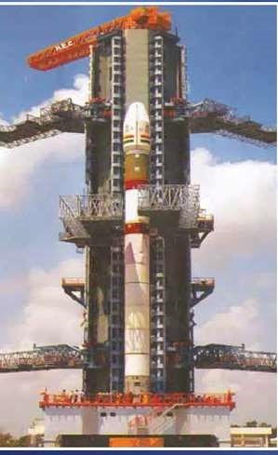

Fig.1.1 Launching pad for ISRO,Sriharikota

7.Nuclear energy

Independent India under the leadership of Pandit Jawaharlal Nehru adopted central economic planning for the industrialization of the country. HEC is one of the ambitious industrial projects for infrastructure development of the country that Pandit Jawaharlal Nehru termed ‘The Temple of Modern India”. Steel plays a vital role in building country’s infrastructure. Enhancement of steel production capability was given priority and it was envisaged hat HEC will manufacture steel plant equipment and machineries that will add steel producing capability to the country. The company was incorporated on 31st December, 1958. Pandit Jawaharlal Nehru, the first prime minister of India, dedicated to HEC the nation on 15th November 1963.

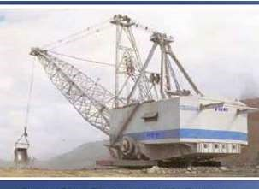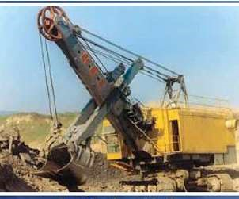

Fig.1.2 Dragline,24 cum Bucket capacity,96m Fig.1.3 Electric rope shovel,5

. boom length.[4] Cu.M.[5]

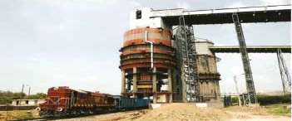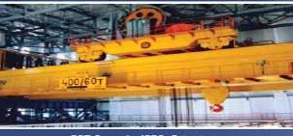

Fig.1.4 Silo,Ore Bedding and Blending Plant, Fig.1.5 EOT Crane for ISRO,

RSP RourkelaSriharikota[3]

1. **UNITS OF HEC:**

* 1. **FOUNDRY FORGE PLANT (FFP):**

It is the largest foundry forge complex in India and one of the largest of its kind in the world. The area of the plant is 13,16,930sq.m. accommodating 76,000 tonnes of installed machinery to cope up with the various operations effectively. This plant is the manufacturer of the heavy casting and forgings for various HEC make equipment and related to Steel Plant, Defense, Power, Nuclear Energy etc.. Manufacturer of forged rolls for Steel Plants, Crank shafts for Railway Loco etc.

* + 1. POWER SUPPLY DEPARTMENT

The power supply department is the main power station of HEC which receives 132kv supply from JSEB. The switching yard is located in building 26. This department is one of the most important areas of HEC and it comes under emergency services. The department is run round the clock and throughout the year. There is a 132KV switching yard in building 26. Then, the transformation takes place to various voltage levels via different substations.

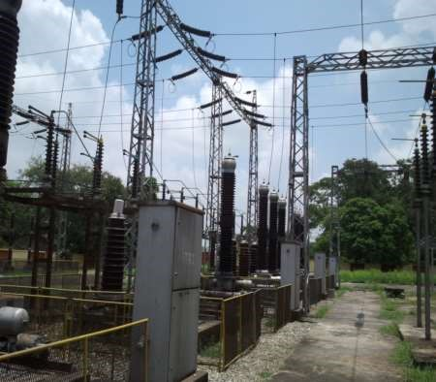

Fig.2.1.1 132KV Switching Yard

* + - 1. LIGHTNING ARRESTOR

It is a device used on electrical power systems and telecommunications systems to protect the insulation and conductor of the system from the damaging effect of lightning. It has a high voltage terminal and a ground terminal. When a lightning surge travels along along the power line to the arrestor, the current from the surge is diverted to the arrestor, in most cases to earth.

If protection fails or absent, lightning that strikes the electrical system introduces thousands of KV that may damage the transmission line and can also cause severe damage to transformer and other electrical or electronic circuit.

Earthing is required between lightning arrestor and isolator, because current is present in a conductor after power is cut off.

Fig.2

.1.1.

1

Lightning Arrestor

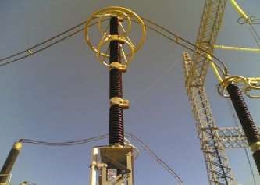

* + - 1. ISOLATOR

In order to disconnect the part of a power system for maintenance and repair purpose, isolator switches are used. The main features of such isolator is that they are operated on no load. The isolators are operated after switching off the load by means of a circuit breaker. The isolators are connected on both sides of the circuit breaker. Thus, to open the isolators, the circuit breaker is to be opened first. Generally, isolator is used for maintenance.[2]

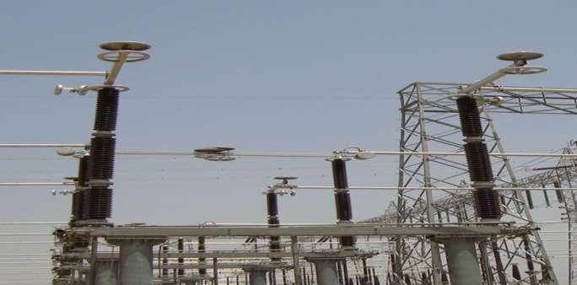

Fig.2.1.1.2 Isolator

* + - 1. CIRCUIT BREAKER

A circuit breaker is an automatically operated electric switch designed to protect an electrical circuit from damage caused by overload or short circuit. Its basic function is to detect a fault condition and by interrupting continuity to immediately discontinue electrical flow. Unlike a fuse, which operate once and then has to be replaced, a circuit

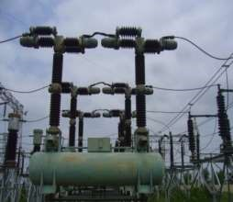

Fig.2.1.1.3 Air Blast Circuit Breaker

breaker can be reset (either manually or automatically) to resume normal operate.

Types of circuit breakers are:

1. Air blast circuit breaker(miniature circuit breaker)
2. Oil circuit breaker
3. Minimum oil circuit breaker
4. Air blast circuit breaker
5. Vacuum circuit breaker
6. Sulphur hexafluoride circuit breaker

2.1.1.4 BUS BAR

An aluminium or copper conductor supported by insulators that interconnect the loads and the sources of electric power in an electric power system. A typical application is the incoming and outgoing transmission lines and transforms at an electrical substation. Bus bar also interconnect the generator and the main transforms in a power plant. In an industrial plant such as an aluminum smelter, large bus-bar supplies several tens of thousands of amperes to the electrolytic process. The bus-bar distributes the current of the two incoming lines between the outgoing line and the transformer. Bus bar collects current and supplies to the other equipment.

TYPES OF BUS BAR:

1. Rigid bus bar
2. Strain bus bar
3. Insulated phase bus bar
4. Sulphur hexafluoride insulated bus bar

2.1.1.5 TRANSFORMER

A Transformer is a static device that transfers electrical energy from one circuit to another through inductively coupled conductors- the transformer’s coils. A varying current in the first or primary winding creates a varying in magnetic flux in the transformer’s core and thus a varying magnetic field through the secondary winding. This varying magnetic field induces a varying electromagnetic force (EMF) or “voltage” in the secondary winding. This effect is called inductive coupling.

If a load is connected to the secondary, current will flow in the secondary winding and electrical energy will be transferred from the primary circuit through the transformer to the load.

In an ideal transformer, the induced voltage in the secondary winding (Vs) is in

proportion to the primary voltage (Vp)and is given by the ratio of the number of turns in the secondary (Ns) to the number of turns in the primary (Np)as follows: Vs/Vp = Ns/Np

By appropriate selection of the turns, a transformer thus enables an alternating current (AC) voltage to be ”stepped up” by making Ns greater than Np or “stepped down” by making Ns less than Np.

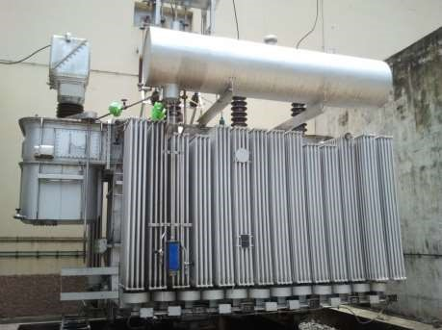 Fig.2.1.1.5 Transformer

2.1.1.6CURRENT TRANSFORMER

It is not possible to use line current for measurement and relaying purpose due to its high value and insulation problem. Current transformer is used to convert line current (primary current) into small standard current values which are suitable for the devices to which it is connected e.g. measuring instruments, meters, protection relays. CT is always connected in series. We can use a transformer to step down current through a power line so that we are able to safely and easily measure high system currents within expensive ammeters. The industry standard secondary current for a CT range is of 0-5A.

2.1.1.7 POTENTIAL TRANSFORMER

Generally, PT is connected in parallel. PT precisely scales dangerous voltage to a safe

value applicable to a conventional voltmeter. PT is designed to provide as accurate a

voltage step down ratio as possible. To aid in precise voltage regulation, loading is kept to a minimum. The voltage is made to have high impedance so as to draw as little current from the PT as possible.

**Number of transformers in HEC:**

1. FFP - 76
2. HMBP - 36
3. HMTP- 07

Township- 64(now under JSEB)

**Protection against 132KV yard:**

1. Protective relay acting overcurrent/earth fault 2. Loss of dc 220V

1. Non parallel acting of poles of circuit breaker
2. Spare
3. Tripping of O.C.C.B. IN 100V circuit AC **Protection against 33KV:**
4. Protective relay acting overcurrent/earth fault
5. Loss of DC 220V
6. Tripping of O.C.C.B. IN 100V circuit AC
7. Breakdown in air pressure system in cell

**Protection against 6.6KV:**

1. Protective relay acting overcurrent/earth fault
2. Loss of DC 220V
3. Fault in T-23
4. Compressor
5. Breakdown in air pressure system in cell
6. Earth leakage in 6.6KV system

**Energy consumption pattern in HEC:**

FFP - 85%

HMBP- 13%

HMTP- 1.5%

Others- 0.5%

**JSEB TARIFF:**

1. Unit charge- Rs. 4.90 per KWH
2. Monthly demand (MD) charges- Rs. 205 per KWA
3. Contract demand (CD)- 18MVA

**Rebates:**

1. 7.5% on voltage(132KV)
2. 1.0% if power factor is between 0.85 to 0.90
3. 2.0% if power factor is more than 0.90

4.0.01 paisa on KWH consumed in a month

NOTE: Rebates are applicable if there is no backlog or arrear **Penalty:**

1. 1.0% on power factorfor every low of 0.01(0.84 to 0.60)
2. 2.0% as delayed payment surcharge(DPS)

**2.2 HEAVY MACHINE BUILDING PLANT:**

The plant has a fenced area of 5,70,000 sq. m. and a floor area of nearly 2,00,000 sq. m.. It is well equipped with sophisticated machine tools and handling equipment to undertake manufacture of heavy machinery and equipment of top quality. It is engaged in design and manufacture of equipment and components for steel plant, mining, mineral processing, crushers, material handling, cranes, power, cement, aluminum, space research, nuclear power etc..

2.2.1 ELECTRICAL REPAIR SHOP

Electrical Repair Shop as the name suggests is complex where all electrical machinery is repaired. HEC has its own shop to take care of any breakdown is functioning if different motors used in other shops. ERS houses knowledgeable and experienced technicians who handle during the breakdown basically winding of motors are burnt due to variation of voltage, detracted insulation, and unbalanced 3 phase supply are the few to name. All such motor windings are repaired in ERS.

I also understood about the identification of dc motor, squirrel cage rotor, slip ring rotor and synchronous machine.

Electrical machines can be broadly classified in:

2.2.1.1 DC MACHINES

As the name suggests it works on DC excitation. It consists of field winding and armature. DC supply is given to the field winding and it produces electromagnetic field. More windings are concentrated type as they are under poles. Poles are nothing but act like magnetic poles, when excited. There are two types of windings. They are lap winding and wave winding.

In lap winding, the number of parallel path is equal to the number of poles.

In wave winding, the number of poles is always two. In this, the slots remain empty which is filled up by dummy coils to maintain the balance of machine.[2]

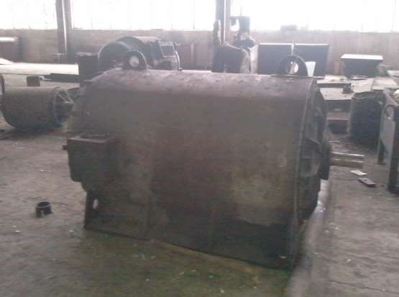

Fig.2.2.1.1 DC Machine

There are two types of DC machine:

1. Separately excited
2. Self excited

Series:thick wires, less no. of turns

Shunt: thin wires, more no. of turns

Compound:combination of series and shunt excited motor

2.2.1.2 AC MACHINE

This is extensively used in industries. These machines work on AC excitation. It may be asynchronous or synchronous. Most machinery comprised of induction motors, squirrel cage and slip ring type. Largely 3-phase slip ring motors are used in different shop of

HEC. Squirrel cage motors are used where constant speed is required we can’t control its speed. Squirrel cage rotor is simpler and economical design. In slip ring rotor, conductors are used as distributed winding.

Thus slip ring rotor is more advantageous than squirrel cage rotor. Synchronous machines

are also widely used in HEC. In small machine, the insulation of polyester is given to the slots of stator for protection and for heavy machine, mica and polyester is given to the slots for protection.

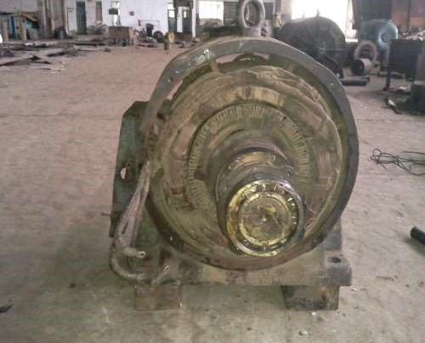

Fig.2.2.1.2 Slip Ring Rotor

The Plant has a fenced area of 5,70,000 sq. m. and a floor area of nearly 2,00,000 sq. m.. It is well equipped with sophisticated machine tools and handling equipments to undertake manufacture of heavy machinery and equipment of top quality. It is engaged in design and manufacture of equipments and components for steel plant, mining, mineral processing, crushers, material handling, cranes, power, cement, aluminium, space research, nuclear power etc. [2]

2.2.2 POWER ENGINEERING DEPARTMENT

Power engineering department takes care of all the electrical machines employed different shops of HMBP. It also takes account of DC drives and AC drives used to run the motors and control their speed and working. As all the machines namely, milling machines, boring machines which are crippled if any flaw in motors occur. This flaw is rectified by electrical technicians.

### 010 SHOPS

PED consists four bays i.e. path. 1st bay, 2nd bay, 3rd bay and 4th bay. 3rd bay and 4th bay consists CNC machine. In 3rd bay, there is only one CNC machine and in 4th bay, there are two CNC machines. CNC may be worked with computerized or manually. **3rd bay:**

The machine name is CNC horizontal turning and boring machine whose serial no. is 1269.

There are five axes:

1. X- Column
2. Y- Headstock
3. Z- Ram/spindle
4. W- Table transverse movement
5. B- Table rotation

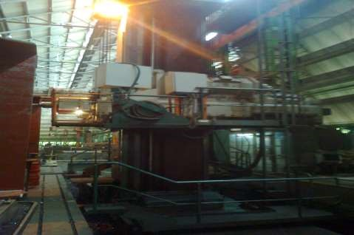

Fig.2.2.2.1 CNC HORIZONTAL TURNING AND BORING MACHINE

**4th bay:** Two CNC’s are used-

1. The machine name is vertical turning and boring machine (VTB) and serial no. is 1262.

It works on two modes:-

(i) Turning : There are two axes (X, Z)

(ii)Milling : There are three axes (X, Z, and C)

X- Headstock

Z- Ram/spindle

C- Table rotation

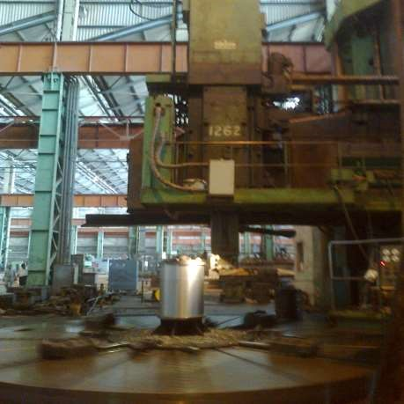

Fig.2.2.2.2 CNC VERTICAL TURNING AND BORING MACHINE **Specifications of job:**

Table diameter -6 m.

Maximum working diameter -14 m.

Height -4.7 m. Weight -250 tones Boring capacity -2.5 m.

Operations with job:

Plane turning

Facing

Boring

Threading

Taper turning

Radius cutting

Grinding

Drilling

Slotting

The machine name is CNC Plano Milling Machine and serial no. is 1265.

There are four axes-

1. Table which slide on the bed.
2. Headstock which slide on cross rail.
3. Ram which slide on the headstock (up and down). W- Cross rail which on the column.

### 020 SHOPS

In this Shop, there are two CNC machines:

1. CNC horizontal boring machine:

Its serial no. is 1687. There are five axes: X, Y, Z, W and B. Name are same as 010 shops.

1. CNC lathe machine:

Its serial no. is 1482. It is different from normal lathe machine in construction. There are two axes.

X :Cross axis

Z :Horizontal axis

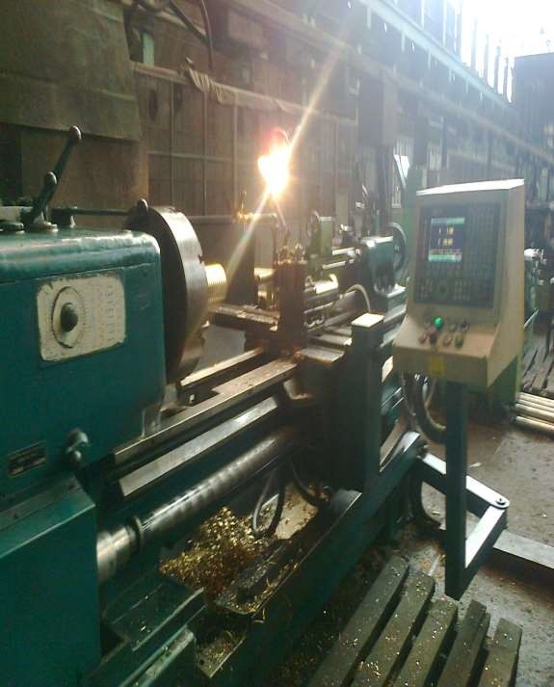

Fig.2.2.2.3 CNC Centre Lathe Machine

**The machine parts are:**

Headstock

Chuck

Tailstock

Tool post

Compound rest

Carriage

Ball screw

Gear

Cross slide

2.2.3 ELECTRIC DRIVE BUREAU

Engineering Device Bureau is the heart of machines. Line diagram is made for any machines/panels in this Bureau.

**Cranes:**

Operations of crane:

1. Hoisting and lowering
2. Cross travel
3. Long travel

Hoisting: Pull up the job with hook.

Lowering: Pull down the job to the table.

Cross travel: Movement of trolley up and down:

Long travel: Movement of crane in a bay.

Transfer car: It is used to move the job from one bay to another bay.

**PROJECT DEVISION**

Design, Engineering and execution of Turnkey Projects in area of bulk material handling plant, coal washening, low temperature carbonization plant.

**Turnkey projects**:

Name project: OBBP (ore bedding blending plant)

Running projects in 2012: 60, 62, 90

60, 62 Bhillai Steel Plant

90 Rourkela Steel Plants **90 RSP:**

Cost: 750 crores

Steel production capacity: Initially: 2.1MTPA

After completion: 4.3 MTPA

**Some points is necessary for a project:**

1. Tender enquiry
2. Submission oftender
3. Techno commercial discussion
4. Price opening
5. Contract signing
6. Design Engineering
7. Plant layout Flow diagram

Motor & Brake power calculation

Preparation of feeder list (motor & component list)

Civil & structural assignment drawing

Purchase specification

Scrutiny of purchase file

Checking of vender drawing and submission of approval

Inspection

Supply to site

Erection & testing

Commissioning & Post Guarantee (PG) test

**Details of tentative feeder list (motor & component list) for some of the equipment involving electrics**:

1. Conveyor system
2. Dust suppression
3. Ventilation & air conditioning
4. Fire fighting
5. Water system, pump & compressor
6. Magnetic separator
7. Metal detector
8. Belt weigh feeder, belt scale
9. Belt feeder
10. Vibro feeder
11. Wagon tippler & side arm charger
12. Pusher car
13. Crane & hoist
14. Shuttle conveyer
15. Stackercumreclaimer
16. Mobile tripper
17. Diverter gate
18. Actuator gate

**Involving the following electrics related to mechanical design**:

1. Motor (DC, AC, Squirrel cage, slip ring, Duty-intermittent & continuous, speed, shaft, coupling, cooling, mounting)
2. Brake (DC shunt, AC solenoid, Disc brake, pith disc brake, thruster)
3. Addressable safety switch (pull cord, belt sway switch, zero speed)
4. Solenoid valve
5. Chute jamming detector
6. Belt rupture switch
7. Level detector
8. CCTV
9. LSTB
10. Welding transformer rectifier
11. Lift

3. **INDUSTRIAL SAFETY**

Preventive measures

1.Use of safety guards for heavy & reciprocating machine component ,e.g crane hook,drophammer,paper cutter etc.

1. Fencing of dangerous and rotating parts like revolving shafts.
2. Incorporating safety devices.
3. Rigid construction of heavy items like hoists,cranes etc.
4. Proper insulation of electric wire &eathlings of neccesary items for body products.
5. Maintenance clearness of shop floor.
6. Removal of metal chips with proper protection.
7. Avoiding fire hazard.
8. Electrical safety
9. All metallic parts , externally accessible must be earthed.
10. Defective and worn out fitting must be replaced promptly.
11. Inflammable matreial should not be kept near electric appliances , live wires or electric control panels.
12. Safety devices like fuse, circuit breaks , and over _ tripping switches must be used when required.

### CONCLUSION

As my training comes to end here in HEC Ltd., RANCHI. I would like to share my experience with you. Now I realize the importance of training & practical applications. During my Engineering Course, I always wonder about theoretical knowledge, which are seeking, would ever be implemented practically. But after my industrial training at HEC Ltd., RANCHI. I can say that have been put to good to use. It was the result of the training only that I got to see the object in real, practical use, which I had only read about & seen as 2-D objects in the books.

These 4 weeks of training gave me a chance to get exposed to the industry culture & work environment these 4 weeks at escorts tractor were learning experience all the way. Here I must mention that learning experience all the way here was due to the full cooperation of the management, staff which helped me in gaining whatever knowledge I gained today about the production improvement & the assembly of tractors. According to me industrial training helped me in the following ways:-

1.It gives us a chance to come across the industrial culture.

2.It tunes and modifies the attitude and always keeps you in learning and inspiring mood.

3.It helps in developing skills for a particular field.

In the end, I would like to conclude that the training is an essential part of the education program. We are pursuing theoretical knowledge which is indeed and a must to have a foundation.