Lesson 102 – Sphere and Torque

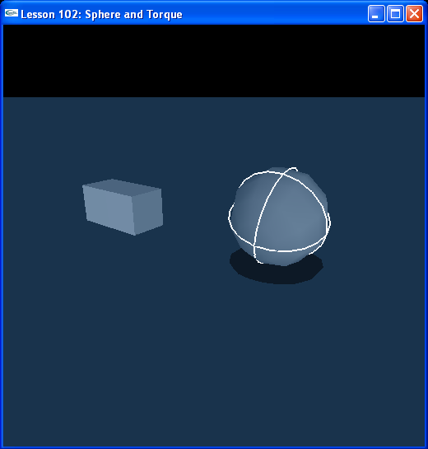

Introduction
In the second lesson everything is set up exactly as the first with some minor changes. The SDK is initialized with the same parameters. The scene is initialized with the same default material, ground plane, and box. We now add a sphere to the scene. KeyboardCallback() and KeyboardUpCallback() have changed to accommodate the fact that we can switch between controlling the box and the sphere and that we will be using torque as well as force on the objects. ApplyForceToActor() adds forces or torques to the focus actor depending on whether we are in Force Mode or Torque Mode.

Creating the Sphere
// Actor globals
NxActor* groundPlane = NULL;
NxActor* box = NULL;
NxActor* sphere = NULL;

// Focus actor
NxActor* gSelectedActor = NULL;
…
void InitNx ()
{
…
// Create the objects in the scene
groundPlane = CreateGroundPlane();
sphere = CreateSphere(NxVec3(0,1,0));
box = CreateBox(NxVec3(5,1,0));

gSelectedActor = sphere;
…
}

The box is back! We have adjusted CreateBox() to take a global position and make a box shape actor like the one in Lesson 101. We have made the box twice as tall as before, for variety, and have moved it 5 meters in the positive x direction (to the left of the camera). There is a also now a new function called CreateSphere().

NxActor* CreateSphere(const NxVec3& pos)
{
// Add a single-shape actor to the scene
NxActorDesc actorDesc;
NxBodyDesc bodyDesc;

// The actor has one shape, a sphere, radius is 1m
NxSphereShapeDesc sphereDesc;
sphereDesc.radius = 1;
actorDesc.shapes.pushBack(&sphereDesc);

actorDesc.body = &bodyDesc;
actorDesc.density = 10;
actorDesc.globalPose.t = pos;
return gScene->createActor(actorDesc);
}

This is exactly the same function as CreateBox(), except instead of a box descriptor, NxBoxShapeDesc boxDesc, we now have a sphere descriptor, NxSphereShapeDesc sphereDesc. Instead of dimensions, the sphere has a radius, which we set to 1 meter.

Setting the Position of an Actor
When you run the lesson, you’ll notice the sphere starting out with a white wireframe outline. The sphere is the currently selected actor or Focus Actor. You can toggle between the sphere and box with “r”, switching focus between the two objects. The actor pointer “gSelectedActor” points to the actor currently in focus.

Try toggling between the box and sphere with “r” and applying forces with “umijkl”. The magnitude of the force is always the same, gForceStrength = 500. Note how the same force accelerates the smaller box more than the larger sphere. Note also how the objects collide and slide off each other.

To return a selected object to a position 5 meters above the origin, hit “t”. This calls the following code in KeyboardUpCallback():

void KeyboardUpCallback(unsigned char key, int x, int y)
{
gKeys[key] = false;

switch (key)
{
…
case 't': { gSelectedActor->setGlobalPosition(NxVec3(0,5,0)); break; }
…
}
}

The function we’re interested in is NxActor::setGlobalPosition(). This function moves the selected object to the position passed in, in this case 5 meters above the origin at (0,5,0). Note that when you hit “t”, the object is immediately teleported to that position. The object does not come to a halt, but retains its velocity and spin.

Applying Torque to the Box and Sphere
Now hit “f” and try the “umijkl” keys again. The yellow force vector is now a light blue torque vector. A torque is applied to the object along the selected axis instead of a force. The torque starts the object spinning in a right-handed manner. Move the camera above the selected object and hit “u”. The torque vector will come up out of the object and the object will start to spin counter-clockwise from your viewpoint. If you put your right hand up to the screen with the thumb up and aligned with the light blue torque vector, you’ll notice the object starts to spin in the direction the fingers on your right hand curl.

The code to do this is as follows.

// Force globals
NxVec3 gForceVec(0,0,0);
NxReal gForceStrength = 500;
bool bForceMode = true;
…
NxVec3 ApplyForceToActor(NxActor* actor, const NxVec3& forceDir, const NxReal forceStrength, bool forceMode)
{
NxVec3 forceVec = forceStrength*forceDir;

if (bForceMode)
actor->addForce(forceVec);
else
actor->addTorque(forceVec);

return forceVec;
}
…
void ProcessKeys()
{
// Process keys
for (int i = 0; i < MAX_KEYS; i++)
{
if (!gKeys[i]) { continue; }

switch (i)
{
…
// Force controls
case 'u': {gForceVec = ApplyForceToActor(gSelectedActor, NxVec3(0,1,0), gForceStrength, bForceMode); break; }
…
}
}
}

So if bForceMode is set, we call gSelectedActor->addForce(), otherwise we call gSelectedActor->addTorque(). Notice the value and the direction of the force and the torque are the same so you can get a sense of what the same vector does to the object as a force and as a torque. Note that the same torque spins the smaller box much more easily than the larger sphere.

Conclusion
We have made actors out of a box and a sphere. We can apply torques as well as forces to both actors.

Related Classes, Functions, and Parameters
NxSphereShapeDesc
radius

NxActor
addTorque()

