Lesson 103 – Capsule, Local Pose, and Center of Mass

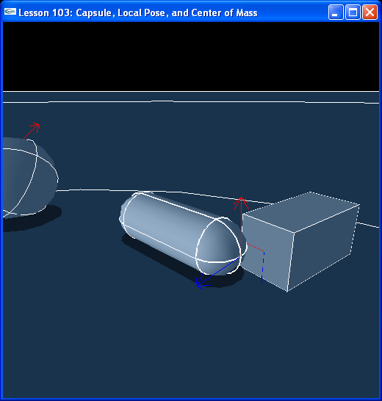

Introduction
The SDK is initialized with the same parameters as the previous two lessons. The scene is initialized with the same default material and ground plane. InitNx() now creates three shapes: a box, a sphere, and a capsule. We make a new function called CreateCapsule(), and flesh it out, along with CreateBox() and CreateSphere(), to take parameters that define the dimensions of each type of shape.

Creating the Capsule
InitNx() now looks like this:

// Actor globals
NxActor* groundPlane = NULL;
NxActor* box = NULL;
NxActor* sphere = NULL;
NxActor* capsule = NULL;

// Focus actor
NxActor* gSelectedActor = NULL;
…
void InitNx()
{
…
// Create the objects in the scene
groundPlane = CreateGroundPlane();
box = CreateBox(NxVec3(5,0,5), NxVec3(0.5,1,0.5), 20);
capsule = CreateCapsule(NxVec3(0,0,0), 2, 0.5, 10);
sphere = CreateSphere(NxVec3(-5,0,5), 1, 10);

gSelectedActor = capsule;
…
}

We have added a new function, CreateCapsule():

NxActor* CreateCapsule(const NxVec3& pos, const NxReal height, const NxReal radius, const NxReal density)
{
// Add a single-shape actor to the scene
NxActorDesc actorDesc;
NxBodyDesc bodyDesc;

// The actor has one shape, a capsule
NxCapsuleShapeDesc capsuleDesc;
capsuleDesc.height = height;
capsuleDesc.radius = radius;
capsuleDesc.localPose.t = NxVec3(0,radius+0.5*height,0);
actorDesc.shapes.pushBack(&capsuleDesc);

actorDesc.body = &bodyDesc;
actorDesc.density = density;
actorDesc.globalPose.t = pos;
return gScene->createActor(actorDesc);
}

The capsule descriptor needs a radius and a height, the radius is the radius of the spheres at the ends of the capsule and the height is the distance between the centers of the spheres. The capsule is set up so that, given an identity pose, the length of the capsule is along the world y-axis. Hence, the capsule starts standing upright.

We now pass the global position, height, radius, and density of the capsule to CreateCapsule() as we want to be able to adjust these parameters each time we call it. We pass similar parameters to CreateBox() and CreateSphere() as well. Note the box is now twice as heavy, with a density of 20. The box is now five units to the left and back of the origin and the sphere is 5 units to the right and back.

Local Pose
Note that the global position of the box and the other actors is now at y = 0. Take a look at the new code in CreateBox().

NxActor* CreateBox(const NxVec3& pos, const NxVec3& boxDim, const NxReal density)
{
// Add a single-shape actor to the scene
NxActorDesc actorDesc;
NxBodyDesc bodyDesc;

// The actor has one shape, a box
NxBoxShapeDesc boxDesc;
boxDesc.dimensions.set(boxDim.x,boxDim.y,boxDim.z);
boxDesc.localPose.t = NxVec3(0,boxDim.y,0);
actorDesc.shapes.pushBack(&boxDesc);

actorDesc.body = &bodyDesc;
actorDesc.density = density;
actorDesc.globalPose.t = pos;
return gScene->createActor(actorDesc);
}

The global position of the actor is “pos”, on the ground at (5,0,5). We set the local position of the box shape in the actor to (0,boxDim.y,0) so that, whatever dimensions we give the box shape, its actor will always start out resting on the ground. Thus, the box actor’s position is (5,0,5) and the local position of the box shape within the actor is (0,1,0). The global position of the box shape within the actor is then (5,1,5).

The local pose of a shape within an actor is often set because very often we want to make an actor out of multiple shapes and place them in different positions with respect to the actor’s center. We usually want the actor to have a global pose somewhere on it so the actor can be easily placed in the scene. The local pose of a shape defines how the shape is positioned within the actor and oriented relative to the actor’s global pose. In this lesson, the shape is offset in its actor by half its height so the actor will start out resting on the ground.

Center of Mass
Look at the code to draw the force arrow on the focus object.

void DrawForce(NxActor* actor, NxVec3& forceVec, const NxVec3& color)
{
// draw only if the force is large enough
NxReal force = forceVec.magnitude();
if (force < 0.1f) return;

forceVec = 3*forceVec/force;

NxVec3 pos = actor->getCMassGlobalPosition();
DrawArrow(pos, pos + forceVec, color);
}

void RenderCallback()
{
…
if (bForceMode)
DrawForce(gSelectedActor, gForceVec, NxVec3(1,1,0));
else
DrawForce(gSelectedActor, gForceVec, NxVec3(0,1,1));
gForceVec = NxVec3(0,0,0);
…
}

The gForceVec is a relative vector denoting the direction and magnitude of the force we are applying to the object. When we call addForce() or addTorque() to an object, we are applying the force or torque to the center of mass of the object. Hence, to represent the force properly, we draw it from the center of mass of the object outward. To get the center of mass of the actor, we use gSelectedActor->getCMassGlobalPosition().

Hit “b” to go to wireframe mode. We currently visualize only collision shapes and actor global poses, so you can see how the actor’s global pose has changed from the last lessons and where it is with respect to the center of mass of the actor which is where forces and torques are applied by addForce() and addTorque().

Conclusion
New things you should have learned: how to create a capsule, what the local pose of a shape within an actor is, and the difference between the global position of an actor, its center of mass, and the local and global positions of its shapes.

Related Classes, Functions, and Parameters
NxCapsuleShapeDesc
height
radius
localPose

NxActor
globalPose
getCMassGlobalPosition()

