Lesson 105 – Materials

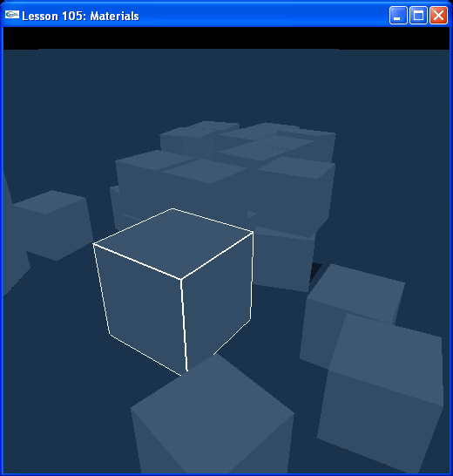

Introduction
In this lesson we learn about object materials and their properties of restitution and friction.

Materials
Materials are the physical substance objects are made of. They define the interior properties of the object, restitution, as well as the surface properties of the object, friction. Both material components are linked to the physical concept of friction. The lower the resitution, the more energy will be lost to heat and the less it will rebound from an impact. The higher the restitution, the less energy it will lose, and the more it will reflect from an impact. How much energy is lost when the object slides along another surface? The higher the surface friction of an object, the more energy will be lost when sliding, the more the object will brake. An object with a low surface friction will lose less energy sliding and tend to glide across a surface unrestricted.

Restitution
If you look at InitNx(), you’ll see that we create a large, heavy box, suspended above the origin and a stack of small boxes to the left. Run the lesson. Hit “p” to unpause the simulation and drop the box from its starting height. On the first bounce, the top of the box just clears the stack of boxes to the left. Now look at the code in that creates the default material.

void InitNx()
{
…
// Create the default material
NxMaterial* defaultMaterial = gScene->getMaterialFromIndex(0);
defaultMaterial->setRestitution(0.5);
defaultMaterial->setStaticFriction(0.5);
defaultMaterial->setDynamicFriction(0.5);
…
}

Change the restitution of the default material to 0.25.

defaultMaterial->setRestitution(0.25);

Now drop the box. Notice that the box rebounds much less than before, not even reaching the height of the stack. When you drive the box into the stack of boxes, it basically just shoves them aside, the boxes in the stack rebound very little. You can return the box to the origin by hitting “t” to make it drop again.

Now change it to 0.75.

defaultMaterial->setRestitution(0.75);

Run the lesson and drop the box. The box rebounds way above the height of the stack. Even the bottom of the box clears the stack. If you run the box into the stack, notice how much the other boxes rebound off it and scatter. Restitution is the bounciness of an object. It defines how much the object will rebound after colliding with other objects.

Static Friction
Set the default material’s restitution back to 0.5 and change the default material’s static friction to 0.95.

defaultMaterial->setStaticFriction(0.95);

Drop the box and wait for it to stop bouncing. Trying moving it with “umijkl”. Notice how difficult it is to start the object moving from a stop with the high static friction, but once you get it moving, it slides fairly easily. This is static friction. It is the stopping force against the object when it’s resting against a surface, basically how well the object sticks to the ground or other surface when it’s not moving. Notice that 0.95 is sticky enough that box occasionally prefers to roll on its edge rather than slide.

Dynamic Friction
Set the default material’s static friction back to 0.5 and change its dynamic friction to 0.1.

defaultMaterial->setDynamicFriction(0.1);

The box glides very easily over the plane with the low dynamic friction. Dynamic friction is a stopping force against the object while it’s moving along the ground or other surface.

Material Combine Modes
All objects in our scene are made of the same material. When objects made of two different materials collide, their restitutions and frictions are averaged by default. You can change this by changing the combine mode on the material to get it to react to other objects' materials in different ways.
There is a Friction Combine Mode field and a Restitution Combine Mode field on each material. The two fields can each be set to one of the following:
NX_CM_AVERAGE - average the values (default)
NX_CM_MIN – take the minimum of the values
NX_CM_MULTIPLY - multiply the values
NX_CM_MAX – take the maximum of the values

Only one combine mode from one material will be used in a collision. If the combine modes on the objects differ, the higher priority combine mode is used. The order of priority of combine modes from lowest to highest is:
NX_CM_AVERAGE
NX_CM_MIN
NX_CM_MULTIPLY
NX_CM_MAX
So, for example, the loweset priority combine mode is the default combine mode, NX_CM_AVERAGE, so any other combine mode set on another object will override it.

To set a friction combine mode on a material, use NxMaterial::setFrictionCombineMode(). To set a restitution combine mode on a material, use NxMaterial::setRestitutionCombineMode().

Friction Scaling
You can scale the magnitude of static and dynamic friction of all your materials at once using the NX_DYN_FRICT_SCALING and NX_STA_FRICT_SCALING parameters. To make use of them, you need to add them to InitNx().

void InitNx()
{
…
gPhysicsSDK->setParameter(NX_DYN_FRICT_SCALING, 0.5);
gPhysicsSDK->setParameter(NX_STA_FRICT_SCALING, 0.5);
…
}

Setting these two parameters this way will halve the static and dynamic friction values on all materials in the simulation (the default for both parameters is 1). An example use for this scaling might be, in a racing game, gradually make all materials slippery if conditions become wet or icy, then gradually return them to their default values once conditions return to normal.

Bounce Threshold
Last in this lesson is the bounce threshold parameter. Set this in InitNx().

gPhysicsSDK->setParameter(NX_BOUNCE_THRESHOLD, -100);

Drop the box. It doesn’t bounce. All objects with a relative velocity below the bounce threshold will not bounce (it is negative because the velocity is a relative velocity, basically a closing velocity between the object and what it’s colliding with.)

This parameter is useful for stopping objects prone to bouncing repeatedly until there is little visible or physical result from their bouncing, like a basketball vibrating on the ground after it has been dropped. These are usually high-restitution objects.

Conclusion
You should now know how to set up a material in the SDK, how to use the material parameters of restitution and friction, how to use the restitution and friction combine modes of materials, how to scale the friction on materials globally, and how to set a lower limit on the “bounce velocity” of your objects.

Related Classes, Functions, and Parameters
NxMaterial
setRestitution()
setStaticFriction()
setDynamicFriction()
setFrictionCombineMode()
setRestitutionCombineMode()

NxCombineMode
NX_CM_AVERAGE
NX_CM_MIN
NX_CM_MULTIPLY
NX_CM_MAX
NxParameter
NX_DYN_FRICT_SCALING
NX_STA_FRICT_SCALING
NX_BOUNCE_THRESHOLD

