Lesson 107 – Static and Kinematic Actors

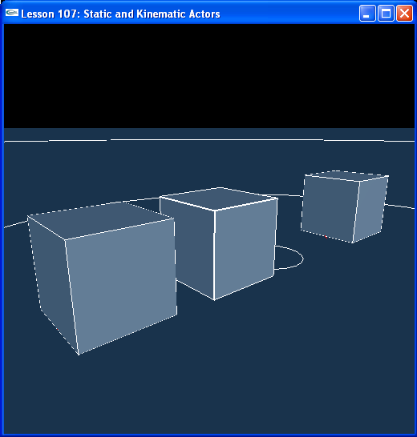

Introduction
So far all of our actors have been dynamic, except for the ground plane, which, defined with no rigid body attached, is static. In this lesson, we build three actors, one static, one dynamic, and one kinematic.

Static Actors
Take a look at InitNx(), we create three box actors there.

// Actor globals
extern NxActor* groundPlane;
NxActor* box1 = NULL;
NxActor* box2 = NULL;
NxActor* box3 = NULL;
...
NxVec3 gKineStartPos = NxVec3(-5,0,0);
...
void InitNx()
{
…
// Create the objects in the scene
groundPlane = CreateGroundPlane();

box1 = CreateBox(NxVec3(5,0,0), NxVec3(1,1,1), 0);
box2 = CreateBox(NxVec3(0,0,0), NxVec3(1,1,1), 5);
box3 = CreateBox(gKineStartPos, NxVec3(1,1,1), 5);
box3->raiseBodyFlag(NX_BF_KINEMATIC);

gSelectedActor = box2;
…
}

Now take a look at CreateBox() and note how it has changed (as have the other single-shape actor creation methods).

NxActor* CreateBox(const NxVec3& pos, const NxVec3& boxDim, const NxReal density)
{
…
if (density)
{
actorDesc.body = &bodyDesc;
actorDesc.density = density;
}
else
{
actorDesc.body = NULL;
}
actorDesc.globalPose.t = pos;
return gScene->createActor(actorDesc);
}

If we assign a positive density to the box, the CreateBox() function makes a body descriptor that it attaches to the actor descriptor and assigns the actor descriptor the density. Otherwise, the body on the actor descriptor is set to NULL. All actor descriptors with a body make an actor that dynamic by default. You can make the actor kinematic from there. If the actor descriptor has a NULL body, it is static.

Note that box1 is set up with a density of 0 and is therefore made static. Box2 has a positive density and is therefore dynamic.

box1 = CreateBox(NxVec3(5,0,0), NxVec3(1,1,1), 0);
box2 = CreateBox(NxVec3(0,0,0), NxVec3(1,1,1), 5);

Run the lesson. Box1 is the box on the left and box2 is the box in the center. Try hitting box1 with box2. Box1 will remain fixed in rotation and translation, it will not move. If you select it with “r”, it will not move under forces or torques. It is a static object and frozen in the scene.

Kinematic Actors
Look at how box3 is set up.

box3 = CreateBox(gKineStartPos, NxVec3(1,1,1), 5);
box3->raiseBodyFlag(NX_BF_KINEMATIC);

It is created as a dynamic actor and then made kinematic with the raiseBodyFlag() function. Try running box2 into box3. For now it behaves exactly like the static actor box1. We can move box3 only when we manually set its position. Take a look at RenderCallback() and the function MoveKinematicActor() that it now calls.

NxReal KT = 0;
NxReal KSpeed = 0.5;
NxVec3 gKineStartPos = NxVec3(-5,0,0);
bool bMoveKinematicActor = false;
…
void SpecialKeys(unsigned char key, int x, int y)
{
switch (key)
{
case 'v': { bMoveKinematicActor = !bMoveKinematicActor; break; }
...
}
}
...
void MoveActorOnPath(NxActor* actor)
{
NxReal x = 5*(NxMath::sin(KT*NxTwoPi)*NxMath::sin(KT*NxTwoPi) - 0.5) + 2.5;
actor->moveGlobalPosition(gKineStartPos + NxVec3(x,0,0));
KT += KSpeed*gDeltaTime;
}

void ProcessInputs()
{
...
// Move the kinematic actor
if (bMoveKinematicActor) MoveActorOnPath(box3);
...
}

void RenderCallback()
{
…
if (gScene && !bPause)
{
GetPhysicsResults();
ProcessInputs();
StartPhysics();
}
…
}

Hit “v” to toggle bMoveKinematicActor to true. Box3, the box on the right, will start moving back and forth. If box2 is in its way, it will push it forward and out of the way. A kinematic actor is like a “movable static” actor, no dynamic object can push it off course and it pushes aside all dynamic actors in its way. We tell the kinematic actor exactly where to be with the MoveActorOnPath() function, in this case somewhere between x = 0 and x = -5 moving on a sine wave.

Hit “v” again to stop the kinematic actor from moving. Now hit “g”, which calls the following piece of code.

// Kinematic motion globals
...
bool bToggleKinematicActor = false;
...
void SpecialKeys (unsigned char key, int x, int y)
{
switch (key)
{
...
case 'g': { bToggleKinematicActor = true; break; }
...
}
}
...
void ProcessInputs()
{
...
// Toggle box3 from kinematic to dynamic
if (bToggleKinematicActor)
{
if (box3->readBodyFlag(NX_BF_KINEMATIC))
box3->clearBodyFlag(NX_BF_KINEMATIC);
else
box3->raiseBodyFlag(NX_BF_KINEMATIC);
bToggleKinematicActor = false;
}
...
}

void RenderCallback()
{
...
if (gScene && !bPause)
{
GetPhysicsResults();
ProcessInputs();
StartPhysics();
}
...
}

“g” toggles box3 between kinematic and dynamic. Once box3 is dynamic, hit “r” to select it. Notice you can move it around now. It is completely dynamic. Hit “g” again. Once it’s kinematic, it will behave like a static actor until you hit “v”, which will teleport it back to where it was on the kinematic path we define in MoveActorOnPath().

While it’s in motion, hit “g” again to make it dynamic. NxActor::moveGlobalPosition() will not move the dynamic actor, and it will come to a halt.

We can move a dynamic actor with NxActor::setGlobalPosition(), though. We are forcing it to a position on the path every frame, but it is free to rotate in this position. Change the MoveActorOnPath() code to use setGlobalPosition().

void MoveActorOnPath(NxActor* actor)
{
NxReal x = 5*(NxMath::sin(KT*NxTwoPi)*NxMath::sin(KT*NxTwoPi) - 0.5) + 2.5;
actor->setGlobalPosition(gKineStartPos + NxVec3(x,0,0));
KT += KSpeed*gDeltaTime;
}

As you can see, using setGlobalPosition() or moveGlobalPosition() on a dynamic actor is an iffy proposition. We are setting a target position for the actor with moveGlobalPosition() and setting the position of the actor explicitly with setGlobalPosition(). Whatever velocities the actor had the frame before remain, so you must be very careful to clear them if you want to make sure you have it under control. Even then, there are certain forces used by the physics solver that are not exposed to the user which might remain, hence using setGlobalPosition() or moveGlobalPosition() on a dynamic actor is inadvisable. Better to make it kinematic, move it, then make it dynamic again.

The kinematic to dynamic transition is very important when considering turning an animated object, like an animated character, into a dynamic one, like a ragdoll. You can select parts of it, like an arm or leg, to be dynamic while the rest of the character is kinematic, but realize the way the SDK is set up, the kinematic parts of the character will always win out over the dynamic parts, i.e., a kinematic piece of the character will push a dynamic one out of the way with seemingly infinite force.

Conclusion
New things you should have learned: how to build a static actor, how to turn a dynamic actor into a kinematic one and back to a dynamic actor again, how to use moveGlobalPosition(), and how to use setGlobalPosition().

Related Classes, Functions, and Parameters
NxActor
setGlobalPosition()
moveGlobalPosition()
readBodyFlag()
raiseBodyFlag()
clearBodyFlag()

NxBodyFlag
NX_BF_KINEMATIC

