Lesson 108 – Freeze Flags and Damping

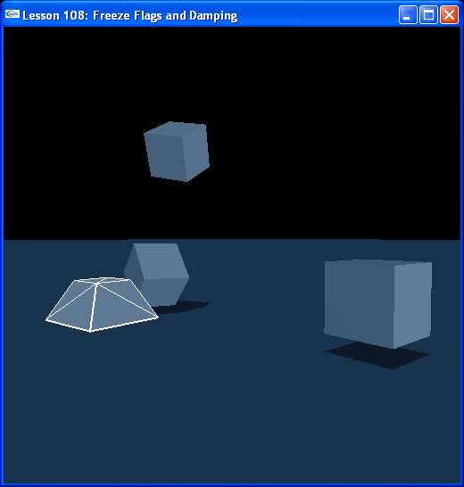

Introduction
In this lesson you will learn about freeze flags and linear and angular damping. Freeze flags are rigid body flags meant to constrain components of an object’s position and rotation, like making sure the object stays at a particular height or is unable to rotate about a particular axis. Disabling gravity is another rigid body flag we will see that makes the actor unaffected by gravity.

Linear and angular damping help stop moving objects that, in the absense of friction, constraints, or collisions, would otherwise continue to travel indefinitely. In a realistic simluation, there is usually a certain measure of air resistance. Doing without linear and angular damping can lead to results that play unrealistically, with objects travelling perpetually, moving without resistance farther than they would normally in an everyday environment.

Freeze Flags
We have created five boxes and a pyramid. The pyramid is not set with the anisotropic friction material, just the default material, and is uncontrained, so you can move it around normally.

// Actor globals
...
NxActor* box1 = NULL;
NxActor* box2 = NULL;
NxActor* box3 = NULL;
NxActor* box4 = NULL;
NxActor* box5 = NULL;
extern NxActor* pyramid;

extern NxActor* gSelectedActor;

...
void InitNx ()
{
…
box1 = CreateBox(NxVec3(10,0.5,0), NxVec3(1,1,1), 10);
box2 = CreateBox(NxVec3(10,0.5,10), NxVec3(1,1,1), 10);
box3 = CreateBox(NxVec3(0,0.5,10), NxVec3(1,1,1), 10);
box4 = CreateBox(NxVec3(-10,0.5,10), NxVec3(1,1,1), 10);
box5 = CreateBox(NxVec3(-10,0.5,0), NxVec3(1,1,1), 10);

pyramid = CreatePyramid(NxVec3(0,0,0), NxVec3(1.5,0.75,1.5), 25);
pyramid->setLinearDamping(0.5);

box1->raiseBodyFlag(NX_BF_FROZEN_POS);
box1->setLinearDamping(0.5);

box2->raiseBodyFlag(NX_BF_FROZEN_POS_X);
box2->raiseBodyFlag(NX_BF_FROZEN_POS_Z);
box2->setLinearDamping(0.5);

box3->raiseBodyFlag(NX_BF_FROZEN_POS_Y);
box3->raiseBodyFlag(NX_BF_FROZEN_POS_Z);
box3->setLinearDamping(0.5);

box4->raiseBodyFlag(NX_BF_FROZEN_POS_X);
box4->raiseBodyFlag(NX_BF_FROZEN_POS_Z);
box4->raiseBodyFlag(NX_BF_DISABLE_GRAVITY);
box4->setLinearDamping(0.5);

box5->raiseBodyFlag(NX_BF_FROZEN_POS_X);
box5->raiseBodyFlag(NX_BF_FROZEN_POS_Y);
box5->setLinearDamping(0.5);

AddUserDataToActors(gScene);

gSelectedActor = pyramid;
…
}

Box1 is frozen in x, y, and z. It cannot move linearly, it can only rotate. Box2 is frozen in x and z, it can only move along the y-axis. Box3 is frozen in y and z, it is constrained to move along the x-axis between boxes 2 and 4. Box4 is frozen in x and z, thus constrained along y, but we have disabled gravity, so when we hit it with the slightest upward force it floats upward effortlessly. The same with box5 if you hit it along z. Box5 is frozen in x and y.

Actors can be frozen in rotation about particular axes as well.

Damping
Linear and angular damping are stopping forces on actors, which, suspended in air with no friction and/or gravity, might continue to tumble to infinity if we didn’t add this. Try taking the linear damping away from box4, in the upper right and hit it with the pyramid. Note that it tumbles upward and keeps going. Linear damping slows it down eventually so this does not happen.

box1->setLinearDamping(0.5);

Instead of stopping an object by contact with another object (either direct collision or friction), think of linear damping as stopping an object with air resistance. Basically, it’s the resistance of the medium you define your objects to reside in.

There is angular damping as well which keeps actors from perpetually spinning. You can think of this as either air resistance or loss of motion due to rotational friction in the interior of the object.

Notice the pyramid has linear damping on it as well. It stops by itself more quickly which makes it easier to control.

Conclusion
From this lesson, you should know everything you need to know about freeze flags and linear and angular damping.

Related Classes, Functions, and Parameters
NxActor
setLinearDamping()
setAngularDamping()

NxBodyFlag
NX_BF_FROZEN_POS_X
NX_BF_FROZEN_POS_Y
NX_BF_FROZEN_POS_Z
NX_BF_FROZEN_ROT_X
NX_BF_FROZEN_ROT_Y
NX_BF_FROZEN_ROT_Z
NX_BF_FROZEN_POS
NX_BF_FROZEN_ROT
NX_BF_FROZEN
NX_BF_DISABLE_GRAVITY

