Lesson 111 – Multishape Actors

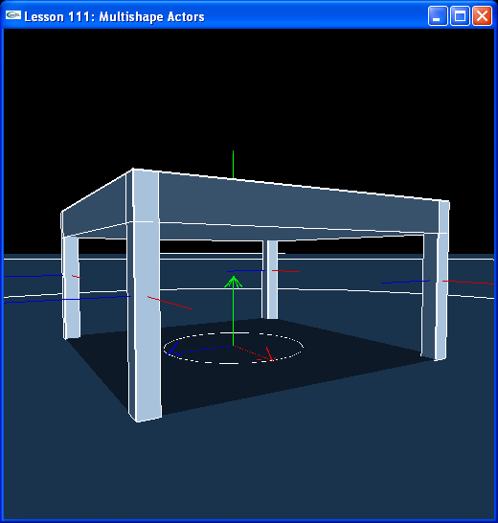

Introduction
So far, we have built all our actors from single shapes. You can supply an actor with more than one shape to build a multi-shape, or compound, actor. In this lesson, we construct a table with a top and four legs.

Multishape Actors
We have a new function called CreateWoodenTable().

NxActor* CreateWoodenTable(const NxVec3& pos, const NxVec3& tableDim, const NxReal topRatio, const NxReal legRatio, const NxReal density)
{
// Add a multi-shape actor to the scene
NxActorDesc actorDesc;
NxBodyDesc bodyDesc;

// The actor has five shapes, a top and four legs
NxBoxShapeDesc topDesc;
topDesc.dimensions.set(tableDim.x,topRatio*tableDim.y,tableDim.z);
topDesc.localPose.t = NxVec3(0,(2-topRatio)*tableDim.y,0);
actorDesc.shapes.pushBack(&topDesc);

NxBoxShapeDesc ulLegDesc;
ulLegDesc.dimensions.set(legRatio*tableDim.x,tableDim.y,legRatio*tableDim.z);
ulLegDesc.localPose.t = NxVec3((1-legRatio)*tableDim.x,tableDim.y,(1-legRatio)*tableDim.z);
actorDesc.shapes.pushBack(&ulLegDesc);

NxBoxShapeDesc urLegDesc;
urLegDesc.dimensions.set(legRatio*tableDim.x,tableDim.y,legRatio*tableDim.z);
urLegDesc.localPose.t = NxVec3(-(1-legRatio)*tableDim.x,tableDim.y,(1-legRatio)*tableDim.z);
actorDesc.shapes.pushBack(&urLegDesc);

NxBoxShapeDesc llLegDesc;
llLegDesc.dimensions.set(legRatio*tableDim.x,tableDim.y,legRatio*tableDim.z);
llLegDesc.localPose.t = NxVec3((1-legRatio)*tableDim.x,tableDim.y,-(1-legRatio)*tableDim.z);
actorDesc.shapes.pushBack(&llLegDesc);

NxBoxShapeDesc lrLegDesc;
lrLegDesc.dimensions.set(legRatio*tableDim.x,tableDim.y,legRatio*tableDim.z);
lrLegDesc.localPose.t = NxVec3(-(1-legRatio)*tableDim.x,tableDim.y,-(1-legRatio)*tableDim.z);
actorDesc.shapes.pushBack(&lrLegDesc);

actorDesc.body = &bodyDesc;
actorDesc.density = density;
actorDesc.globalPose.t = pos;
return gScene->createActor(actorDesc);
}

void InitNx()
{
…
table = CreateWoodenTable(NxVec3(0,0,0), NxVec3(2,1,2), 0.2, 0.05, 10);
…
}

CreateWoodenTable() works just like our other actor creation functions, CreateSphere(), CreateCube(), etc., only this time we push more than one shape onto the actor descriptor's shape array. This creates an actor made out of multiple shapes, each with its own local transform within the actor.

Note that you need to maintain a separate copy of each shape descriptor when constructing the actor, i.e., you can’t use the same instance of a shape descriptor on two different shapes within the actor.

Actor Axes and Collision Shape Axes
Hit “b” to go to wireframe mode. Note that we have turned on collision axis visualization in InitNx().

gPhysicsSDK->setParameter(NX_VISUALIZE_COLLISION_AXES, 1);

You can use this to see the local frames on the tabletop and each of the four legs. You can turn this on in earlier lessons as well to see the local position of the shape within the actor and how its position differs from the actor's position. For the single shape actors in previous lessons, we put the actor axis where it would be if we set the object on the floor, the shape axis is always located at the center of mass of the shape. For our multi-shape actor we do the same thing. Notice how the table’s actor axis is centered on the ground when the table is standing upright. This is done for convenience. All an artist needs to do is select a spot on the floor to place the table.

Conclusion
That’s all for this lesson! This is a very powerful feature of the SDK. It allows you to make very complicated rigid bodies from a few simple shape types.

Related Classes, Functions, and Parameters
NxParameter
NX_VISUALIZE_COLLISION_AXES

