Lesson 112 – Local Forces and Force Modes

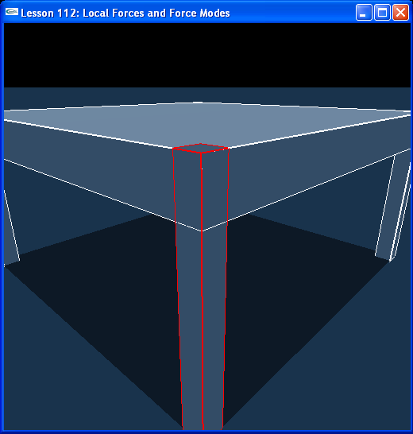

Introduction
Forces and torques can be applied at different positions on an actor, not just at the center of mass. We can also specify these forces locally, so that to apply thrust to a rocket, for example, we need only specify that the thrust be applied along the rocket's forward axis.

Local Forces
We have set up our table as in the last lesson. We now have a focus shape as well as a focus object. We point the focus shape to the first shape in the focus object.

// Actor globals
extern NxActor* groundPlane;
NxActor* table = NULL;

// Focus actor and shape
extern NxActor* gSelectedActor;
extern NxShape* gSelectedShape;
…
void InitNx()
{
…
table = CreateWoodenTable(NxVec3(0,0,0), NxVec3(2,1,2), 0.2, 0.05, 10);
gSelectedActor = table;
gSelectedShape = table->getShapes()[0];
…
}

Use “v” to toggle between Actor Selection Mode and Shape Selection Mode. Use “r” to toggle through objects when in Actor Selection Mode as usual and to toggle through the shapes on the focus objects when in Shape Selection Mode.

Hit “v” to go to Shape Selection Mode. Use “r” to select one of the table’s legs. Now use the “umijkl” keys to move the object around. Notice the force is now applied at the center of the focus shape. We are applying our force at the shape’s local position in the object using NxActor::addForceAtLocalPos(). Look at ApplyForceToActorAtShape(), called from ProcessKeys().

NxVec3 ApplyForceToActorAtShape(NxActor* actor, NxShape* shape, const NxVec3& forceDir, const NxReal forceStrength, bool forceMode, bool actorSelectMode)
{
NxVec3 forceVec = forceStrength*forceDir*gDeltaTime;

if (forceMode)
{
if (shapeSelectMode)
{
actor->addForceAtLocalPos(forceVec, shape->getLocalPosition());
}
else
{
actor->addForce(forceVec);
}
}
else
{
actor->addTorque(forceVec);
}

return forceVec;
}
…
void ProcessForceAtShapeKeys()
{
// Process force keys
for (int i = 0; i < MAX_KEYS; i++)
{
if (!gKeys[i]) { continue; }

switch (i)
{
…
// Force controls
case 'i': {gForceVec = ApplyForceToActorAtShape(gSelectedActor, gSelectedShape, NxVec3(0,0,1), gForceStrength, bForceMode, bActorSelectMode); break; }
…
}
}
}

So far, we have been applying forces and torques defined by global vectors and applied at the centers of mass of our actors. The SDK is much more flexible than this. You can apply forces defined globally at a local position, as we have done in this example. You can also apply forces defined locally at global positions using NxActor::addLocalForceAtPos() as well as forces defined locally at local positions on the actor using NxActor::addLocalForceAtLocalPos().

All the different combinations of adding forces and torques to objects are listed at the end of this lesson.

Force Modes
Forces are normally applied at the first substep of a time step, that is, when you call addForce() on an actor, the force will be applied to that object all at once on the first substep. This is the default Force Mode the SDK uses called NX_FORCE.

There are other methods, enumerated by NxForceMode:

NX_FORCE
NX_IMPULSE
NX_VELOCITY_CHANGE
NX_SMOOTH_IMPULSE
NX_SMOOTH_VELOCITY_CHANGE
NX_ACCELERATION

When you call NxScene::simulate() for a certain time step, the SDK divides this time step into a number of substeps that it integrates the physics over.

Use NX_FORCE to apply a force (mass*distance/time^2) to your object at the first substep of the time step. Use NX_IMPULSE to apply an impulse, which is a momentum change (mass*distance/time), to your object at the first substep of the time step. Use NX_VELOCITY_CHANGE to adjust the velocity (distance/time) of your object directly at the first substep of the time step. Use NX_ACCELERATION to apply an acceleration (distance/time^2) to your object at the first substep of the time step.

Use NX_SMOOTH_IMPULSE to apply an impulse to the object over every substep of the time step. Use NX_SMOOTH_VELOCITY_CHANGE to make a velocity change to your object over every substep of the time step. The “smooth” force modes are useful for motion controllers, like character controllers or wheel controllers, which repeatedly apply impulses to their objects.

Try adjusting the force mode to see the results of the different modes. For instance, try changing the aforementioned line of code to the following and run the demo.

gSelectedActor->addForceAtLocalPos(gForceVec, gSelectedShape->getLocalPosition(), NX_IMPULSE);

Try this out and see how the momentum units of the NX_IMPULSE mode differs from the force units of the NX_FORCE mode.

Conclusion
You now know how to do the following: how to add forces at different locations on an actor, how to add forces in local and global reference frames, and how to adjust the force mode to apply forces, momentum impulses, velocity changes, or accelerations to your objects. You can also use the force mode to apply impulses at each substep of the simulation with NX_SMOOTH_IMPULSE and NX_SMOOTH_VELOCITY_CHANGE.

Related Classes, Functions, and Parameters
NxActor
addForceAtPos ( )
addForceAtLocalPos ( )
addLocalForceAtPos ( )
addLocalForceAtLocalPos ( )
addForce ( )
addLocalForce ( )
addTorque ( )
addLocalTorque ()

NxForceMode
NX_FORCE
NX_IMPULSE
NX_VELOCITY_CHANGE
NX_SMOOTH_IMPULSE
NX_SMOOTH_VELOCITY_CHANGE
NX_ACCELERATION

