Lesson 117 – PMaps

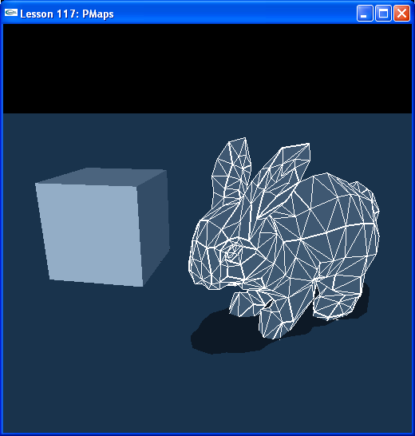

Introduction
For very complicated concave objects, mesh collisions become increasingly slow and less robust. For certain triangle meshes, you may want to create a PMap for the object instead. PMaps are a voxelization of the object, the object no longer uses its surface triangles to do collisions. Instead it uses this voxel geometry, much like the box shape uses the geometry of the box to do collisions instead of creating a triangle mesh to conform to the box and using the individual triangles for collision. This would be much more computationally expensive.

Penetration Maps (PMaps)
The vertex and triangle index information for our object is stored in BunnyData.cpp. Look at InitNx(). We call a function InitBunny() that creates a PMap for our object from this data. The PMap takes a while to create, therefore we save it to a file for future use once we create it.

// Actor globals
NxActor* groundPlane= NULL;
NxActor* bunny = NULL;
NxActor* box = NULL;

// Focus actor
NxActor* gSelectedActor = NULL;

// Mesh globals
NxTriangleMesh* bunnyTriangleMesh;
…
void InitNx()
{
…
// Create the objects in the scene
groundPlane = CreateGroundPlane();

// Initialize bunny data
InitBunny();

bunny = CreateBunny(NxVec3(-2,0,0), bunnyTriangleMesh, 10);
box = CreateBox(NxVec3(2,0,0), NxVec3(0.5,0.5,0.5), 10);

gSelectedActor = bunny;
…
}
…
void InitBunny()
{
// Build vertex normals (used only for rendering)
gBunnyNormals = new NxVec3[BUNNY_NBVERTICES];
NxBuildSmoothNormals(BUNNY_NBFACES, BUNNY_NBVERTICES, (const NxVec3*)gBunnyVertices, (const NxU32*)gBunnyTriangles, NULL, gBunnyNormals, true);

// Initialize PMap
NxPMap bunnyPMap;
bunnyPMap.dataSize = 0;
bunnyPMap.data = NULL;

// Build physical model
NxTriangleMeshDesc bunnyDesc;
bunnyDesc.numVertices = BUNNY_NBVERTICES;
bunnyDesc.numTriangles = BUNNY_NBFACES;
bunnyDesc.pointStrideBytes = sizeof(NxVec3);
bunnyDesc.triangleStrideBytes = 3*sizeof(NxU32);
bunnyDesc.points = gBunnyVertices;
bunnyDesc.triangles = gBunnyTriangles;
bunnyDesc.flags = 0;

bunnyTriangleMesh = gPhysicsSDK->createTriangleMesh(bunnyDesc);

// PMap stuff
// Try loading PMAP from disk
FILE* fp = fopen("bunny.pmap", "rb");

// Set PMap data directory
int set = 0;

#ifndef LINUX
set = SetCurrentDirectory(&fname[0]);
if (!set) set = SetCurrentDirectory(&fname2[0]);
if (!set) set = SetCurrentDirectory(&fname3[0]);
#else
set = chdir(&fname[0]);
//if (set != 0) set = chdir(&fname[1]);
if (set != 0) set = chdir(&fname2[0]);
if (set != 0) set = chdir(&fname3[0]);
#endif

FILE* fp = fopen("bunny.pmap", "rb");
if(!fp)
{
// Not found => create PMap
printf("please wait while precomputing pmap...\n");
if(NxCreatePMap(bunnyPMap, *bunnyTriangleMesh, 64))
{
// The pmap has successfully been created, save it to disk for later use
fp = fopen("bunny.pmap", "wb");
if(fp)
{
fwrite(bunnyPMap.data, bunnyPMap.dataSize, 1, fp);
fclose(fp);
fp = NULL;
}

// Assign pmap to mesh
bunnyTriangleMesh->loadPMap(bunnyPMap);

// sdk created data => sdk deletes it
NxReleasePMap(bunnyPMap);
}
printf("...done\n");
}
else
{
// Found pmap file
bunnyPMap.dataSize = getFileSize("bunny.pmap");
bunnyPMap.data = new NxU8[bunnyPMap.dataSize];
fread(bunnyPMap.data, bunnyPMap.dataSize, 1, fp);
fclose(fp);

// Assign pmap to mesh
bunnyTriangleMesh->loadPMap(bunnyPMap);

// We created data => we delete it
delete bunnyPMap.data;
}
}

Note we create the triangle mesh exactly as we did in the concave object lesson, the major difference in the code is the inclusion of the following lines around the triangle mesh creation code to build a PMap out of the triangle mesh.

// Initialize PMap
NxPMap bunnyPMap;
bunnyPMap.dataSize = 0;
bunnyPMap.data = NULL;
…
if(!fp)
{
…
if(NxCreatePMap(bunnyPMap, *bunnyTriangleMesh, 64))
…
}

These other lines, before the PMap initialization, are not physics related. They are just to create normals on the bunny object for smooth rendering.

// Build vertex normals (used only for rendering)
gBunnyNormals = new NxVec3[BUNNY_NBVERTICES];
NxBuildSmoothNormals(BUNNY_NBFACES, BUNNY_NBVERTICES, (const NxVec3*)gBunnyVertices, (const NxU32*)gBunnyTriangles, NULL, gBunnyNormals, true);

Now look further along in InitNx() where we call CreateBunny() to create the bunny actor. We have already built bunnyTriangleMesh and assigned it bunnyPMap to indicate we will be using this PMap for collision instead of the triangle mesh. We only need to point the triangle mesh shape descriptor’s mesh data to bunnyTriangleMesh.

void InitNx ()
{
…
bunny = CreateBunny(NxVec3(-2,0,0), bunnyTriangleMesh, 10);
box = CreateBox(NxVec3(2,0,0), NxVec3(0.5,0.5,0.5), 10);

gSelectedActor = bunny;
…
}
…
NxActor* CreateBunny(const NxVec3& pos, NxTriangleMesh* triangleMesh, const NxReal density, NxTriangleMeshDesc& tmd)
{
NxActorDesc actorDesc;
NxBodyDesc bodyDesc;

// Create triangle mesh instance
NxTriangleMeshShapeDesc bunnyShapeDesc;
bunnyShapeDesc.meshData = triangleMesh;
bunnyShapeDesc.localPose.t = NxVec3(0,1,0);

if (bunnyShapeDesc.meshData)
{
actorDesc.shapes.pushBack(&bunnyShapeDesc);
if (density)
{
actorDesc.body = &bodyDesc;
actorDesc.density = density;
}
else
{
actorDesc.body = NULL;
}
actorDesc.globalPose.t = pos;
NxActor* actor = gScene->createActor(actorDesc);

// Attach drawable mesh to mesh shape's user data
NxShape*const* shapes = actor->getShapes();
shapes[0]->isTriangleMesh()->getTriangleMesh().saveToDesc(tmd);
shapes[0]->userData = (void*)&tmd;

return actor;
}

return NULL;
}

Try pushing the bunny and box together to test the collision between PMaps and simpler shapes. Change the code to make multiple bunnies to test PMap-to-PMap collisions.

Conclusion
We have now learned how to create a PMap from a triangle mesh. PMaps are very robust for collisions, but are memory and time intensive, so they must be used sparingly. In building collision shapes for your game objects, always remember that simpler is better and faster. Only resort to more complicated means when absolutely necessary. A hierarchy of collision shapes in order of preference of use looks like this:

Box - Box
Convex - Convex
PMap - PMap

Related Classes, Functions, and Parameters
NxPMap
data
dataSize

NxCreatePMap()
NxReleasePMap()

NxBuildSmoothNormals()

