Lesson 119 – Dynamic Continuous Collision Detection

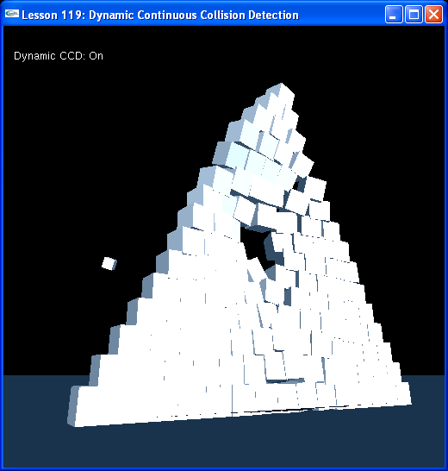

Introduction
Continuous collision detection is required to prevent fast-moving objects from tunneling through other objects. PhysX does a broad phase collision sweep that catches most collisions, though small, high-speed objects will still pass through undetected. To remedy this, you can turn on continuous collision detection.

Continuous Collision Detection
We turn on continuous collision detection in InitNx().

// CCD globals
bool bCCDEnabled = true;
...
void InitNx()
{
// Create a memory allocator
gAllocator = new UserAllocator;

// Create the physics SDK
gPhysicsSDK = NxCreatePhysicsSDK(NX_PHYSICS_SDK_VERSION, gAllocator);
...
// Turn on continuous collision detection for dynamic objects
gPhysicsSDK->setParameter(NX_CONTINUOUS_CD, bCCDEnabled);
gPhysicsSDK->setParameter(NX_CCD_EPSILON, 0.01);
...
}

NxParameter::NX_CONTINUOUS_CD enables continuous collision detection. NxParameter::NX_CCD_EPSILON specifies the minium safe object length, so all objects with dimensions greater than 0.01 m are guaranteed for collision. Objects under this length may or may not collide.

Dynamic-dynamic CCD
Hit “1”, “2”, or “3” to create a small pyramid of boxes, a large pyramid of boxes, or a tower of boxes.

void SpecialKeys(unsigned char key, int x, int y)
{
switch(key)
{
case '1': CreateStack(10); break;
case '2': CreateStack(15); break;
case '3': CreateTower(10); break;
...
}

Look at CreateStack().

void CreateStack(int size)
{
const float cubeSize = 0.2f;
const float spacing = 0;
NxVec3 pos(0,0,0);
float offset = -size * (cubeSize * 2.0f + spacing) * 0.5f;
while(size)
{
for(int i=0;i<size;i++)
{
pos.x = offset + (float)i * (cubeSize * 2.0f + spacing);
CreateCCDBox(pos, NxVec3(cubeSize, cubeSize, cubeSize), 10, false);
}

offset += cubeSize;
pos.y += (cubeSize * 2.0f + spacing);
size--;
}
}

CreateStack() calls CreateCCDBox() to generate the boxes that make the stack.

NxActor* CreateCCDBox(const NxVec3& pos, const NxVec3& boxDim, const NxReal density, bool doDynamicCCD)
{
// Add a single-shape actor to the scene
NxActorDesc actorDesc;
NxBodyDesc bodyDesc;

// The actor has one shape, a box
NxBoxShapeDesc boxDesc;
boxDesc.dimensions.set(boxDim.x,boxDim.y,boxDim.z);
boxDesc.localPose.t = NxVec3(0,boxDim.y,0);

// Set box up with CCD skeleton
boxDesc.ccdSkeleton = CreateCCDSkeleton(boxDim.x*0.8f);
if (doDynamicCCD) boxDesc.shapeFlags |= NX_SF_DYNAMIC_DYNAMIC_CCD; // Activate dynamic-dynamic CCD for this body

actorDesc.shapes.pushBack(&boxDesc);

if (density)
{
actorDesc.body = &bodyDesc;
actorDesc.density = density;
}
else
{
actorDesc.body = NULL;
}
actorDesc.globalPose.t = pos;
return gScene->createActor(actorDesc);
}

CreateCCDBox() creates a box actor from a box shape, just like our usual CreateBox() function, only with the addition that we build a CCD skeleton for the box shape.

// Set box up with CCD skeleton
boxDesc.ccdSkeleton = CreateCCDSkeleton(boxDim.x*0.8f);

This CCD skeleton is a convex mesh that conforms to the box.

NxCCDSkeleton* CreateCCDSkeleton(float size)
{
NxU32 triangles[3 * 12] = {
0,1,3,
0,3,2,
3,7,6,
3,6,2,
1,5,7,
1,7,3,
4,6,7,
4,7,5,
1,0,4,
5,1,4,
4,0,2,
4,2,6
};

NxVec3 points[8];

// Static mesh
points[0].set( size, -size, -size);
points[1].set( size, -size, size);
points[2].set( size, size, -size);
points[3].set( size, size, size);

points[4].set(-size, -size, -size);
points[5].set(-size, -size, size);
points[6].set(-size, size, -size);
points[7].set(-size, size, size);

NxSimpleTriangleMesh stm;
stm.numVertices = 8;
stm.numTriangles = 6*2;
stm.pointStrideBytes = sizeof(NxVec3);
stm.triangleStrideBytes = sizeof(NxU32)*3;

stm.points = points;
stm.triangles = triangles;
stm.flags |= NX_MF_FLIPNORMALS;
return gPhysicsSDK->createCCDSkeleton(stm);
}

Hit space to fire a small, fast box at your stack of boxes.

bool bFireCCDBox = false;
...
void SpecialKeys(unsigned char key, int x, int y)
{
switch(key)
{
...
case ' ':
{
bFireCCDBox = true;
}
break;
}
}

void ProcessInputs()
{
...
if (bFireCCDBox)
{
bFireCCDBox = false;
NxActor* ccdBox = CreateCCDBox(gCameraPos, NxVec3(0.1,0.1,0.1), 10, true);
NxVec3 vel = gCameraForward;
vel.normalize();
vel *= 344;
ccdBox->setLinearVelocity(vel);
}

We call CreateCCDBox() again, to make our projectile box, but this time we flag doDynamicCCD as true.

// Set box up with CCD skeleton
boxDesc.ccdSkeleton = CreateCCDSkeleton(boxDim.x*0.8f);
if (doDynamicCCD) boxDesc.shapeFlags |= NX_SF_DYNAMIC_DYNAMIC_CCD; // Activate dynamic-dynamic CCD for this body

NxShapeFlag::NX_SF_DYNAMIC_DYNAMIC_CCD activates dynamic CCD for the box we are firing. It will get special attention from the solver to make sure that it collides with other shapes that are fitted with continuous collision detection skeletons.

The speed of your box is 344 meters/sec, yet it will still collide with the stack of boxes you create.

Hit “c” to turn off continuous collision detection.

// CCD globals
bool bCCDEnabled = true;

bool bToggleCCDEnabled = false;
...
void SpecialKeys(unsigned char key, int x, int y)
{
switch(key)
{
...
case 'c':
{
bToggleCCDEnabled = true;
}
...
}
}
...
void ProcessInputs()
{
ProcessForceKeys();

if (bToggleCCDEnabled)
{
bToggleCCDEnabled = false;
bCCDEnabled = !bCCDEnabled;
gPhysicsSDK->setParameter(NX_CONTINUOUS_CD, bCCDEnabled);
RefreshDisplayString();
}
...
}

When you fire boxes with “v”, they will now pass right through your stacks as they are moving too fast to collide with Continuous collision detection removed.

Conclusion
You should now know how to enable continuous collision detection for your scene, set your objects up with Continuous collision skeletons, and enable select objects for dynamic-dynamic continuous collision detection with objects fitted with these skeletons.

Related Classes, Functions, and Parameters
NxParameter
NX_CONTINUOUS_CD
NX_CCD_EPSILON

NxShapeFlag
NX_SF_DYNAMIC_DYNAMIC_CCD

NxSimpleTriangleMesh

NxPhysicsSDK
createCCDSkeleton()

NxActor
setLinearVelocity()

