Lesson 203 – Joint Limit Planes

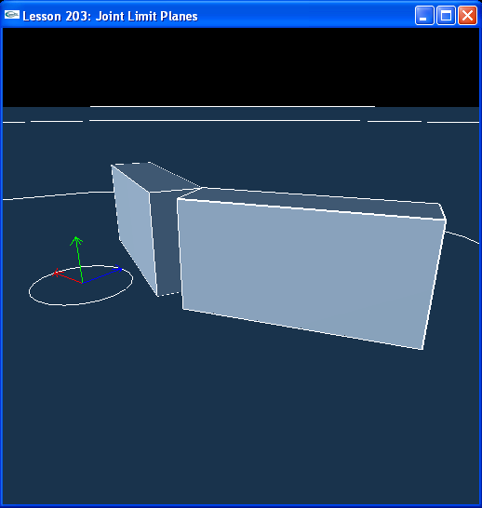

Introduction
Limit planes are another way to specify joint limits. They can be used alone or in conjunction with joint limit values. They are an extra mechanism provided to define joint limits and can be more intuitive than joint limit values given the way the joint is modelled.

The general idea is to attach one or more limit planes to the first actor in the joint and then attach a limit point to the second actor in the joint. The second actor is free to move about the joint as long as the limit point attached to it stays on the positive sides of the limit planes attached to the first actor. You can think of limit planes as stopping planes for the limit point, as the second actor will stop once the limit point on it hits one of the limit planes on the first actor.

Using the same actors and revolute joint from the previous lessons, we put limit planes on the upper actor and a limit point on the lower actor to produce exactly the same joint limit behaviour we produced with limit values in the previous lesson.

Limit Planes
Box1, the upper box, is the first actor in the joint. When we set the limit planes for the joint, they will get attached to box1. Box2, the lower box, is the second actor in the joint.

NxRevoluteJoint* CreateRevoluteJoint(NxActor* a0, NxActor* a1, NxVec3 globalAnchor, NxVec3 globalAxis)
{
NxRevoluteJointDesc revDesc;

revDesc.actor[0] = a0;
revDesc.actor[1] = a1;
revDesc.setGlobalAnchor(globalAnchor);
revDesc.setGlobalAxis(globalAxis);

NxJoint* joint = gScene->createJoint(revDesc);

joint->setLimitPoint(globalAnchor + NxVec3(0,-4,0));
joint->addLimitPlane(NxVec3(-0.707,-0.707,0), globalAnchor);
joint->addLimitPlane(NxVec3(1,0,0), globalAnchor);

return (NxRevoluteJoint*)joint;
}

void InitNx()
{
…
box1 = CreateBox(NxVec3(0,5,0), NxVec3(0.5,2,1), 10);
box1->raiseBodyFlag(NX_BF_KINEMATIC);
box2 = CreateBox(NxVec3(0,1,0), NxVec3(0.5,2,1), 10);

NxVec3 globalAnchor = NxVec3(0.5,5,-1);
NxVec3 globalAxis = NxVec3(0,0,-1);
revJoint = CreateRevoluteJoint(box1, box2, globalAnchor, globalAxis);

gSelectedActor = box2;
…
}

When we set the limit point for the joint, it will get attached to box2. We need to create the joint and use the returned NxJoint pointer to set the limit points and planes on the joint. Note how this differs from limit values, which get set in the joint descriptor before the joint is created.

First, we set the limit point:

joint->setLimitPoint(globalAnchor + NxVec3(0,-4,0));

The limit point is located at the bottom of box2 on the left side (down 4 meters from the globalAnchor of the joint). Then we set the limit planes:

joint->addLimitPlane(NxVec3(-0.707,-0.707,0), globalAnchor);
joint->addLimitPlane(NxVec3(1,0,0), globalAnchor);

The first plane slices diagonally through the joint anchor. Take a plane parallel to the xz-plane passing through the joint anchor, then rotate it 45 degrees about the z-axis. This will stop motion of the lower actor up and to the left. The second plane is parallel to the yz-plane and passes through the joint anchor. It will keep box2 from rotating to the right of the origin.

Run the lesson. We have set up the limit planes so the behaviour of the jointed actors is exactly the same as the behaviour using limit values. This shows how the two are interchangeable. We can also combine them. We could use limit values to set up general limits for the joint and then refine the limits with limit planes or vice versa. In this example, combining the two would probably be redundant, but when you take a look at other types of joints you may see situations where you want to use both depending on how the limits you want to set emerge from the particular situation.

Conclusion
You now know how to use limit values and limit planes to restrict the motion of jointed actors. We will see how to set up limits for new joints as we encounter them in future lessons.

Related Classes, Functions, and Parameters
NxJoint
setLimitPoint()
getLimitPoint()
addLimitPlane()
purgeLimitPlanes()
resetLimitPlaneIterator()
hasMoreLimitPlanes()
getNextLimitPlane()

