Lesson 204 – Joint Springs

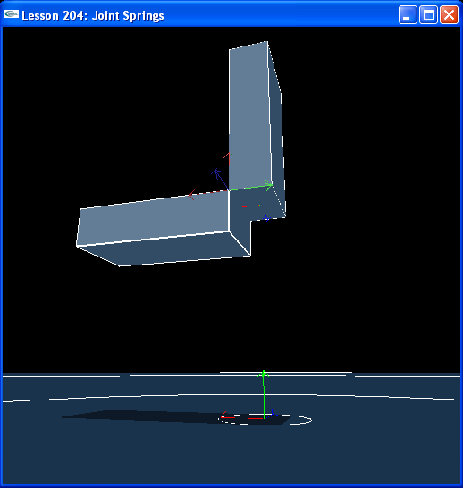

Introduction
Joint springs are a way to specify an angle between the jointed bodies that the bodies tend to move toward. They define a natural resting angle between the joint axes of the two jointed bodies.

Joint Springs
Box2 is once again hanging from kinematic box1 and swings from it by a revolute joint about the z-axis.

NxRevoluteJoint* CreateRevoluteJoint(NxActor* a0, NxActor* a1, NxVec3 globalAnchor, NxVec3 globalAxis)
{
NxRevoluteJointDesc revDesc;
revDesc.actor[0] = a0;
revDesc.actor[1] = a1;
revDesc.setGlobalAnchor(globalAnchor);
revDesc.setGlobalAxis(globalAxis);

revDesc.flags |= NX_RJF_SPRING_ENABLED;

NxSpringDesc springDesc;
springDesc.spring = 5000;
springDesc.damper = 50;
springDesc.targetValue = 0.5*NxPi;

revDesc.spring = springDesc;

return (NxRevoluteJoint*)gScene->createJoint(revDesc);
}

void InitNx()
{
…
box1 = CreateBox(NxVec3(0,5,0), NxVec3(0.5,2,1), 10);
box1->raiseBodyFlag(NX_BF_KINEMATIC);
box2 = CreateBox(NxVec3(0,1,0), NxVec3(0.5,2,1), 10);

box2->raiseBodyFlag(NX_BF_DISABLE_GRAVITY);

NxVec3 globalAnchor = NxVec3(0.5,5,-1);
NxVec3 globalAxis = NxVec3(0,0,-1);
revJoint = CreateRevoluteJoint(box1, box2, globalAnchor, globalAxis);

gSelectedActor = box2;
…
}

To put a spring on the joint, first we enable a spring on the revolute joint descriptor.

revDesc.flags |= NX_RJF_SPRING_ENABLED;

Then we attach a spring descriptor to the revolute joint descriptor.

NxSpringDesc springDesc;
springDesc.spring = 5000;
springDesc.damper = 50;
springDesc.targetValue = 0.5*NxPi;

revDesc.spring = springDesc;

The target value on the spring is the angle the local normal of box2 is pushed toward with respect to the local normal of box1 around the global axis, negative z. This angle is 0.5*NxPi, so box2 rotates about z so that it is perpendicular to the ground once the simulation begins.

springDesc.targetValue = 0.5*NxPi;

The force that pushes box1 toward its target value is 5000. The spring is damped to 50 so box1 doesn’t keep swinging back and forth around the target angle. It eventually loses energy and comes to rest.

springDesc.spring = 5000;
springDesc.damper = 50;

Hit “b” to see how the joint axes are aligned. When box2 is at rest, its local normal is rotated 90 degrees (0.5*NxPi) away from box1’s local normal around box2’s local axis.

Make box1 dynamic by taking out box1->raiseBodyFlag(NX_BF_KINEMATIC) and watch how the two boxes move with respect to each other. The actors will maintain a 90 degree angle with respect to each other unless otherwise forced apart.

Conclusion
Joint springs are very useful for making linked bodies that have a natural resting orientation the springs will pull them back to. You can make things like a rope or a mattress using joint springs. Divide the rope into segments, joint them together, then attach spring descriptors to the joints. You can apply a force to bend the rope, and the spring forces will cause the jointed bodies composing the rope to return to their rest configurations once the force is gone.

Related Classes, Functions, and Parameters
NxRevoluteJointDesc
spring
flags

NxSpringDesc
spring
damper
targetValue

NxRevoluteJointFlag
NX_RJF_SPRING_ENABLED

