Lesson 205 – Joint Motors

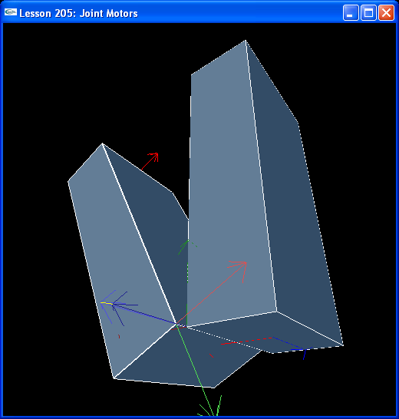

Introduction
Joint motors are used to supply a relative torque between two bodies connected by a revolute or spherical joint.

Joint Motors
Take a look at the new CreateRevoluteJoint() and InitNx():

NxRevoluteJoint* CreateRevoluteJoint(NxActor* a0, NxActor* a1, NxVec3 globalAnchor, NxVec3 globalAxis)
{
NxRevoluteJointDesc revDesc;
revDesc.actor[0] = a0;
revDesc.actor[1] = a1;
revDesc.setGlobalAnchor(globalAnchor);
revDesc.setGlobalAxis(globalAxis);

revDesc.flags |= NX_RJF_MOTOR_ENABLED;

NxMotorDesc motorDesc;
motorDesc.velTarget = 1000;
motorDesc.maxForce = 500;
motorDesc.freeSpin = true;

revDesc.motor = motorDesc;

return (NxRevoluteJoint*)gScene->createJoint(revDesc);
}

void InitNx()
{
…
box1 = CreateBox(NxVec3(0,5,0), NxVec3(0.5,2,1), 10);
box1->raiseBodyFlag(NX_BF_KINEMATIC);
box2 = CreateBox(NxVec3(0,1,0), NxVec3(0.5,2,1), 10);

box2->raiseBodyFlag(NX_BF_DISABLE_GRAVITY);
box2->setAngularDamping(0);
box2->setMaxAngularVelocity(700);

NxVec3 globalAnchor = NxVec3(0.5,5,-1);
NxVec3 globalAxis = NxVec3(0,0,-1);
revJoint = CreateRevoluteJoint(box1, box2, globalAnchor, globalAxis);

gSelectedActor = box2;
…
}

We disable gravity and set the angular damping to 0 so we can see the motor at work without interference.

box2->raiseBodyFlag(NX_BF_DISABLE_GRAVITY);
box2->setAngularDamping(0);

We also do not make the boxes collidable so box2 can spin freely through box1. Finally, we set the maximum angular velocity to 700 so we can get box2 spinning at a good clip. The default maximum angular velocity for objects is 7 and is set this low for objects in general for computational and performance reasons. However, you can set the maximum angular velocity higher by changing the default or setting it higher on a per-actor basis, as above, to simulate objects like wheels or a spinning top which need to rotate at a higher velocity.

Starting the Motor
Run the lesson and hit “p” to unpause the physics. The lower body will start to accelerate around the kinematic upper body until it comes to a constant rotational velocity. The torque supplied to box2 is maxForce. The target rotational velocity is velTarget. The motor is set to freeSpin, so if the motor is turned off during the simulation (maxForce set to 0), box2 will continue spinning.

NxMotorDesc motorDesc;
motorDesc.velTarget = 1000;
motorDesc.maxForce = 500;
motorDesc.freeSpin = true;

revDesc.motor = motorDesc;

If freeSpin is not set, a braking force will be applied and box2 will eventually come to a halt.

Adjusting the Motor Velocity
When you run the demo, you'll notice that hitting “t” will toggle the speed of the motor. Hitting “t” calls the ShiftMotorVelocity() function.

void ShiftMotorVelocity()
{
NxRevoluteJointDesc revDesc;
revJoint->saveToDesc(revDesc);

if (revDesc.motor.velTarget == 1000)
revDesc.motor.velTarget = 10;
else
revDesc.motor.velTarget = 1000;

revJoint->loadFromDesc(revDesc);
}
You can adjust the motor on the fly by saving away the joint descriptor, changing the pertinent values, in this case, velTarget, the motor's target velocity, and loading the descriptor back into the joint. In this case, we save away the joint descriptor, change velTarget, the motor's target velocity, and load it back into the joint, adjusting the target velocity of the joint's motor. You can do this with other object descriptors as well, i.e., save away the descriptor, adjust values on the descriptor, then reload it into the object to change the properties of an object. You will eventually be doing this quite a bit with the 6 DOF joint descriptors to reconfigure the joint parameters on the fly.

Conclusion
Joint motors are useful for creating objects that rotate under some mechanical motivation applied at the joint, such as a car wheel, merry-go-round, record player, etc.

Related Classes, Functions, and Parameters
NxRevoluteJointDesc
motor

NxMotorDesc
velTarget
maxForce
freeSpin

NxRevoluteJointFlag
NX_RJF_MOTOR_ENABLED

NxRevoluteJoint
setMotor()

NxActor
setMaxAngularVelocity()

NxParameter
NX_MAX_ANGULAR_VELOCITY

