Lesson 208 – Prismatic Joints

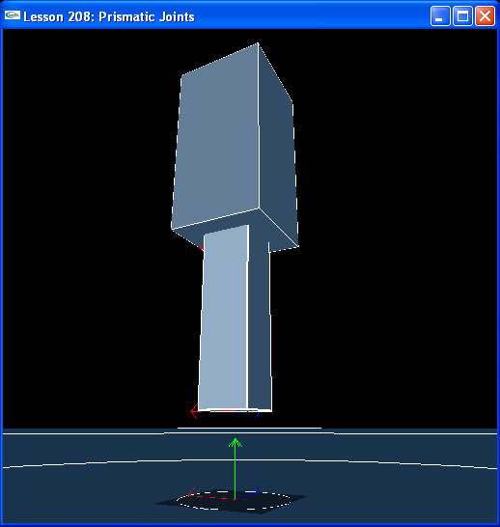

Introduction
Prismatic joints are the first translational joint we will learn. It is purely translational and only free to move along its primary axis. A good example of a prismatic joint is a shock absorber.

Prismatic Joints
// Actor globals
NxActor* groundPlane = NULL;
NxActor* box1 = NULL;
NxActor* box2 = NULL;

// Joint globals
NxPrismaticJoint* prismaticJoint = NULL;
…
void InitNx()
{
…
box1 = CreateBox(NxVec3(0,5,0), NxVec3(1,2,1), 10);
box1->raiseBodyFlag(NX_BF_KINEMATIC);
box2 = CreateBox(NxVec3(0,3,0), NxVec3(0.5,2,0.5), 10);
box2->setLinearDamping(0.5);

NxVec3 globalAnchor = NxVec3(0,7,0);
NxVec3 globalAxis = NxVec3(0,1,0);
prismaticJoint = CreatePrismaticJoint(box1, box2, globalAnchor, globalAxis);

gSelectedActor = box2;
…
}

We make two box actors and attach them at a point two units up inside the top actor, (0,7,0).

NxPrismaticJoint* CreatePrismaticJoint(NxActor* a0, NxActor* a1, NxVec3 globalAnchor, NxVec3 globalAxis)
{
NxPrismaticJointDesc prismaticDesc;
prismaticDesc.actor[0] = a0;
prismaticDesc.actor[1] = a1;
prismaticDesc.setGlobalAnchor(globalAnchor);
prismaticDesc.setGlobalAxis(globalAxis);

NxJoint* joint = gScene->createJoint(prismaticDesc);

joint->setLimitPoint(globalAnchor);
joint->addLimitPlane(-globalAxis, globalAnchor + 1.5*globalAxis);
joint->addLimitPlane(globalAxis, globalAnchor - 1.5*globalAxis);

return (NxPrismaticJoint*)joint;
}

We attach a limit point to the top of the lower actor and limit planes 3 meters apart inside the upper actor and perpendicular to the globalAxis, the axis of motion for the prismatic joint. If we didn’t put these limiting planes in, the lower box would be free to move along the primary axis with nothing inherent in the joint to stop it.

Run the lesson and hit “p” to unpause the simulation. Notice the lower box falls and gets stopped short of the ground by the lower limit plane. If you push it upward with “u”, it will move upward until it is stopped by the upper limit plane.

Conclusion
This lesson demonstrates how to set up a prismatic joint with limit planes defining the range of motion for the joint along its primary axis.

Related Classes, Functions, and Parameters
NxPrismaticJointDesc
NxPrismaticJoint

NxJoint
setLimitPoint()
getLimitPoint()
addLimitPlane()

