Lesson 211 – Point-in-Plane Joints

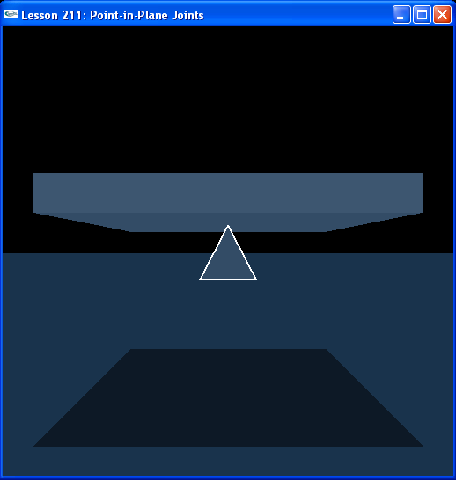

Introduction
The last joint we will learn about is the point-in-plane joint. This joint allows its actors to rotate about all axes with respect to each other and translate along two axes. An example of a point-in-plane joint would be a refrigerator magnet, something that moves along a planar surface and is free to rotate around any axis while attached to the plane.

Point-in-Plane Joints
Instead of the down wedge from the last lesson, we make a kinematic box that we attach the pyramid to.

// Actor globals
NxActor* groundPlane = NULL;
NxActor* box = NULL;
NxActor* pyramid = NULL;

// Joint globals
NxPointInPlaneJoint* pipJoint = NULL;
…
void InitNx()
{
…
box = CreateBox(NxVec3(0,6,0), NxVec3(5,0.5,5), 10);
box->raiseBodyFlag(NX_BF_KINEMATIC);
pyramid = CreatePyramid(NxVec3(0,4,0), NxVec3(1,1,1), 10);
pyramid->setLinearDamping(0.5);
pyramid->setAngularDamping(0.5);

NxVec3 globalAnchor = NxVec3(0,6,0);
NxVec3 globalAxis = NxVec3(0,1,0);
pipJoint = CreatePointInPlaneJoint(box, pyramid, globalAnchor, globalAxis);
…
gSelectedActor = pyramid;
…
}

The globalAnchor is at the tip of the pyramid and in the middle and along the bottom surface of the box.

NxPointInPlaneJoint* CreatePointInPlaneJoint(NxActor* a0, NxActor* a1, NxVec3 globalAnchor, NxVec3 globalAxis)
{
NxPointInPlaneJointDesc pipDesc;
pipDesc.actor[0] = a0;
pipDesc.actor[1] = a1;
pipDesc.setGlobalAnchor(globalAnchor);
pipDesc.setGlobalAxis(globalAxis);
pipDesc.jointFlags |= NX_JF_COLLISION_ENABLED;

NxJoint* joint = gScene->createJoint(pipDesc);

return joint->isPointInPlaneJoint();
}

We enable collision between the pyramid and the box, as before, and build the limiting planes in InitNx().

void InitNx()
{
…
NxJoint* jointPtr = &pipJoint->getJoint();
jointPtr->setLimitPoint(globalAnchor);
// Add left-right and up-down limiting planes
jointPtr->addLimitPlane(NxVec3(1,0,0), globalAnchor - 5*NxVec3(1,0,0));
jointPtr->addLimitPlane(NxVec3(-1,0,0), globalAnchor + 5*NxVec3(1,0,0));
jointPtr->addLimitPlane(NxVec3(0,0,1), globalAnchor - 5*NxVec3(0,0,1));
jointPtr->addLimitPlane(NxVec3(0,0,-1), globalAnchor + 5*NxVec3(0,0,1));
…
}

The limiting planes are flush with the edges of the box and perpendicular to the ground. They catch the pyramid by the tip if it tries to move off any side of the box.

Conclusion
This concludes the point-in-plane joint training program. You now know how to build all the major types of joints in the SDK, attach springs and motors to them as well as limits in the form of limit values and limit planes. Joints are the heart of the intermediate lessons, they are the primary method to make connections between rigid bodies in the PhysX SDK.

Related Classes, Functions, and Parameters
NxPointInPlaneJointDesc
NxPointInPlaneJoint

NxJoint
setLimitPoint()
addLimitPlane()
isPointInPlaneJoint()

NxJointFlag
NX_JOINT_COLLISION_ENABLED

