Lesson 213 – Distance Joints

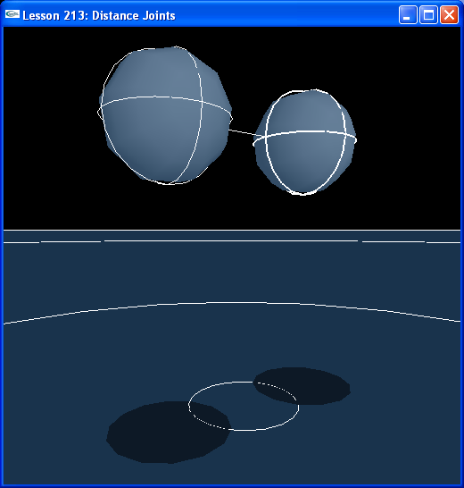

Introduction
The distance joint connects two actors by a rod. Each end of the rod is attached to an anchor point on each actor.

Distance Joints
The distance joint connects two spheres.

NxActor* sphere1 = NULL;
NxActor* sphere2 = NULL;
...
NxDistanceJoint* distanceJoint = NULL;
...
NxDistanceJoint* CreateDistanceJoint(NxActor* a0, NxActor* a1, const NxVec3& anchor0, const NxVec3& anchor1, const NxVec3& globalAxis)
{
NxDistanceJointDesc distanceDesc;
distanceDesc.actor[0] = a0;
distanceDesc.actor[1] = a1;
distanceDesc.localAnchor[0] = anchor0;
distanceDesc.localAnchor[1] = anchor1;
distanceDesc.setGlobalAxis(globalAxis);

NxVec3 dist = a1->getGlobalPose()*anchor1 - a0->getGlobalPose()*anchor0;
distanceDesc.maxDistance = dist.magnitude()*1.5; // maximum rest length of the rope or rod between the two anchor points
distanceDesc.minDistance = dist.magnitude()*0.5; // minimum rest length of the rope or rod between the two anchor points
NxSpringDesc spring;
spring.spring = 100;
spring.damper = 0.5;
distanceDesc.spring = spring; // makes the joint springy. The spring.targetValue field is not used.
distanceDesc.flags = (NX_DJF_MIN_DISTANCE_ENABLED | NX_DJF_MAX_DISTANCE_ENABLED); // combination of the bits defined by ::NxDistanceJointFlag
distanceDesc.flags |= NX_DJF_SPRING_ENABLED;

// distanceDesc.projectionMode = NX_JPM_NONE;
// distanceDesc.projectionMode = NX_JPM_POINT_MINDIST;

distanceDesc.jointFlags |= NX_JF_COLLISION_ENABLED;

return (NxDistanceJoint*)gScene->createJoint(distanceDesc);
}

void InitNx()
{
// Create a memory allocator
gAllocator = new UserAllocator;

// Create the physics SDK
gPhysicsSDK = NxCreatePhysicsSDK(NX_PHYSICS_SDK_VERSION, gAllocator);
if (!gPhysicsSDK) return;

// Set the physics parameters
gPhysicsSDK->setParameter(NX_SKIN_WIDTH, 0.01);

// Set the debug visualization parameters
gPhysicsSDK->setParameter(NX_VISUALIZATION_SCALE, 1);
gPhysicsSDK->setParameter(NX_VISUALIZE_COLLISION_SHAPES, 1);
gPhysicsSDK->setParameter(NX_VISUALIZE_JOINT_LIMITS, 1);
gPhysicsSDK->setParameter(NX_VISUALIZE_JOINT_LOCAL_AXES, 1);

// Create the scene
NxSceneDesc sceneDesc;
sceneDesc.gravity = gDefaultGravity;
sceneDesc.broadPhas = NX_BROADPHASE_COHERENT;
sceneDesc.collisionDetection = true;
gScene = gPhysicsSDK->createScene(sceneDesc);

// Create the default material
NxMaterial* defaultMaterial = gScene->getMaterialFromIndex(0);
defaultMaterial->setRestitution(0.5);
defaultMaterial->setStaticFriction(0.5);
defaultMaterial->setDynamicFriction(0.5);

// Create the objects in the scene
groundPlane = CreateGroundPlane();
...
sphere1 = CreateSphere(NxVec3(-5,4,0), 1, 5);
sphere1->raiseBodyFlag(NX_BF_FROZEN_ROT);
sphere2 = CreateSphere(NxVec3(-8,4,0), 1, 5);
sphere2->raiseBodyFlag(NX_BF_FROZEN_ROT);

// Create distance joint
NxVec3 anchor1 = NxVec3(0,1,0);
NxVec3 anchor2 = NxVec3(0,1,0);
NxVec3 globalAxis2 = NxVec3(-1,0,0);
distanceJoint = CreateDistanceJoint(sphere1, sphere2, anchor1, anchor2, globalAxis2);
...
}

This creates two spheres connected by a distance joint. The anchors for the joint are at the centers of the spheres. The anchors get set in local coordinates, so (0,1,0) is the center of a sphere with radius 1.

Remember to get the rest distance between the anchors in global coordinates:

NxVec3 dist = a1->getGlobalPose()*anchor1 – a0->getGlobalPose()*anchor0;

Set the maxDistance parameter to specify the farthest the anchors of the joint are allowed to separate.

distanceDesc.maxDistance = dist.magnitude()*1.5; // maximum rest length of the rope or rod between the two anchor points

Set the minDistance parameter to specify the closest the anchors of the joint are allowed to come together.

distanceDesc.minDistance = dist.magnitude()*0.5; // minimum rest length of the rope or rod between the two anchor points

Set a spring to add springiness to the joint. With this on, the joint behaves much like a spring and damper effector. With the spring off, the joint is more like a stiff rod connecting the two spheres.

NxSpringDesc spring;
spring.spring = 100;
spring.damper = 0.5;
distanceDesc.spring = spring; // makes the joint springy. The spring.targetValue field is not used.

You need to enable the spring on the flags as well.

distanceDesc.flags |= NX_DJF_SPRING_ENABLED;

Conclusion
The distance joint is an additional joint supplied for gameplay purposes by the SDK.

Related Classes, Functions, and Parameters
NxDistanceJointDesc
minDistance
maxDistance
spring
flags

NxDistanceJoint
loadFromDesc()
saveToDesc()
setFlags()

NxDistanceJointFlag
NX_DJF_MIN_DISTANCE_ENABLED
NX_DJF_MAX_DISTANCE_ENABLED
NX_DJF_SPRING_ENABLED

NxParameter
NX_VISUALIZE_JOINT_LIMITS
NX_VISUALIZE_JOINT_LOCAL_AXES

