Lesson 214 – Spring and Damper Effectors

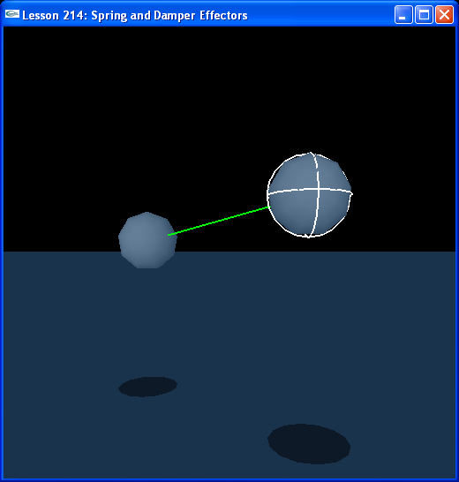

Introduction
We have just learned how to connect actors via joints. Joints are the principle method of linking actors together in PhysX, but not the only method. You can also use spring-damper effectors. You can attach a spring-damper effector from a point on one body to a point on another body. These act as springs between the two bodies, if you push the two bodies together and compress the spring, it will exert an outward force to push the bodies apart. If you pull the bodies away from each other, the spring will act to pull the bodies back together.

The damper part of the effector means you have added friction to the spring, instead of perpetually pulling and pushing the bodies back and forth, the system will eventually lose energy and the bodies will come to a resting distance between each other along the effector.

Spring and Damper Effectors
Look at the new InitNx().

// Actor globals
NxActor* groundPlane = NULL;
NxActor* sphere1 = NULL;
NxActor* sphere2 = NULL;

// Spring and Damper Effector globals
NxSpringAndDamperEffector* spring = NULL;
…
void InitNx()
{
…
sphere1 = CreateSphere(NxVec3(3,0,0), 1, 25);
sphere1->raiseBodyFlag(NX_BF_FROZEN_ROT);
sphere1->raiseBodyFlag(NX_BF_DISABLE_GRAVITY);
sphere1->setLinearDamping(0.5);
sphere2 = CreateSphere(NxVec3(-3,0,0), 1, 25);
sphere2->raiseBodyFlag(NX_BF_FROZEN_ROT);
sphere2->raiseBodyFlag(NX_BF_DISABLE_GRAVITY);
sphere2->setLinearDamping(0.5);

NxVec3 pos1 = sphere1->getCMassGlobalPosition();
NxVec3 pos2 = sphere2->getCMassGlobalPosition();
NxVec3 springVec = pos2 - pos1;

spring = CreateSpring(sphere1, pos1, sphere2, pos2);

sphere1->wakeUp(1e10);
sphere2->wakeUp(1e10);

gSelectedActor = sphere1;
…
}

We make two spheres at a distance of 6 units from each other. We freeze their rotations and disable gravity to isolate the action of the spring-damper from other forces. We then call CreateSpring() to make the spring.

NxSpringAndDamperEffector* CreateSpring(NxActor* actor1, const NxVec3& pos1, NxActor* actor2, const NxVec3& pos2)
{
NxSpringAndDamperEffectorDesc sadeDesc;

sadeDesc.body1 = actor1;
sadeDesc.body2 = actor2;

sadeDesc.pos1 = pos1;
sadeDesc.pos2 = pos2;

NxVec3 springVec = pos2 - pos1;

// Linear spring parameters
sadeDesc.springDistRelaxed = springVec.magnitude();
sadeDesc.springMaxCompressForce = 2000;
sadeDesc.springDistCompressSaturate = 0.25*sadeDesc.springDistRelaxed;
sadeDesc.springMaxStretchForce = 2000;
sadeDesc.springDistStretchSaturate = 2*sadeDesc.springDistRelaxed;

// Linear damper parameters
sadeDesc.damperMaxCompressForce = 100;
sadeDesc.damperVelCompressSaturate = 200;
sadeDesc.damperMaxStretchForce = 100;
sadeDesc.damperVelStretchSaturate = 200;

return gScene->createSpringAndDamperEffector(sadeDesc);
}

We attach the spring to sphere1 and sphere2 at point pos1 on sphere1 and pos2 on sphere2, the centers of mass of the spheres.

sadeDesc.body1 = actor1;
sadeDesc.body2 = actor2;

sadeDesc.pos1 = pos1;
sadeDesc.pos2 = pos2;

Setting the Spring Parameters
We now set the spring parameters for the spring-damper effector. The spring parameters act to restore the length of the spring to its relaxed length. We set this length first, the distSpringRelaxed for the spring. This is the resting length of the spring, the length at which no force is applied along it. We want to set up the spring so that there is no force between the actors at startup, so we set the distSpringRelaxed to the starting distance between the attach points.

NxVec3 springVec = pos2 - pos1;

// Linear spring parameters
sadeDesc.springDistRelaxed = springVec.magnitude();

Next we set the spring compression force parameters. The spring will start to apply an outward force if it is compressed below its distSpringRelaxed length. This force grows linearly until it reaches a maximum of springMaxCompressForce when the spring has length springDistCompressSaturate. At any length below springDistCompressSaturate, the spring will apply a constant outward force of springMaxCompressForce. We set the springMaxCompressForce to 2000 and the springDistCompressSaturate to one-fourth the springDistRelaxed.

sadeDesc.springMaxCompressForce = 2000;
sadeDesc.springDistCompressSaturate = 0.25*sadeDesc.springDistRelaxed;

Next we set the spring stretch force parameters. The spring will start to apply an inward force if it is stretched beyond its springDistRelaxed length. This force grows linearly until it reaches a maximum of springMaxStretchForce when the spring has length springDistStretchSaturate. At any length beyond springDistStretchSaturate, the spring will apply a constant inward force of maxSpringStretchForce. We set the springMaxStretchForce to 2000 and the springDistStretchSaturate to twice the springDistRelaxed.

sadeDesc.springMaxStretchForce = 2000;
sadeDesc.springDistStretchSaturate = 2*sadeDesc.springDistRelaxed;

Setting the Damper Parameters
The spring parameters of the spring-damper effector act against changes to the length of the spring. The damper parameters on the spring-damper effector act against changes to speed of change in the spring, that is, they act against the relative velocities of the two bodies along the spring-damper.

First, we set the damperMaxCompressForce. This is the maximum force the spring-damper applies to counteract compression velocity. The force starts at zero, when the bodies are at rest relative to each other, then ramps up to damperMaxCompressForce as the velocity between the two connected objects approaches damperVelCompressSaturate.

// Linear damper parameters
sadeDesc.damperMaxCompressForce = 100;
sadeDesc.damperVelCompressSaturate = 200;

damperMaxStretchForce and damperVelStretchSaturate work the same way only they act to resist stretch velocity, the relative velocity of the attached bodies moving away from each other.

sadeDesc.damperMaxStretchForce = 100;
sadeDesc.damperVelStretchSaturate = 200;

Remember, this does not damp the global velocity of the spheres, only the relative velocity between them. Try taking off the general linear damping on the spheres.

sphere1->setLinearDamping(0);
…
sphere2->setLinearDamping(0);

Notice the bodies are damped when moving relative to each other, but the spring-mass system as a whole is not, i.e., if you push either sphere, the entire system will continue to move through space without loss of velocity.

Conclusion
Spring-damper effectors are a second way to connect actors using the PhysX SDK. The actors are held together by forces acting across a distance. Spring-damper systems can be used anywhere you would use springs or spring forces in real life.

Related Classes, Functions, and Parameters
NxSpringAndDamperEffectorDesc

NxSpringAndDamperEffector
body1
body2
pos1
pos2
springDistRelaxed
springMaxCompressForce
springDistCompressSaturate
springMaxStretchForce
springDistStretchSaturate
damperMaxCompressForce
damperVelCompressSaturate
damperMaxStretchForce
damperVelStretchSaturate
setBodies()
setLinearSpring()
setLinearDamper()

NxScene
createSpringAndDamperEffector()

