Lesson 307 – Visual Remote Debugger

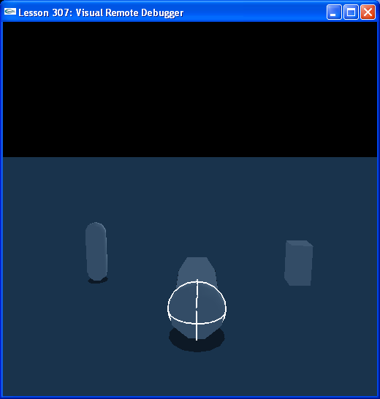

Introduction
The Visual Remote Debugger allows you to use a separate application to monitor the PhysX SDK as it is running.

Visual Remote Debugger
Connect to the Visual Remote Debugger right after creation of the SDK.

// User report globals
...
extern NxRemoteDebugger* gRemoteDebugger;
...
void InitNx()
{
// Create a memory allocator
gAllocator = new UserAllocator;

// Create the physics SDK
gPhysicsSDK = NxCreatePhysicsSDK(NX_PHYSICS_SDK_VERSION, gAllocator);
gRemoteDebugger = gPhysicsSDK->getFoundationSDK().getRemoteDebugger();
gRemoteDebugger->connect("localhost");
...
}

This establishes connection between the SDK and your remote application. You can set up the SDK to send information to the remote debugger via the remote debugger object.

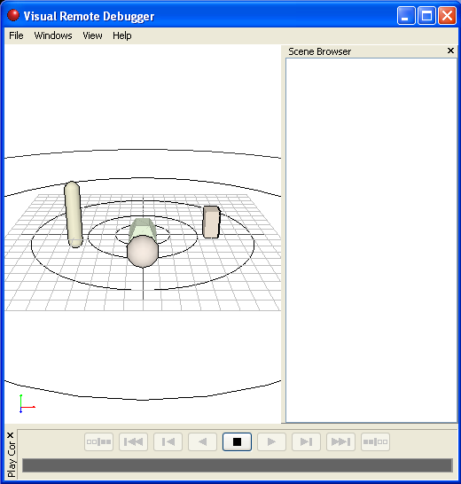

If you run the VRD and then run the demo, you're physics objects will show up in the VRD, as in the above picture.

From the VRD, you can view object's properties and adjust them as well.

Conclusion
The Visual Remote Debugger is handy when you want to run an application alongside your PhysX application to monitor your PhysX appliction.

Related Classes, Functions, and Parameters
NxFoundationSDK
getRemoteDebugger()

NxRemoteDebugger
connect()
flush()
isConnected()
frameBreak()
createObject()
removeObject()
addChild()
removeChild()
writeParameter()
getMask()
getPickedObject()
getPickPoint()

NxRemoteDebuggerObjectType
NX_DBG_OBJECTTYPE_GENERIC
NX_DBG_OBJECTTYPE_ACTOR
NX_DBG_OBJECTTYPE_PLANE
NX_DBG_OBJECTTYPE_BOX
NX_DBG_OBJECTTYPE_SPHERE
NX_DBG_OBJECTTYPE_CAPSULE
NX_DBG_OBJECTTYPE_CYLINDER
NX_DBG_OBJECTTYPE_CONVEX
NX_DBG_OBJECTTYPE_MESH
NX_DBG_OBJECTTYPE_WHEEL
NX_DBG_OBJECTTYPE_JOINT
NX_DBG_OBJECTTYPE_CONTACT
NX_DBG_OBJECTTYPE_BOUNDINGBOX
NX_DBG_OBJECTTYPE_VECTOR
NX_DBG_OBJECTTYPE_CAMERA

