Lesson 402 – Spring-Mass Cloth

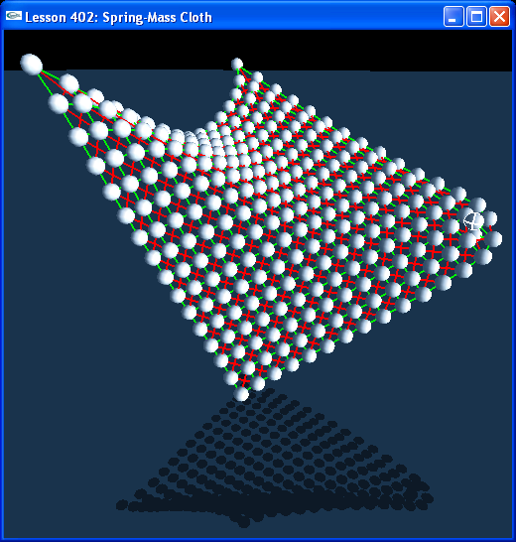

Introduction
We can also create large-scale rigid body effects with springs. This example simulates cloth by connected a grid of spheres together with springs.

Spring-Mass Cloth
We call a function CreateCloth() in InitNx().

// Actor globals
extern NxActor* groundPlane;
NxActor** clothMasses = NULL;

class ClothSpring
{
public:
NxSpringAndDamperEffector* horizSpring;
NxSpringAndDamperEffector* vertSpring;
NxSpringAndDamperEffector* crossUpSpring;
NxSpringAndDamperEffector* crossDownSpring;
};

ClothSpring** clothSprings = NULL;

void InitNx()
{
…
CreateCloth(NxVec3(0,0,0), 16, 16, 0.5, 0.5);
…
}

This creates a 16-by-16 grid of spheres connected together by a spring mesh using the four spring-dampers of ClothSpring. We define the compress and stretch constants globally for the cloth.

const NxReal kSpringCompressSaturateRatio = 0.1;
const NxReal kSpringStretchSaturateRatio = 2;
const NxReal kSpringCompressForce = 1;
const NxReal kSpringStretchForce = 4;

const NxReal kDamperCompressSaturateVel = -0.1;
const NxReal kDamperStretchSaturateVel = 0.1;
const NxReal kDamperCompressForce = 0.25;
const NxReal kDamperStretchForce = 0.25;

Try adjusting these parameters, as well as the sphere mass parameters, and see how it changes the cloth. Notice how if you change any of the spring constants too much, the cloth can start resonating too much and explode.

Conclusion
This has been a lesson on spring-mass cloth. In the next lesson we build cloth out of jointed rigid bodies.

