Lesson 403 – Jointed Rigid Body Cloth

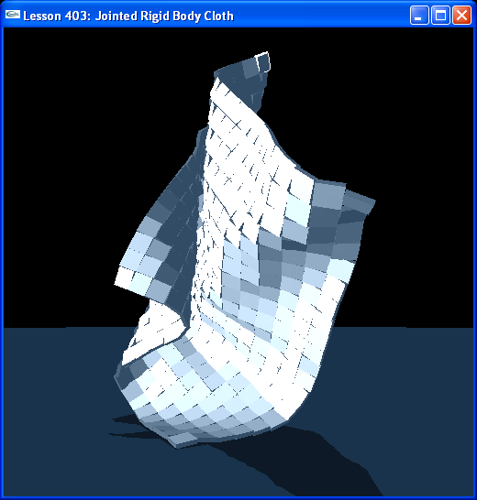

Introduction
We create a large, mattress-like cloth by connecting a grid of rigid bodies together with spherical joints.

Jointed Rigid Body Cloth
We call CreateMattress() in InitNx().

// Actor globals
extern NxActor* groundPlane;
NxActor** patches = NULL;

class PatchLink
{
public:
NxSphericalJoint* xJoint;
NxSphericalJoint* zJoint;
};

PatchLink** patchLinks = NULL;
…
void InitNx()
{
…
CreateMattress(NxVec3(0,30,0), 16, 16, NxVec3(1,0.2,1));
…
}

The mattress is made by taking a 16-by-16 grid of box shape actors and connecting them together with spherical joints.

Run the lesson and hit “b” to go to Debug Mode. Notice how the actors are connected together by the grid of joints. The joints are given a wide swing and just a little twist.

Cloaks and Capes
Cloth like this can be used to create cloaks and capes that you can attach to characters. When attaching a cloth like this to a character, flagpole, or other object, you need to remember not to move the cloth too quickly using NxActor::setGlobalPosition() or NxActor::moveGlobalPosition(). This can cause the cloth to explode or behave erratically.

Either create the cloak in the starting position you want, or, if it’s out of position, move all the bodies of the cloak kinematically to the new position making sure they keep within the constraints of their joints.

Conclusion
We have seen rope and cloth built from jointing rigid bodies together. Try playing around with the joint parameters to create different types of objects.

