Lesson 404 – Ragdolls

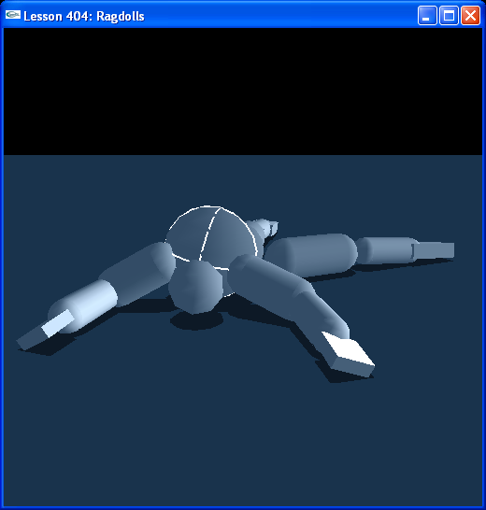

Introduction
Ragdolls are often used in games to simulate a character going limp or staggering back after getting killed or injured. From the start, you want to build your character with the joints and masses in place. You then turn off the physics on the character and make it move under your animation. When you want the character to go ragdoll, turn off the animation control, make the bodies in the ragdoll dynamic and turn on their joints.

Ragdolls
We use a Ragdoll class to create our ragdoll.

class Ragdoll
{
…
NxActor* head;
NxActor* torso;
NxActor* pelvis;
NxActor* leftUpperArm;
NxActor* rightUpperArm;
NxActor* leftForeArm;
NxActor* rightForeArm;
NxActor* leftHand;
NxActor* rightHand;
NxActor* leftThigh;
NxActor* rightThigh;
NxActor* leftCalf;
NxActor* rightCalf;
NxActor* leftFoot;
NxActor* rightFoot;

NxSphericalJoint* neck;
NxSphericalJoint* leftShoulder;
NxSphericalJoint* rightShoulder;
NxSphericalJoint* spine;
NxSphericalJoint* leftHip;
NxSphericalJoint* rightHip;

NxRevoluteJoint* leftElbow;
NxRevoluteJoint* rightElbow;
NxRevoluteJoint* leftWrist;
NxRevoluteJoint* rightWrist;
NxRevoluteJoint* leftKnee;
NxRevoluteJoint* rightKnee;
NxRevoluteJoint* leftAnkle;
NxRevoluteJoint* rightAnkle;
};
...
Ragdoll* guy = NULL;
…
InitNx()
{
..
guy = new Ragdoll(NxVec3(0,0,0));
…
}

The ragdoll is made of 15 actors composing the body. The actors are connected by joints, half spherical and half revolute. The spherical joints are used for the inner connections, like the neck, shoulders, and hips, while the revolute joints are used for the outer connections, like the wrists and ankles.

Ragdoll Joint Limits
Run the lesson and hit “b” to go to Debug Mode. Note the limits on the spherical joints and how they tend to match the range of motion for a human. The revolute joints currently have no limits in place, so our ragdoll is fairly limber. As an exercise, put in limits on the revolute joints using your own body as a reference.

Conclusion
Ragdolls are probably the most mainstream use of jointed physics in games. In future lessons, we will take an animated character and turn it into a ragdoll. We will also look at how to drive an animation with physics using the 6 DOF joint.

