Lesson 405 – Gears

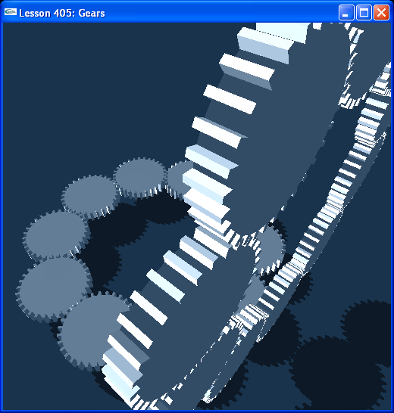

Introduction
In this lesson, we create a gear using a convex shape for its center and box shapes for teeth. We then make copies of the gears and joint them to the world with revolute joints to create an array of interlocking gears that move together.

Gears
We call the following code in InitNx():

// Actor globals
extern NxActor* groundPlane;
NxU32 numGears = 10;
NxActor** gear = NULL;
...
// Joint globals
NxRevoluteJoint** gearJoint = NULL;

// Mesh globals
NxConvexMeshDesc gearConvexMeshDesc;

void InitNx()
{
…
gScene->setTiming(1.0f/200.0f, 30); // timeStep, maxIter, TIMESTEP_FIXED

NxReal gearHeight = 1;

gear = new NxActor*[numGears*2];
gearJoint = new NxRevoluteJoint*[numGears*2];

// CREATE BOTTOM ROW OF GEARS
int i;
for (i = 0; i < numGears; i++)
{
NxReal a,c,s;
NxReal radius = 4.35;
a = 360*(i/(NxReal)numGears);
c = NxMath::cos(a*(NxPi/180))*radius;
s = NxMath::sin(a*(NxPi/180))*radius;

gear[i] = CreateBoxGear(NxVec3(c,0.3+gearHeight,s), 1.25, 1.4, 0.5, 30, 10); // pos, minRad, maxRad, height, numTeeth, density
gear[i]->setGlobalOrientationQuat(AnglesToQuat(NxVec3(0,5*NxMath::mod((NxF32)i,2),0)));
// gear[i] = CreateBoxGear(NxVec3(0,0,0), 1.25, 1.4, 0.5, 30, 10); // pos, minRad, maxRad, height, numTeeth, density
}
for (i = 0; i < numGears; i++)
{
NxReal a,c,s;
NxReal radius = 4.35;
a = 360*(i/(NxReal)numGears);
c = NxMath::cos(a*(NxPi/180))*radius;
s = NxMath::sin(a*(NxPi/180))*radius;

gearJoint[i] = CreateRevoluteJoint(gear[i], NULL, NxVec3(c,0.3+gearHeight,s), NxVec3(0,1,0));
}

// CREATE SIDE COLUMN OF GEARS
for (i = 0; i < numGears; i++)
{
NxReal a,c,s;
NxReal radius = 4.35;
a = 360*(i/(NxReal)numGears);
c = NxMath::cos(a*(NxPi/180))*radius;
s = NxMath::sin(a*(NxPi/180))*radius;

gear[i+numGears] = CreateBoxGear(NxVec3(5.88,c+6.2+gearHeight,s), 1.25, 1.4, 0.5, 30, 10); // pos, minRad, maxRad, height, numTeeth, density
gear[i+numGears]->setGlobalOrientationQuat(AnglesToQuat(NxVec3(0,5*NxMath::mod((NxF32)i,2),90)));
// gear[i] = CreateBoxGear(NxVec3(0,0,0), 1.25, 1.4, 0.5, 30, 10); // pos, minRad, maxRad, height, numTeeth, density
}
for (i = 0; i < numGears; i++)
{
NxReal a,c,s;
NxReal radius = 4.35;
a = 360*(i/(NxReal)numGears);
c = NxMath::cos(a*(NxPi/180))*radius;
s = NxMath::sin(a*(NxPi/180))*radius;

gearJoint[i+numGears] = CreateRevoluteJoint(gear[i+numGears], NULL, NxVec3(5.88,c+6.2+gearHeight,s), NxVec3(-1,0,0));
}
…
}

We create ten gears parallel to the ground and ten gears perpendicular. Each gear is a multishape actor connected to the world by a revolute joint. Take a look at CreateBoxGear() in Actor.cpp.

NxActor* CreateBoxGear(const NxVec3& pos, const NxReal minRadius, const NxReal maxRadius, const NxReal height, const NxU32 numTeeth, const NxReal density)
{
NxActorDesc actorDesc;
NxBodyDesc bodyDesc;
bodyDesc.solverIterationCount = 30; // Fast-moving body, higher solver iteration count

NxReal perimeter = 2*NxPi*minRadius;
NxReal toothWidth = (perimeter / (numTeeth*2))*(NxReal)0.75;
NxReal toothHeight = height;
NxReal toothDepth = maxRadius - minRadius;
NxReal a,c,s;
NxU32 i;

NxVec3 *verts = new NxVec3[numTeeth*2];

for (i = 0; i < numTeeth; i++)
{
a = 360*(i/(NxReal)numTeeth);
c = NxMath::cos(a*(NxPi/180))*minRadius;
s = NxMath::sin(a*(NxPi/180))*minRadius;
verts[2*i] = NxVec3(s, -height/2, c);
verts[2*i+1] = NxVec3(s, height/2, c);
}

// Create descriptor for gear center convex mesh
NxConvexMeshDesc centerDesc;
centerDesc.numVertices = numTeeth*2;
centerDesc.pointStrideBytes = sizeof(NxVec3);
centerDesc.points = verts;
centerDesc.flags = NX_CF_COMPUTE_CONVEX;

NxConvexShapeDesc centerShapeDesc;
centerShapeDesc.localPose.t = NxVec3(0,0,0);

NxInitCooking();
if (0)
{
// Cooking from file
bool status = NxCookConvexMesh(centerDesc, UserStream("c:\\tmp.bin", false));
centerShapeDesc.meshData = gPhysicsSDK->createConvexMesh(UserStream("c:\\tmp.bin", true));
}
else
{
// Cooking from memory
MemoryWriteBuffer buf;
bool status = NxCookConvexMesh(centerDesc, buf);
centerShapeDesc.meshData = gPhysicsSDK->createConvexMesh(MemoryReadBuffer(buf.data));
}
actorDesc.shapes.pushBack(&centerShapeDesc);

NxBoxShapeDesc* boxDesc = new NxBoxShapeDesc[numTeeth];

for (i = 0; i < numTeeth; i++)
{
a = 360*(i/(NxReal)numTeeth);
c = NxMath::cos(a*(NxPi/180))*(minRadius+toothDepth/2);
s = NxMath::sin(a*(NxPi/180))*(minRadius+toothDepth/2);

boxDesc[i].dimensions.set(NxVec3(toothWidth/2,toothHeight/2,toothDepth/2));

NxQuat q = AnglesToQuat(NxVec3(0,a,0));
boxDesc[i].localPose.M.fromQuat(q);
boxDesc[i].localPose.t = NxVec3(s,0,c);

actorDesc.shapes.pushBack(&boxDesc[i]);
}

if (density)
{
actorDesc.body = &bodyDesc;
actorDesc.density = density;
}
else
{
actorDesc.body = NULL;
}
actorDesc.globalPose.t = pos;
return gScene->createActor(actorDesc);
}

The gear is a circular triangle mesh shape arrayed with box-shape teeth.

Moving the Gears
Run the lesson and hit “r” to select a gear. Hit “f” to go to Torque Mode and create a torque perpendicular to the gear. Notice how all the gears move together.

PSCL to C++
The gear array we created was originally created in John Ratcliff’s Physics Scripting Language (PSCL). Take a look at the gears.lua file included in this directory and see how the C++ code we have created closely matches the PSCL script. You can take any PSCL file and, with minor modifications, easily create a stand-alone C++ program from it. In the next few lessons, we will be buidling physics objects originally created using PSCL.

Conclusion
This has been a demonstration of how you can create a small machine made out of gears using the PhysX SDK.

