Lesson 406 – Gears and Belt

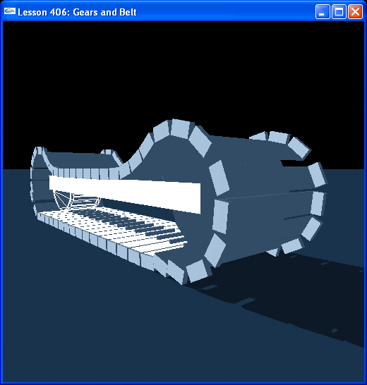

Introduction
In this lesson, we take a modified version of the gear from the last lesson and wrap a belt around it to create a functioning tread.

Gears and Belt
For this lesson, we use the following objects:

// Actor globals
NxActor* groundPlane = NULL;

NxActor* wheel[2];
NxActor* frame;
NxActor* step[47];

NxRevoluteJoint* wheelJoint[2];
NxRevoluteJoint* stepJoint[47];

// Focus actor
NxActor* gSelectedActor = NULL;

In InitNx(), we create two wheels, each made of three round triangle meshes and several box shapes for teeth. We connect the two wheels to a frame by revolute joints.

We then build a belt made of “steps” that we link together with revolute joints. The tread is constructed so that the teeth of the two wheels interlock with the teeth of the steps in the tread, so the wheels move the tread along as they rotate.

Conclusion
This has been a lesson on constructing a tread using a modification of the gear from the last lesson and a belt.

