Lesson 407 – Tank

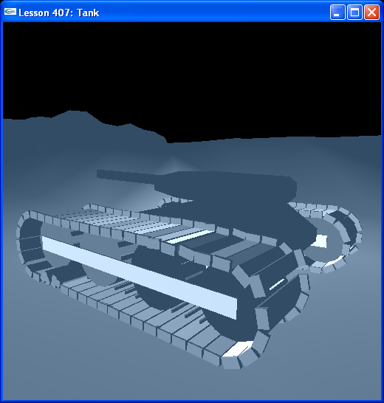

Introduction
For the grand finale of the gears group of lessons, we create a tank.

Tank
We have a Tread class and Tank class we construct the tank from.

class Tread
{
NxActor* wheel[4];
NxActor* frame;
NxActor* step[47];

NxRevoluteJoint* wheelJoint[4];
NxRevoluteJoint* stepJoint[47];
};

class Tank
{
…
Tread* tread[2];
NxActor* chassis;
NxActor* turret;
NxActor* cannon;
NxRevoluteJoint* chassisJoint [2];
NxRevoluteJoint* turretJoint;
NxRevoluteJoint* cannonJoint;
};

The tread is essentially the same as in the last lesson, only now it has 4 wheels. The tank is created from two treads, a chassis, a turret, and a cannon. The chassis is connected to the tread by two fixed joints, the turret is connected to the chassis by a revolute joint, and the cannon is connected to the turret by another revolute joint.

Tank Motors
The tank runs on motors set to each tread. We initialize the descriptors for these motors in InitMotors() called from InitNx().

// Motor globals
NxMotorDesc mNeutralDesc;
NxMotorDesc mForwardDesc;
NxMotorDesc mReverseDesc;
NxMotorDesc mBrakeDesc;

NxMotorDesc mLeftDesc;
NxMotorDesc mRightDesc;
NxMotorDesc mStopDesc;
...
void InitMotors()
{
// Neutral
mNeutralDesc.maxForce = 0;
mNeutralDesc.velTarget = 0;
mNeutralDesc.freeSpin = 1;

// Forward
mForwardDesc.maxForce = 750;
mForwardDesc.velTarget = 200;
mForwardDesc.freeSpin = 1;

// Reverse
mReverseDesc.maxForce = 750;
mReverseDesc.velTarget = -200;
mReverseDesc.freeSpin = 1;

// Brake
mBrakeDesc.maxForce = 500;
mBrakeDesc.velTarget = 0;
mBrakeDesc.freeSpin = 0;

// Left
mLeftDesc.maxForce = 100;
mLeftDesc.velTarget = -50;
mLeftDesc.freeSpin = 0;

// Right
mRightDesc.maxForce = 100;
mRightDesc.velTarget = 50;
mRightDesc.freeSpin = 0;

// Stop
mStopDesc.maxForce = 500;
mStopDesc.velTarget = 0;
mStopDesc.freeSpin = 0;
}

void InitNx()
{
...
InitMotors();
...
}

NxRevoluteJoint::setMotor() called from SetMotorOnTread() called from ProcessKeys(), sets the four wheels on the tread to have one of three motor descriptors: forward, reverse, or brake. It also sets the motor descriptor on the turret joint to either left or right.

void SetMotorOnTread(int i, const NxMotorDesc& mDesc)
{
tank->tread[i]->wheelJoint[0]->setMotor(mDesc);
tank->tread[i]->wheelJoint[1]->setMotor(mDesc);
tank->tread[i]->wheelJoint[2]->setMotor(mDesc);
tank->tread[i]->wheelJoint[3]->setMotor(mDesc);
}

void ProcessKeys()
{
// Process keys
for (int i = 0; i < MAX_KEYS; i++)
{
if (!gKeys[i]) { continue; }

switch (i)
{
// Motor controls
case 'i': {SetMotorOnTread(0, mForwardDesc); SetMotorOnTread(1, mForwardDesc); break; }
case 'k': {SetMotorOnTread(0, mReverseDesc);SetMotorOnTread(1, mReverseDesc); break; }
case ',': {SetMotorOnTread(0, mBrakeDesc);SetMotorOnTread(1, mBrakeDesc); break; }
case 'l': {SetMotorOnTread(0, mForwardDesc);SetMotorOnTread(1, mBrakeDesc); break; }
case 'j': {SetMotorOnTread(0, mBrakeDesc);SetMotorOnTread(1, mForwardDesc); break; }
case 'u': {SetMotorOnTread(0, mReverseDesc);SetMotorOnTread(1, mForwardDesc); break; }
case 'm': {SetMotorOnTread(0, mForwardDesc);SetMotorOnTread(1, mReverseDesc); break; }

case 'c': {tank->turretJoint->setMotor(mLeftDesc); break; }
case 'v': {tank->turretJoint->setMotor(mRightDesc); break; }
}
}
}

In the RenderCallback() function, we call SetMotorOnTread() to reset the tank treads to a neutral motor and NxRevoluteJoint::setMotor() to reset the turret to a stopped motor.

Run the lesson. Use “i” and “k” for forward and reverse, “j” and “l” for left and right, “u” and “m” for hard left and hard right and “,” to brake. Use “c” and “v” to rotate the turret left and right.

Conclusion
This has been a lesson on constructing a tank using a modification of the gear and tread from the last lesson.

