Lesson 501 – Core Dump

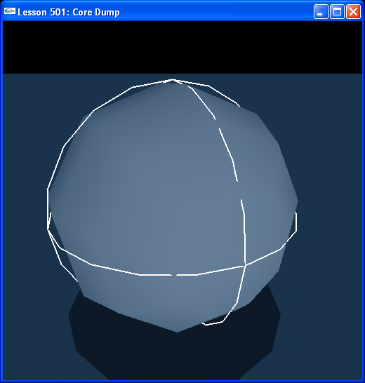

Introduction
In the first chapter on Tools, we describe how to do a core dump. The core dump is a means to save the state of a simulation to a file and load in the simulation state from a file.

Core Dump
Look at ProcessInputs() in Lesson501.cpp.

// Core dump globals
CoreContainer cc;

bool bCoreDump = false;
bool bLoadCore = false;
bool bInstantiateCore = false;
...
void ProcessInputs()
{
...
// Core dump
if (bCoreDump)
{
NxCoreDump(gPhysicsSDK,"MyCoreDump.cda",false,false);
// NxCoreDump(gPhysicsSDK,"MyCoreDump.cdb",true,false); // sdk, file, binary, cooked meshes
bCoreDump = false;
}

// Load core dump to core container
if (bLoadCore)
{
cc.LoadCoreDump(gPhysicsSDK, "MyCoreDump.cda");
// cc.LoadCoreDump(gPhysicsSDK, "MyCoreDump.cdb");
bLoadCore = false;
}

// Instantiate core from core container
if (bInstantiateCore)
{
if (gScene)
{
gPhysicsSDK->releaseScene(*gScene);
}
gScene = cc.InstantiateCoreDump(gPhysicsSDK);
gSelectedActor = *gScene->getActors();
bInstantiateCore = false;
}
...
}
...
void SpecialKeys(unsigned char key, int x, int y)
{
switch (key)
{
case 'c': { printf("Coredumping...\n"); bCoreDump = !bCoreDump; break; }
case 'v': { printf("Loading Core Dump to Container...\n"); bLoadCore = !bLoadCore; break; }
case 'n': { printf("Instantiating Core...\n"); bInstantiateCore = !bInstantiateCore; break; }
}
}

We have three options here:

- Save out a core dump file.
- Load a core dump file to a core container object.
- Instantiate a scene from a loaded core container object.

We discuss each option in detail.

Saving a Core Dump
Hit “c” to save out a core dump file. Hitting “c” sets the bCoreDump flag which calls NxCoreDump().

// Core dump
if (bCoreDump)
{
NxCoreDump(gPhysicsSDK,"MyCoreDump.cda",false,false);
...
bCoreDump = false;
}

NxCoreDump() is defined in CoreDump.cpp.

bool NxCoreDump(NxPhysicsSDK *sdk,const char *fname,bool binary,bool saveCooked)
{
CoreDump cd;
return cd.coreDump(sdk,fname,binary,saveCooked);
}
...
//==================================================================================
// save the contents of the state of the physics SDK in text or binary.
//==================================================================================
bool CoreDump::coreDump( NxPhysicsSDK *sdk, const char *fname, bool binary, bool saveoutCookedData )
{
bool ret = false;
...
}

We pass in four parameters. The first parameter is the physics sdk. The second is the name of the file we will be writing the core dump to, “MyCoreDump.cda”. The third flags whether or not the core dump file is binary. In this case the file is text (.CDA) and not binary (.CDB). The fourth flags whether or not we will be saving away cooked mesh data. In this case, we won't be saving the cooked data.

Look over the CoreDump::coreDump() function to see how the scene data is saved.

After hitting “c”, take a look at the “MyCoreDump.cda” file in the “Core_Dump” directory of the training programs. You'll see all the objects in the simulation listed there along with their saved positions and velocities.

Loading a Core Dump to a Core Container
Hit “v” to load a core dump file to a core container. Hitting “v” sets the bLoadCore flag which calls CoreContainer::LoadCoreDump().

// Core dump globals
CoreContainer cc;
...
// Load core dump to core container
if (bLoadCore)
{
cc.LoadCoreDump(gPhysicsSDK, "MyCoreDump.cda");
...
bLoadCore = false;
}

CoreContainer::LoadCoreDump() is defined in CoreContainer.cpp.

//==================================================================================
// load a core dump...
//==================================================================================
bool CoreContainer::LoadCoreDump( NxPhysicsSDK *sdk, const char *fname )
{
bool ret = false;
...
}

Look at CoreContainer::LoadCoreDump() to see how a core dump file gets loaded to the CoreContainer object.

Hitting “v” will load “MyCoreDump.cda” file from the “Core_Dump” directory of the training programs to the CoreContainer object.

Instantiating a Core Dump
Hit “n” to instantiate the core dump loaded to the core containter. Hitting “n” sets the bInstantiateCore flag which calls CoreContainer::InstantiateCoreDump().

// Core dump globals
CoreContainer cc;
...
// Instantiate core from core container
if (bInstantiateCore)
{
if (gScene)
{
gPhysicsSDK->releaseScene(*gScene);
}
gScene = cc.InstantiateCoreDump(gPhysicsSDK);
gSelectedActor = *gScene->getActors();
bInstantiateCore = false;
}

CoreContainer::InstantiateCoreDump() is defined in CoreContainer.cpp.

NxScene * CoreContainer::InstantiateCoreDump( NxPhysicsSDK *sdk, CoreUserNotify *callback,CoreUserScene *userScene,NxVec3 *offset,SceneType stype)
{
NxScene *ret = 0;
...
}

Look at CoreContainer::InstantiateCoreDump() to see how a CoreContainer object gets instantiated.

Hitting “n” will now instantiate the CoreContainer object. We loaded this with the “MyCoreDump.cda” file from the “Core_Dump” directory. So the program will erase the current scene and reproduce the scene as it existed when you hit “v” to save the core dump file.

Conclusion
The core dump is a means to save away and load back a snapshot of the simulation.

Related Classes, Functions, and Parameters
NxCoreDump() (from CoreDump.cpp)

CoreContainer (from CoreContainer.cpp)
LoadCoreDump()
InstantiateCoreDump()

