Lesson 505 – Asset Export

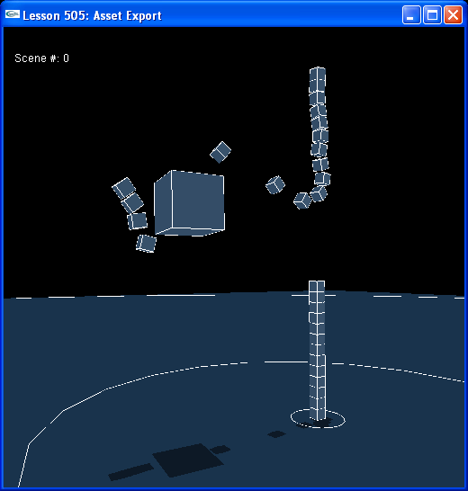

Introduction
In addition to exporting and importing whole scenes, we can export and import scene assets. In this lesson we use the PhysX Import/Export Layer to save a scene out, asset by asset, to a binary file and load one in, asset by asset, from a binary file.

Assets can be interspersed in other files to be imported and exported with the same machinery.

Asset Export
Hit “1” to export the scene asset by asset.

// Include exporter here
#include "NxuStream.h"
#include "NxuStreamFactory.h"
#include "NxuPhysicsExport.h"
#include "NxuPhysicsImport.h"
...
void KeyboardCallback(unsigned char key, int x, int y)
{
gKeys[key] = true;

switch (key)
{
...
case '1':
{
gSave = true;
}
break;
...
}
}
...
void ProcessInputs()
{
...
else if (gSave)
{
SaveScene("pdump1.bin");
}
...
}
...
//==================================================================================
// This is the function that calls the exporter to save out the state of the currently selected scene to a file
void SaveScene(const char* pFilename)
{
// Open our file directly so we can write out application specific data first.
FILE* file = fopen(pFilename, "wb");
if (!file) return;

NxU32 actorCount = gScenes[gCurrentScene]->getNbActors();
NxActor** actorList = gScenes[gCurrentScene]->getActors();

// Write out a custom header. For this example, we will just write out a count of the number of actors
// Note that to make the file be portable across platforms, endian issues would need to be handled here
fwrite(&actorCount, 1, sizeof(actorCount), file);

// Create a stream to write Physx data to our file
NxuOutputStream* stream = NxuStreamFactory::getOutputStream(gFileFormat, file);
if (stream)
{
// Create an exporter to write out the scene.
NxuPhysicsExport exporter;
exporter.setStream(stream); // Assign it the stream

for (NxU32 i=0;i<actorCount;++i)
{
// For each actor, we first right out our application specific data for that actor
// In this case we will store the user data, which is the half-extent of the cube.
int size = (int)(actorList[i]->userData);
fwrite(&size, 1, sizeof(size), file);

// Now stream the actor
exporter.Write(actorList[i]);
// Force everything into the stream so that we can continue writing to the file
exporter.flush();
// Clear out the previous actor to prevent it from being streamed again
// Otherwise it would be cached to allow subsequent joints and effectors to reference it
exporter.clear();
}
}
// We are done streaming Physx objects
NxuStreamFactory::releaseStream(stream);

// Write out any other application data needed. We will write out a string to be echoed on load
// so that we can easily see if any file corruption has occured.
char buffer[256];
sprintf(buffer, "File successfully loaded!\n");
int length = strlen(buffer);
fwrite(&length,1,sizeof(length), file);
fwrite(buffer,length, sizeof(char), file);

fclose(file);
gSave = false;
printf("Scene %d saved to file %s.\n", gCurrentScene, pFilename);
}

This will write out your scene to “pdump1.bin”, actor by actor, using NxuPhysicsExport::Write().

Asset Import
Hit “3” to import “pdump1.bin” asset by asset.

void KeyboardCallback(unsigned char key, int x, int y)
{
gKeys[key] = true;

switch (key)
{
...
case '3':
{
gLoad = true;
}
break;
...
}
}
...
void ProcessInputs()
{
...
else if (gLoad)
{
LoadScene("pdump1.bin");
}
...
}
...
//==================================================================================
// This is the function that calls the importer to load the state of the currently selected scene from a file
NX_BOOL LoadScene(const char* pFilename)
{
NX_BOOL success = false;

if ( gScenes[gCurrentScene] )
{
// Load our actor file into the current scene

if ( gPhysicsSDK )
{
FILE* file = fopen(pFilename, "rb");
if (!file) return false;

// Read in our application header. This was the number of actors in the file.
NxU32 count;
fread(&count, 1, sizeof(count), file);

// Get a stream to read the PhysX actors
NxuInputStream* stream = NxuStreamFactory::getInputStream(gFileFormat, file);
if (stream)
{
NxuPhysicsImport importer; // Create the importer

for (NxU32 i=0;i<count;++i)
{
// Read in our application data for the actor
int size;
fread(&size, 1, sizeof(size), file);

NxuSectionTypes type;
// Read in the PhysX actor
type = importer.parse(*stream); // Read in the stream
assert(type == NxuTypeActor); // Should be an actor!

// We could use the following call to have the importer creat the object for us
// importer.instantiate(*gPhysicsSDK, &gUserNotify, &gUserCreate); //Add the imported data to the SDK

// However, for this example we will show how to simple grab the descriptor directly
const NxuPhysicsCollection* collection = importer.getCollection();

// Since we just imported an actor directly, we extract it from the collection's default model
// If we had imported a whole scene, we would need to traverse the scene to examine all the descriptors
NxActorDesc* actor = collection->defaultModel.mActors[0];
assert(actor); // There should be one there!

actor->userData = (void*)size; // Assign our custom user data
NxActor* instance = gScenes[gCurrentScene]->createActor(*actor); // Add the actor to the scene

// Clear the collection
importer.reset();
}
success = true;
}
// Release the stream as we are done reading in PhysX data
NxuStreamFactory::releaseStream(stream);

// Read in the validation string we put at the end
int length;
fread(&length, 1, sizeof(length), file);
char buffer[256];
memset(buffer, 0, 256); //Clear it out
fread(buffer, length, sizeof(char), file);
printf(buffer); // Echo the confirmation so we can see file was read in correctly.
fclose(file);
}
}

gLoad = false;
printf("Scene %d loaded from file %s.\n", gCurrentScene, pFilename);

return success;
}

This will read in “pdump1.bin” to the current scene, actor by actor, using NxuPhysicsImport::parse() to load the scene.

We could use NxuPhysicsImport::instantiate() to build the loaded scene, but in this lesson, we create each actor according to its model in the importer's NxuPhysicsCollection object.

// We could use the following call to have the importer creat the object for us
// importer.instantiate(*gPhysicsSDK, &gUserNotify, &gUserCreate); //Add the imported data to the SDK

// However, for this example we will show how to simple grab the descriptor directly
const NxuPhysicsCollection* collection = importer.getCollection();

// Since we just imported an actor directly, we extract it from the collection's default model
// If we had imported a whole scene, we would need to traverse the scene to examine all the descriptors
NxActorDesc* actor = collection->defaultModel.mActors[0];
assert(actor); // There should be one there!

actor->userData = (void*)size; // Assign our custom user data
NxActor* instance = gScenes[gCurrentScene]->createActor(*actor); // Add the actor to the scene

Conclusion
We can use our import/export layer to import and export scenes wholesale. Or we can import and export PhysX asset singly as we have done in this lesson.

Related Classes, Functions, and Parameters

