Lesson 801 – Running on Hardware

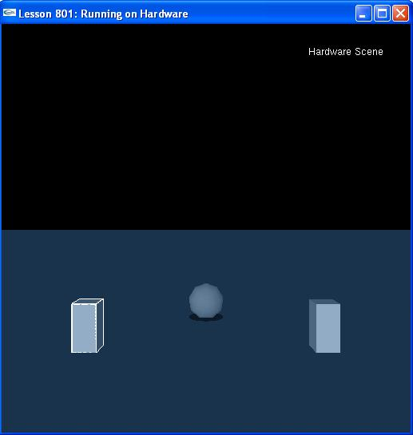

Introduction
In this lesson, we will set up a simple application to run on the PhysX card. If your code is set up to run completely asynchronously, the transition only requires setting a single scene flag.

Running on Hardware
You first need to make sure the PhysX drivers and firmware are installed. The firmware is the microcode that runs on the card and the driver talks to the card to upload and reset the firmware. Go to the Ageia official website and walk through the instructions provided.

First, install the PhysX drivers:
(You can download the newest driver from www.ageia.com/drivers/drivers.html)

The driver files will be written to C:\WINDOWS\system32\ageia

C:\WINDOWS\system32\ageia\app.bin
C:\WINDOWS\system32\ageia\diag.bin

The Simulation Type
Take a look at InitNx().

void InitNx()
{
// Create a memory allocator
gAllocator = new UserAllocator;

// Create the physics SDK
gPhysicsSDK = NxCreatePhysicsSDK(NX_PHYSICS_SDK_VERSION, gAllocator, &gErrorStream);
if (!gPhysicsSDK) return;

// Check for hardware availability
NxHWVersion hwCheck = gPhysicsSDK->getHWVersion();
if (hwCheck == NX_HW_VERSION_NONE)
{
printf("Unable to find any AGEIA PhysX hardware, this sample requires hardware physics to run. Please make sure that you have correctly installed the latest version of the AGEIA PhysX SDK.\n");
exit(1);
}

// Set the physics parameters
gPhysicsSDK->setParameter(NX_SKIN_WIDTH, 0.05);

// Set the debug visualization parameters
gPhysicsSDK->setParameter(NX_VISUALIZATION_SCALE, 1);
gPhysicsSDK->setParameter(NX_VISUALIZE_COLLISION_SHAPES, 1);
gPhysicsSDK->setParameter(NX_VISUALIZE_ACTOR_AXES, 1);
gPhysicsSDK->setParameter(NX_VISUALIZE_COLLISION_FNORMALS, 1);

// NEW, MANAGED, WAY
//Create a managed hardware scene attached to this scene
NxCompartmentDesc cdesc;
cdesc.type = NX_SCT_RIGIDBODY;
cdesc.deviceCode = NX_DC_PPU_AUTO_ASSIGN;
gCompartment = gScene->createCompartment(cdesc);
……
}
We have set the scene's compartment type to NX_DC_PPU_AUTO_ASSIGN.

cdesc.deviceCode = NX_DC_PPU_AUTO_ASSIGN;

The other fields, type define whether it is a rigid body only or rigid body and fluid/cloth simulation.

Run the simulation and watch your demo run on the hardware.

Conclusion
Congratulations! You can now using the PhysX hardware to simulate your scene.

Related Classes, Functions, and Parameters
NxCompartmentDesc
type
deviceCode

NxCompartmentType
NX_SCT_RIGIDBODY
NX_SCT_FLUID
NX_SCT_CLOTH

NxDeviceCode
NX_DC_CPU
NX_DC_PPU_AUTO_ASSIGN

