Lesson 804 – Mesh Paging

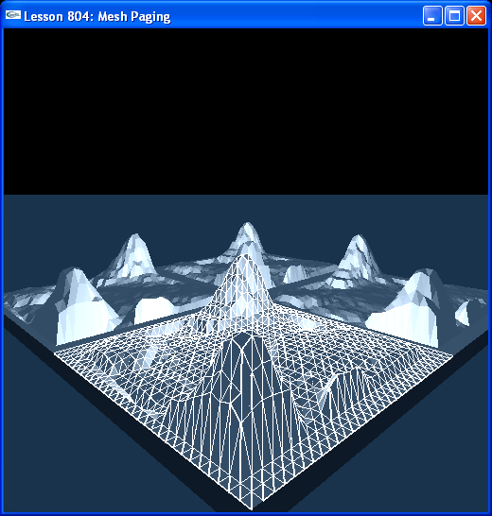

Introduction
You may need to page in your mesh data for large terrains.

Mesh Paging
In this lesson, we build a large terrain from four mesh shapes. Look at InitNx().

// Mesh globals
...
extern NxTriangleMeshDesc terrainPageTriangleMeshDesc[4][4];
...
void InitNx()
{
...
// Build the four terrain components
for (int i = 0; i < 2; i++)
{
for (int j = 0; j < 2; j++)
{
// width*step, height*step
BuildTerrainComponent(NxVec3(31*20*i, 0, 31*20*j), terrainPageTriangleMeshDesc[i][j]);
}
}
...
}

Each terrain component is created in BuildTerrainComponent().

void BuildTerrainComponent(const NxVec3& pos, NxTriangleMeshDesc& tmd)
{
heightfield = CreateHWHeightfield(pos, 2, 200, tmd);

NxShape * const * shapes = heightfield->getShapes();
for( unsigned int s = 0; s < heightfield->getNbShapes(); ++s )
{
NxShape * shape = (NxShape*)(shapes[s]);
if( shape->is( NX_SHAPE_MESH ) )
{
NxTriangleMeshShape* triMeshShape = (NxTriangleMeshShape *)shape;
NxTriangleMesh& triMesh = triMeshShape->getTriangleMesh();
int pageCnt = triMesh.getPageCount();
for ( int t = 0; t < pageCnt; ++t )
{
if (!triMeshShape->isPageInstanceMapped(t))
{
bool ok = triMeshShape->mapPageInstance(t);
assert(ok);
}
}
}
}

box = CreateBox(pos + gCameraPos + NxVec3(5,0,10), 4*NxVec3(0.5,1,0.5), 1);
sphere = CreateSphere(pos + gCameraPos + NxVec3(0,0,15), 4*1, 1);
capsule = CreateCapsule(pos + gCameraPos + NxVec3(-5,0,10), 4*2, 4*0.5, 1);
// pyramid = CreatePyramid(pos + gCameraPos + NxVec3(0,0,10), NxVec3(1,0.5,1.5), 10, pyramidConvexMeshDesc);
// concaveObject = CreateConcaveObject(pos + gCameraPos + NxVec3(-4,0,15), NxVec3(1,1,1), 5, supplyHullConvexMeshDesc);
}

The CreateHWHeightfield() is the same as CreateHeightfield(), with the addition of setting the NX_MF_HARDWARE_MESH flag in the triangle mesh descriptor.

NxActor* CreateHWHeightfield(const NxVec3& pos, int index, NxReal step, NxTriangleMeshDesc& tmd)
{
...
// Build physical model
NxTriangleMeshDesc heightfieldDesc;
...
heightfieldDesc.flags = NX_MF_HARDWARE_MESH;
...
}

Each component mesh shape gets cooked into pages. If you break on the “int pageCnt = triMesh.getPageCount();” line, you'll see each of our terrain mesh shapes is composed of 6 pages. This makes 6*4 = 24 pages total in the scene.

NxShape*const* shapes = heightfield->getShapes();
for (unsigned int s = 0; s < heightfield->getNbShapes(); ++s )
{
NxShape* shape = (NxShape*)(shapes[s]);
if (shape->is(NX_SHAPE_MESH) )
{
NxTriangleMeshShape* triMeshShape = (NxTriangleMeshShape *)shape;
NxTriangleMesh& triMesh = triMeshShape->getTriangleMesh();
int pageCnt = triMesh.getPageCount();

for ( int t = 0; t < pageCnt; ++t )
{
if (!triMeshShape->isPageInstanceMapped(t))
{
bool ok = triMeshShape->mapPageInstance(t);
assert(ok);
}
}
}
}

Call NxTriangleMesh:getPageCount() to get the number of pages in the mesh. Call NxTriangleMeshShape::isPageInstanceMapped(i) to find out if the ith page of the mesh has been uploaded to the hardware. Call NxTriangleMeshShape::mapPageInstance(i) to upload the ith page of the mesh to the hardware.

Once all instances are gone, the page gets removed from the hardware.

The maximum number of pages that can be uploaded to the hardware at any one time is 256.

Conclusion
For large worlds, you will need to manage your terrain triangle meshes. Your terrain triangle meshes will get cooked into pages and you will need to ascertain whether the pages comprising each mesh have been uploaded to the hardware. If any of the mesh pages are not there, you will need to upload them.

Related Classes, Functions, and Parameters
NxTriangleMeshDesc
flags

NxMeshFlags
NX_MF_HARDWARE_MESH

NxTriangleMesh
getPageCount()

NxTriangleMeshShape
isPageInstanceMapped()
mapPageInstance()
unmapPageInstance()

