100-1EN1
09/2005

PhysX Installation Manual



Printed in USA

Liability Disclaimer
Ageia makes no warranties, either express or implied, in this document. Information in this document, including URL and other Internet website references, is subject to change without notice. The entire risk of the use or the results of the use of this document remains with the user. Unless otherwise noted, the example companies, organizations, products, people, and events depicted herein are fictitious and no association with any real company, organization, product, person, or event is intended or should be inferred. Complying with all applicable copyright laws is the responsibility of the user.
Intellectual Property
Copyright © 2005, 2006, Ageia Technologies, Inc. All rights reserved.
Without limiting the rights under copyright, no part of this document may be reproduced, stored in, or introduced into a retrieval system, or distributed or transmitted in any form or by any means (electronic, mechanical, photocopying, recording, on a website, or otherwise) or for any purpose, without the express written permission of Ageia Technologies Corporation.
Ageia may have patents, patent applications, trademarks, copyrights, or other intellectual property rights covering subject matter in this document. Except as expressly provided in any written license agreement from Ageia, the furnishing of this document does not give you any license to these patents, trademarks, copyrights, or other intellectual property.
Ageia Technologies Inc, AGEIA, NovodeX, PhysX are either registered trademarks or trademarks of Ageia Technologies Corporation in the United States and/or other countries.
Other product and company names mentioned herein may be the trademarks of their respective owners.
Warranty Limitations
“BLANK – VENDOR TO COMPLETE THIS SECTION.”

Table of Contents
Table of Contents iii
List of Figures iv
List of Tables v
Installation Requirements 1
Hardware Requirements and Specifications 1
PhysX Driver Installation CD 1
Record Your PhysX Card Serial Number 1
Record Your PhysX CD Serial Number 1
Installing the Ageia PhysX Card 2
Cautions and Warnings 2
PhysX Card Installation 2
Installing the Ageia PhysX Driver 7
Found New Hardware 7
PhysX Driver Installation 7
Troubleshooting 13
Basic Troubleshooting 13
PhysX Card Troubleshooting 13
Verifying the PhysX Card Is Present 13
PhysX Driver Troubleshooting 16
Verifying the PhysX Driver Is Installed 16
Customer Service 18
Product Registration 18
Product Assistance 18
PhysX Card Warranty 18
PhysX Driver Warranty 18
Warranty Service 18
Web Resources 18
Index 19

List of Figures
Figure 1: PCI Slots on the Motherboard 3
Figure 2: Inserting the PhysX Card in the PCI Slot 4
Figure 3: Securing the PhysX Card with the Bracket Screw 5
Figure 4: Connecting the IDE Power Cable 6
Figure 5: Found New Hardware Wizard 7
Figure 6: PhysX Driver Installation Setup 8
Figure 7: Welcome to the PhysX Installer 9
Figure 8: Successful Installation, PhysX Card Not Installed 10
Figure 9: Successful Installation, PhysX Card Installed 11
Figure 10: Setup Completed 11
Figure 11: Viewing Release Notes 12
Figure 12: Device Manager Window 14
Figure 13: Device Properties Window 15
Figure 14: Driver Properties Window 17

List of Tables
Table 1: Hardware Requirements and Specifications 1
Table 2: Basic Troubleshooting Tips 13
Table 3: PhysX Card Troubleshooting 13
Table 4: PhysX Driver Troubleshooting 16

VENDOR: This is a placeholder page. May be deleted if you add enough copy to any of the preceding pages to overflow to this page. Otherwise, make this a “Notes” page or just leave it blank. The Roman-numbered pages must end on an even-numbered page (left-side page).

The numbering system changes at this point from Roman to Arabic. In “Print Layout View” look up in the headers to see the change. This page is vi. The next page is 1.

Requirement is that Arabic-numbered page 1 of the first chapter (the next page) must begin on an odd-numbered page (right-side page).

This matters because the page layout is based on mirror margins with a half-inch gutter for the folio fold. Click the Print Preview icon in the Word toolbar and select a 2-up view to see the layout as it will appear in print.

Installation Requirements
Before you begin to install the Ageia PhysX card or the Ageia PhysX driver, make sure you have the items required for a successful installation.

Hardware Requirements and Specifications
Table 1: Hardware Requirements and Specifications
Processor | Pentium® 4
Operating System | Windows® XP Home or Pro
RAM | 128 MB
Hard Drive Space | ??
CD-DVD Drive | Yes

PhysX Driver Installation CD
You must have an Ageia PhysX driver installation CD.

Record Your PhysX Card Serial Number
Your PhysX card’s serial number (S/N) and part number (P/N) are required for product registration. Write down these numbers before you install the card. The numbers are located on a sticker on the back of the card.

Record Your PhysX CD Serial Number
Your PhysX CD’s serial number (S/N) and part number (P/N) are required for product registration. The numbers are located on the CD.

Installing the Ageia PhysX Card
Use this chapter as a guide to install your PhysX PPU card.

Cautions and Warnings
WARNING! Never open the computer chassis when the computer is powered ON. This could result in serious personal injury. Power OFF the computer and unplug the computer power cord before you open the chassis.
CAUTION! Do not handle the PhysX card or any computer component unless you are properly grounded. The card and computer components are electrostatic-sensitive devices and can be damaged by static electricity. Before you install the PhysX card, ground yourself by touching the metal back or side panel of the computer chassis. If you have an ESD wristband, wear it when handling the PhysX card or computer components.
CAUTION! Do not attempt to install the PhysX card if the computer is powered ON.
CAUTION! After you have installed the PhysX card, be sure you plug in the IDE power cable before you power the computer ON.

PhysX Card Installation
- Before you handle the PhysX card or remove the computer cover, ground yourself by touching the metal back or side panel of the computer.
- Power OFF the computer, the monitor, and all other peripheral devices connected to the computer.
- Tag and unplug the computer power cord from the computer and the power receptacle.
- Tag and disconnect all cables from the back of the computer.
- Remove the computer cover. (Refer to your computer manual for help.)
- Locate an empty 5 V/3.3 V PCI slot on the motherboard in which to insert the PhysX card. Figure 1 shows PCI slots.
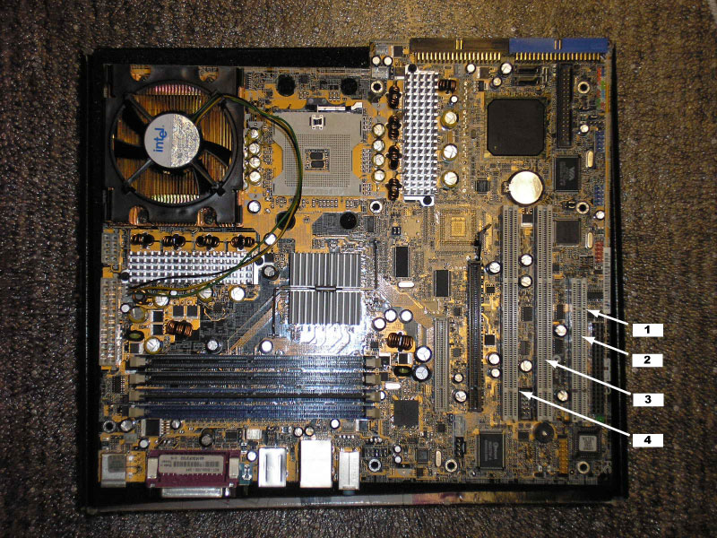
Figure 1: PCI Slots on the Motherboard
1 – 5 Volt Key
2 – 32-bit Slot
3 – 64-bit Slot
4 – 3.3 Volt Key

- Hold the PhysX card by its edges, and align it with the PCI slot on the motherboard. See Figure 2.
- Press the card gently and evenly into the slot until the card is fully seated. See Figure 2.
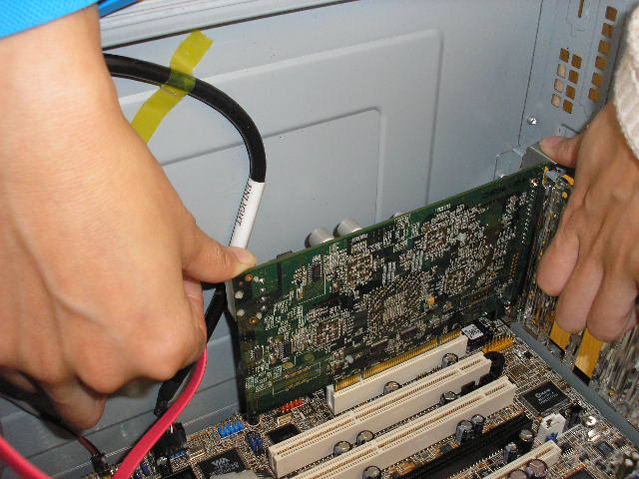
Figure 2: Inserting the PhysX Card in the PCI Slot

- Secure the bracket screw that holds the PhysX card in place. See Figure 3.
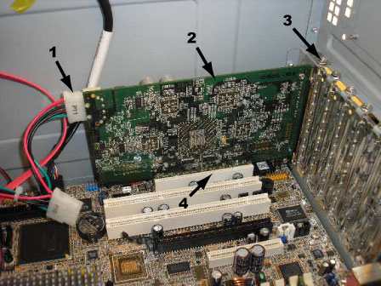
Figure 3: Securing the PhysX Card with the Bracket Screw
1 – IDE Power Cable
2 – PhysX Card
3 – Bracket Screw
4 – PCI Slot

- Connect the IDE power cable from the supply that powers the motherboard to the four-pin IDE power connector on the PhysX card. The IDE connector on the card is located at the top edge of the card on the side opposite the bracket. See Figure 4.
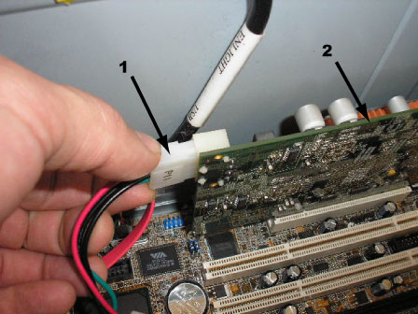
Figure 4: Connecting the IDE Power Cable
1 – IDE Power Cable
2 – PhysX Card

- Replace the computer cover.
- Reconnect any cables you removed, as tagged.
- Plug the power cord into the computer and the power receptacle, as tagged.
- Power ON the computer, and allow the system to boot.
- Power ON any peripheral devices.
- The computer detects the presence of the PhysX card. If the Found New Hardware Wizard window pops up, click Cancel. See Figure 5.

Installing the Ageia PhysX Driver
Use this chapter as a guide to install your Ageia PhysX driver. The driver enables you to access and enjoy all the exciting features offered by the PhysX card … in real time.

Found New Hardware
If you have already installed the PhysX card, the Found New Hardware Wizard window may pop up before or during driver installation. To continue installing the driver you must click Cancel. See Figure 5.
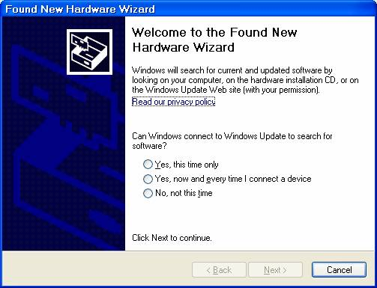
Figure 5: Found New Hardware Wizard

PhysX Driver Installation
- Insert the Ageia PhysX Driver Installation CD into your CD-DVD drive.
If Windows® runs the CD automatically, go to step 5.
- Select Start > Run.
- Type D:\setup.
Note: If D is not your CD-DVD drive, substitute the correct drive letter.
- Click OK.
- Click I Agree to the License Agreement, or click Cancel to exit the installation program.
- The Installation Options window opens. Select the XFIRE checkbox (selected by default), and then click Next.
The installation setup program creates the registry settings and installs the PhysX versions. See Figure 6.

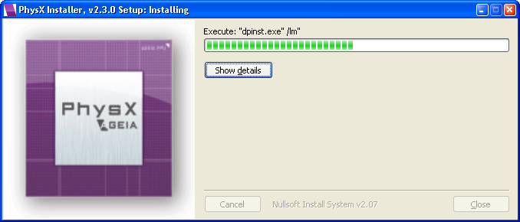
Figure 6: PhysX Driver Installation Setup

- Click Next in the Welcome to the PhysX Installer window. See Figure 7.

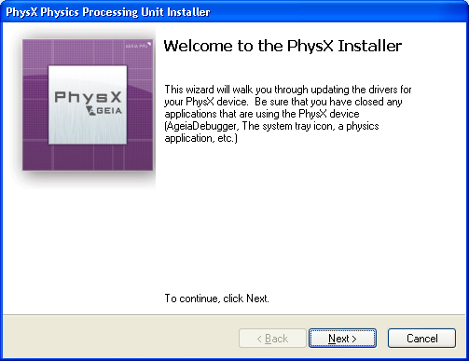
Figure 7: Welcome to the PhysX Installer

- You will see a screen that shows the progress of the installation.
- If the PhysX card is not yet installed in your computer, you will see the window shown in Figure 8. Click Finish to exit the PhysX Installer, and then install the PhysX card in your computer. (See Installing the Ageia PhysX Card.)

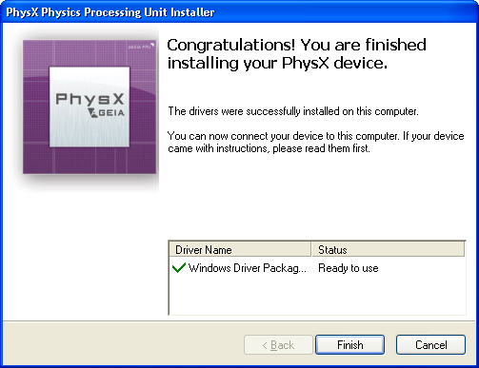
Figure 8: Successful Installation, PhysX Card Not Installed

- If the PhysX card is already installed in your computer, you will see the window shown in Figure 9. Click Finish to exit the PhysX Installer and complete the installation.

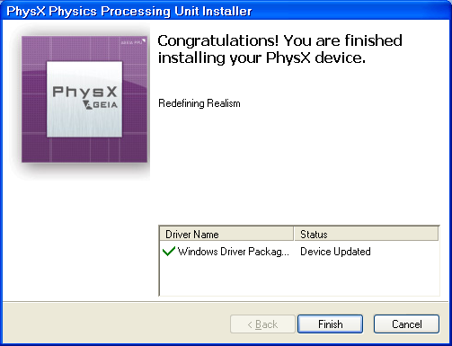
Figure 9: Successful Installation, PhysX Card Installed

- Click Close on the Setup Completed window to exit the PhysX Installer. See Figure 10.

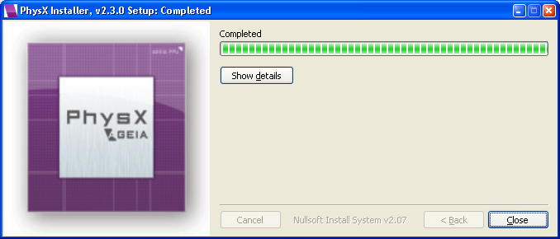
Figure 10: Setup Completed

- Click Yes to view release notes. See Figure 11.

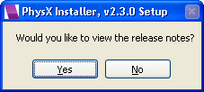
Figure 11: Viewing Release Notes

Troubleshooting

Basic Troubleshooting
Use the following tips if you experience problems during installation. Contact your vendor for more advanced troubleshooting help.
Table 2: Basic Troubleshooting Tips
- Is the AC power cord firmly plugged into the power receptacle and the computer?
- Is the computer power switch in the ON position?
- Is the line voltage correct for your computer’s power configuration?
- Is the power source you plugged the computer into energized?
- Are all cables, boards, cards and connectors firmly seated?
- Is the monitor connected to the computer and to a power source? Is the monitor power switch in the ON position?
- Are all peripheral devices connected to the computer and to a power source? Are the peripheral-device power switches in the ON position?

PhysX Card Troubleshooting
Table 3: PhysX Card Troubleshooting
Symptom | Action Required
I need to verify that the PhysX card is present, or check device status. | See Verifying the PhysX Card Is Present.

Verifying the PhysX Card Is Present
- On the PC desktop, right-click the My Computer icon, and select Properties > Hardware (tab).
- Click the Device Manager button.
- If the PhysX card and driver have been installed on your computer, and there is IDE power supplied to the card, the card is listed in the Device Manager window. See Figure 12.
If you do not see the Ageia PhysX card listed, the card is not physically present or there is no IDE power supplied to the card.
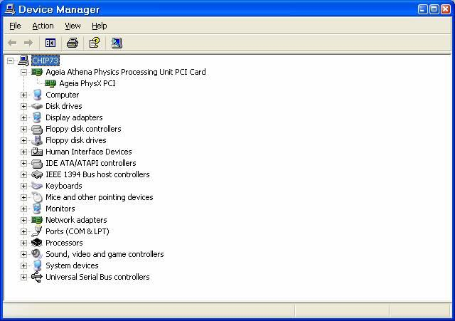
Figure 12: Device Manager Window

- Right-click the name of the card, and select Properties.
- Click the General tab to open the Device Properties window.
- The Device Properties window should display the Device Type, Manufacturer, and Location of the PhysX card on the motherboard. If the card is present and working properly, Device Status should read: This device is working properly. See Figure 13.
If Device Status does not show that message, you can try to re-install the PhysX driver, or use Windows troubleshooting. If you need more help, see Product Assistance.
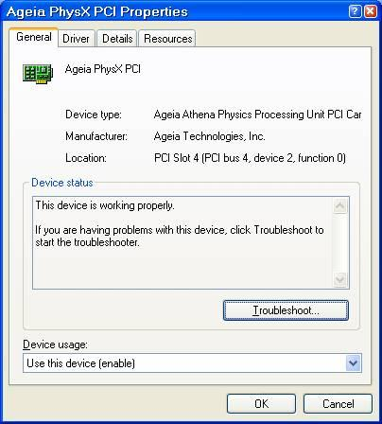
Figure 13: Device Properties Window

- Exit the Device Manager.

PhysX Driver Troubleshooting
Table 4: PhysX Driver Troubleshooting
Symptom | Action Required
Connect the Device to the Computer message appears during installation. | If you have installed the PhysX card and installed the driver, but the installation program still displays that message, then plug the IDE power cable into the PhysX card.
I need to verify that the PhysX driver is installed, or check the driver version. | See Verifying the PhysX Driver Is Installed.

Verifying the PhysX Driver Is Installed
- On the PC desktop, right-click the My Computer icon, and select Properties > Hardware (tab).
- Click the Device Manager button.
- If the PhysX card and driver have been installed on your computer, and there is IDE power supplied to the card, the PhysX card is listed in the Device Manager window. See Figure 12.
- Right-click the name of the card, and select Properties.
- Click the Driver tab to open the Driver Properties window.
- The Driver Properties window should display the Driver Provider and Driver Version details for the PhysX driver. See Figure 14.
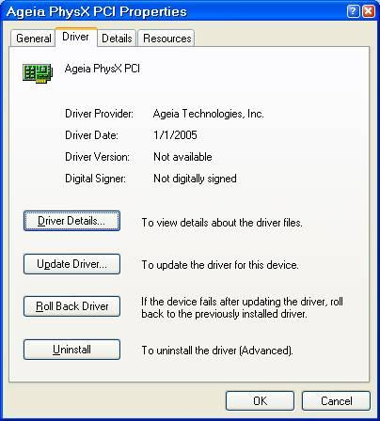
Figure 14: Driver Properties Window

- Exit the Device Manager.

Customer Service
“BLANK – VENDOR TO COMPLETE ALL SECTIONS IN THIS CHAPTER.”

Product Registration

Product Assistance

PhysX Card Warranty

PhysX Driver Warranty

Warranty Service

Web Resources

Index

-- B --
Basic Troubleshooting, 13
-- C --
Cautions
PhysX card installation, 2
Customer Service Information, 18
-- F --
Found New Hardware
driver installation, 7
-- H --
Hardware Requirements, 1
-- I --
Installation
PhysX card, 2
cautions and warnings, 2
troubleshooting, 13
verify, 13
PhysX driver, 7
found new hardware, 7
troubleshooting, 16
verify, 16
Installation Requirements, 1
-- P --
PhysX Card
record serial number, 1
troubleshooting, 13
verify installation, 13
PhysX Card Installation, 2
cautions and warnings, 2
troubleshooting, 13
verify, 13
PhysX Driver
troubleshooting, 16
verify installation, 16
PhysX Driver Components
destination location, 7
PhysX Driver Installation, 7
found new hardware, 7
troubleshooting, 16
verify, 16
PhysX Installation CD
record serial number, 1
-- S --
Serial Number
record
PhysX card, 1
PhysX CD, 1
Static Electricity
caution, 2
-- T --
Troubleshooting
basic, 13
PhysX card, 13
PhysX driver, 16
-- W --
Warnings
PhysX card installation, 2

