PORTFOLIOS

**Digital Marketing Website**

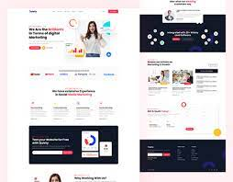The term digital marketing refers to the use of digital channels to market products and services to consumers.

### Food Delivery Website

Food delivery apps are third-party delivery services hosted on mobile applications that restaurants or retailers partner with to showcase their menu and food offerings, allowing customers to order food and get it delivered to their doorstep.

### food_delivery_dashboard.png

### Social Media Website

Social media is a collective term for websites and applications that focus on communication, community-based input, interaction, content-sharing and collaboration.

