**Project** **Title**:

NOVELty

***Project description:***

Have you ever read a book and thought to yourself: “I need to share this book?” You have come to the right place. Leveraging the TasteDive, Google Books and OpenLibrary APIs, we are a one-stop shop for personalized book recommendations.

***User Story:***

***As someone always looking to recommend new books based on my preferences.***

***I want to be able to have the app track how often I go back to a book, how much time I spend on it, and whether I finish it or not***

***So that I can have books recommended to me based on similar users and the ratings given by the API.***

***As a user of the app,***

***I want a clean dashboard interface to easily view and update my preferences, books and recommendations.***

***So that I can easily use and navigate the app and spend more time reading.***

***As a reader on the go,***

***I want a mobile-friendly app to take with me.***

***So that I can read on multiple devices.***

***As a fan of books,***

***I want to be able to share my literary preferences, list of books read, and books I’m reading.***

***So that I can receive recommendations from other users with similar tastes.***

***As a user of the app,***

***I want to be able to share personal ratings of books to others.***

***So that others can find out whether or not users with similar book preferences recommend them or not.***

***As a user of the app,***

***I want to be able to track how many days it takes me to read a book.***

***So that I can see how often I reach for the book and how committed to finishing it I am.***

***As a frequent and dedicated user of the app,***

***I want to be able to join Book Clubs dedicated to the shared interest of a genre, author or series.***

***So that I can join a community of like-minded readers through the app.***

***”***

***Wireframe / Rough Draft:***

***Logo idea:***

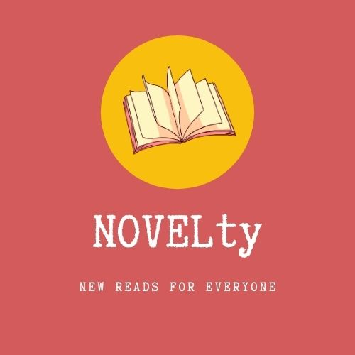

***Initial wireframe samples:***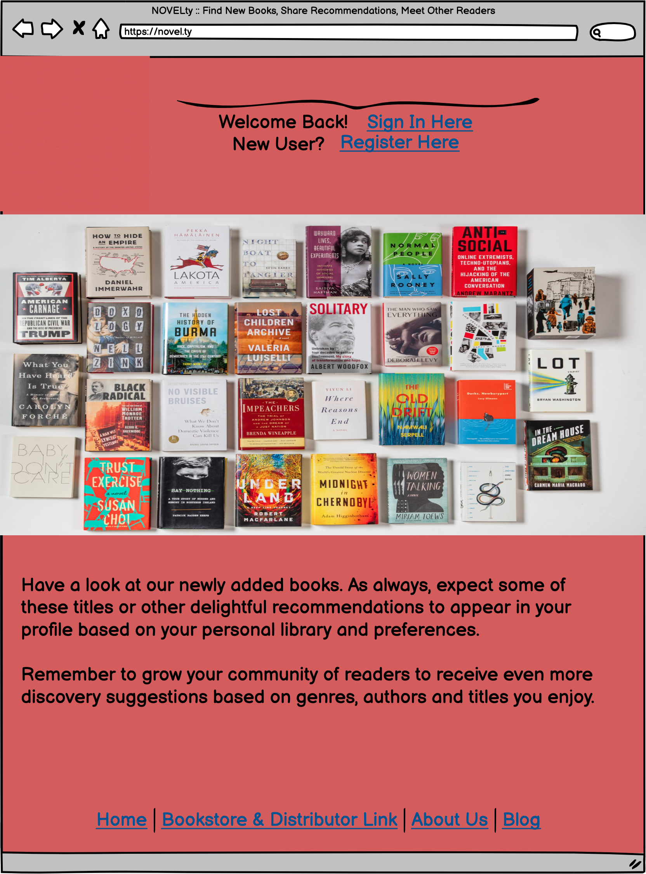

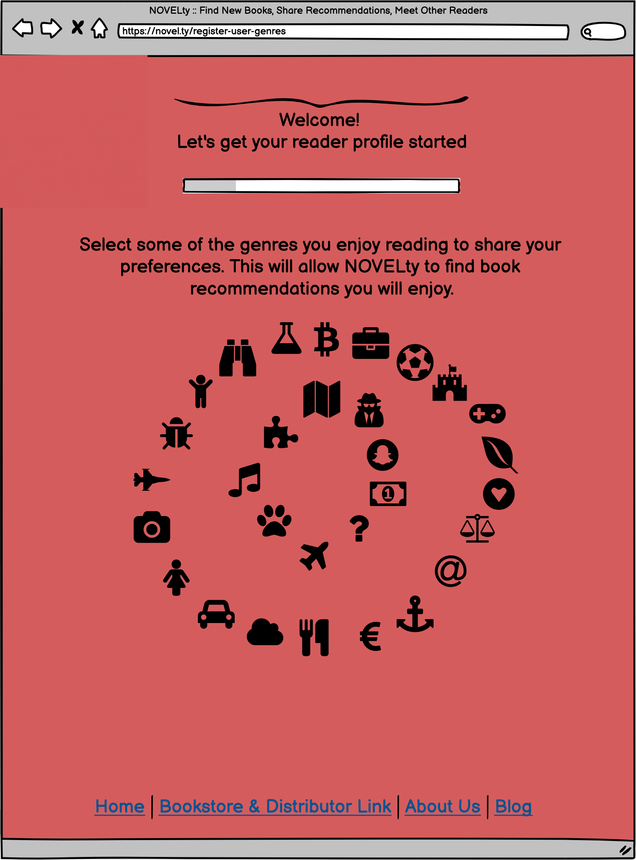

***Homepage - (GIF logo not showing)*** [***https://share.balsamiq.com/c/hvzZHEqB4jnMzpFaWHVxdd.png***](https://share.balsamiq.com/c/hvzZHEqB4jnMzpFaWHVxdd.png)

***App Flow:***

1. ***Homepage***
2. ***Log In / Register***
3. ***First Time Dashboard > Best Sellers Displayed, user selection***
4. ***Choose to log genre preferences, favourite authors, titles of interest***

***APIs to be used:***

* *TasteDive*
* *OpenLibrary*
* *Google Books?*
* *Amazon?*

***Breakdown of tasks:***

1. GitHub Repo - Creating dir structure - Nagesh
2. Model - MySQL, CRUD, Sequelize, ORM - Nagesh
3. View - UI, Handlebar, Bootstrap - Hector
4. Controller - Routes, etc. - Annie
5. Heroku deployment <-- possible Travis-CI usage
6. Testing - Natasha
7. Passport - Authentication - Ivan?
8. API Usage - Annie
9. Prepare the presentation
10. Future enhancements
11. NASA - Ivan